HUMAN
WELLBEING
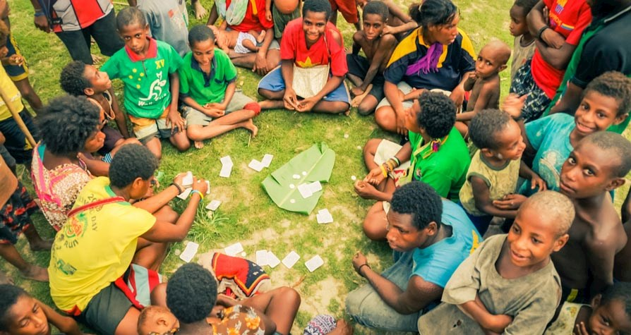

Year 10 Geography

Name:
Teacher:

Syllabus Specifications
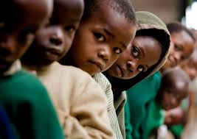

KEY INQUIRY QUESTIONS
- What makes human wellbeing a geographical issue?
- How can the spatial variations in human wellbeing and development be measured and explained?
- What are the economic, social and environmental impacts of variations in development and human wellbeing?
- How do governments, groups and individuals respond to inequalities in development and human wellbeing for a sustainable future?

CONTENT FOCUS
Students examine the nature of, and differences in, human wellbeing and development that exist within and between countries. They describe ways of measuring human wellbeing and development to reveal spatial variations and develop explanations for differences. Students investigate examples from Australia and across the world of issues affecting development, the impact on human wellbeing and the consequences of spatial variations across scales. Local, national and global initiatives to improve human wellbeing are also examined.

CONTNET TOPICS
- Human wellbeing and development
- Spatial variations in human wellbeing
- Human wellbeing in Australia
- Improving human wellbeing

Glossary
Write the definition for the following terms in the space provided.
Aid
Developed
Development
Economic migrant
Famine
Global indicators
Government organisation
Human Development Index
Human Wellbeing
Inequality
Economically developed nation
Non-government organisation
Overpopulation
Population pyramid
Poverty
Refugee
Slum
Social justice
Standard of living
Territory
Third World
Under-developed
Welfare

Topic 1: Human Wellbeing and Development


In this section you will:

• investigate ways of measuring and mapping human wellbeing and development, for example:
- examination of global indicators and benchmarks for human wellbeing
- description of ways of measuring and mapping human wellbeing and development for the purpose of identifying and analysing spatial variations
- analysis of contemporary trends in human wellbeing and development

Defining Human Wellbeing
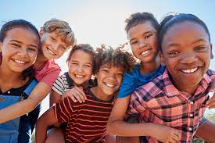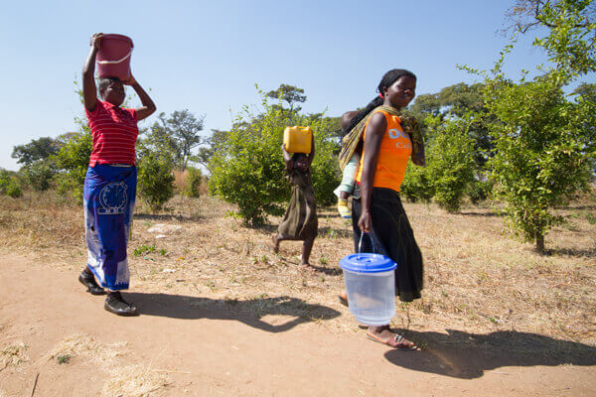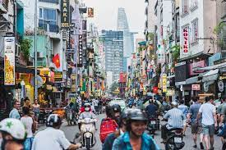
Activity 1
Brainstorm 10 words that remind you of the term Human Wellbeing.

What do you think is the most important aspect of a person’s life that would contribute to their wellbeing?
_______________________________________________________________________________________

As a class list them on the board. Listen to those of other people and then decide if the aspect can be measured or cannot be measured.
Aspect of wellbeing
Measured | Cannot be measured

Watch the clip ‘What is Human development?' (found on the Canvas page titled ‘Defining Human Wellbeing’) and write down 5 points below.
______________________________________________________________________________________________________________________________________________________________________________________________________________________________________________________________________________________________________________________________________________________________________________________________________________________________________________ ___
Activity 2: Refer to the Canvas page title ‘Defining Human Wellbeing’ and complete Activity 2.
Activity 3: Refer to the Canvas page titled ‘Defining Human Wellbeing’ and complete Activity 3.

MEASURING HUMAN WELLBEING

Activity 1: Dollar Street
Link to website found on Canvas page or https://www.gapminder.org/dollar-street
Using the sliders on the Dollar Street website, narrow down to the lowest incomes and then gradually move the sliders to the more expensive. Write down what observations you can make between the lowest, middle and highest incomes for the following categories:
- Bedding
- Get water
- Plates of food
- Next big things I plan to buy
 | Lowest | Middle | Highest
Bedding
Get Water
Plates of Food
Next big things I plan to buy

After completing the table above, what differences did you notice most between the lower and higher incomes?
What do you think could be some of the problems of only measuring wellbeing by income?

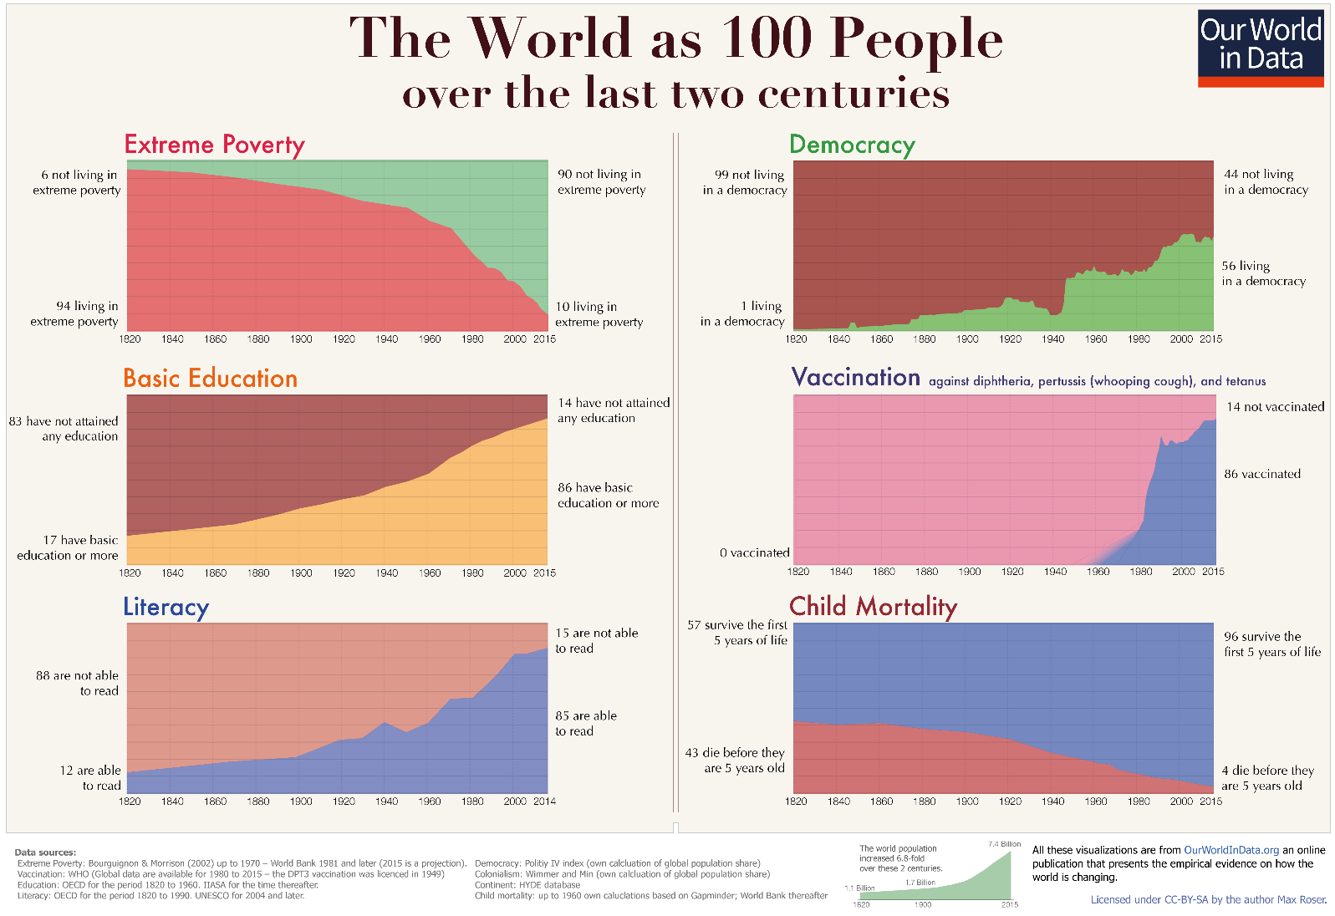

Activity 2: Measuring Wellbeing
Define the following ways of measuring wellbeing:

GDP - _________________________________________________________________________________
_______________________________________________________________________________________
OECD – _______________________________________________________________________________
_______________________________________________________________________________________
HDI - __________________________________________ _______________________________________
________________________________________________ _______________________________________
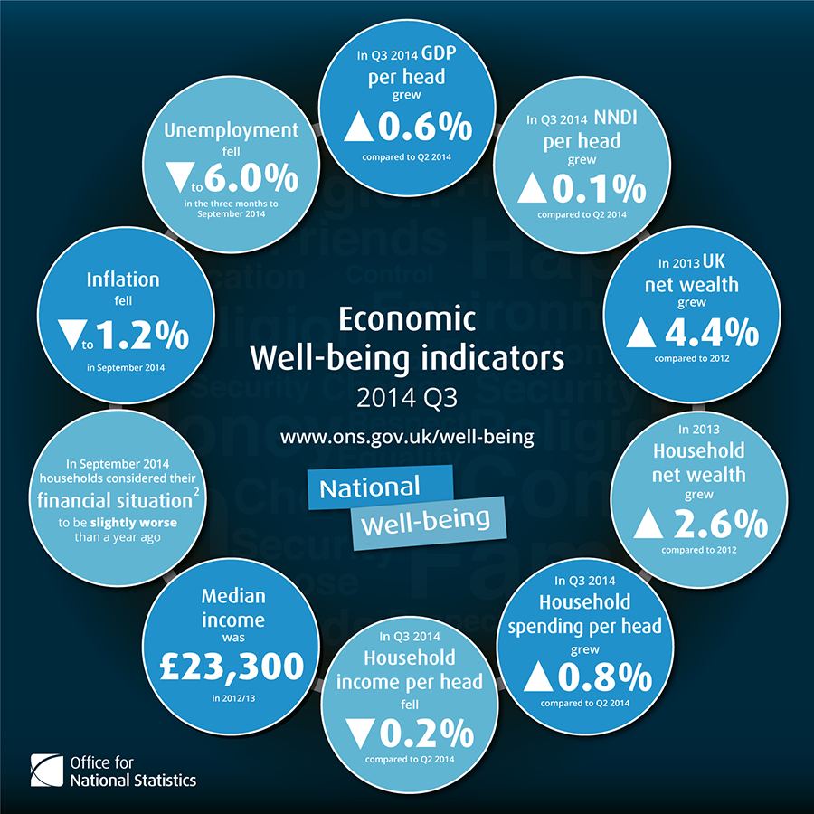

From the graph above, answer the following questions:

What percentage did unemployment fall to? ________________________ ____________________

What percentage did household net wealth grow by in 2013? __________ ____________________

What was the median income in 2012/2013? _______________________ ____________________

Activity 3: Video Clip
Watch as a class.
Link found on Canvas page or https://www.youtube.com/watch?v=jbkSRLYSojo&t=1s
Watch the clip '200 countries, 200 years in 4 mins' and write down 4 points about measuring wellbeing.

______________________________________________________________________________________________________________________________________________________________________________________________________________________________ _______________________________________
___________________________________ ____________________________________________________
What two criteria is he using to map human wellbeing?
How are things changing over time?
Which region looks like it is being left behind?

Measuring Wellbeing - Indicators of development
Activity 1: Global indicators for human wellbeing
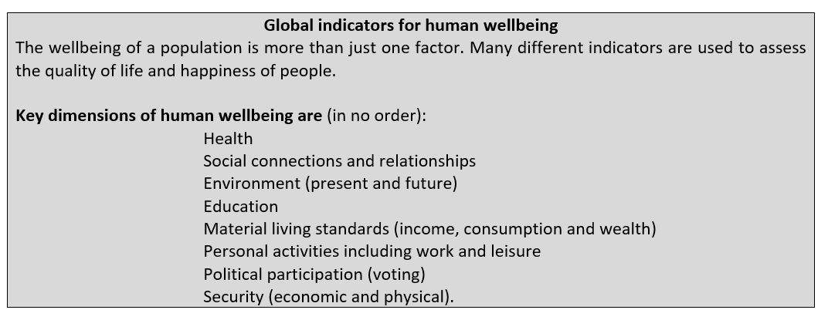
ACTIVITY: Rank the indicators of wellbeing in the box above in order of most to least important for you in the list above. Put a 1 next to the dimension that you think is the most important, a 2 next to the second most important, and so on.

Activity 2:
Annotate (label) the image below for the needs you would have to live a happily and healthily at the different stages of life below.
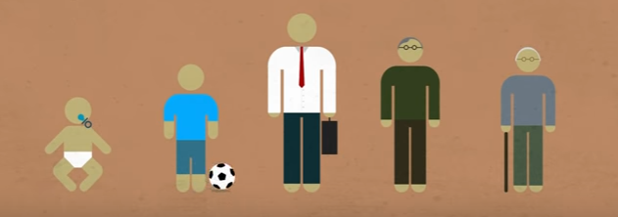

ACTIVITY 3 : Weekly diets - an indicator of wellbeing
Guess which country is shown in each image, the cost of their weekly diet and rate between the 3 shown which you consider the most healthy diet. (Answers: https://time.com/8515/what-the-world-eats-hungry-planet/)
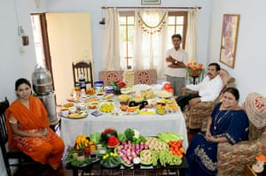 | Country
 | Cost (Aus $)
Rank
1 = Most healthy
to
3 = Least healthy
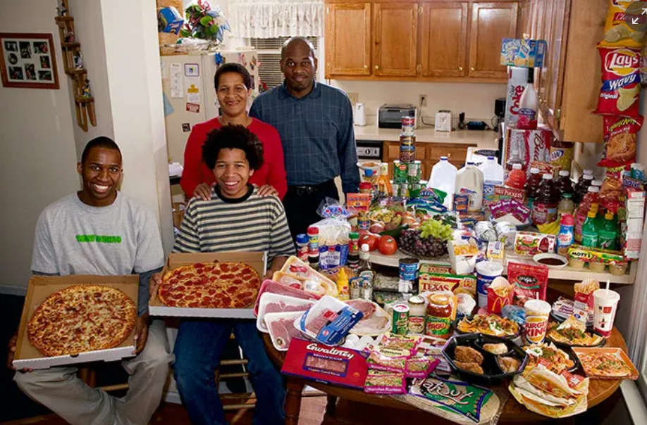 | Country
 | Cost (Aus $)
Rank
1 = Most healthy
to
3 = Least healthy
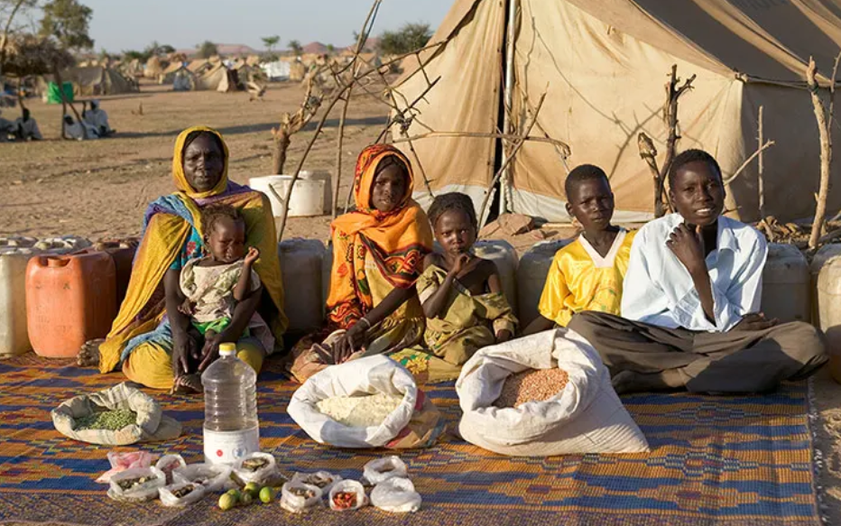 | Country
 | Cost (Aus $)
Rank
1 = Most healthy
to
3 = Least healthy

Activity 4: GNI - Gross National Income - an indicator of wellbeing
Below is a graph showing three Eastern European nation’s GNI. View the graph and then respond to the questions.
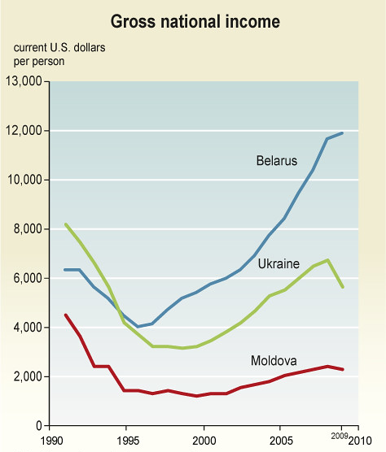
- Which country has the highest GNI per person in 1992?

- Which country had the highest GNI per person in 2010?

- In 2005 what was the difference in GNI per person of Moldova and Belarus?

- Which of the following statements are likely to be True and False:
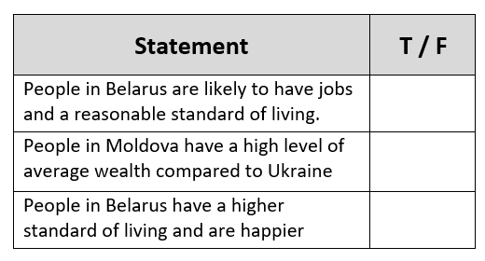

Activity 5: Life Expectancy – an indicator of wellbeing
Respond to the multiple choice and short response questions below:
- Do you think GNI is a strong indicator of a country’s life expectancy? Why/Why not?

____________________________________________________________________________________________________________________________________________________________________________________________________________________________________________________________________________________________________________________________________

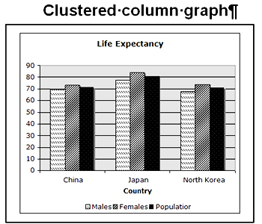
Questions 2 – 4 refer to the graph
Males

Females
Life Expectancy in selected Asian nations
China Japan Korea
Countries
Life expectancy (years)
90
80
70
60
50
40
30
20
10
0

- Which group of people have the highest life expectancy? State the life expectancy, gender and country.
_____________________________________________________________________________

- What is the difference in life expectancy for females in China and Japan?
____________________________________________________________________________

- Which statement best describes the information from the graph? Circle the correct answer
  - Males in China, Japan and Korea can expect to live beyond 70 years of age
  - Females in Korea have the longest life expectancy
  - Males in China have a similar life expectancy to females in Japan
  - Females in Korea can expect to live to around 73 years of age

Activity 7: Working with Data – Human Development Index (HDI)

The Human Development Index (HDI) was developed by the United Nations as a metric to assess the social and economic development levels of countries (Investopedia, 2016).

Visit the United Nations (UN) HDI Website to complete the following questions –
https://hdr.undp.org/en/content/human-development-index-hdi

- Why was the HDI developed?

________________________________________________________________________________________________________________________________________________________________________________________________________________________________________________________________________________________________________________________________________________

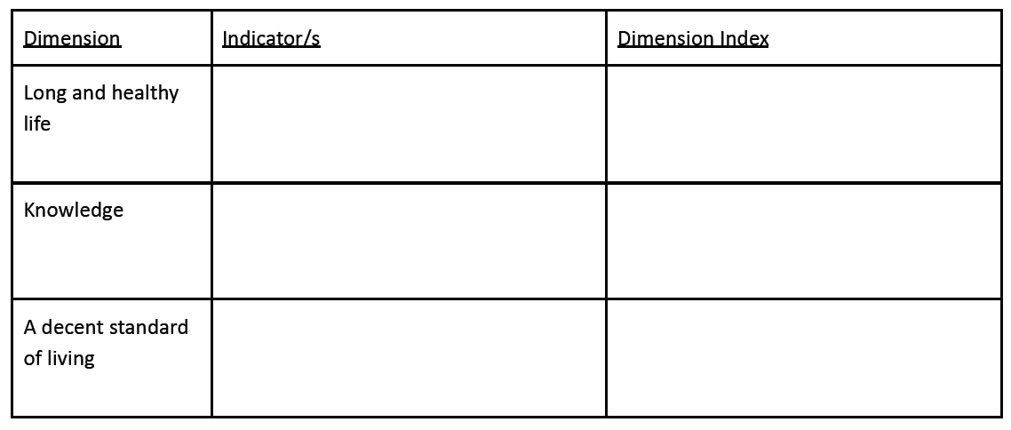
- Complete the table below on the three dimensions and their indicators of HDI.

- What does the HDI not measure?

- In your opinion, why does the HDI aggregate three dimensions, and not just one?

- Visit the data download and select “All Tables” – https://hdr/undp.org/data-center/documentation-and-downloads

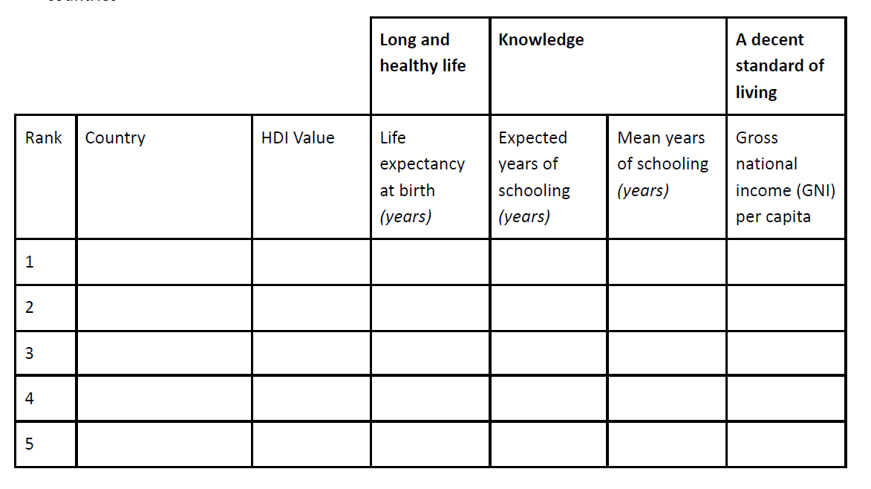
- Open the Spreadsheet, and using the data from ‘Table 1’ complete the following table of the top 5 countries
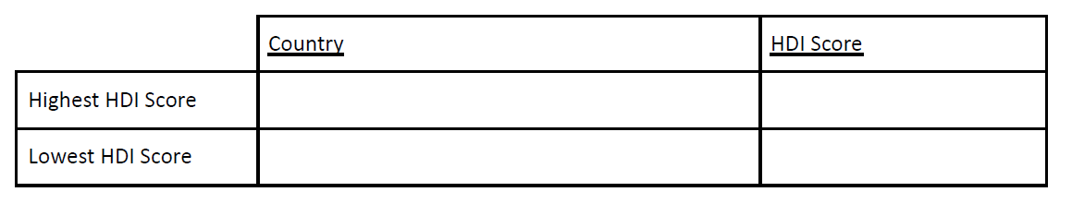
- Using the data from ‘Table 1’, complete the following table

- If the HDI just used Gross National Income (GNI) per capita, would the rankings be the same? Give an example.

- Where does Australia rank? In which indicators should Australia be commended? In which areas is there room for improvement?

- Why is ‘mean years of schooling’ an important component of the HDI?

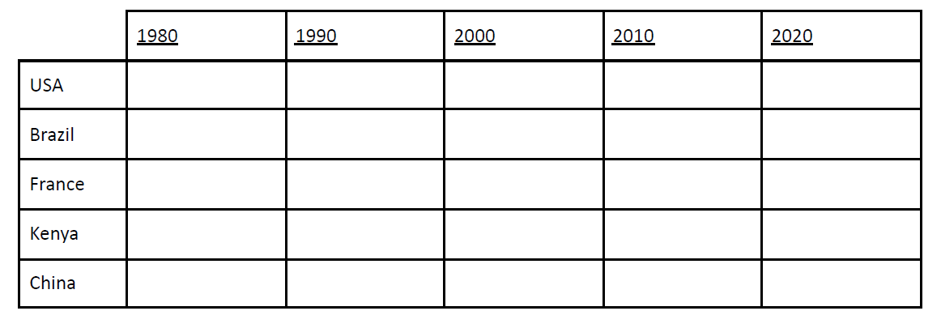
- Visit the HDI Map to estimate the average HDI for the following countries for each decade – https://ourworldindata.org/grapher/human-development-index?year=1999
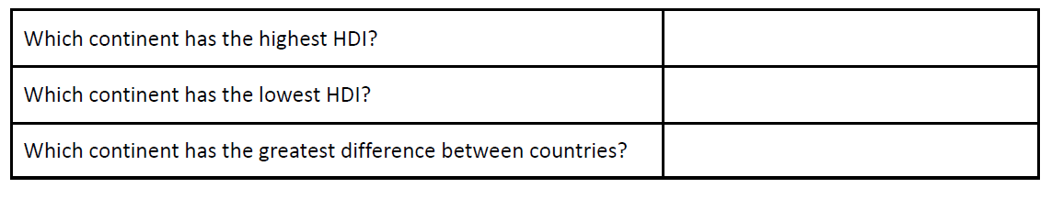
- Based on the HDI Map answer the following questions (in relation to 2020)

- Extension Activity – Although the HDI only incorporates three dimensions (with four measurements), the United Nations Development Programme (UNDP) does publish data of other statistics. Complete the table below using the data in the spreadsheet.

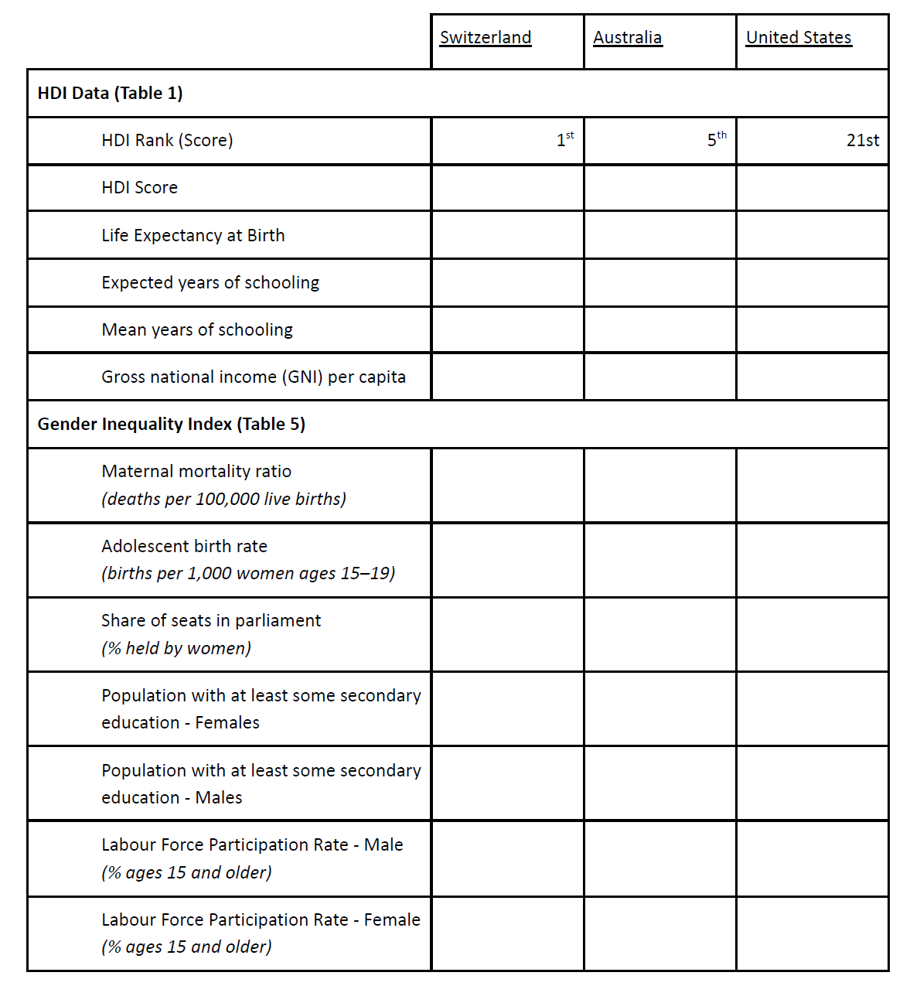
https://hdr/undp.org/data-center/documentation-and-downloads

- What is the main problem with the HDI? Reference the specific data from the table above.
MAPPING WELLBEING
CHOROPLETH MAPS
Use the following data to create a choropleth map showing rates of homelessness in Australia, 2016.
State / Territory | Number | % | Rate per 10,000 of the Population
New South Wales | 37,715 | 32 | 50.4
Victoria | 24,817 | 21 | 41.9
Queensland | 21,671 | 19 | 46.1
South Australia | 6,224 | 5 | 37.1
Western Australia | 9,005 | 8 | 36.4
Tasmania | 1,622 | 1 | 31.8
Northern Territory | 13,717 | 12 | 599.4
Australian Capital Territory | 1,596 | 1 | 40.2
Total homeless persons | 116,427 | 100 | 49.8

Steps to Creating a Choropleth Map:
- Locate your highest and lowest values in the rate per 10,000 of population column. We will not use percentage or number, because the percentage is that of the homeless population and does not accurately reflect the total number of people. For example, smaller states will of course have a much lower percent of homeless than states which have much larger populations.
- Add to your map on the next page a title, border and orientation
- When making your map you will want to create a key which ranges from light to dark. Light colours equal low values and dark colours equal high values. Aim for four shades of one colour.
- Decide a suitable range of data to help divide up your shades. Your lowest rate is 31.8 but your highest is 599.4. In this instance your final range might be 60+ to help include the outlier of Northern Territory.
- Create your key and place it next to your map.
- Colour in your map of Australia accordingly.

After creating your map answer the following questions:
How did this kind of map help to show you rates of homelessness? Did you find the data easier to “see”?

Which state or territory was problematic to include? Why?

What are some potential negatives of using this kind of mapping tool?

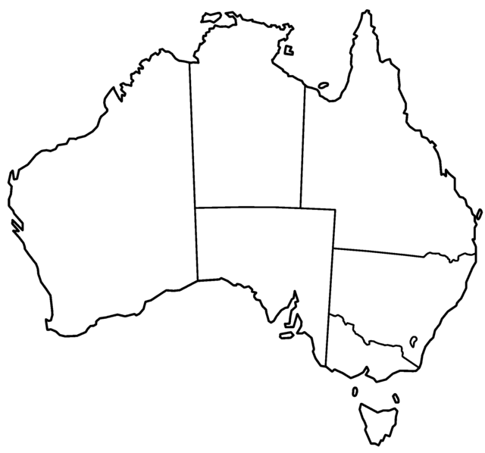

Rate Per 100,000 of Population | Colour

POPULATION PYRAMIDS

Extension Activity
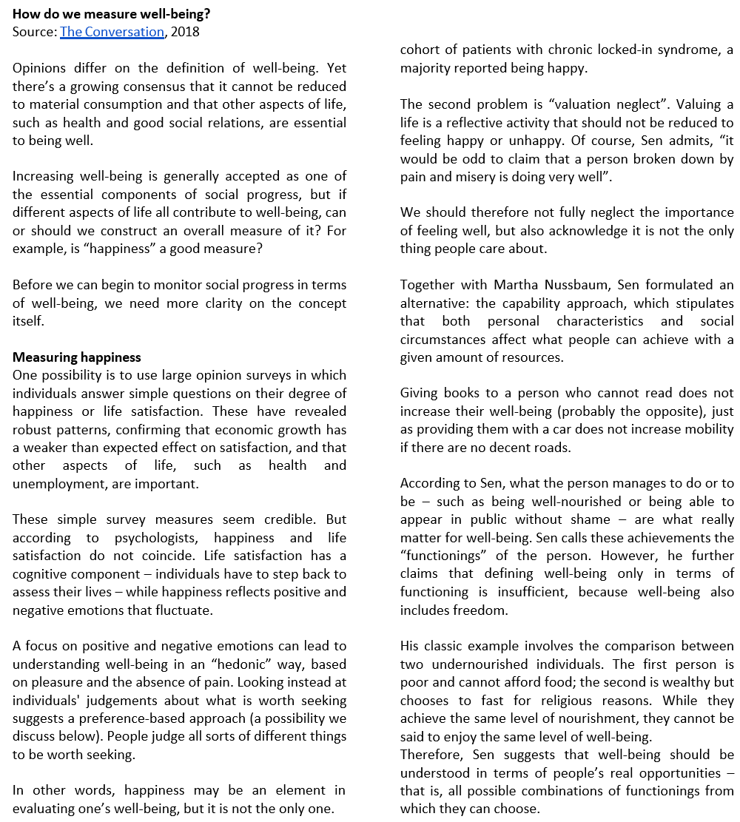
Activity 1
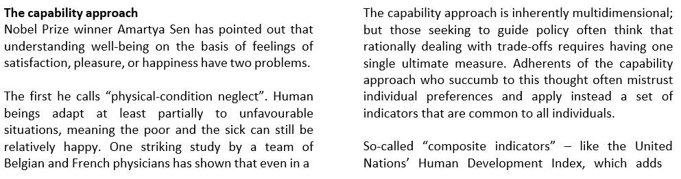

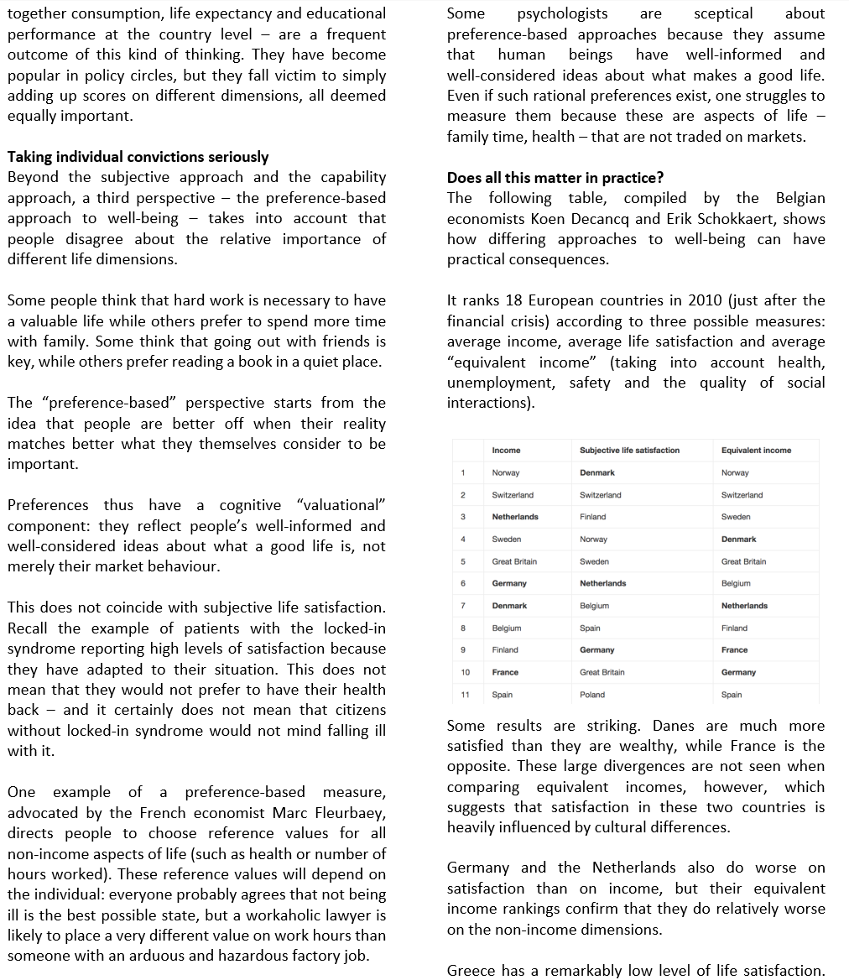
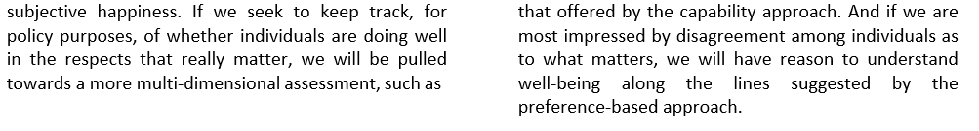

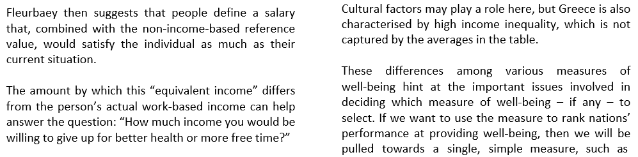
Refer to ‘How do we measure well-being?’ article to answer the following questions
- What is 'material consumption'?
- Why would economic growth have a "weaker than expected effect on satisfaction"?
- What is the limitation of solely using happiness to measure wellbeing?
- Why does Sen champion measuring wellbeing in 'people’s real opportunities'?
- What is the limitation of the Human Development Index (HDI)?
- Using the table, which European country has the best wellbeing? Why?
- What is "high income inequality"?
- What is the author's preference for measuring wellbeing?

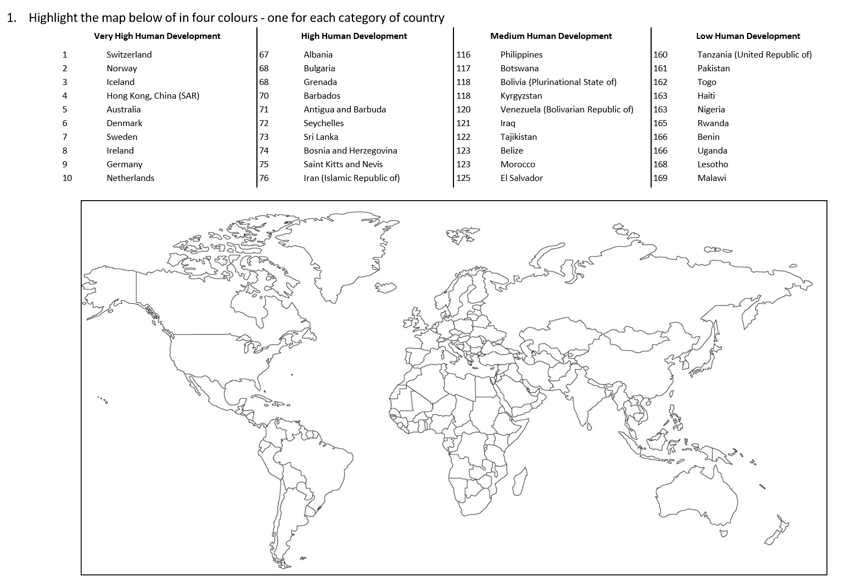
Activity 2
With reference to the HDI Map, answer the following question
- Which areas of the world (continents and countries) are dominated by high levels of human development? (one paragraph)

- Which areas of the world (continents and countries) are dominated by low levels of human development? (one paragraph)

- Hypothesise two reason for high levels of human development in Europe (one paragraph)

- Hypothesise two reason for low levels of human development in Africa (one paragraph)

- Explain how one country's level of human development impacts another? (one paragraph)

POPULATION PYRAMIDS
Define the term population pyramid:
Activity 1

Estimated resident population of Australia, Age and Sex, 30 June 2010.
Years | Males | % Persons | Females | % Persons
0-4 | 749,322 | 3.4 | 711,435 | 3.2
5-9 | 701,176 | 3.1 | 664,543 | 3.0
10-14 | 719,775 | 3.2 | 683,954 | 3.1
15-19 | 770,551 | 3.5 | 729,803 | 3.3
20-24 | 850,180 | 3.8 | 798,065 | 3.6
25-29 | 843,634 | 3.8 | 818,706 | 3.7
30-34 | 767,118 | 3.4 | 765,257 | 3.4
35-39 | 801,784 | 3.6 | 813,374 | 3.6
40-44 | 771,081 | 3.5 | 780,356 | 3.5
45-49 | 780,525 | 3.5 | 794,015 | 3.6
50-54 | 726,190 | 3.3 | 743,127 | 3.3
55-59 | 655,407 | 2.9 | 669,617 | 3.0
60-64 | 603,728 | 2.7 | 608,057 | 2.7
65–69 | 449,957 | 2.0 | 458,975 | 2.1
70–74 | 343,680 | 1.5 | 366,513 | 1.6
75–79 | 256,049 | 1.1 | 295,493 | 1.3
80–84 | 188,941 | 0.8 | 250,340 | 1.1
85–89 | 98,996 | 0.4 | 168,059 | 0.8
90+ | 39,010 | 0.2 | 92,054 | 0.4
Total Persons Australia 22,328,847

Source: Australian Demographic Statistics, Dec 2010 (ABS cat.no. 3101.0)

Using the data on the previous page, practice drawing a population pyramid in the space below.
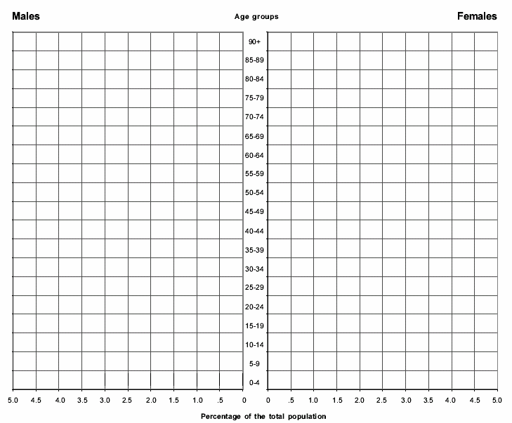
Use the population pyramid you created to answer the following questions
Estimate the proportion of the population between the ages of 15 to 30.
_______________________________________________________________________________________
Estimate the proportion of the population above the age of 60.
_______________________________________________________________________________________
Specify which group of Australia’s population was the largest in 2015.
_______________________________________________________________________________________
Explain two geographical reasons why in 2015 the majority of Australia’s population was over the age of 50. Based on the ABS data.
_____________________________________________________________________________________________________________________________________________________________________________________________________________________________________________________________________

Activity 2
On the following population pyramid, label the elderly dependents, economically active, and young dependants.

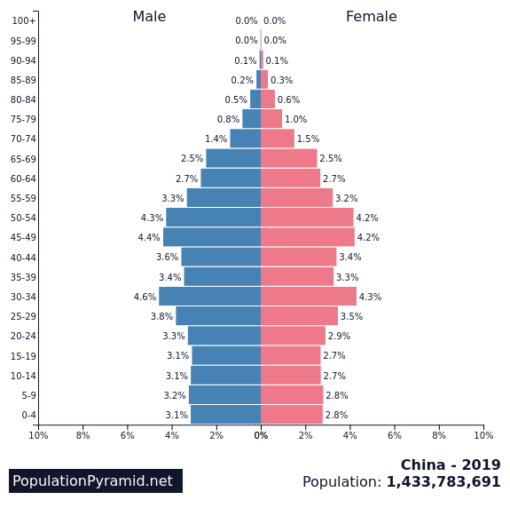

How would you describe the population of China? What patterns can you see?

Similar to before, on the following population pyramid, label the elderly dependents, economically active, and young dependants.

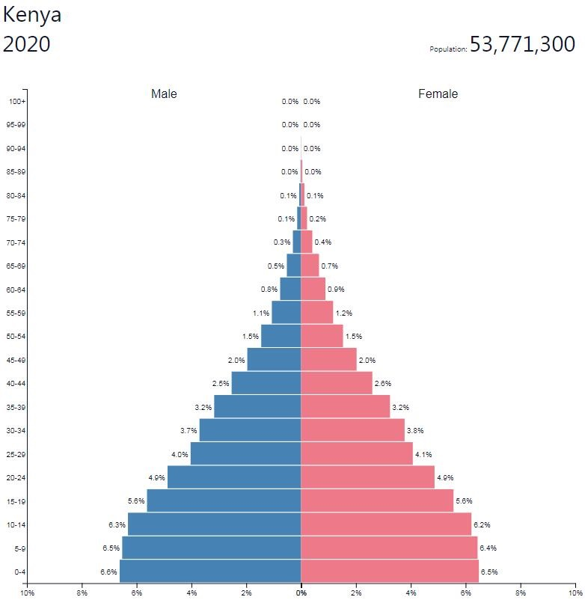

How does the population of Kenya compare to that of China? What might account for these differences?

4C’s Thinking Routine: Hans Rosling - How to end poverty in 15 years
Watch Don’t Panic — End Poverty to answer the following questions - https://www.gapminder.org/videos/dont-panic-end-poverty/
- Complete the table below AFTER watching the video

Connections  What connections do you draw between the video and your own life or your other learning? | Challenge  What ideas, positions or assumptions do you want to challenge or argue with in the video?
Concepts  What key concepts or ideas do you think are important and worth holding onto from the video? | Changes  What changes in attitudes, thinking or action are suggested by the video, either for you or others?

- Identify the United Nations Sustainable Development Goal, Hans Rosling will be discussing in the video?

- What does relative poverty measure?

- What is the major difference between extreme poverty and relative poverty?

- What are some of the struggles families living in Malawi in extreme poverty experience?

- What does Dollar Street show us?

- What has been the trend in poverty in the world since the 1800's till 2015?

- What does Hans Rosling suggest is the best measure for human progress?

- List the factors that child mortality depends on?

- From what you learnt in the video, explain the role economic and social progress plays in improving human wellbeing for those living in extreme poverty?

Topic 2: Spatial variations in human wellbeing

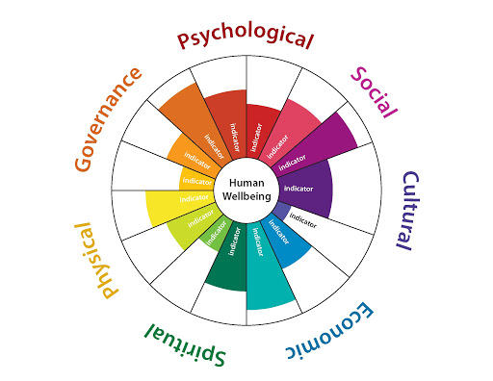

In this section you will:

- investigate causes, issues and consequences of spatial variations in human wellbeing, for example:
-description of spatial variations in human wellbeing and development between and within countries using selected indicators
-examination of reasons for and consequences of spatial variations in human wellbeing and development
-discussion of issues affecting the development of places and their impact on human wellbeing in ONE country or region

Variations in Wellbeing

List the inequalities of wellbeing: ____________________________________________________________
_______________________________________________________________________________________
Read the following information and answer the questions below.
There are many reasons for the inequalities in wellbeing that exist between countries. The environment and climate can make a difference, affecting access to fresh water and the ability to grow food. The presence of natural resources such as oil and minerals is an important source of wealth for countries that influences levels of wellbeing.
The political, economic and social organisation of a country can also have a big impact on its wellbeing. Important factors include the make-up of the population, the levels of gender equality and access to technology. One of the most significant factors affecting wellbeing, however, is conflict.

Case Study: Syria
Source 1: a Syrian refugee going to wash her clothes in a refugee camp in Jordan.

It has also resulted in one of the largest refugee exoduses in recent history. Neighbouring countries have borne the brunt of the refugee crisis, with Lebanon, Jordan and Turkey struggling to accommodate the flood of new arrivals. The exodus accelerated dramatically in 2013, as conditions in Syria deteriorated.
A further 7.6 million Syrians have been internally displaced within the country, bringing the total number forced to flee their homes to more than 11 million – half the country’s pre-crisis population. Overall, an estimated 12.2 million are in need of humanitarian assistance inside Syria, including 5.6 million children, according to the United Nations.

Activity 1
Identify five possible reasons for the inequalities in wellbeing that exist between countries.
_______________________________________________________________________________________
_______________________________________________________________________________________
How many Syrians have been affected by the civil war conflict there?
_______________________________________________________________________________________
Read the following information and answer the questions below.
The two Koreas: A study in wellbeing
The Korean Peninsula is shared by two countries – South Korea and the Democratic People’s Republic of Korea (more commonly known as North Korea). Due to their proximity to each other they have similar climates, soils, topography and mineral resources. And yet South Korea is rated as the country with the 12th highest level of wellbeing in the world, while North Korea is 63 places lower at 75th. South Koreans live, on average, 10 years longer and have a GDP 18 times higher than their northern counterparts. These differences cannot be explained by differences in resources but in the ways in which these countries are governed and their resources managed. South Korea is a democracy with a market driven economy. It has a strong economy with high exports and imports, is highly industrialised with a large urban population and is technologically advanced. South Korea also has relatively low levels of corruption and a free media. North Korea is a totalitarian state, meaning there is only one political party and no elections. It has little to do with the rest of the world and the economy is strictly controlled by the central government. The population is still largely rural and farming methods are technologically backwards. The North Korean Government places a great emphasis on having a strong military and up to one-third of the country’s budget goes towards maintaining it. North Korea also has very high levels of corruption and no freedom of the press.

Source: The Korean Peninsula at night

Describe the pattern shown in this satellite photograph above and explain it in relation to wellbeing.

_______________________________________________________________________________________
_______________________________________________________________________________________
Activity 2
Watch the clip ‘Escaping from North Korea in search of freedom _ Yeonmi Park _ One Young World’ (Watch as a class – clip found on Canvas under Lesson 10: Variations in Wellbeing) and outline 6 experiences present by the young Korean girl.

_______________________________________________________________________________________
_______________________________________________________________________________________
_______________________________________________________________________________________
_______________________________________________________________________________________
_______________________________________________________________________________________

Activity 3: Slumming It Episode 1 – Documentary
Watch the documentary ‘Slumming It’ and answer the following questions.
- Why is Mumbai one of the world’s megacities?
______________________________________________________________________________________________________________________________________________________________________________
- How many people live in this slum?
______________________________________________________________________________________________________________________________________________________________________________
- Where do the latest arrivals to the slum go to settle?
______________________________________________________________________________________________________________________________________________________________________________
- How do people feel about living in the slum?
______________________________________________________________________________________________________________________________________________________________________________
- Describe what is inside the toxic sludge in the slum.
______________________________________________________________________________________________________________________________________________________________________________
- Explain the structure of the Dharvai slum.
______________________________________________________________________________________________________________________________________________________________________________
- How many people does Rajesh live with in his 12x12m home?
______________________________________________________________________________________________________________________________________________________________________________
- How do the slums deal with the water shortages in Mumbai?
______________________________________________________________________________________________________________________________________________________________________________
- How many people share each toilet?
______________________________________________________________________________________________________________________________________________________________________________
- What is the result of these conditions with the toilet?
______________________________________________________________________________________________________________________________________________________________________________
- How are clothes washed in the slum?
______________________________________________________________________________________________________________________________________________________________________________
- Describe the slums ‘High Street’.
______________________________________________________________________________________________________________________________________________________________________________
- How does McCloud describe the Kumbawanda slum?
______________________________________________________________________________________________________________________________________________________________________________
- How does McCloud describe living in the slum?
______________________________________________________________________________________________________________________________________________________________________________
- What are some ways that people improvise in a slum to make it more liveable?
______________________________________________________________________________________________________________________________________________________________________________

Spatial Variations in Population
Overpopulated Documentary
Watch the documentary ‘Overpopulated’ and answer the following questions.
- What is Earth’s current population size? ____________________________________________________ _

- What was the average number of babies that women of Bangladesh had in 1970 and how long was the child predicted to live? _______________________________________________________________________ _

- What is the average number of babies that women of Bangladesh have now and how long is the child predicted to live? _______________________________________________________________________ _

- In 1963, what made the biggest difference in population size and number of offspring a woman had?
__________________________________________________________________________ _

- Globally from 1963 to 2012, babies born per woman changed from 5 per woman to _______ per woman in 2012.

- What has helped to decrease the number of children born per woman globally? _________________________________________________________________________________

- List two things that have helped save the life of children (increase their lifespan) in Bangladesh?
______________________________________ __
_______________________________________ _

- How many people are predicted to be on Earth before the growth rate starts to flatten? _________________

- How can the population of the Earth increase if the number of children being born is less?
____________________________________________________________________________________

- In the year 2100, which countries of the world will have the smallest population? Largest?
____________________________________________________________________________________

- How has life in Mozambique improved for the people there, list some examples?
__________________________________________________ _
__________________________________________________ _
___________________________________________________

- How do the people making $100 per day view the people below them?
____________________________________________________________________________________

- How do the people making $1 per day view the people above them?
____________________________________________________________________________________

- What does literate mean? And how many of the world’s current population of adult’s are literate?
____________________________________________________________________________________

- In 2012, which country (blue on graph) has the most people that live in extreme poverty?
____________________________________________________________________________________

- What could help Africa’s agriculture? _____________________________________________________ __

- What does a good life mean for most people in the world?
____________________________________________________________________________________

- How much energy used today is still harvested from fossil fuels? _________________________________ _

- What is the correlation between use of fossil fuels and wealth?
____________________________________________________________________________________

- What is the conclusion regarding the overpopulation of the Earth (in other words, is it possible for the Earth to continue at this rate)? _________________________________________________________

Wellbeing in Australia
Read the following information and answer the questions below.
Australia is one of the world’s wealthiest nations. In the 2015 United Nations Human Development Report, Australia was placed second in the world in the Human Development Index (HDI) rankings. As with all countries, however, there are variations in wellbeing within Australia. Some places provide better access to reliable medical and educational facilities, a range of occupations and affordable housing. Other places have limited access to some or all of these services or facilities. These variations can be difficult to measure at a regional or local scale using common indicators such as life expectancy and literacy rates. These are generally only measured at the national scale. So, how do we know how all people are doing? Are their lives getting better? If not, then what can be done about it? There are no datasets in Australia that are able to provide estimates of subjective wellbeing for small areas. However, there are other objective sources of information that can help geographers measure wellbeing at the regional and local scale. Australia’s very early census gives us a great deal of information about living in Australia, such as the areas with the highest and lowest quality of life.
Quality of Life Studies
In 2008 Bankwest (a bank based in Perth, Western Australia) conducted its own quality-of-life study to rank 590 local government areas (LGAs) using indicators such as access to health, education and employment services, home ownership, house size, internet access, income and rates of crime. The study found the Sydney suburb of Ku-ring-gai to have the highest quality of life. Virtually all of the top 25 LGAs were suburbs in our capital cities, particularly Sydney, Melbourne and Perth. The Western Australian town of Hall’s Creek was found to have the lowest quality of life. Of the bottom 25 LGAs, 23 were in remote and regional areas.
Subjective Studies
Other studies have created their own indexes measuring how Australians feel about their lives. Notable among them is the Australian Unity Wellbeing Index (2001–15) produced by Deakin University for Australian Unity Ltd and, since 2013, adopted by both the World Health Organization (WHO) and the Organisation for Economic Development and Cooperation (OECD) as their instrument to measure subjective wellbeing. This index incorporates feelings about personal health, relationships, safety, standard of living, achievements, community involvement and future security. Sources 9.5 and 9.6 display the Australian federal electorate areas that were reliably above and reliably below the normal range, shown by the grey band, of personal satisfaction with their lives using this index.

Why is it difficult to measure, rank and map variations in wellbeing within countries?

_______________________________________________________________________________________

Use examples to distinguish between objective and subject indicators of human wellbeing.

_______________________________________________________________________________________

Scope of Wellbeing in Australia
Analyse the following graphics and answer the following questions:
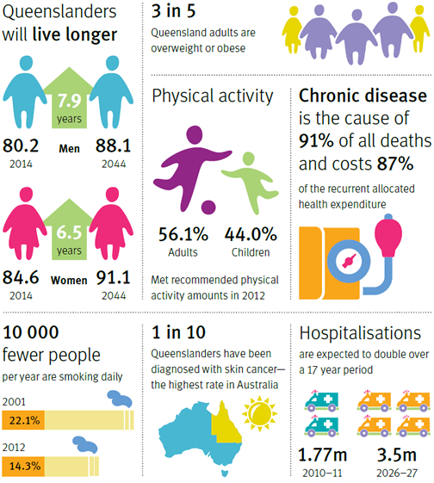

Which state population are estimated to live longer?
_______________________________________________________________________________________

What was the percentage of people who smoked in 2001? Also in 2012? What is the difference?
_______________________________________________________________________________________

What will the level of hospitalisations by 2026?
_______________________________________________________________________________________

What is the estimated difference of hospitalisations from 2010 to 2026? State some reasons for this.
_______________________________________________________________________________________

What is represented by 91%? Also what does 3 in 5 represent?
_______________________________________________________________________________________

Which state has the highest diagnosis of skin cancer? What is the rate of diagnosis?
_______________________________________________________________________________________
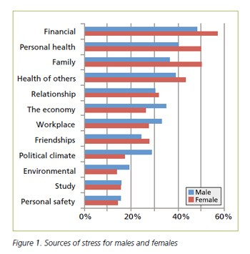
What does the data in the graph represent?
_______________________________________________________________________________________
What groups are represented in this graph?
_______________________________________________________________________________________
What is the percentage range of data for females?
_______________________________________________________________________________________
What is the percentage range of data for males?
_______________________________________________________________________________________

What percentage of woman stress about finance? Give a reason why.
_______________________________________________________________________________________

What percentage of male’s stress about the workplace? Give a reason why?
_______________________________________________________________________________________

Which gender is more concerned about the health of others?
_______________________________________________________________________________________
Which gender is more concerned about the political climate?
_______________________________________________________________________________________
Improving Human Wellbeing
Activity 3: Read the following information and answer the questions below.
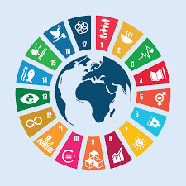
On 1 January 2016, the 17 Sustainable Development Goals (SDGs) of the_2030 Agenda for Sustainable Development – adopted by world leaders in September 2015 at an historic UN Summit – of_ officially came into force. Over the next 15 years, countries will target efforts to end all forms of poverty, fight inequalities and tackle climate change, while ensuring that no one is left behind. The SDGs build on the success of the Millennium Development Goals (MDGs)_and aim to go further to end all forms of poverty.
The new goals are unique in that they call for action by all countries – poor, rich and middle-income – to promote prosperity while still protecting the planet. They recognise that ending poverty must go hand-in-hand with strategies for economic growth and address a range of social needs including education, health, social protection and job opportunities, while tackling climate change and environmental protection. While the SDGs are not legally binding, governments are expected to establish national programs for the achievement of the 17 goals.
The Millennium Development Goals
At a meeting of the United Nations in 2000, representatives of all the 193 countries present agreed to a set of goals designed to end poverty and improve wellbeing across the globe by 2015. Eight goals, known as the Millennium Development Goals (MDGs), were created and agreed to by all of the world’s countries and leading development institutions. The MDGs showed the world that goals mattered. They helped all countries to focus on specific issues, such as extreme poverty, HIV/AIDS and school retention rates. By the end of 2015, progress had been made but not all goals had been reached. For example, progress was made in reducing the number of Africans living on less than $1.25 a day but more than one-third of the world’s extreme poor still live in Sub-Saharan Africa. However, the goals did motivate significant action and global cooperation, paving the way for the 2030 Agenda for Sustainable Development. Many countries, including Australia, used these goals as a framework for allocating funds to their overseas aid programs.
The Sustainable Development Goals
The 17 Sustainable Development Goals (SDGs) have 169 targets. They are both broader in scope and go further than the MDGs, aiming to address the root causes Building on the success and momentum and production, peace and justice. of poverty and the need for development that works for all countries. The goals cover the three dimensions of sustainable development: economic growth, social inclusion and environmental protection. of the MDGs, the new global goals aim to address inequalities, economic growth, decent jobs, cities and human settlements, industrialisation, oceans, ecosystems, energy, climate change, sustainable consumption and production, peace and justice.
Describe the aim behind the creation of the MDGs.
_______________________________________________________________________________________
What do countries like Australia use these goals for?
_______________________________________________________________________________________
Activity 4: Living on a Dollar a Day Documentary
Watch the documentary Living on a Dollar a Day and complete the following questions.
- What is something important that you took away from this film?
_______________________________________________________________________________________
- What surprised you about the lives of the poor?
_______________________________________________________________________________________
- What do you think would be the hardest thing for you, if you were living on $1 a day in that village?
_______________________________________________________________________________________
- What were some of the hardest things you saw in Chino’s life?
_______________________________________________________________________________________
- How did you feel when you saw that Chino wanted to go to school but his family didn’t have enough money to send him there?
_______________________________________________________________________________________
- What do you think Zach, Chris, Sean and Ryan learned by living on $1 a day themselves instead of just reading about it?
_______________________________________________________________________________________
- Did Zach, Chris, Sean and Ryan each get exactly $1 to spend every day? Why not?
_______________________________________________________________________________________
- Chino’s family couldn’t afford to send him to school, but Rosa was using the money from her weaving business to go to school, herself. What helped her start her business?
_______________________________________________________________________________________
- What is something in your life that you will no longer take for granted after watching this film?
_______________________________________________________________________________________
- What is one small thing you can do today to make a difference for someone around you?
_______________________________________________________________________________________

Activity 5: Improving Education
Watch clip ‘Improving Access to Quality Education in Afghanistan’ (see Canvas page) and list 3 points.
_______________________________________________________________________________________
_______________________________________________________________________________________
_______________________________________________________________________________________
Read the following information and answer the questions below.
Education has been included as a standalone goal in the 2030 Agenda for Sustainable Development, following the positive work begun with the MDGs 2000–15 and the United Nations Global Education Initiative launched in 2012. Sustainable Development Goal 4 is to ensure inclusive and quality education for all and promote lifelong learning. Obtaining a quality education is seen as the foundation to improving the living conditions and future wellbeing of millions of children.

The benefits of education
Many social researchers believe that the key to improving human wellbeing around the world, particularly in poorer communities, is to improve participation rates in education. Their studies show that education allows individuals to break the cycle of poverty and live healthier, longer lives. The benefits to society are multiplied when girls are able to access an education at the same rate and level as boys. Studies show that mothers who have attended school have a lowered risk of their babies falling victim to infant mortality, have fewer children and earn more than mothers who are less educated. Children born to these women are 50 per cent more likely to live past the age of five and have much lower rates of HIV infection than children born to less educated mothers.
Over the past 40 years the Chinese Government has made a real effort to get more children into education for longer periods. This push has included increasing the education levels of girls. Educating girls has had many benefits for Chinese society. Educated women generally want smaller families and make better use of reproductive health and family planning services to achieve their desired family size. Educated women contribute more to the economy and help increase economic growth. With China’s booming economy, China now has 68 per cent of women in paid employment. This is a higher rate than Australia (which has 59 per cent).

Successful schools
As well as getting all children into schools, the United Nations Global Education First Initiative is also interested in improving the standard of schooling that children receive and creating a positive school environment. Too many schools in the developing world currently have poorly trained teachers and not enough books or other resources to teach with. Too many children are also going to school hungry, which is affecting their ability to learn.
What are some of the links between education and wellbeing?

_______________________________________________________________________________________
Explain why educating girls can improve wellbeing for everyone in a community.

_______________________________________________________________________________________
Non – Government Organisations

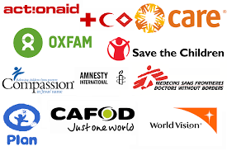

You are to research a non-government organisation that assists in the improving the wellbeing of a range of groups. Choose an organisation from the list below to create a factsheet outlining the points below.

Non-government Organisations to choose from:
- World Vision
- Red Cross
- Bangladesh Rural Advancement Committee
- Médecins Sans Frontières
- The Bangladesh Rural Advancement Committee
- Amnesty International
- Save the Children
- Oxfam
- CARE Australia

Outline the following on your chosen non-government organisation on your factsheet:
- Name of the organisation
- Date it started
- Group the organisation assists
- Purpose of the organisation
- Programs run by the organisation
- Impact of the wellbeing of groups
- Data on success of the organisation
- Images of the organisation

