Geography
Year 10
Map Skills Booklet

Name: Teacher:

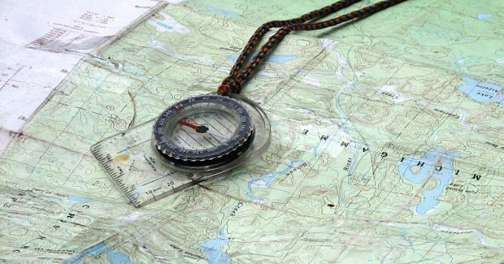

Direction
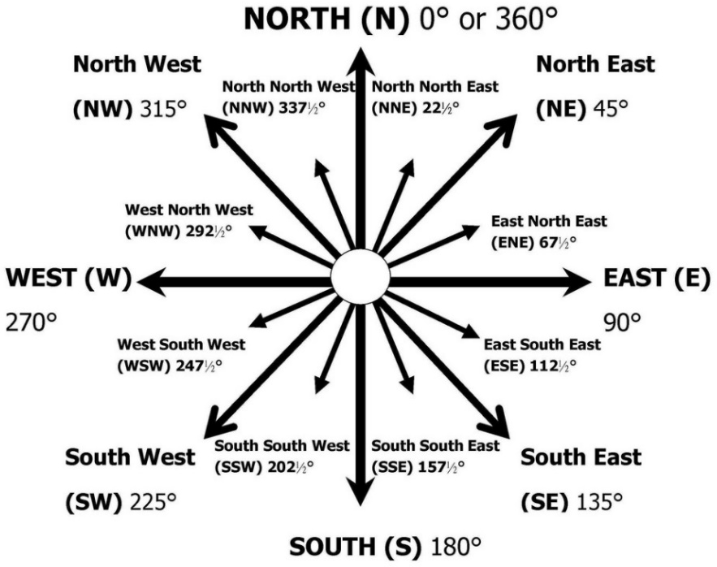
Direction is the description of the position of one place from another. There are 16 compass points: 4 cardinal points, 4 inter- cardinal points & 8 inter-inter-cardinal points. True North/ Geographic North points to the North Pole which is definite on a map. It is also the meeting point for all meridians
(line of longitude).
Magnetic North is the northern magnetic pole of the earth. It has a magnetic field which is also spherical. The magnetic pole lies north east of true north and is in Canada.

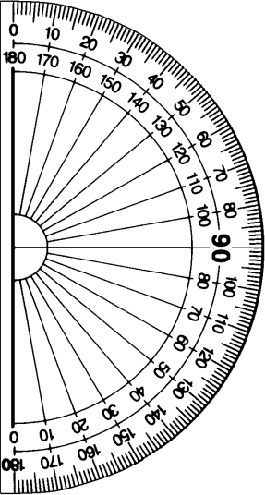
Bearing
Bearing is used to give us an accurate direction. We make use of a protractor to work out the bearing and our answer is always given in degrees ° (not degrees Celsius).
Bearing is the angular difference from the North-South line to a place.
Maps are drawn so that North is at the top of the map. This is why we should always read the protractor with the 0° at the top of the map/placed at North, then we read the degrees clockwise.

How to measure bearing:
- Always take note of where you are measuring from. Start at the point you are measuring from.
- Draw a North-South line through the point from which you are measuring.
- Join the two points with a straight line.
- Place the ˫ or  on your protractor over the point you are measuring from on the North- South line (0° facing North) and measure the angle in a clockwise direction.
- Show your working.

Note: If you are measuring to the right of the North-South line your bearing will be 0°- 180°. If you are measuring to the left of the North-South line your bearing will be between 180°-360°.

Direction and Bearing
Activity 1. Study the map of Canada below. *Remember to show your working*

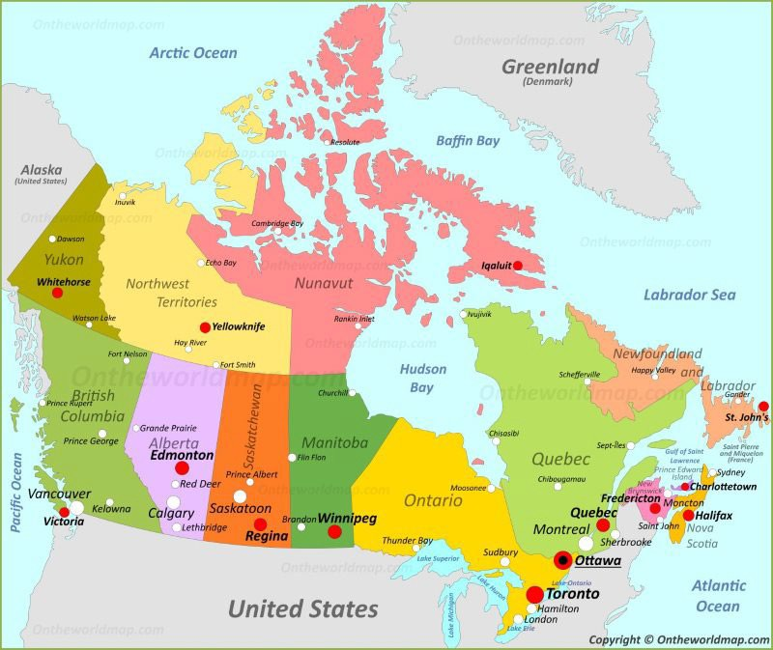
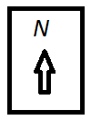

- Give the direction of Yellowknife from Winnipeg
- Give the direction from Regina to Victoria
- Give the direction from Toronto to St. John’s
- Give the direction of Edmonton to Whitehorse
- Calculate the bearing of Iqaluit from Yellowknife
- Calculate the bearing from Whitehorse to Winnipeg
- Calculate the bearing of Victoria from Ottawa
- Calculate the bearing of Edmonton from Yellowknife
- Calculate the bearing from Iqaluit to Quebec
- Calculate the bearing from Regina to Fredericton
- Name the ocean to the north of Canada
- Name the ocean to the east of Canada
- Name the continent to the West of Canada

Skills Focus – Reading Maps (Basic Mapping Skills incl. BOLTSS) Activity 1
BOLTSS
- Write each map feature beside the correct definition. Use the following terms in bold print below.

Border; Orientation (compass bearing – usually a north point); Legend (or key), Title, Scale, Source.
  - Names the place a map is representing
  - The relationship between a unit of length on a map and the actual length over the ground
  - Represent features or objects
  - Explains the symbols used
  - An arrow used to show the orientation of a map
  - Indicates who made / and or where the map comes from

Map of Cape Beauty
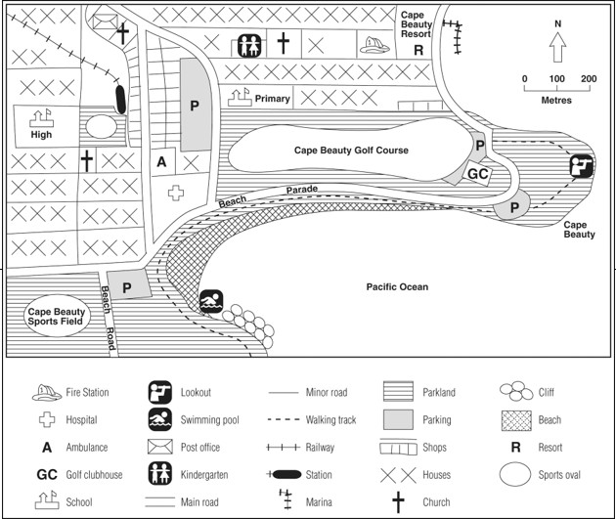

- How many churches are shown?
- Which school is the railway line closest to?
- Name two recreational activities residents of this town can do.

- Name two services that this town offers to its residents.

- If you were a tourist visiting this town, list three activities which you could do.

SCALE
Maps are accurate, smaller representations of areas on the land. The map scale converts real distance on the ground to smaller distances on the map. The scale is used to find distances and areas. A map always shows the world to be smaller than it actually is. The scale on every map shows how many times the land has been reduced (made smaller) in order to fit the map.

There are three main types of scale:
0 | 1 | 2 | 3cm
0 | 1 | 2 | 3km

- Word scale: The word scale is the scale written out as a statement
e.g. 1cm on the map represents 100 000cm on the ground.

- Line scale: The line scale is a line that has been divided into equal distances.
This enables you to read the actual distance directly from your scale.

- Ratio scale: Written as a ratio and is always in centimetres. 1 : 100 000

1 : 100 000 means that 1cm on the map represents 100 000cm/1km in reality.

NB: In order to convert cm into km: ÷ 100 000 (as there are 100 000cm in 1km)
e.g. 1 : 100 000 → ¹⁰⁰ ⁰⁰⁰ → 1km
100 000

Activity 1
- Write the following ratio as a word scale: 1 : 500 000 Word scale:

- Write the following word scale as a ratio scale:

One centimetre on the map represents 100 000 cm in reality. Ratio scale (cm : cm):

- Draw the following word scale as a line scale (Note: convert your scale to km first):

One centimetre on the map represents 300 000 centimetres in reality.
Line scale:
Conversion:
1cm : 300 000cm
300 000 ÷ = km

Distance
Measuring distances on a map helps us determine how close/far it is to and from certain points on a map. We can calculate distance by using a word scale, line scale or a ratio scale.
Working with a line scale:
Activity 1: Line scales
- Measure the following lines with your ruler and write down the answer in centimetres.
- Then use the line scale below to measure the same line in kilometres.

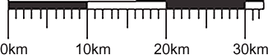

a)
Measurement (cm)
b)
Measurement (cm)
c)
Measurement (cm)
d)
Measurement (cm)
e)
Measurement (cm)
f)
Measurement (cm)

Answer (km) Answer (km) Answer (km) Answer (km) Answer (km) Answer (km)

Working with a ratio scale:
A key word to help you remember the formula for calculating distance: MCM (Measure, Convert, Multiply)
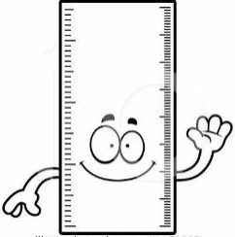
  - Measure the distance on your map with a ruler
  - Convert your scale
  - Multiply your measurement with your scale

EXAMPLE:
- M: From X to Y = cm
Map
Y

X
Scale 1 : 200 000

- C: 1 : 200 000

200 000
=
100 000
= 2km

- M: cm x 2km = km

- Therefore the distance from X to Y in reality is km.

Activity 2:
Using the given scales, calculate the distances from A to B. All answers must be in km.

- M:

1 : 50 000

C:

M:

- M:

1 : 100 000

C:
M:

- M:

1 : 25 000 000

C:
M:

Activity 3:
Using the given ratio scale, answer the questions that follow: 1 : 20 000
- Complete the following:
  - One centimetre on the map represents centimetres in reality.
  - One centimetre on the map represents kilometres in reality.

Distance cont..

Study the map below of the United Kingdom and calculate the distance between each point.
*Remember to ALWAYS show your working and give your answer in KM’s (unless otherwise
stated).

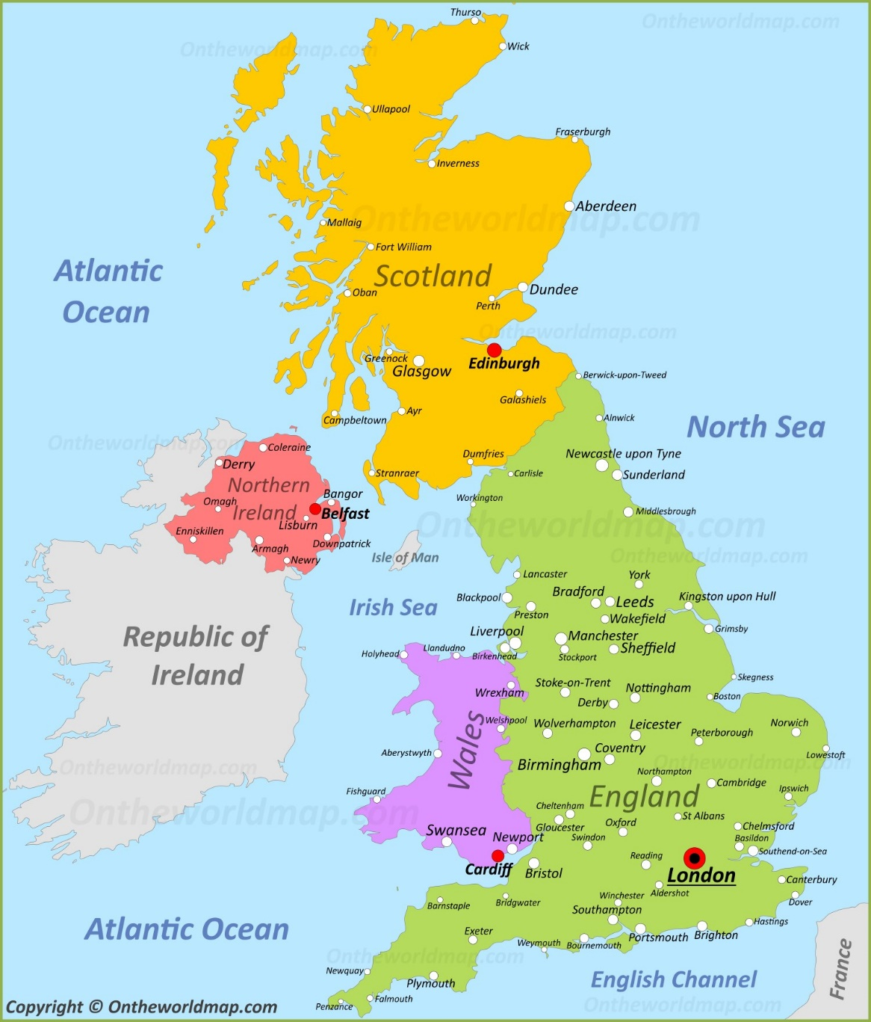
Map of the United Kingdom

1:5 000 000

Activity 4

  - Calculate the distance between Blackpool and Oxford.
  - Calculate the distance between Sunderland and Dover.
  - Calculate the distance between Oban and Perth (in Scotland).
  - Calculate the distance between Ipswich and Derby.
  - Calculate the distance along the road between Thurso and Dundee (in Scotland).
____________________________________________________________________________________
  - Calculate the distance between Workington and York.
  - Name the capital city of North Ireland. How do you know this?

  - Name the country bordering England to the West.
  - Name the country South East of England.
  - List the map features of BOLTSS that are missing on the map.

Scale and Distance
Activity 5
Use the map of Bigtown below, answer the following questions.
*Remember to show all your working*
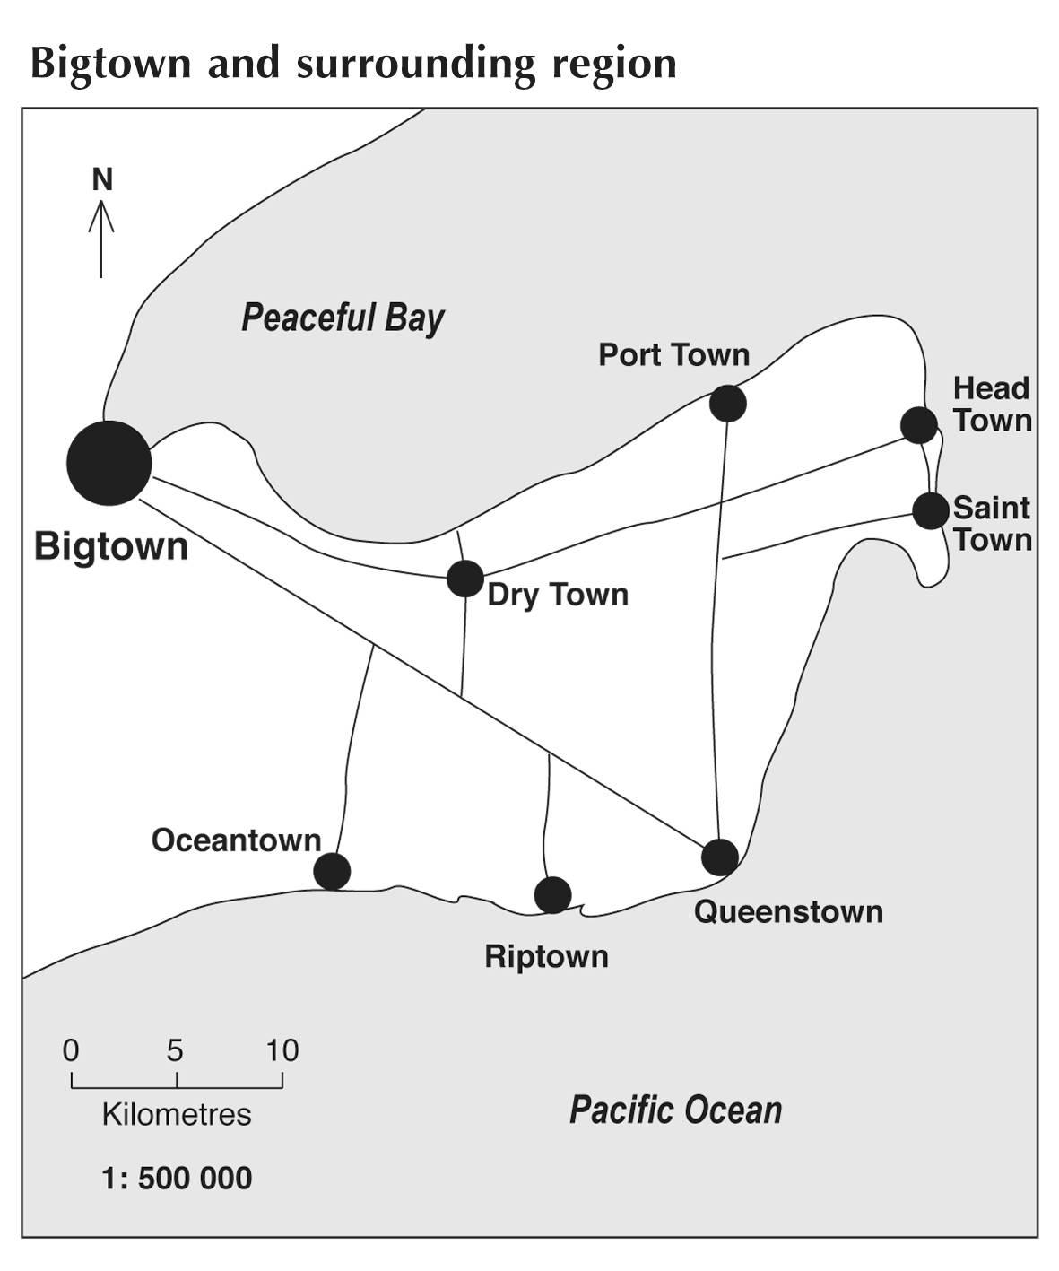

- How far apart are Dry Town and Port Town on the ground, ‘as the crow flies’ (straight line)?
___________________________________________________________________________
- How far is it to drive (along the road) from Dry Town to Port Town?
___________________________________________________________________________
- How far apart are Big Town and Queenstown on the ground, ‘as the crow flies’ (straight line)?
__________________________________________________________________________
- Using the line scale, estimate the distance between Oceantown and Queenstown if you are travelling by road.
___________________________________________________________________

- How far is it between Oceantown and Queenstown ‘as the crow flies’ (straight line)?

_________________________________________________________________________

- What is the distance in Km’s from Brisbane to Perth? __________________________

Scale and distance
Activity 6
Study the map of Australia below. *Remember to show your working*
- What type of scale is shown on this map?

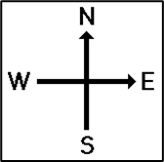
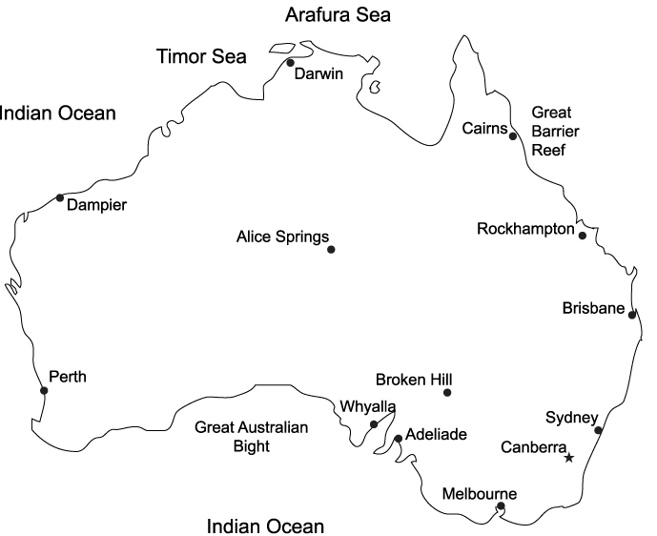
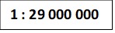
- What is the distance in KM from Brisbane to Perth?
- Write the scale of this map as a word scale.

- Calculate the distance from Darwin to Melbourne along the road (squiggle line)

- What is the capital of Australia? How do you know this from the map?

Scale, distance, bearing and direction
Activity 7
Study the map of China below. *Remember to show all working*
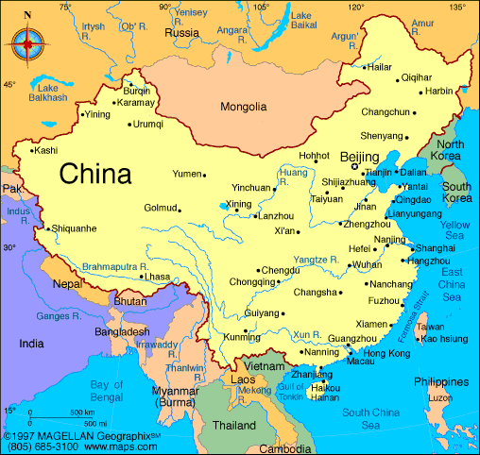
1: 50 000 000

- State the type of scale shown on the map.
- Write this scale as a ratio scale
- Calculate the distance from Yumen to Harbin. Your answer must be in km.

- Calculate the distance from Kashi to Urumqi. Your answer must be in km.

- Calculate the distance along the river from Yinchaun to Jinan

- Calculate the direction from Changsha to Golmud
- Calculate the direction of Fuzhou from Lhasa
- Calculate the bearing from Beijing to Harbin
- Calculate the bearing of Kashi from Hohhot
- Calculate the bearing from Jinan to Hangzhou
- Calculate the bearing of Chongqing from Nanning

Altitude
  - Altitude is the height above sea level (sea level is at 0m)
  - There are 4 ways to indicate altitude on a topographic map:
    - Contour Lines – lines that join places of equal height above sea level. The contour interval on a topographical map is 20m and they are brown lines. On an orthophoto the contour interval is 5m and they are black lines.
    - Spot height – a black dot with an exact height next to it. Eg: •56, the height is 56m.
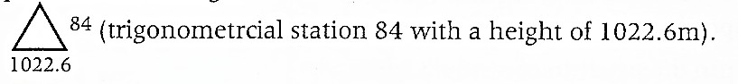
    - Trigonometrical station (aka Trig beacon) – found at high points on the map. These beacons consist of a triangle with 2 sets of numbers. The top number to the right is always the trig beacon number, the bottom number under the triangle is always the height.

    - Bench mark – these are heights along roads. They are indicated with an arrow with a height next to it.

Contour Lines and Elevation

A contour line represents an imaginary line on the ground, above or below sea level that shows the height of an area. All points on the contour line are at the same elevation or depth.
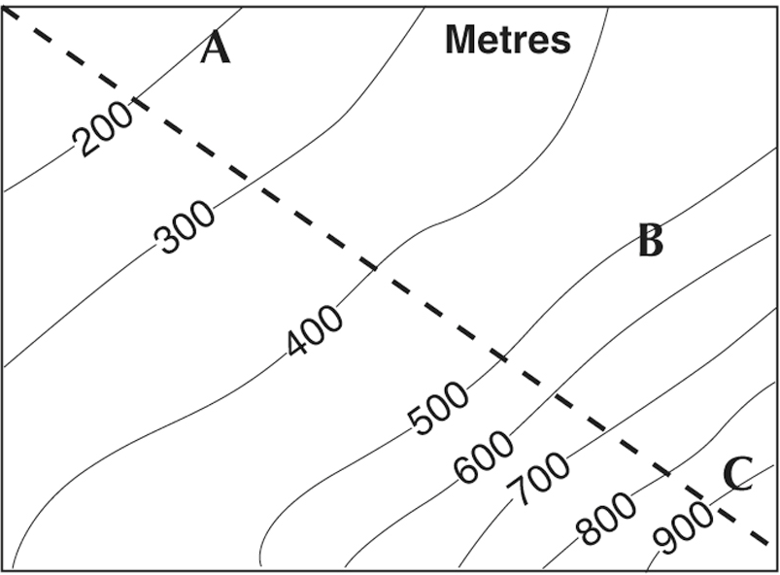
Height = Altitude Unit of measurement = Meters Contour interval = how many meters each contour line increases by

- What is the elevation of the fifth line from the right?
- What is the elevation of the 2nd line from the left?
- What is the contour interval on this map?
- If you walked from point A straight to point B, by how much would the elevation increase?

- If you walked from point B to point C, would this be a steeper or flatter walk than from point A to B? How do you know?

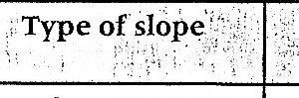
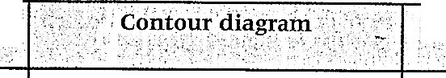
An understanding of contour lines is necessary in order to interpret relief features on a topographic map. The following examples are basic representations of the most common geomorphological features.
Characteristics
of contour pattern
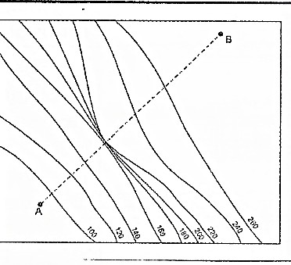
Even slope | Contours are evenly spaced. | 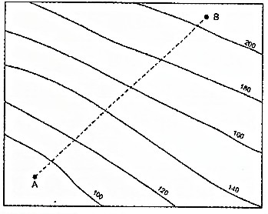
Gentle slope | Contours are far apart. |  |  | 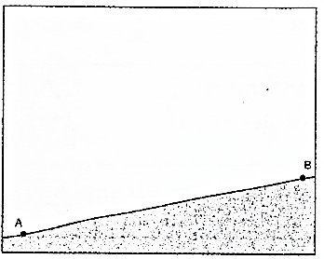
Steep slope | Contours are close together. | 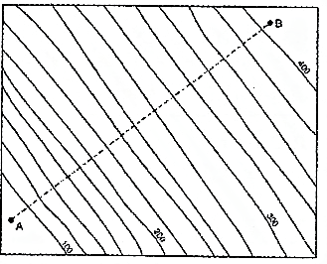
Stepped slope | Contours close together in sets. Each group or set is.furt er apart. | 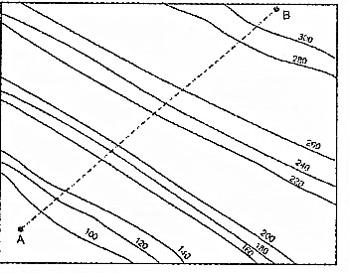 |  | 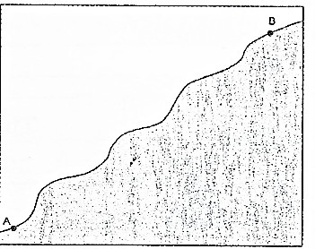
Vertical slope (Cliff) | Contours merge or r.un very close together at this point. |  |  |  | 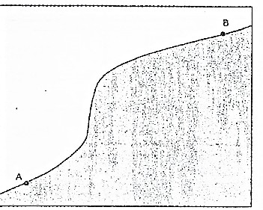

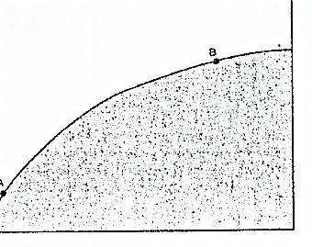
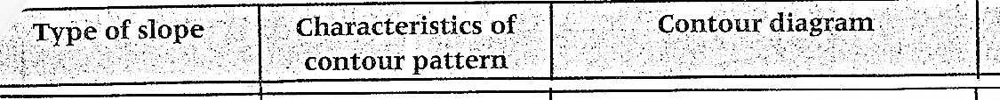
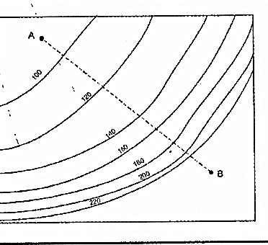
:

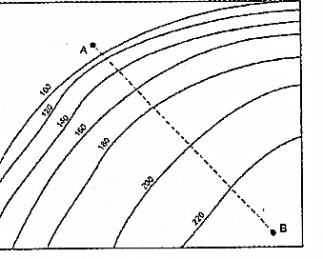
Convex slope Contours are close together at the bottom of the slope and further apart at the top of the slope.
:·,:

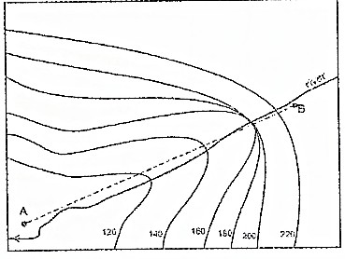
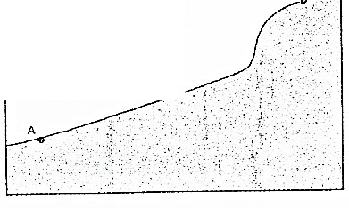
Concave slope

40 m w-,tcr fall (200m. 1GO m)

Valley

Spur

Wc\terfall
Contours are far apart at the bottom of the slope and closer together at the top of the slope.

Contours always point upstream or towards the highest point.
Rivers may flow through valleys.

Contours always point 'downstream' or away from the highest point. They do not have rivers flowing over them as they form the 'highland' between valleys.

Two or more contours. meet at a point with a river flowing at right angles to the contour lines.

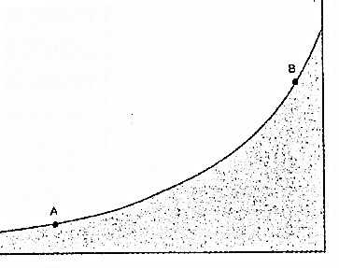
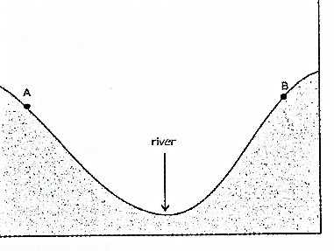

.••
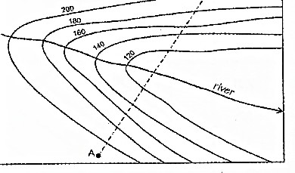

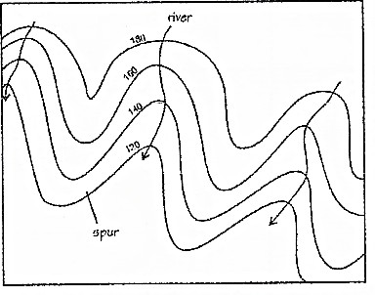
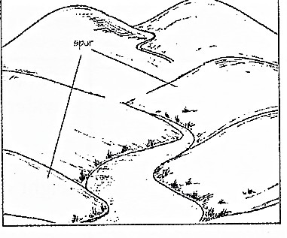

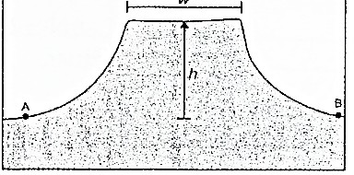
Pass | A dip between two pieces of highland that is accessible by road and sometimes by rail. Many railway lines actually pass through tunnels in passes. It is costly to build railways  in such areas. | 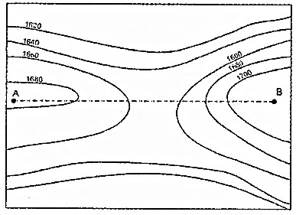 |  | 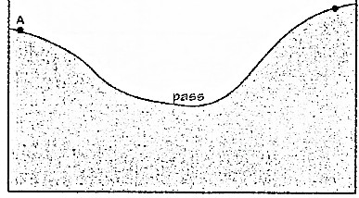
Poort or water gap | A total break between two pieces of highland that is passable by road and railway. It may have a river flowing through it. |  | 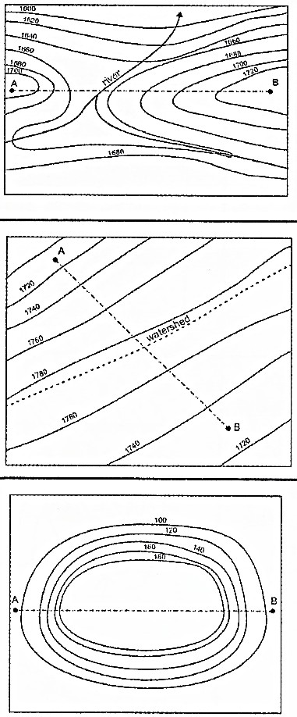 |  | 8  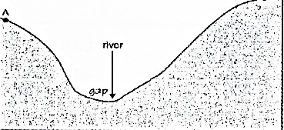  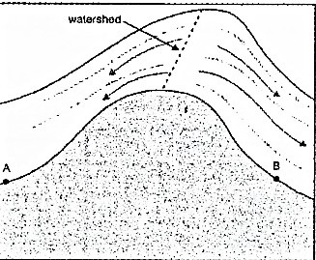  w•vrlcf/h  h •hmghl  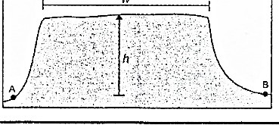
Watershed | An imaginary line that separates one drainage basin from another. It is found in an area of highland.
Mesa | A flat topped hill that is wider than it is high.
 | height < width
Butte | A flat topped hill that is higher than it is wide.
 | height > width

Cross Sections
A cross-section is a side view (or profile) of the land. Drawing a cross-section from a topographic map is a useful way of interpreting contour lines and gaining a visual impression of the shape of the land. The following method can be used when drawing a cross-sectional profile between two points; in this case, point X and Y on either side of an island (in this example the island is in a lake with a water level of 100m).

Skills Focus – Drawing a Cross Section

A cross-section is a side view (or profile) of the land. Drawing a cross-section from a topographic map is a useful way of interpreting contour lines and gaining a visual impression of the shape of the land. The following method can be used when drawing a cross-sectional profile between two points; in this case, point X and Y on either side of an island (in this example the island is in a lake with a water level of 100m).
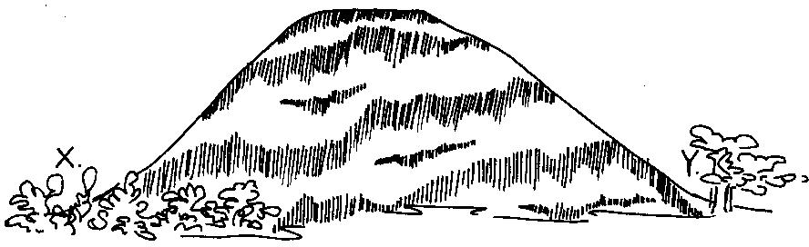
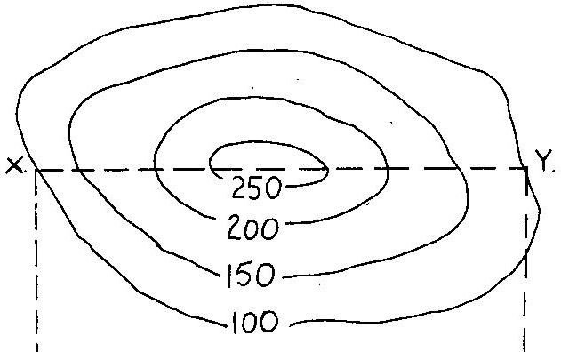

Drawing a cross-section involves the following steps:
Step 1 Place the straight edge of a piece of paper along a line joining points X and Y. Mark points X and Y on your sheet of paper.
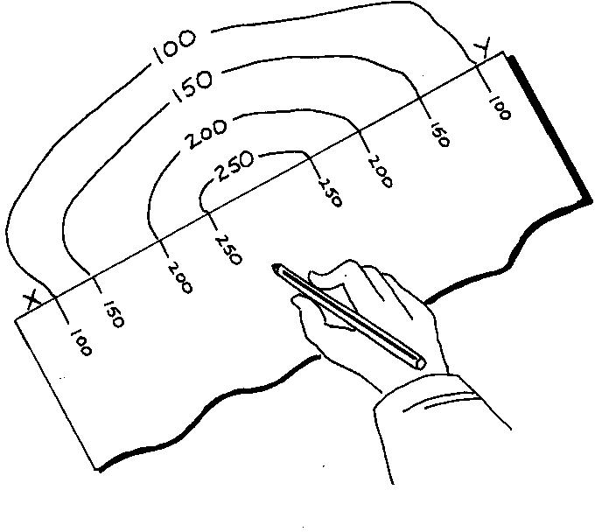

Step 2 Starting from Point X, mark the position where the edge of your sheet of paper cuts each contour line. Write the value of each contour on your sheet of paper

Step 3 Draw the horizontal and vertical axis for your cross-section. (In this case it has been done for you). The length of the horizontal axis should equal the length of the line X-Y. The vertical axis, showing the height of the land above sea level (lake level), you should use a scale that is appropriate to your needs.

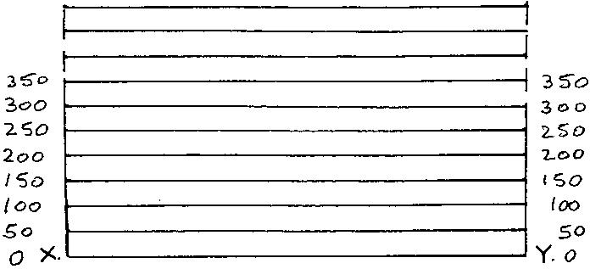

Step 4 Place your sheet of paper along the horizontal axis and then plot the contour points and heights as if you were drawing a line graph.

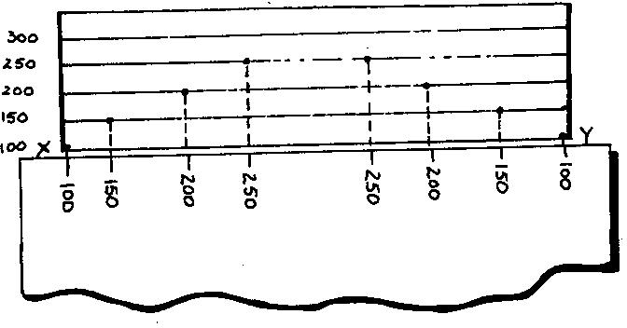

Step 5 Join the dots with a single smooth, curved line and then- shade in the area under the line to highlight the relief.

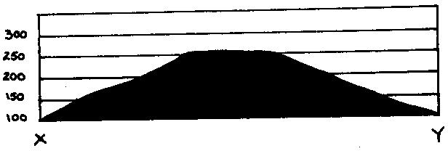

NOW TRY THIS
On the diagram below complete the cross section from Connor Peak to the Field Study centre at Madeline Bay

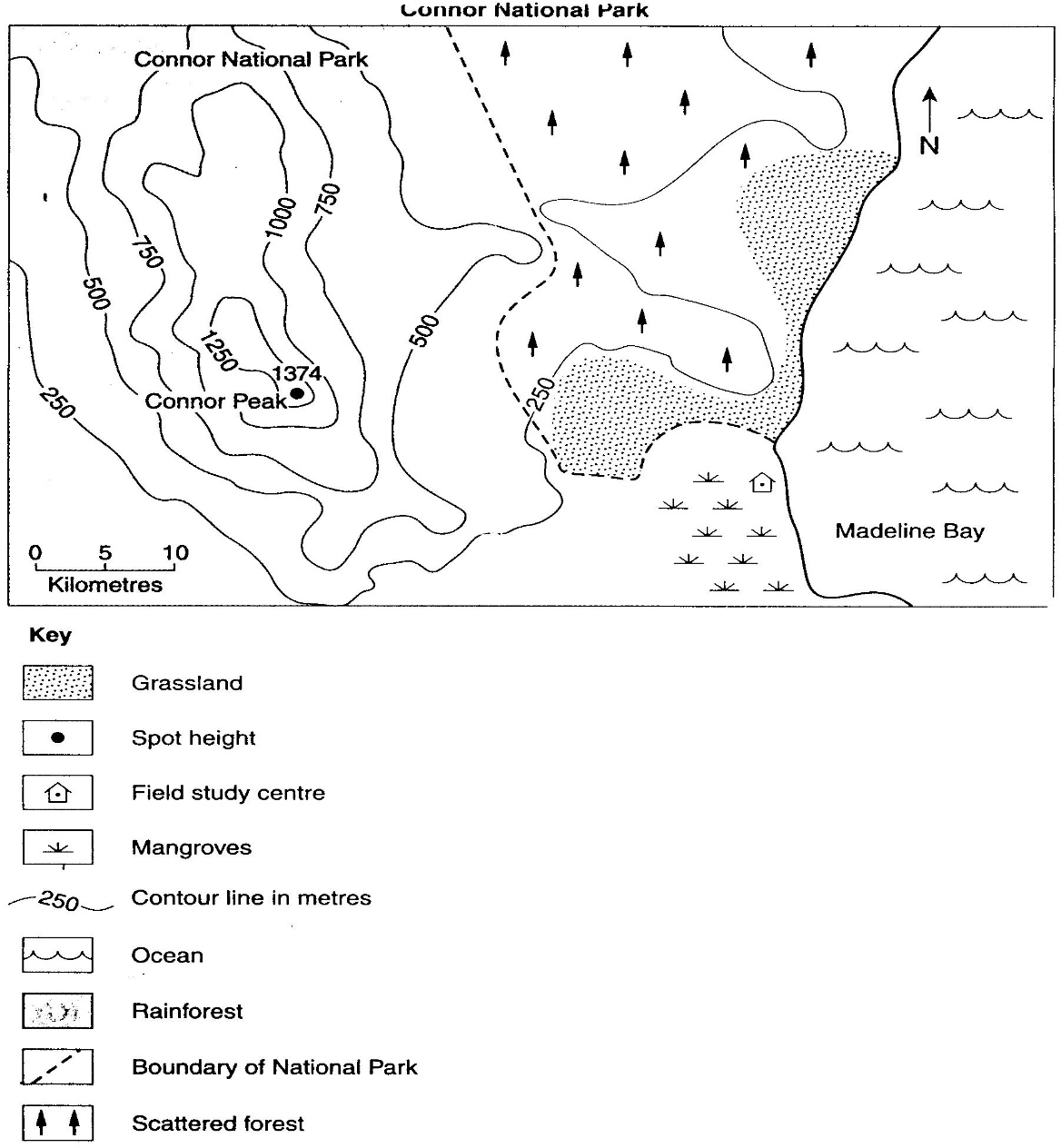

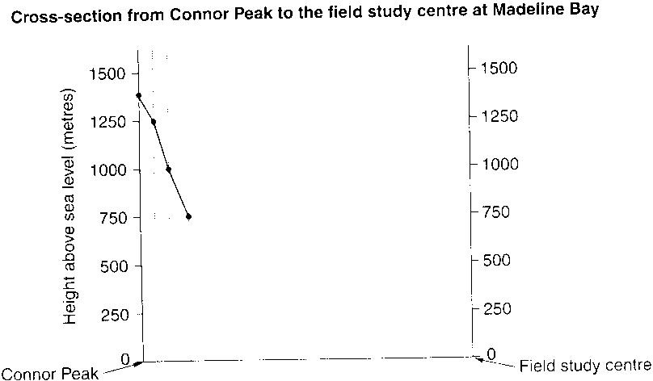

Activity 1
Draw a cross section from A to B.

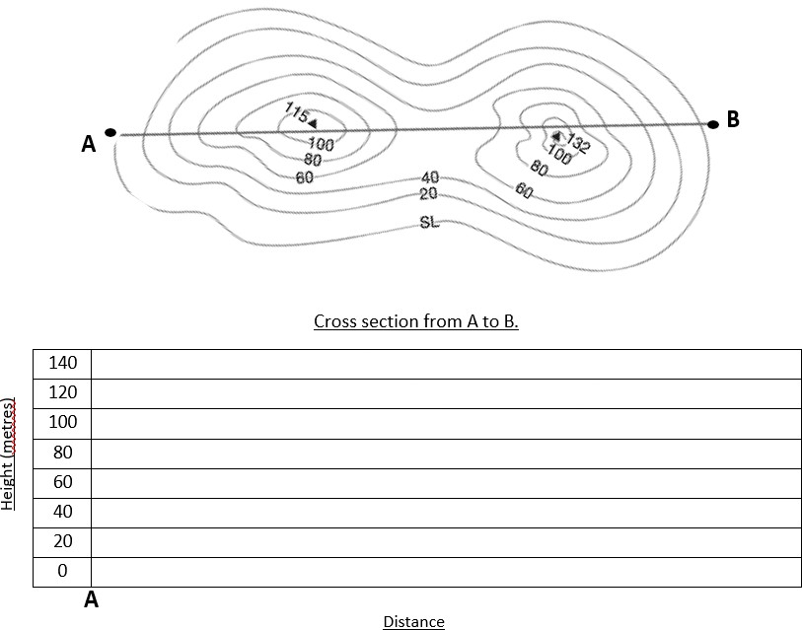

Activity 1: Revision contours
Use the map below and answer the questions
1 | Complete the numbering of the contour lines. | (2)
2. | Mark a spur and a valley with arrows. | (2)
3. | What type of slope is marked at A and B? A: B: | (2)
4. | Give heights for the trig beacon E and spot height (F). E: F: Explain the difference between the two.
5. | Calculate the difference in height between points C and point D. | (3)
6. | Calculate the following:  Direction Bearing  From Point D to C | (5)
7 | What is the distance between C and D?
8. | Draw a cross section from C to D with a vertical scale of 1 line = 20m. | (6)

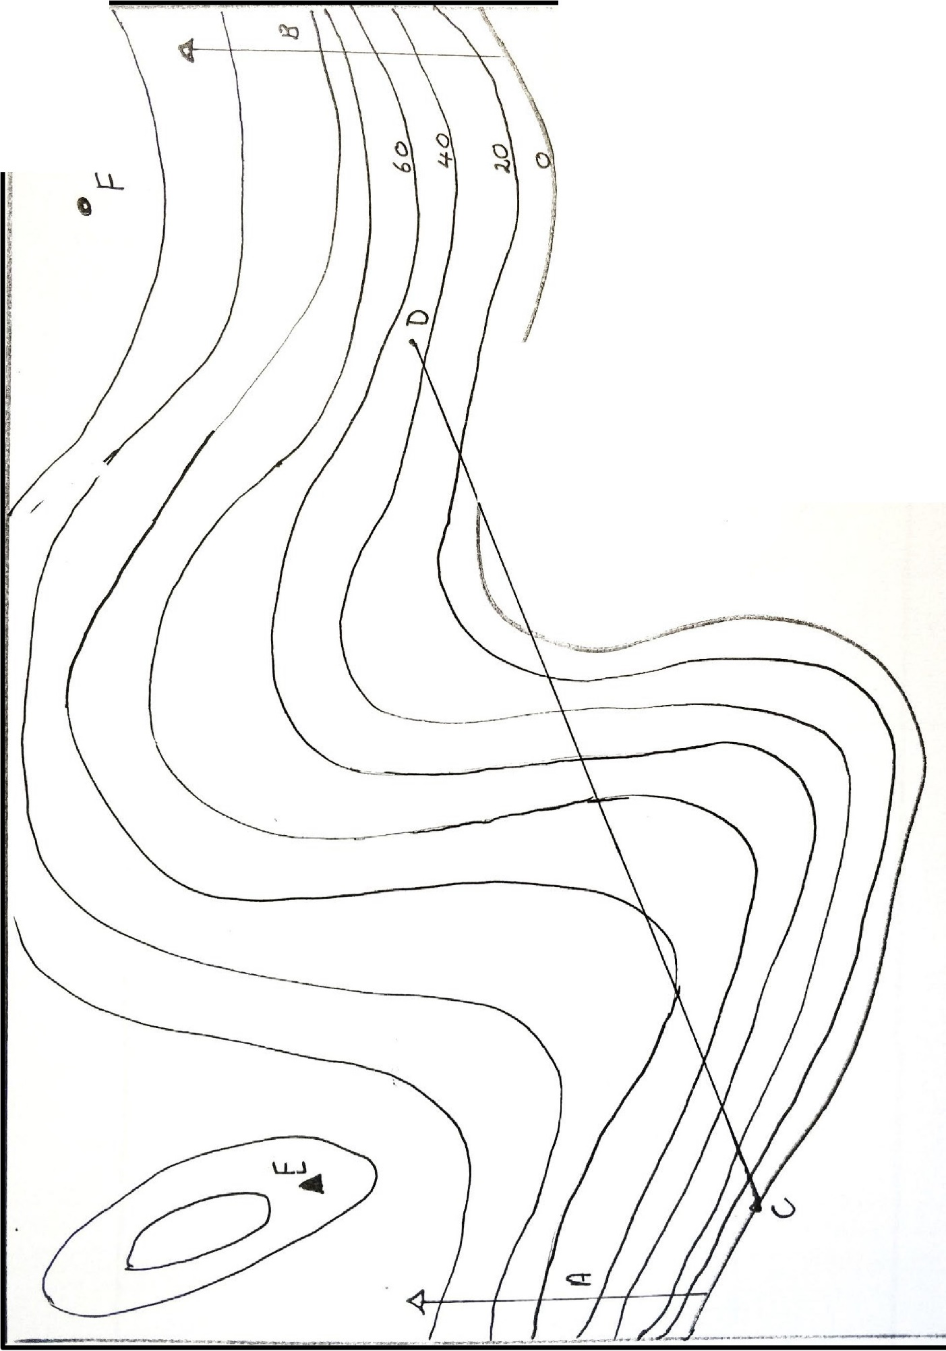
i
0
()
()
Q "'3-

½

LL
0 ._

\n
I
I
::::.
--t
\.

:\

1: 50 000

Activity 2: Types of slopes
Use the map below.
1. | Identify the following slopes:  a d  b e  c f
2. | Suggest an altitude for the following numbers:  2: 6: 7:
3. | Label the following on the map: a spur, a valley and a saddle.

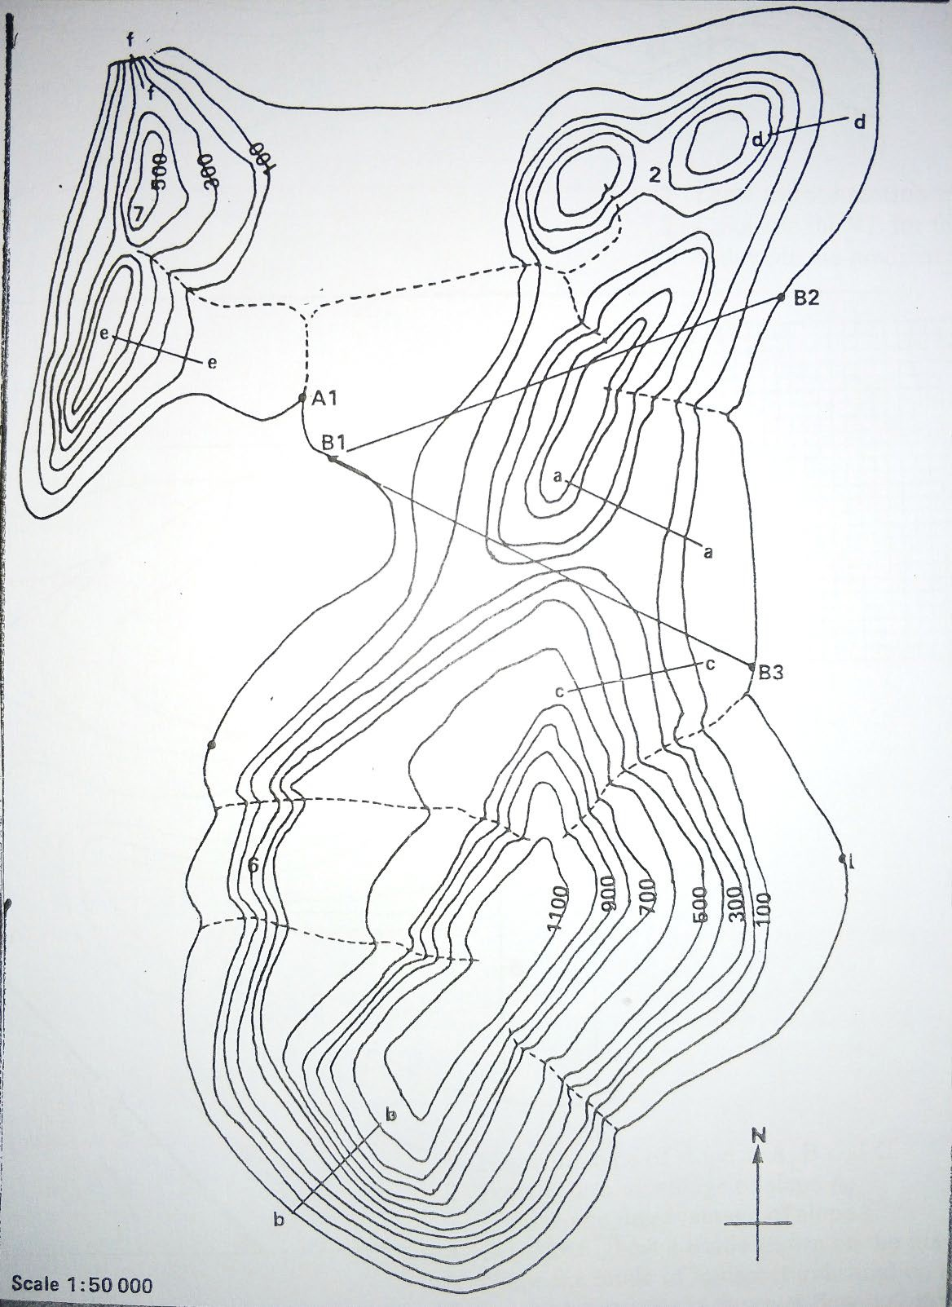

Activity 3: Contours
Study map 1 below.
Draw a cross section from A to B. Use a vertical scale of 1cm: 20m.
Identify the following slopes
E: F: Identify the following contour features
G: H:
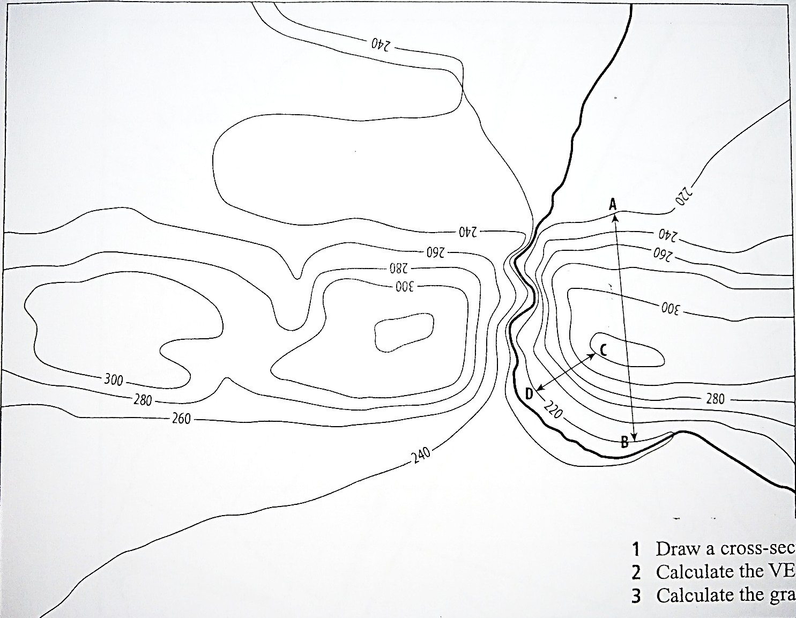

H

F
G

E
Scale 1 : 50 000 Contour interval = 20m
Activity 4
Study Map 2 below.
1 | Name the type of slope at A, B and C.
2 | Provide one advantage of slope A.
3 | Provide one disadvantage of slope C.
4 | Give the highest altitude shown on the map.
5 | Name the mode of transport indicated on the mapped area.
6 | In which direction is the river flowing? Provide evidence from the map.

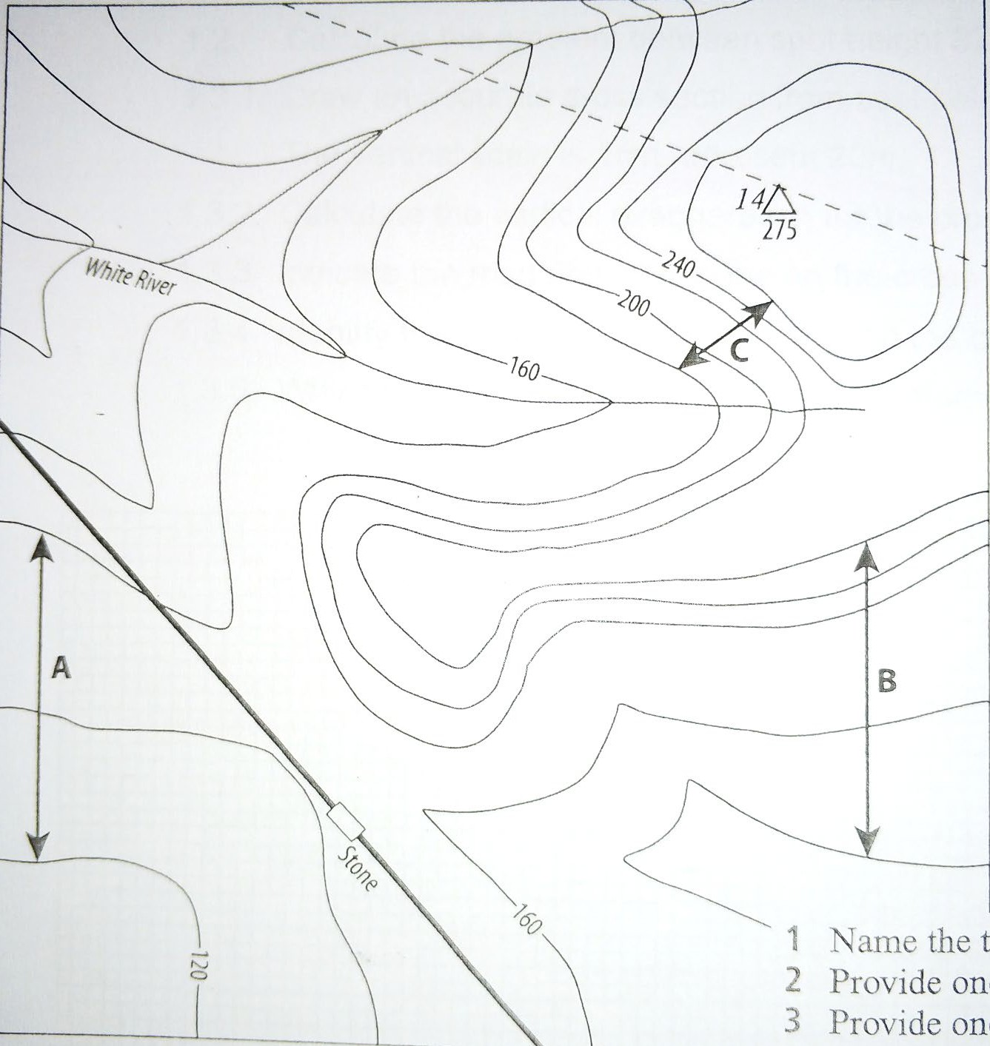
Scale 1 : 50 000
Contour interval = 20m
Activity 3
Study the map below
1.1 Calculate the following:

 | Direction | Bearing
From spot height 1046 to spot height 1066
1.2 (5)

    - Draw an accurate cross section from spot height 1066 to 1046 using a vertical scale of 1cm represents10m.
(8)

    - Indicate the road and power lines on the cross section. (2)

    - Identify the landform you have drawn on the cross section.
    - Why does the road pass through this landform?
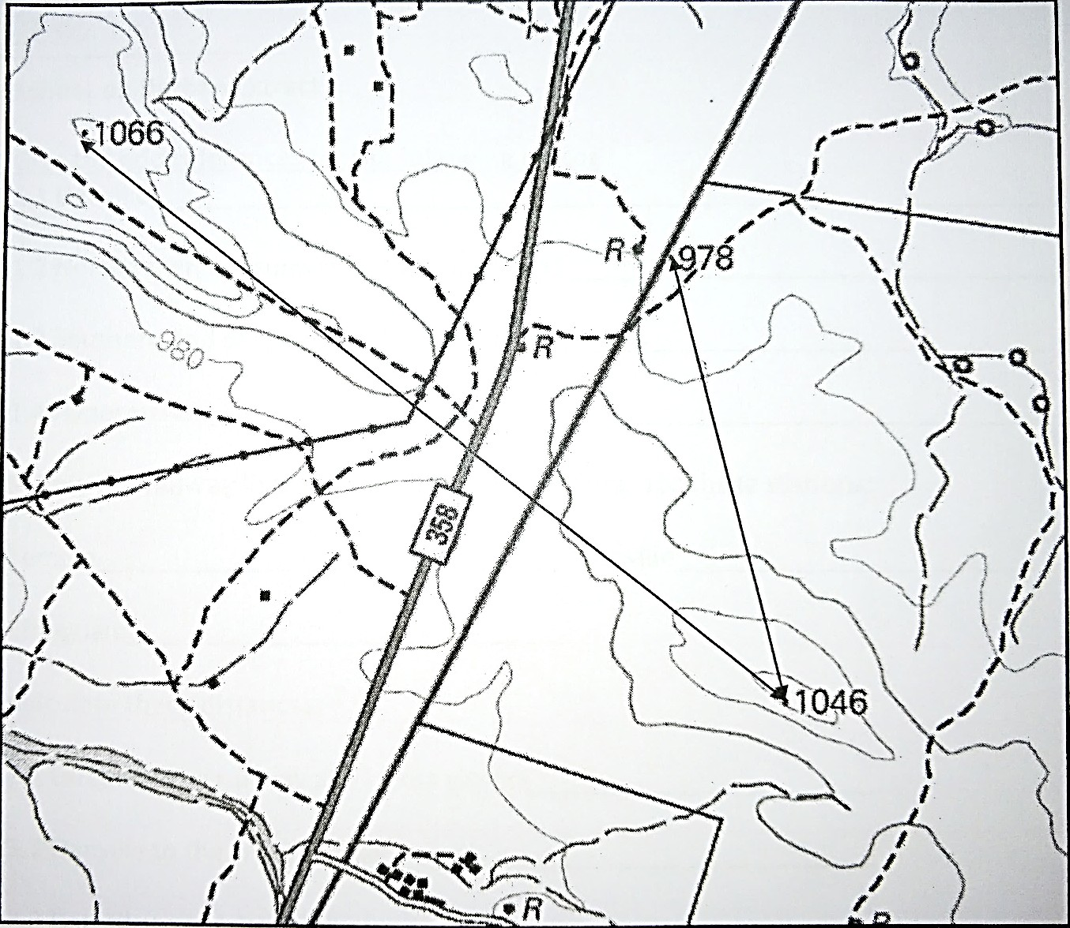
(1)
(2)

Aerial Photos
Aerial photography is the taking of photographs of the ground from an elevated/direct-down position. There are THREE types of aerial photographs that are named according to the angle from which they are taken.

Aerial photograph | Information | Picture
Vertical | Bird’s eye view (90°) which is ideal for making  and updating maps as one is able to calculate distance and scale.  Adv: Uniform scale  : Objects don’t obstruct each other.  : Distances, areas and shapes are correct.  Disadv: Perspective is unfamiliar  : Shadows may obscure detail  : Difficult to recognise objects. | 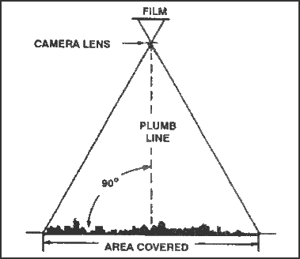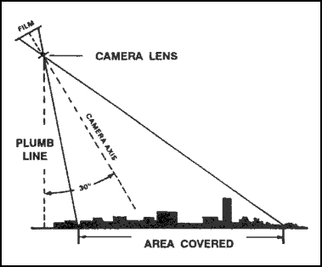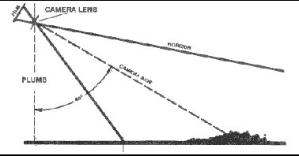
Low angle oblique | The camera is angled at 30° to the vertical which results in features in the foreground being distorted. A small, definite area is photographed.
High angle oblique | The camera is angled at 60° to the vertical and the horizontal is visible. A large area can be photographed.  Adv: Easy to identify features.  : Covers a large area  : relatively uncluttered by vegetation and buildings.  Disadv: Features in the foreground seem larger than those in background.  : Scale is distorted.  : Larger objects can hide smaller ones.

Mapping activities – Peaceful Cove
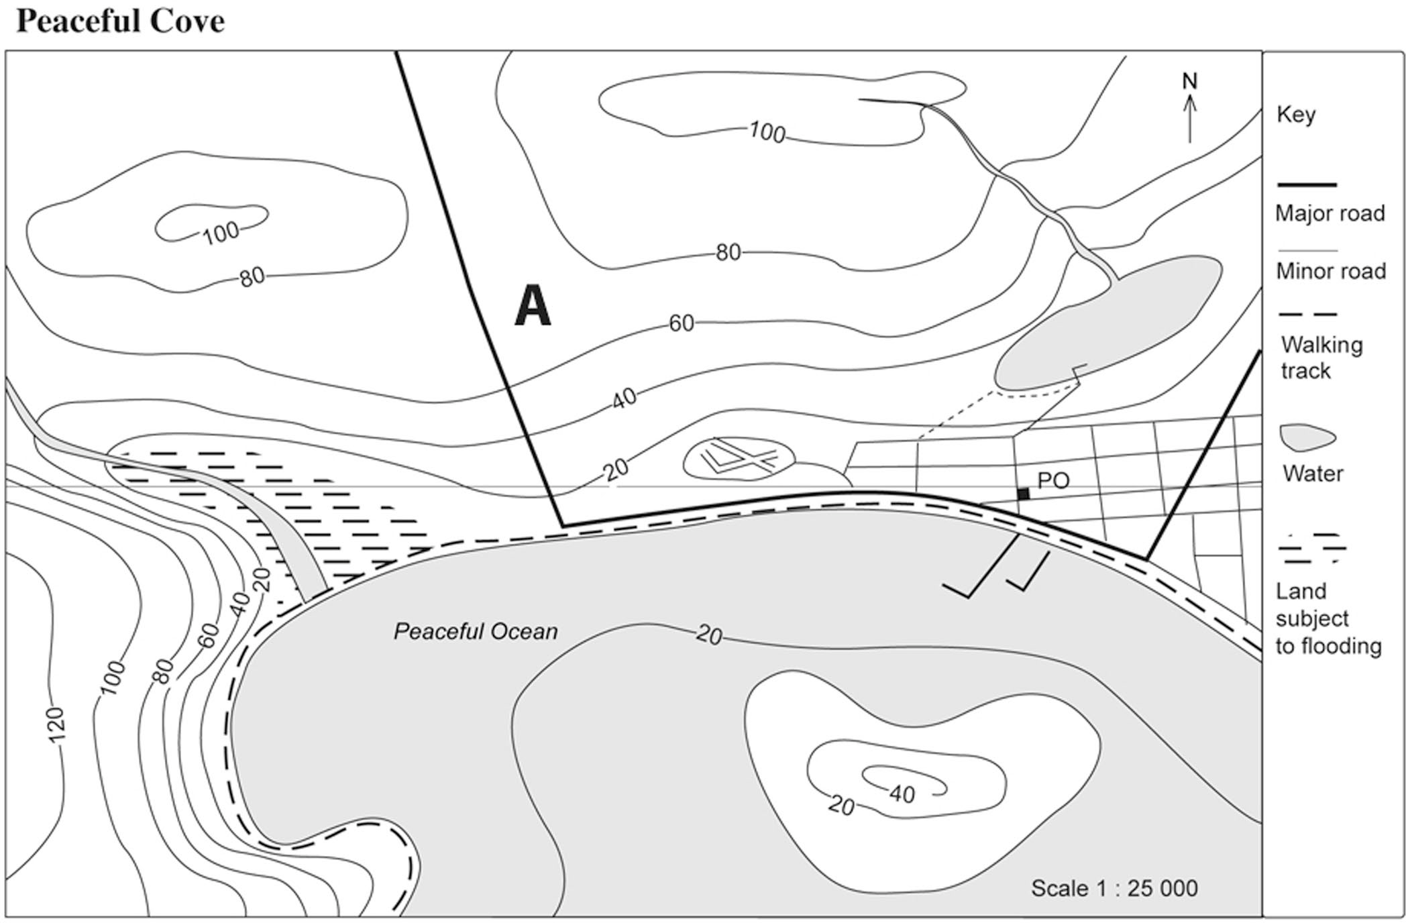
Z
X
-20

- What is the scale on this map?
- Calculate the distance from point C to point D
- Calculate the distance from E to F
- On the map, identify each feature shown in the key. Circle each one.
- Tick the place that has the highest elevation.
- Cross the area that has the lowest elevation.
- What is the contour interval?
- Mobile telephone coverage cuts out 140 km from the Post Office. On the map, shade the area that does not have mobile telephone coverage.
- Imagine you are standing at the post office, looking west. What does the landscape look like?

- List what you would see if you started at point A, and walked on a bearing of 100°.

- From the post office, on what bearing would you walk to reach point A?

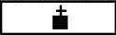

Skills Focus – Analysing Graphs (Bearings and Direction)
Parking
Church
Direction
On the compass below, using a different colour for each:
  - Label the rest of the cardinal points.
  - Label the inter cardinal points (four points between the cardinal points).
  - Label the inter-inter cardinal points (eight points between cardinal and inter cardinal points).
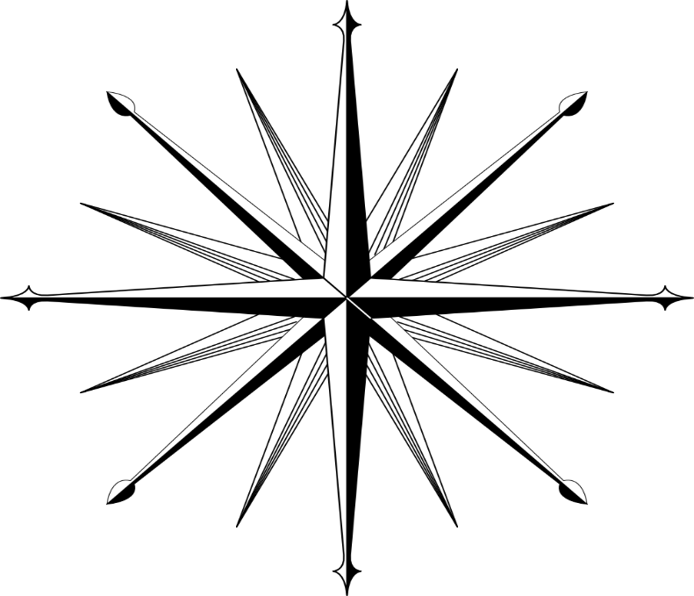
N

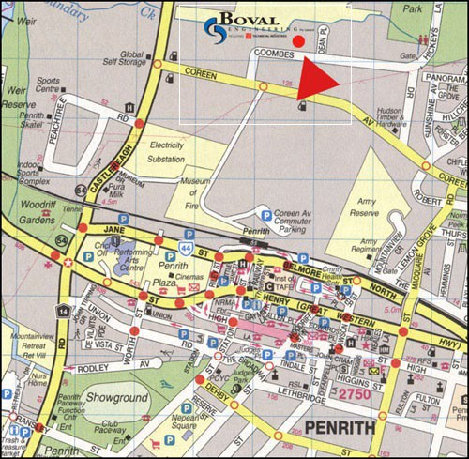
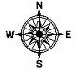
Using the directions and the bearings given, look at the map of Penrith and answer the questions.

Questions
- What direction and bearing is the showground from Penrith
Plaza?

- What direction and bearing is the Fire Museum from Penrith
Plaza?

- If I walked in a northerly direction Castlereagh Road from Ransley Street what gardens would I find?

- What bearing is Nepean square from the Showground?

- What bearing and direction is Jane Street from Lethbridge street?

- What bearing and direction is the Army Reserve base from the Mountainview Retirement home?
- What bearing and direction is the Electricity Substation from Woodriff
Gardens?

Skills Focus – Reading Maps (LATITUDE and

LONGITUDE (using degrees))

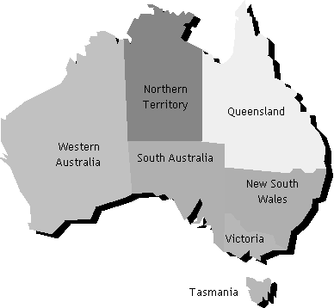
Latitude Longitude Latitude and Longitude

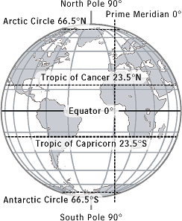

LATITUDE and LONGITUDE (using degrees and minutes)

Latitude

Longitude

Latitude and Longitude

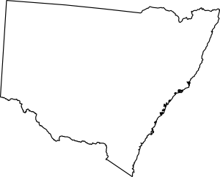


EXAMPLE:

Locate “A” using degrees and minutes
A= Latitude 11 º30’E Longitude 21 º30’S
To work out the “minutes” remember to count the jumps:
Find the degrees using the smaller number
Then count the jumps.

It takes 60 small jumps (minutes) to get all the way to the next line.
It takes 30 small jumps (minutes) to get half way
C
20ºS
21ºS
A
22ºS
23ºS
10ºE
11ºE
12ºE
13ºE
14ºE
D
B

Activity 1

Using DEGREES AND MINUTES what is the latitude and longitude for following places on the diagram above.
the

Places: | Latitude  (in degrees and minutes): | Longitude  (in degrees and minutes):
A | 21⁰30’S | 11⁰30’E
B
C
D

Activity 2

Answer the following questions using the diagrams above and the map of Australia below.

- Which major line of latitude runs through northern Australia?

- Name the hemispheres in which Australia is located.

- Give the co-ordinates for the following (use the solid dot as your point of reference):
  - Brisbane:
  - Canberra:
  - Melbourne:

  - Darwin:
  - Perth:

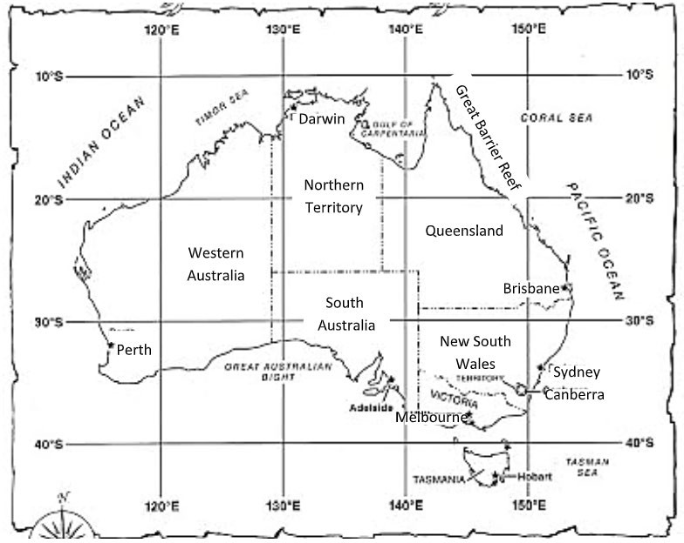

Activity 3
Using the map of South Africa below, answer the following:

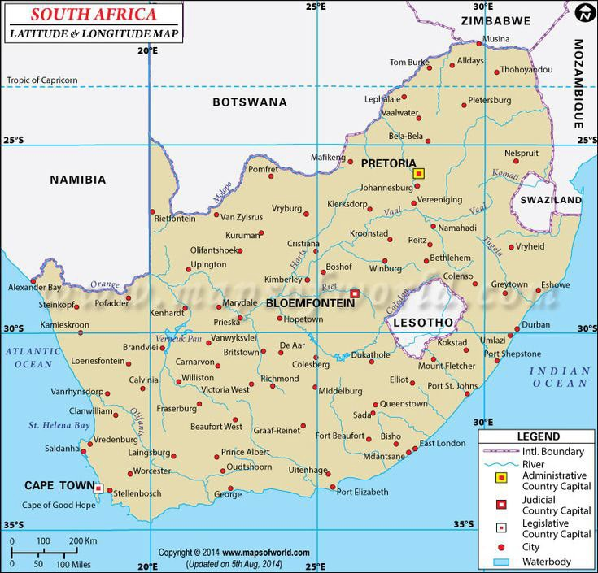

Using DEGREES and MINUTES what is the latitude and longitude for the following places:

Places: | Latitude  (in degrees and minutes): | Longitude  (in degrees and minutes):
Cape Town
Pretoria
Bloemfontein
Vryheid

Skills Focus – Interpreting Synoptic Charts (Weather Maps)
A synoptic chart or weather map is a simple map that shows high pressure systems, low pressure systems, wind speed, wind direction, cold fronts, high fronts and atmospheric pressure. It allows us to predict the weather we are likely to experience over the next two or three days.

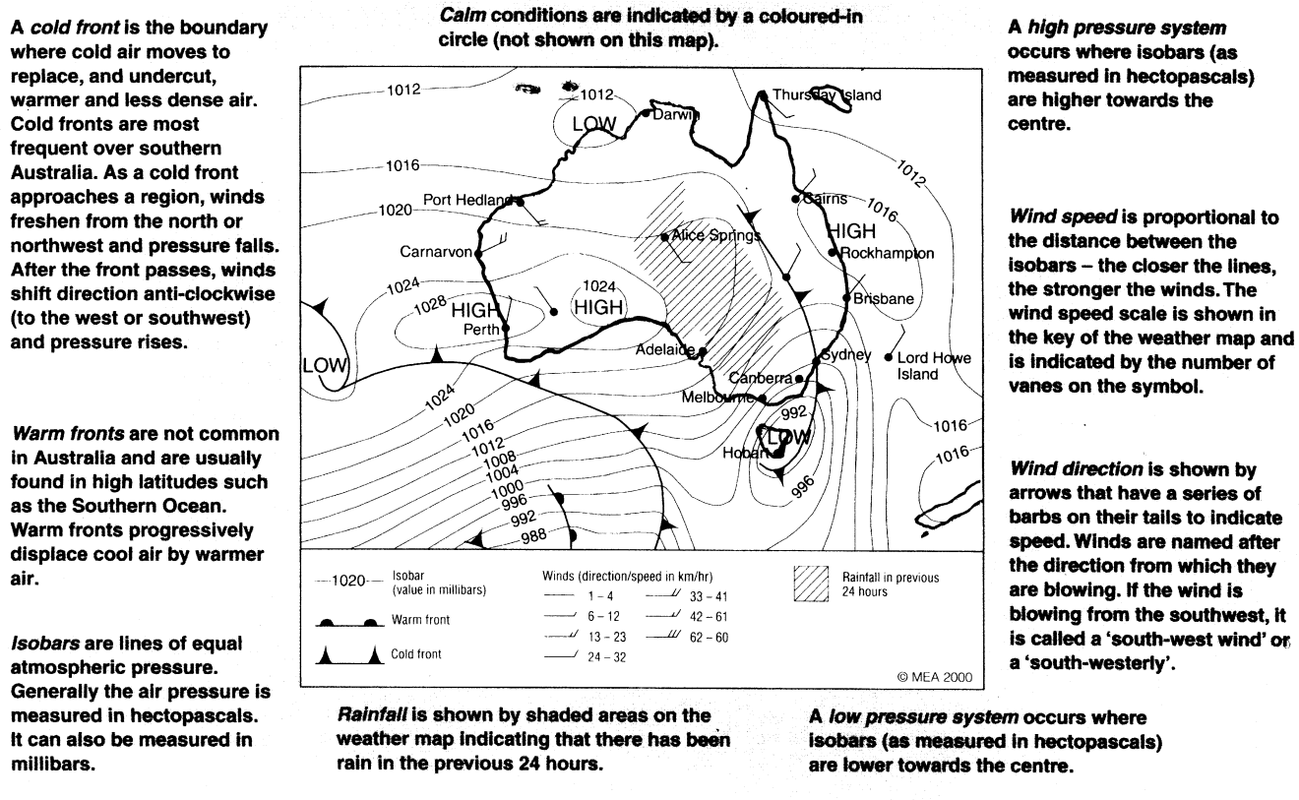

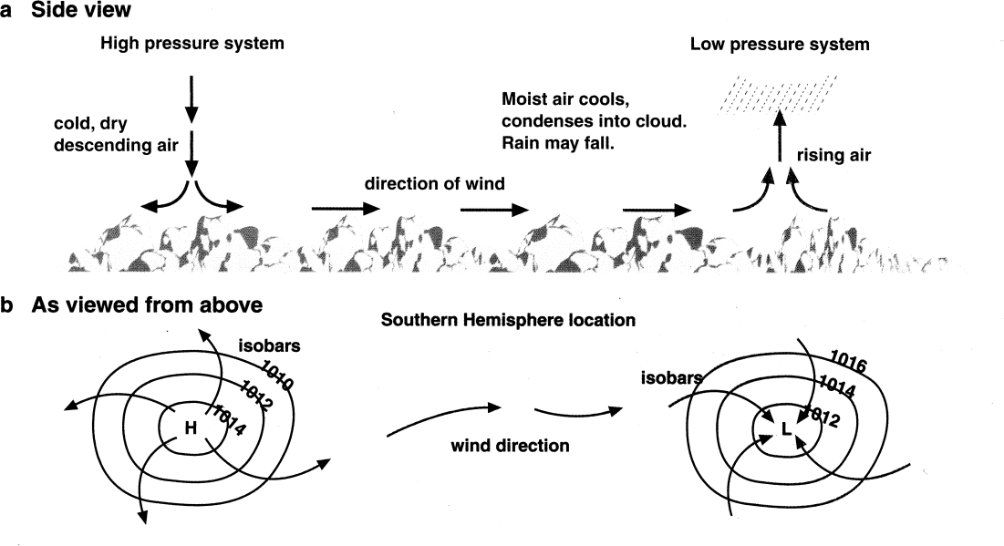
Pressure Systems

High pressure systems tend to bring the following:  - Warm air  - Stable conditions  - Clear skies  - Gentle to no wind  - Air pressure moving in an anti-clockwise direction | Low pressure systems tend to bring the following:  - Cool air (sometime from a cold front  - Unstable conditions  - Cloudy skies and rain  - Relatively strong winds  - Air pressure moves in a clockwise direction
Satellite Image and Synoptic Chart

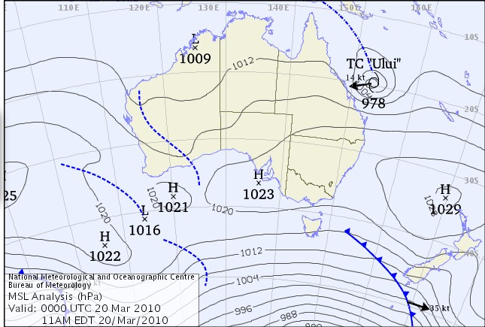

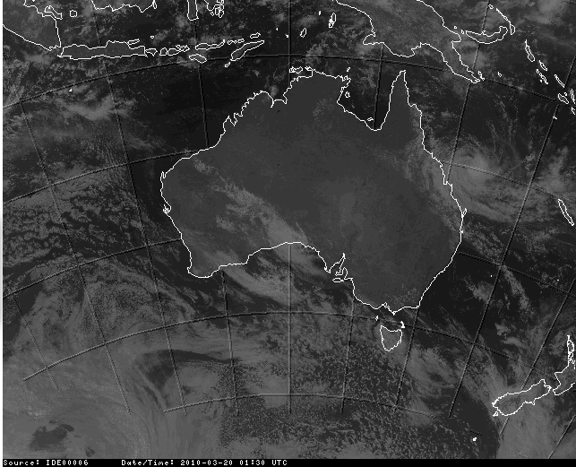
www.bom.gov.au

Using the satellite picture and the synoptic chart above, answer the following questions:

- What weather conditions are coming from off the SW coast of Australia?

- Describe the weather conditions being forecast for Sydney.

- What type of front is heading towards New Zealand?

- What weather conditions will it bring?

- What parts of Australia could be experiencing rain?

Weather Maps
Activity 1
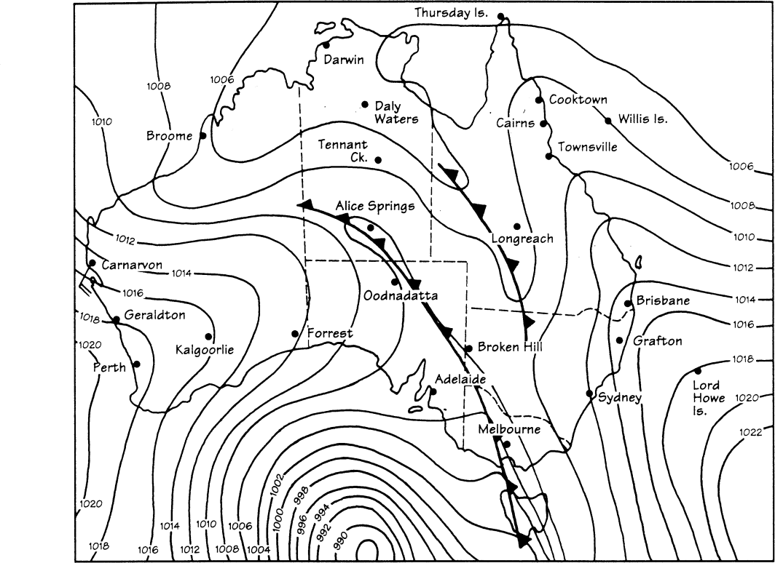

Complete the following questions:

- Mark a high pressure centre on the map with a (H)

- March a low pressure centre on the map with a (L)

- Label the fronts on the map.

- Which location would be likely to experience rain within the last/next 24 hours?

- Which location would be experiencing the strongest winds?

- What is the air pressure at the following locations? Kalgoorlie hPa
Broome hPa
Sydney hPa

Hobart hPa
Alice Springs hPa
- As the cold front moves forward and passes Broken Hill, what effect will this have on the wind direction at Broken Hill?

- Would you expect the winds in Cairns to be stronger or weaker than the wind at Carnarvon? Give a reason for your answer.

Map Revision
Refer to the map of Zeerust to answer the following questions: Activity 1: Zeerust
Calculate the direction and bearing for the following:  - from • 1279 (B1) to •1315 (B7).  - from 106 (A8) to 52 (A3).  - to 295 (C3) from •1463 (A5).  - to Vergenoegd (E1) from bench mark 1229.1 (D3).  - from the N4 sign (C2) to the r49 sign (D/E1). | (5X2)
- Identify the type of scale used on the map.  - Write this scale as a word scale.  - Which scale is larger – 1:50 000 or 1:10 000?  - Which scale shows more detail – 1:50 000 or 1:100 000?  - Which scale shows more land – 1:25 000 or 1: 250 000? | (5X1)
Activity 2: Zeerust
Refer to the map of Zeerust to answer the following questions:
Calculate the:
  - straight-line distance from 124 (C6) to 119(C8).
 | (3)
1.2 straight-line distance from the Dam wall in (B8) to the opposite side of the dam
(C6). | (3)
1.3 route distance from the intersection of the N4 and R49 (D3) to Lobatse (B1).
 | (3)
1.4 route distance from Kopfonteinhek (D1) to the intersection of the N4 and R49
(C4).
 | (3)
1.5 length of the Rifle range (A4) in metres.
 | (4)

