Year 10 Practice Paper:
Multiple Choice:
1. Which indicator is commonly used to measure human wellbeing?
A. GDP only
B. Latitude
C. Human Development Index (HDI)
D. Rainfall totals
2. The Human Development Index (HDI) includes which three main indicators?
A. Rainfall, vegetation and climate
B. Income, education and life expectancy
C. Employment, exports and tourism
D. Population, migration and density
3. Environmental change refers to:
A. Only natural disasters
B. Changes occurring in the natural environment over time
C. Population growth only
D. Weather occurring each day
4. Coastal erosion is primarily caused by:
A. River pollution only
B. Wave action and coastal processes
C. Farming practices inland
D. Urban migration
5. Which group is most likely to experience lower levels of wellbeing?
A. Communities with reliable healthcare and education
B. Communities with limited access to clean water and services
C. Communities with high employment opportunities
D. Communities with developed infrastructure
6. Which option best reflects sustainable environmental management?
A. Clearing forests for rapid development
B. Ignoring environmental impacts
C. Balancing economic growth with environmental protection
D. Using resources without limits

7. Which factor is most likely to improve food security?
A. Drought
B. Political conflict
C. Reliable water supply
D. Soil erosion
8. Which management strategy is designed to protect coastlines naturally?
A. Seawalls only
B. Beach nourishment and dune vegetation
C. Road construction
D. Quarry mining
9. A seawall is an example of:
A. Soft engineering
B. Natural revegetation
C. Hard engineering
D. Sustainable agriculture
10. Which statement best describes human wellbeing?
A. The total population of a place
B. The physical and social quality of people’s lives
C. The amount of rainfall received
D. The number of cities in a country

Short Questions:
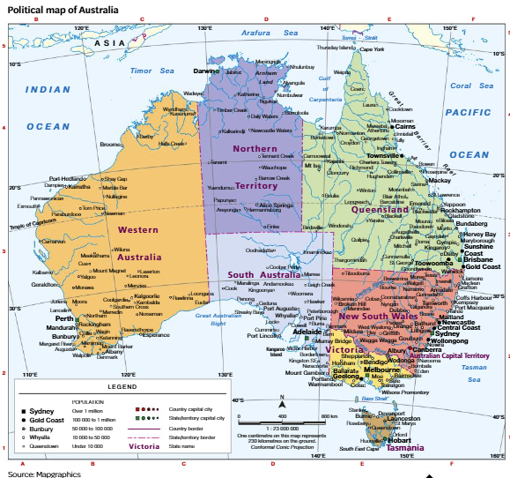
11. Using the map, identify the Australian state in which Perth is located. [1]
_________________________________________________________________________________
12. Using the map, identify the direction of Brisbane from Sydney [1]
_________________________________________________________________________________
13. Using the map scale, estimate the distance between Sydney and Canberra. [2]
_________________________________________________________________________________
_________________________________________________________________________________
14. Using the latitude and longitude shown, describe the location of Australia in relation to the Equator and surrounding oceans [3]
_________________________________________________________________________________
_________________________________________________________________________________
_________________________________________________________________________________
_________________________________________________________________________________

15. Identify one human activity that contributes to environmental change. [1]
_________________________________________________________________________________
_________________________________________________________________________________
16. Describe how access to healthcare can improve human wellbeing. [2]
_________________________________________________________________________________
_________________________________________________________________________________
17. Explain how coastal erosion can affect local communities. [3]
_________________________________________________________________________________
_________________________________________________________________________________
_________________________________________________________________________________
_________________________________________________________________________________
18. Analyse the relationship between water security and wellbeing. [4]
_________________________________________________________________________________
_________________________________________________________________________________
_________________________________________________________________________________
_________________________________________________________________________________
_________________________________________________________________________________
_________________________________________________________________________________
19. Explain how sustainability strategies can reduce environmental degradation. [4]
_________________________________________________________________________________
_________________________________________________________________________________
_________________________________________________________________________________
_________________________________________________________________________________
_________________________________________________________________________________
_________________________________________________________________________________
20. Using examples, evaluate strategies used to improve human wellbeing [5]
_________________________________________________________________________________
_________________________________________________________________________________
_________________________________________________________________________________
_________________________________________________________________________________

_________________________________________________________________________________
_________________________________________________________________________________
_________________________________________________________________________________

21. Evaluate the environmental impacts of urban development. [5]
_________________________________________________________________________________
_________________________________________________________________________________
_________________________________________________________________________________
_________________________________________________________________________________
_________________________________________________________________________________
_________________________________________________________________________________
_________________________________________________________________________________
_________________________________________________________________________________
_________________________________________________________________________________
_________________________________________________________________________________

22. To what extent can humans effectively manage environmental change to achieve sustainability? [6]
_________________________________________________________________________________
_________________________________________________________________________________
_________________________________________________________________________________
_________________________________________________________________________________
_________________________________________________________________________________
_________________________________________________________________________________
_________________________________________________________________________________
_________________________________________________________________________________
_________________________________________________________________________________
_________________________________________________________________________________
_________________________________________________________________________________
_________________________________________________________________________________

Extended Response Questions:
Assess the extent to which access to clean water influences human wellbeing.

To what extent does environmental quality determine human wellbeing?

Assess the effectiveness of strategies used to manage coastal erosion.

Evaluate whether sustainable environmental management can balance economic and environmental needs.

To what extent can environmental management strategies protect ecosystems while supporting human wellbeing?

