Student Name: ____________________________________



Year 10 MATHEMATICS 5.2/5.3 2022
TASK 1

General Instructions  - No reading time given  - Working time – 55 minutes  - Show all necessary working / units  - Board approved calculators are allowed  - Exam guidelines  - Use black pen for your working  - Use a pencil and ruler for diagrams  - Marks may be lost for poorly organised written work. | Total Marks – 40  Section 1 5.2 – 20 marks  Allow 25 mins  Section 2 5.3 – 20 marks  Allow 30 mins

Examiner’s use only D.Luo, B.Vincent
Question | Indices (incl Surds) and Algebra | Equations | Total
Section 1 (5.2) |  |  | /20
1,2,5 | /3
3,4, 6-9 |  | /17
Section 2 (5.3) |  |  | /20
1,2, 6-9 | /9
3-5, 10-13 |  | /11
Total | /12 | /28 | /40

Section 1 – 5.2 (20 marks)
Attempt Questions 1 to 10.
Allow approximately 25 minutes for this section

Multiple Choice Questions

1. Simplify $\frac{{14x}^{5}}{{2x}^{3}}$ :
A. $7x$ B. $7x^{2}$
C. $x^{14}$ D. $x^{2}$

2. $2×4^{-3}$ expressed with a positive index is:
A. $24$ B. ${12}^{3}$
C. $\frac{2}{4^{3}}$ D. $\frac{1}{{2×4}^{3}}$
3. If $2(x-5)=12$, $x$ is equal to:

A. $12$ B. 11
C. 10 D. $1$

4. If 4 is subtracted from $2x$, the result is 12, which of the following is correct?
A. $4+2x=12$ B. $4-x=12$
C. $x-4=12$ D. $2x-4=12$

5. ${\left(-a^{3}b^{2}\right)}^{3}$ is equivalent to:
A. $-a^{9}b^{6}$ B. $a^{9}b^{6}$
C. $-a^{6}b^{5}$ D. $a^{6}b^{5}$

Short Answer Questions
Answer the questions in the spaces provided. Your responses should include relevant mathematical reasoning and/or calculations.
Marks CANNOT be awarded for poorly organised written work.

6. Solve for $x$:
(a) $5x-29=11$ (2 marks)
………………………………………………………………………………………………..
………………………………………………………………………………………………..
………………………………………………………………………………………………..
………………………………………………………………………………………………..
(b) $\frac{5m+6}{3}=12$ (3 marks)
………………………………………………………………………………………………..
………………………………………………………………………………………………..
………………………………………………………………………………………………..
………………………………………………………………………………………………..
………………………………………………………………………………………………..

7. The cost (in dollars) of a taxi is $C=4+1.2d$, where $d$is the distance travelled in kilometres.

a. What is the cost of a 15 km trip? (1 mark)
………………………………………………………………….…………………………..

- How many kilometres can be travelled for $\$40?$ (2 marks)

………………………………………………………………………………………………..

………………………………………………………………………………………………..

………………………………………………………………………………………………..

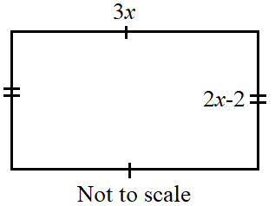
8. The dimensions of a rectangle room are measured in metres (m).

The length and the width of the room are 3x and 2x – 2.

a. If $P$ is the perimeter of the room, show that the simplified expression for $P$ is:
$$P=10x-4$$
.
(2 marks)

………………………………………………………………………………………………..

………………………………………………………………………………………………..

………………………………………………………………………………………………..

………………………………………………………………………………………………..

………………………………………………………………………………………………..

………………………………………………………………………………………………..

b. If P = 34 m, find the value of x in metre. (1 mark)

………………………………………………………………………………………………..

………………………………………………………………………………………………..

………………………………………………………………………………………………..

9. a. Fill in the tables below for the 2 equations. Then plot the two equations on the same
graph paper provided below. (3 marks)

$$y=-2x+6$$
$$x$$ | 0 | 1 | 2
$$y$$

$$y=3x+1$$

$$x$$ | 0 | 1 | 2
$$y$$
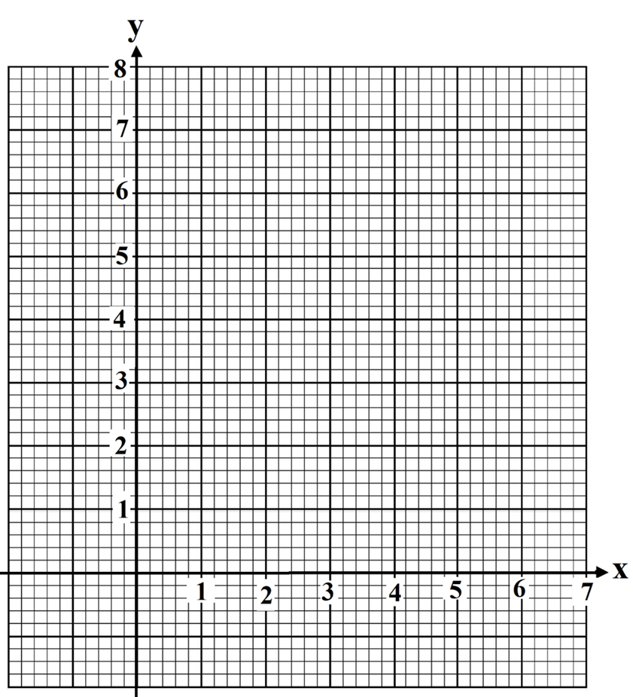

- From the graphs drawn in (a) above, find the solution to the simultaneous equations.
(1 mark)
………………………………………………………………………………………………..

………………………………………………………………………………………………..

Section 2 – 5.3 (20 marks)
Attempt Questions 1 to 13.
Allow approximately 30 minutes for this section

Multiple Choice Questions

1. $\sqrt{20}$ in its most simplified form is:
A. $5\sqrt{4}$
B. $4\sqrt{5}$
C. $2\sqrt{5}$
D. $\sqrt{2×10}$

2. Simplify fully:

$2\sqrt{5}+3\sqrt{45}$

A. $5\sqrt{50}$
B. $11\sqrt{5}$
C. $11\sqrt{50}$
D. $29\sqrt{5}$

3. Expand and simplify: $-2\left(x+4y\right)-3x\left(6-2x\right).$
A. $6x^{2}-28xy$
B. $6x^{2}-16x-8y$
C. $6x^{2}-20x-8y$
D. $20x-8y-6x^{2}$

4. The rule for the following linear relation is:
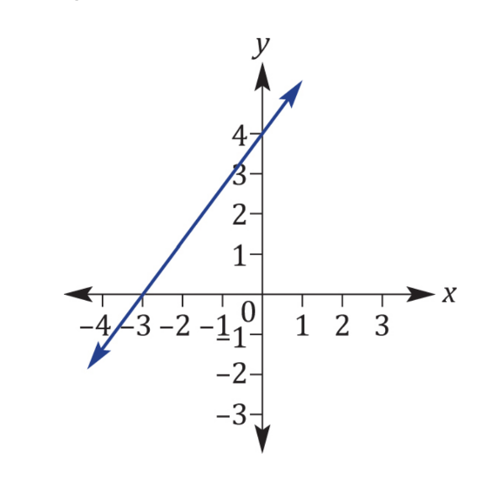

- $y=\frac{3}{4}x+4$

- $y=\frac{-3}{4}x-4$

- $y=4x-4$

- $y=\frac{4}{3}x+4$

5. The point of intersection of the 2 lines $y=ax$ and $x=-b$ is:

- $(1,-b)$

- $(-b,ax)$

- $(b,ax)$

- $(-b,-ab)$

Short Answer Questions
Answer the questions in the spaces provided. Your responses should include relevant mathematical reasoning and/or calculations.
Marks CANNOT be awarded for poorly organised written work.

6. Expand and simplify: (1)

${\left(7-\sqrt{2}\right)}^{2}$

…………………………………………………………………………………………….

……………………………………………………………………………………………

……………………………………………………………………………………………

……………………………………………………………………………………………

7. Rationalise the denominator and fully simplify: (2)
$$\frac{4\sqrt{2}-\sqrt{3}}{\sqrt{3}}$$

…………………………………………………………………………………………….

……………………………………………………………………………………………

……………………………………………………………………………………………

8. Solve for $x:$

$5^{x-3}=\frac{1}{25}$ (2)

………………………………………………………………………………………………

………………………………………………………………………………………………

………………………………………………………………………………………………

………………………………………………………………………………………………

………………………………………………………………………………………………

………………………………………………………………………………………………

9. If and , find the value of x. (2)

…………………………………………………………………………………………….

…………………………………………………………………………………………….

…………………………………………………………………………………………….

…………………………………………………………………………………………….

10. Solve the following inequality.

$5-\frac{2x}{3}≥1$ (2)

…………………………………………………………………………………………..

…………………………………………………………………………………………..

…………………………………………………………………………………………..

…………………………………………………………………………………………..

…………………………………………………………………………………………..

11. Determine the linear equation of the line that passes through the given points. (2)
(4, 10), (−2, 1)

…………………………………………………………………………………………..

…………………………………………………………………………………………..

…………………………………………………………………………………………..

…………………………………………………………………………………………..

…………………………………………………………………………………………..

…………………………………………………………………………………………..

…………………………………………………………………………………………..

…………………………………………………………………………………………..

12. Find the equation of the line which is perpendicular to the line $3x-5y-7=0$ (2)
and which passes through the point $(2, –6).$

…………………………………………………………………………………………..

…………………………………………………………………………………………..

…………………………………………………………………………………………..

…………………………………………………………………………………………..

…………………………………………………………………………………………..

…………………………………………………………………………………………..

…………………………………………………………………………………………..

…………………………………………………………………………………………..

13. Solve the following equations simultaneously, using a suitable method: (2)
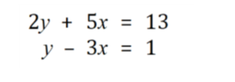
…………………………………………………………………………………………………..

…………………………………………………………………………………………………..

…………………………………………………………………………………………………..

…………………………………………………………………………………………………..

…………………………………………………………………………………………………..

…………………………………………………………………………………………………..

…………………………………………………………………………………………………..

…………………………………………………………………………………………………..

…………………………………………………………………………………………………..

…………………………………………………………………………………………………..

…………………………………………………………………………………………………..

…………………………………………………………………………………………………..

END OF EXAM

