Name: __________________________
Teacher’s name: __________________

Student Name: ____________________________________



Year 10 2025
MATHEMATICS ADVANCED
TASK 1

- No reading time given  - Working time – 50 minutes  - Show all necessary working / units  - Answer Multiple Choice questions on the Answer Sheet provided  - Board approved calculators are allowed  - Exam guidelines  - Use black pen for your working  - Use a pencil and ruler for diagrams  - Marks may be lost for poorly organised written work. | Total Marks – 50  Section 1 STANDARD – 25 marks  Allow 20 mins  Section 2 ADVANCED – 25 marks  Allow 30 mins
Questions | Indices and Surds | Equations, Inequalities and Simultaneous Equations | Total
Section I  STANDARD |  |  | /25
Qs 1-3, 6-9 | /13
Qs 4-5, 10-13 |  | /12
Section II  ADVANCED |  |  | /25
Qs 1-3, 6-9 | /12
Qs 4-5, 10-14 |  | /13
Total | /25 | /25 | /50

Section I - STANDARD (25 marks)
Attempt Questions 1 to 13. Allow approximately 20 minutes for this section.
Multiple Choice Questions – ANSWER ON THE MULTIPLE CHOICE ANSWER SHEET

- The expression $\frac{8a^{2}×3a^{7}}{12a^{3}}$ simplifies to:
- $2a^{3}$
- $2a^{6}$
- $2a^{12}$
- $2a^{15}$

- When fully factorised, $8au-10uh$ factorises to:
- $2\left(4au-5uh\right)$
- $8u\left(a-1.25h\right)$
- $2u(4a-5h)$
- $2u\left(4a+5h\right)$

- The expression $5-3(x+1)$ is equal to:
- $2x-2$
- $2-3x$
- $8-3x$
- $2x+2$

- The solution to $8-4k=-2$ is:
- $k=2\frac{1}{2}$
- $k=-2\frac{1}{2}$
- $k=1\frac{1}{2}$
- $k=-1\frac{1}{2}$

- To solve the pair of simultaneous equations given below, the first step could be to:

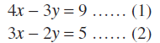

- Multiply equation (1) by 3 and equation (2) by 4 and then add resulting equations to eliminate $x$
- Multiply equation (1) by 4 and equation (2) by 3 and then add resulting equations to eliminate $x$
- Multiply equation (1) by 2 and equation (2) by 3 and then subtract resulting equations to eliminate $y$
- Multiply equation (1) by 3 and equation (2) by 2 and then subtract resulting equations to eliminate $y$

Short Answer Questions
Answer the questions in the spaces provided. Your responses should include relevant mathematical reasoning and/or calculations. Marks CANNOT be awarded for poorly organised written work.

- Simplify:
- ${\left(\frac{a^{2}}{c^{5}}\right)}^{3}$ (2 marks)

- $\frac{{\left(b^{8}\right)}^{5}}{b^{10}}$ (2 marks)

- Simplify the fraction by first factorising: $\frac{4x-12}{x-3}$ (2 marks)

- Expand and simplify: $\left(2x-1\right)\left(x+3\right)$ (2 marks)

- Simplify: $\frac{2x}{3}+\frac{4x}{5}$ (2 marks)

- Solve: $\frac{2a+5}{6}=10$ (2 marks)

- The product of a number and 7 is subtracted from 63 and the result is twice the number. By first forming an equation, find the value of the number. (2 marks)

- Solve the following equation by first expanding and collecting like terms: (3 marks)

$$3\left(x+3\right)=7\left(2x-5\right)-11$$

- Solve the pair of simultaneous equations by using either the elimination or substitution method:
(3 marks)

$2x-5y=-11$
$2x+y = 7$

SECTION II on the next page

Section II - ADVANCED (25 marks)
Attempt Questions 1 to 14. Allow approximately 30 minutes for this section
Multiple Choice Questions – ANSWER ON THE MULTIPLE CHOICE ANSWER SHEET

- When expressed in simplest form, $2\sqrt{98}-3\sqrt{72}$ is equal to:
- $-4\sqrt{2}$
- $-4$
- $-2\sqrt{4}$
- $4\sqrt{2}$

- The value of ${\left(2\sqrt{5}\right)}^{3}$is:
- $30\sqrt{5}$
- $10\sqrt{5}$
- $8\sqrt{5}$
- $40\sqrt{5}$

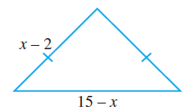
- The algebraic expression for the perimeter of the triangle shown is:
- $x+19$
- $x+11$
- $3x+19$
- $3x+11$

- The equation of the line through $\left(2,1\right)$ with gradient $-\frac{1}{3}$ is:
- $x+3y-5=0$
- $x+3y+5=0$
- $x-3y-5=0$
- $3x+y-5=0$

- Which one of the following straight lines is perpendicular to the line $2x+y-4=0$?
- $x+2y-4=0$
- $2x-y-4=0$
- $x-2y-4=0$
- $2x+y+4=0$

Short Answer Questions
Answer the questions in the spaces provided. Your responses should include relevant mathematical reasoning and/or calculations. Marks CANNOT be awarded for poorly organised written work.

- By showing full working, expand and simplify: $\left(2\sqrt{6}-5\right)\left(2\sqrt{3}+3\sqrt{2}\right)$ (2 marks)

- Find the value of $x$ when: $2^{x+2}=4\sqrt{2}$ (2 marks)

- By showing full working, rationalise the denominator of: $\frac{2\sqrt{2}}{\sqrt{5}+2\sqrt{6}}$ (2 marks)

- Simplify the following, expressing your answer with positive indices: (3 marks)
$${\left(8m^{-9}\right)}^{-\frac{2}{3} }×{\left(81m^{-12}\right)}^{\frac{1}{4}}$$

- Solve the following inequality: $\frac{3x}{4}-\frac{5x-2}{3}<2$ (2 marks)

- Rearrange to make$b$ the subject of: $c=a\sqrt{b^{2}+9}$ (2 marks)

- Find the equation of the straight line passing through the points $(-1,12)$ and $\left(-4,-3\right).$ (2 marks)

- The distance between the points $A(2, r)$ and $B(-4, 6)$ is $6$. Find the value of $r$. (2 marks)

- An equilateral triangle and rectangle are shown below: (3 marks)

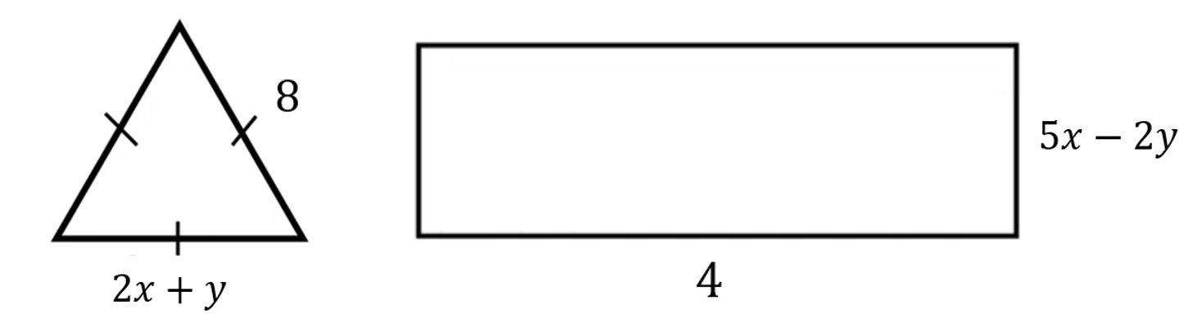

The perimeter of the rectangle is $30$cm. Form two equations and solve to find the values of $x$ and $y$.

END OF EXAM

NAME: _____________________________________

Multiple Choice Answer Sheet

Select the alternative A, B, C or D that best answers the question. Fill in the response oval completely.
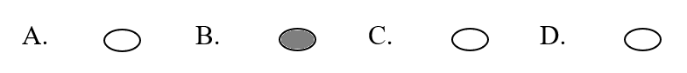
Sample: A. 2 B. 6 C. 8 D. 9

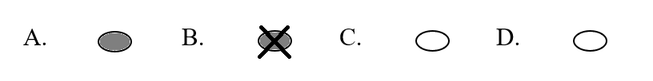
- If you think you have made a mistake, put a cross through the incorrect answer and fill in the new answer.
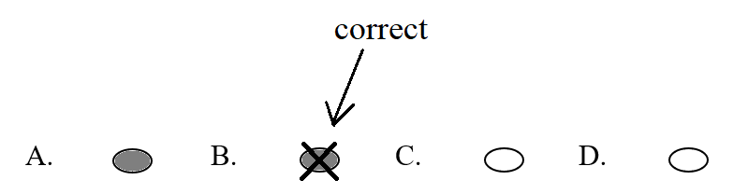
- If you change your mind and have crossed out what you consider to be the correct answer, then indicate the correct answer by writing the word correct and drawing an arrow as follows.

SECTION I

 | A. |  | B. |  | C. |  | D.
 | A. |  | B. |  | C. |  | D.
 | A. |  | B. |  | C. |  | D.
 | A. |  | B. |  | C. |  | D.
 | A. |  | B. |  | C. |  | D.

SECTION II

 | A. |  | B. |  | C. |  | D.
 | A. |  | B. |  | C. |  | D.
 | A. |  | B. |  | C. |  | D.
 | A. |  | B. |  | C. |  | D.
 | A. |  | B. |  | C. |  | D.

MATHEMATICS – Stage 5 (Advanced)
REFERENCE SHEET
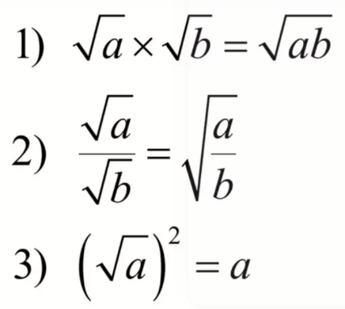
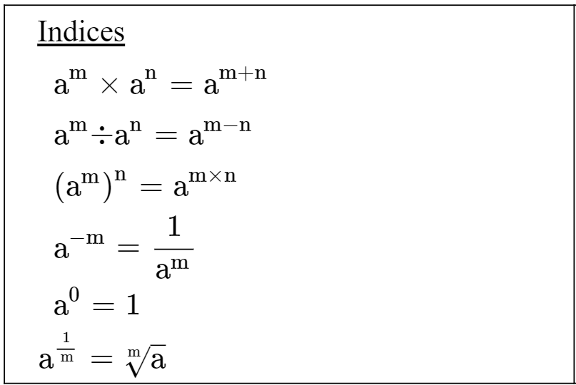
Surds

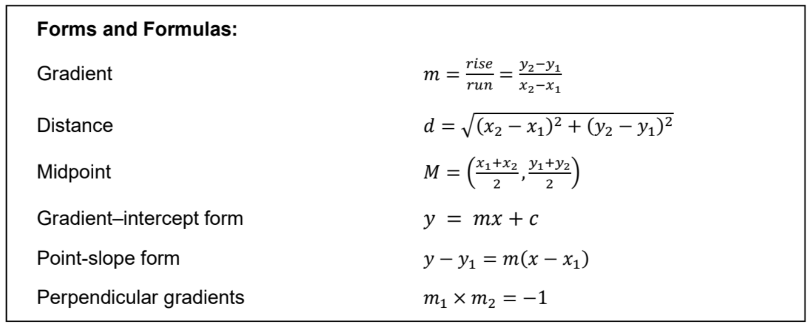
Linear Relationships

