Chapter 4: Measurement and surds
Test A (40 marks)

Name: ___________________________________
Part A – Multiple-choice (10 marks)

1 If the perimeter of this shape is 34.9 cm the value of x is:

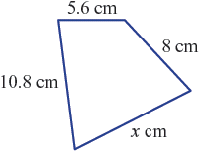

A 9.3 B 9.5 C 10.5

D 11.5 E 12.4

2 The circumference of a circle with radius 3 mm correct to one decimal place is:

A 9.4 mm B 18.8 mm C 28.3 mm

D 37.7 mm E 56.5 mm

3 42 cm² is equivalent to:

A 0.42 m² B 42 000 mm² C 4.2 m²

D 420 mm² E 0.0042 m²

4 The area of the given sector, correct to two decimal places, is:

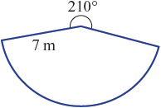

A 32.33 m² B 39.66 m² C 64.14 m²

D 89.80 m² E 153.94 m²

5 If the area of this shape is 49 km², the value of h is closest to:

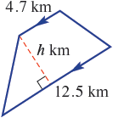

A 4.9 B 5.3 C 5.5

D 5.7 E 6.1

6 The volume of the following solid is:

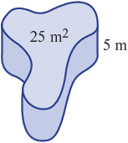

A 25 m³ B 50 m³ C 75 m³

D 125 m³ E 250 m³

7 The exact volume of this oblique cylinder is:

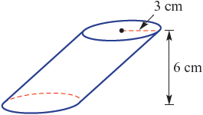

A 9π cm³ B 18π cm³ C 24π cm³

D 36π cm³ E 54π cm³

8 The upper limit for a measurement of 8.4 m is:

A 8.3 m B 8.45 m C 8.5 m

D 8.35 E 8.44 m

9 A cube has a surface area of 1014 cm². The side length of the cube is:

A 10.05 cm B 6 cm C 5.31 cm

D 13 cm E 15.92 cm

10 For the rectangular prism with dimensions as shown, the length of BH to two decimal places is:

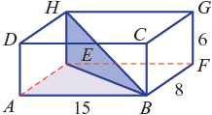

A 18.03 B 18.02 C 29.07

D 90.14 E 325.00

Part B – Short-answer (20 marks)

1 A sector has radius r and interior angle θ as shown.

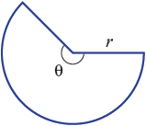

a Write a rule for the perimeter P of a sector in terms of r and θ.

_______________________________________________________________________________________________

_______________________________________________________________________________________________

b Find the perimeter of a sector with radius 3 and interior angle 50°, correct to two decimal places.

_______________________________________________________________________________________________

_______________________________________________________________________________________________

(1 + 1 = 2 marks)

2 Find the area of these basic shapes, rounding to two decimal places where necessary.

a b
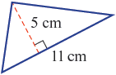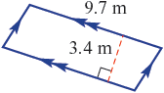

____________________________________ ____________________________________

____________________________________ ____________________________________

c d
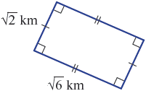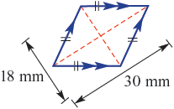

____________________________________ ____________________________________

____________________________________ ____________________________________

e f
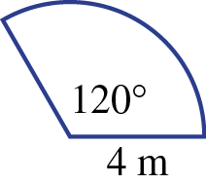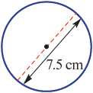

____________________________________ ____________________________________

____________________________________ ____________________________________
<insert new line each part>
(4 × 1 + 2 + 2 = 8 marks)

3 Find i the total surface area, and ii the volume of these solids, rounding to two decimal places where necessary.

a
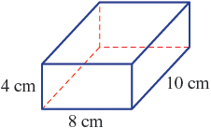
i First draw a labelled diagram of the surface area net then find this area.

_______________________________________________________________________________________________

_______________________________________________________________________________________________

_______________________________________________________________________________________________

_______________________________________________________________________________________________

ii Find the volume. _______________________________________________________________________________________________

_______________________________________________________________________________________________

b
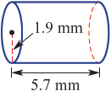
i Draw a labelled diagram of the surface area net then find this area to 2 decimal places.
_______________________________________________________________________________________________

_______________________________________________________________________________________________

_______________________________________________________________________________________________

_______________________________________________________________________________________________

ii Find the volume to two decimal places.
_________________________________________________________________________________

_________________________________________________________________________________

(2 × (2 + 2) = 8 marks)
4 Write down the upper and lower limits of accuracy for each of these measurements.

a 7.2 m _______________________________

b 47.95°C _______________________________

(2 × 1 = 2 marks)

Part C – Extended-response (10 marks)

1 Consider the following composite 2D shape.

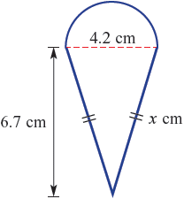

a Use Pythagoras’ theorem to find the value of x, correct to one decimal place.

_______________________________________________________________________________________________

_______________________________________________________________________________________________

b Hence calculate the perimeter of the shape, correct to one decimal place.

_______________________________________________________________________________________________

_______________________________________________________________________________________________

c Find the area of the shape, correct to two decimal places.

_______________________________________________________________________________________________

_______________________________________________________________________________________________

(2 + 2 + 2 = 6 marks)

2 The following composite shape consists of a semicircle and rectangle as shown.

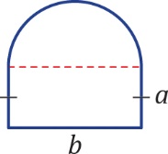

a Find the perimeter of the shape when a = 3 cm and b = 5 cm, correct to two decimal places.

_____________________________________________________________________________________________

_____________________________________________________________________________________________

_____________________________________________________________________________________________

b Find the length of a when b = 8 cm and the perimeter is 32.57 cm.

_____________________________________________________________________________________________

_____________________________________________________________________________________________

_____________________________________________________________________________________________

(2 + 2 = 4 marks)

