

Student Name: ____________________________________

Year 10 MATHEMATICS 5.2/5.3 2022
TASK 2 – Half Yearly Examination

General Instructions  - Reading time – 5 minutes  - Working time – 90 minutes  - Show all necessary working / units  - Board approved calculators are allowed  - Exam guidelines  - Use black pen for your working  - Use a pencil and ruler for diagrams  - Marks may be lost for poorly organised written work. | Total Marks – 80  Section 1 5.2 – 40 marks  Suggested time: 40 mins  Section 2 5.3 – 40 marks  Suggested time: 50 mins
Examiner’s use only |  |  | B.Su, D.Luo, E.Shing , B.Vincent
Question | Indices and Surds | Equations inequalities and formulas | Quadratic expressions non-linear Relationships | Right-angled triangles | Total
Section 1 (5.2) |  |  |  |  | /40
2-4,10,11 | /10
1,9,12 |  | /7
5-7,13-15,17 |  |  | /20
8,16 |  |  |  | /3
Section 2 (5.3) |  |  |  |  | /40
2,6 | /8
7, |  | /12
1,3,4,5,8,9 |  |  | /20
 |  |  |  |  | /40
Total | /18 | /19 | /40 | /3 | /80

Section 1 – 5.2 (40 marks)
Attempt Questions 1 to 17.
Allow approximately 50 minutes for this section

Multiple Choice Questions. Circle the correct answer on the question paper.

1. A number is decreased by 8 and then doubled. The result is equal to 24. This can be written as:
A. $2x-8=24$ B. $2\left(x-8\right)=24$
C. $x-8=2×24$ D. $x-8×2=24$

2. $2×{4a}^{3}$ is equal to:
A. ${24a}^{3}$ B. ${8a}^{3}$
C. ${64a}^{3}$ D. ${128a}^{3}$

3. ${\left(a^{2}b^{3}\right)}^{3}$ is equivalent to:
A. $a^{6}b^{9}$ B. $a^{5}b^{6}$
C. $a^{3}b^{9}$ D. $a^{2}b^{6}$

4. ${4x}^{0}+3$ is equal to:
A. $3$ B. $4$
C. $6$ D. $7$

5. Which ONE of the following lines is parallel to $y=2x+4$?
A. $y=-2x+4$
B. $y=\frac{1}{2}x+4$
C. $y=4x+2$
D. $y=2x-5$
6. The non-linear relationship, $y=x^{2}+2$ can be represented by
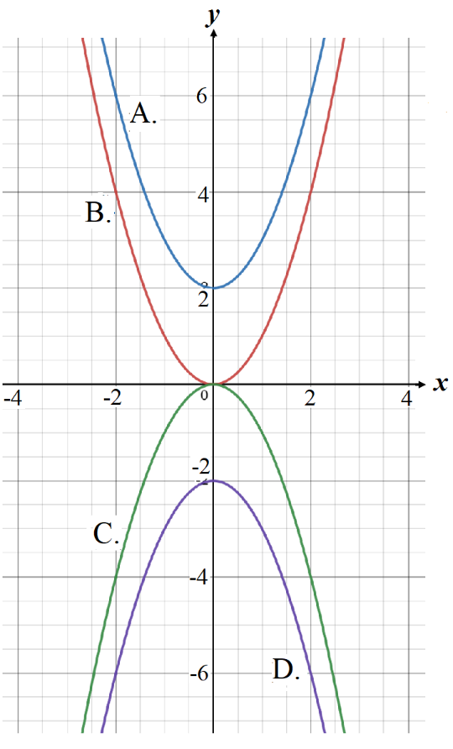

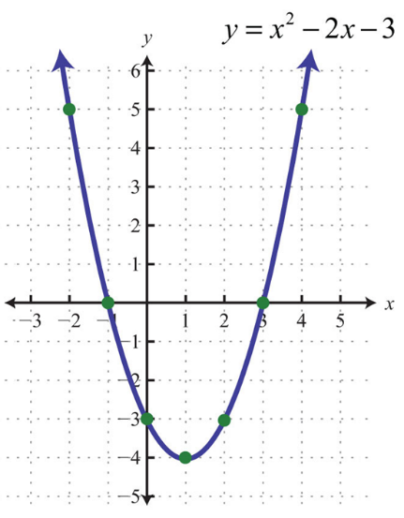
7. The turning point of the parabola below is:
A. $(-1, 0)$
B. $(0, -3)$
C. $(1, -4)$
D. $(3, 0)$

8. Which ONE of the following is a right-angled triangle? (All diagrams are not in scale.)
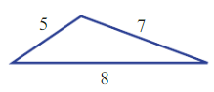
A.

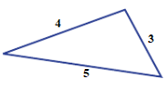
B.

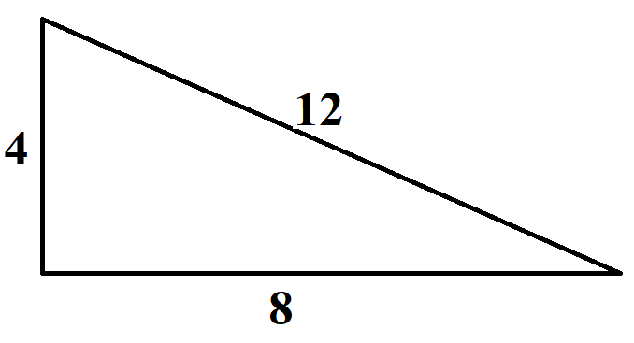
C.

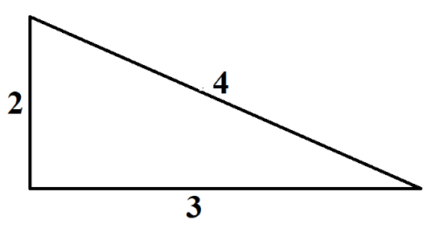
D.

Short Answer Questions
Answer the questions in the spaces provided. Your responses should include relevant mathematical reasoning and/or calculations.
Marks CANNOT be awarded for poorly organised written work.

9. Find $x$ in the following equations.
a. $3\left(x+1\right)=9$ (2 marks)
………………………………………………………………………………………………
………………………………………………………………………………………………
………………………………………………….……………………………………………

b. $\frac{x}{2}-1=4$ (2 marks)

………………………………………………………………………………………………..
……………………………………………………………………………………………….. ……………………………………………………………………………………………… ………………………………………………….……………………………………………
10. Expand and simplify:
a. $5+4(x-2)$ (1 mark)
………………………………………………………………………………………………..
………………………………………………………………………………………………..
………………………………………………………………………………………………..
………………………………………………………………………………………………..

b. $3\left(2x+y\right)-2x$ (2 marks)
………………………………………………………………………………………………..
………………………………………………………………………………………………..
………………………………………………………………………………………………..
………………………………………………………………………………………………..
11. Using index laws to simplify the following:
a. $3x^{2}×({2x)}^{3}$ (2 marks)
………………………………………………………………………………………………..
………………………………………………………………………………………………..
………………………………………………………………………………………………..

b. ${(x-4x)}^{0}+2×7^{0}$ (2 marks)
………………………………………………………………………………………………..
………………………………………………………………………………………………..
………………………………………………………………………………………………..

12. If $S=ut+\frac{1}{2}at^{2}$, if $u=2$, $a=10$ and $t=3$, find the value of $S$. (2 mark)
……………………………………………………………………………………………………
…………………………………………………………………………………………………….
…………………………………………………………………………………………………….
…………………………………………………………………………………………………….
…………………………………………………………………………………………………….
…………………………………………………………………………………………………….
…………………………………………………………………………………………………….

13. Solve the following simultaneous equations using suitable methods.

- $x=y$ (2 marks)
$3y=x+4$
…………………………………………………………………………………………………

…………………………………………………………………………………………………

…………………………………………………………………………………………………

…………………………………………………………………………………………………

…………………………………………………………………………………………………

…………………………………………………………………………………………………

…………………………………………………………………………………………………

…………………………………………………………………………………………………

- $x+y=11$ (2 marks)
$x-y=5$
…………………………………………………………………………………………………

…………………………………………………………………………………………………

…………………………………………………………………………………………………

…………………………………………………………………………………………………

…………………………………………………………………………………………………

…………………………………………………………………………………………………

…………………………………………………………………………………………………

…………………………………………………………………………………………………

…………………………………………………………………………………………………

…………………………………………………………………………………………………

…………………………………………………………………………………………………

14. a. Fill in the tables below for the given equation and then plot the graph of this equation on number plane below. (2 marks)
$$L_{1} : y=2x+6$$
$$x$$ | -2 | -1 | 0 | 1
$$y$$

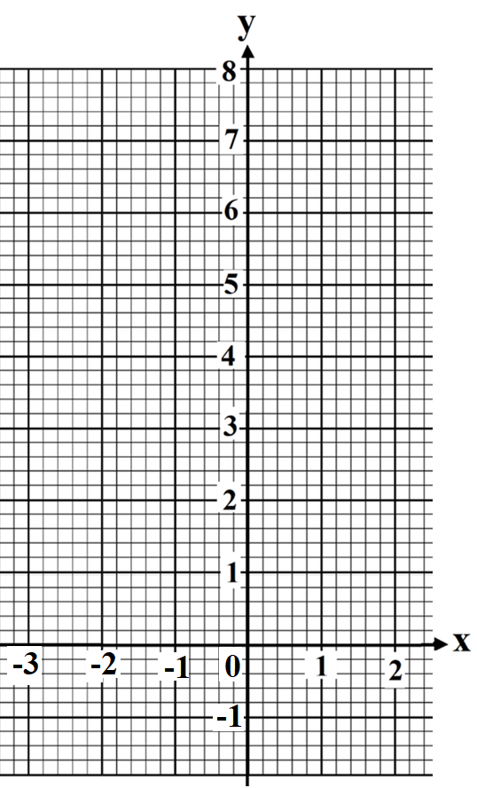

- On the number plane above, draw a line L₂ which is parallel to L₁ and with y-intercept equals 3. (1 mark)

- Find the equation of L₂. (1 mark)

………………………………………………………………………………………………..

………………………………………………………………………………………………..

15. a. Fill in the tables for the given equation below and then plot the graph of this equation on number plane below. (2 marks)
$$y=x^{2}-4x+3$$
$$x$$ | -1 | 0 | 1 | 2 | 3 | 4 | 5
$$y$$

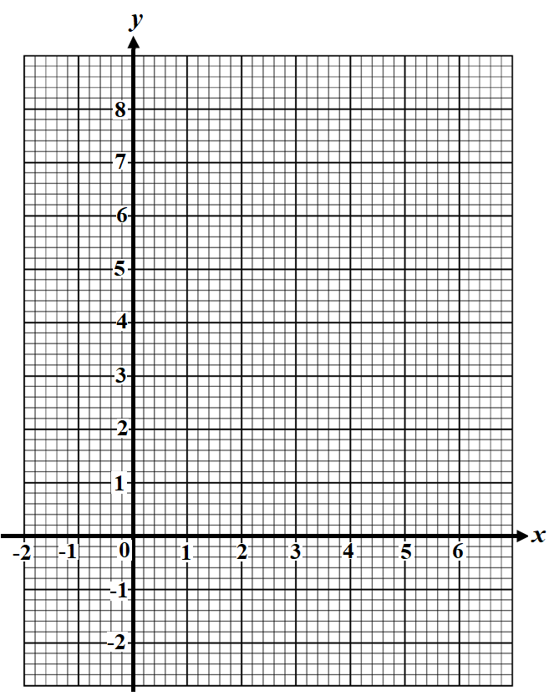

- From the number plane above, find
- The y-intercept. (1 mark)
……….…………………………………………….…………………………….
- The axis of symmetry. (1 mark)

…………………………………………………………………………………….

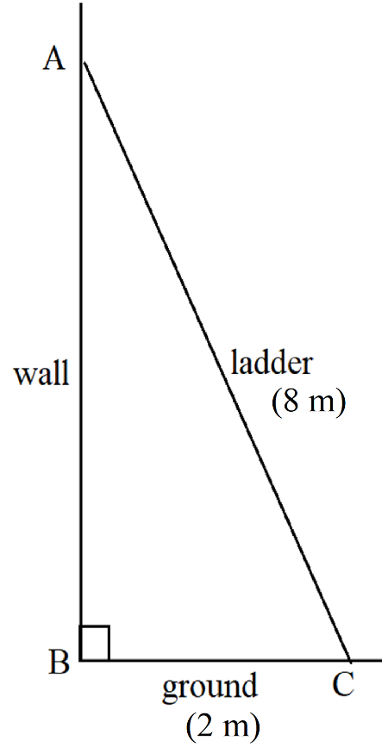
16. A 8 m ladder leans against a vertical wall. If the base of the ladder is 2 m from the wall, determine how high the ladder is up the wall, correct to 2 decimal ponits. (2 marks)

………………………………………………………………….

………………………………………………………………….

………………………………………………………………….

………………………………………………………………….

………………………………………………………………….

………………………………………………………………….

………………………………………………………………….

………………………………………………………………….

………………………………………………………………….

………………………………………………………………….

………………………………………………………………….

………………………………………………………………….

17. Peter delivers pizza for a fast-food restaurant. He is paid $25 a shift plus $3 per delivery.

- Complete the table of values below. (1 mark)
No. of deliveries (d) | 0 | 5 | 10 | 15 | 20
Wages (W)

- Plot a graph of Peter’s wages (W) against number of deliveries (d). (1 mark)

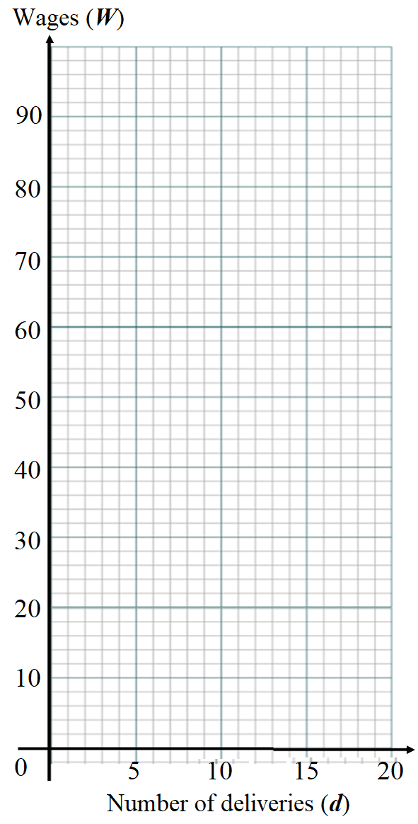

- Find the linear relationship between his wages (W) and the number of deliveries (d).
(1 mark)
………………………………………………………………………………………………...

………………………………………………………………………………………………...

………………………………………………………………………………………………...

- Use the graph to determine: (2 marks)

- Peter’s wages for 8 deliveries. (1 mark)

…………………………………………………………………………………………

………………………………………………………………………………………….

………………………………………………………………………………………….

- The minimum number of deliveries made if Peter wants to earn more than $60.
(1 mark)

…………………………………………………………………………………………

………………………………………………………………………………………….

………………………………………………………………………………………….

Section 2 – 5.3 (40 marks)
Attempt Questions 1 to 9.
Allow approximately 50 minutes for this section

Multiple Choice Questions

- What are the solutions to the equation: (3x – 2)(x + 4) = 0?

(A) x = − $\frac{\text{2}}{\text{3}}$ and x = 4 (B) x = $\frac{\text{2}}{\text{3}}$ and x = 4

(C) x = $\frac{\text{2}}{\text{3}}$ and x = −4 (D) x = $\frac{\text{3}}{\text{2}}$ and x = −4

- simplifies to:

(A)

- What is the length of the interval joining (2, -2) to (-4,6)?

(A) 2$\sqrt{5}$ (B) $\sqrt{6}$ (C) 10 (D) 2$\sqrt{13}$

- The transformation of the graph to is described by:

- a translation of 2 units left

- a translation of 2 units up

- a translation of 2 units right

- a translation of 2 units down

5 | The graph of $y=-\frac{2}{x-1}$ is best represented by:  A  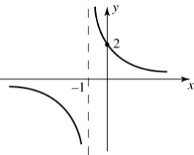  B  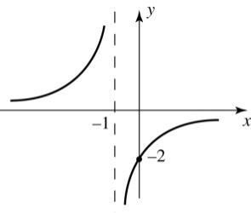  C  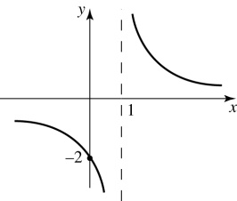  D  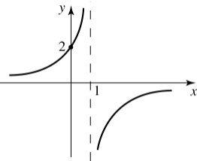

Short Answer Questions
Answer the questions in the spaces provided. Your responses should include relevant mathematical reasoning and/or calculations.
Marks CANNOT be awarded for poorly organised written work.

Question 6 (Indices and surds) (7 marks)

- Expand and simplify: (2)

$(2\sqrt{5}+\sqrt{10})(6-3\sqrt{2})$

…………………………………………………………………………………………………

…………………………………………………………………………………………………

…………………………………………………………………………………………………

…………………………………………………………………………………………………

- Rationalise the denominator of the following expression

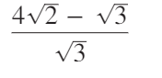 (2)

………………………………………………………………………………………………….

…………………………………………………………………………………………………

…………………………………………………………………………………………………

(c) Solve for x: (3)

$9^{3-2x}={27}^{x-2}$

…………………………………………………………………………………………………….

…………………………………………………………………………………………………….

…………………………………………………………………………………………………….

…………………………………………………………………………………………………….

…………………………………………………………………………………………………….

…………………………………………………………………………………………………….

……………………………………………………………………………………………………

Question 7 Equations, inequalities, and simultaneous equations (12 marks)

(a) A line passes through the points $A\left(2,-5\right) and B\left(-1, 1\right)$ on the Cartesian plane.

- Find the gradient of the line AB. (1)
……………………………………………………………………………………………….
……………………………………………………………………………………………….
- Find the equation of the line which passes through A and is perpendicular to AB. (2)
……………………………………………………………………………………………….
……………………………………………………………………………………………….
…………………………………………………………………………………………........
…… …………………………………………………………………………………………
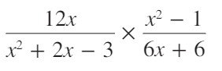
(b) Simplify (2)

(b)
………………………………………………………………………………………………….
………………………………………………………………………………………………

………………………………………………………………………………………………

………………………………………………………………………………………………

………………………………………………………………………………………............

………………………………………………………………………………………………

………………………………………………………………………………………............

………………………………………………………………………………………………

………………………………………………………………………………………............

………………………………………………………………………………………………

………………………………………………………………………………………............
(c)  (d) | Solve for $x$  $\frac{x+1}{3}+2=9$ (2)  ………………………………………………………………………………………………..  ………………………………………………………………………………………………..  ……………………………………………………………………………………………….  ………………………………………………………………………………………………..  Solve for $x$ (2)  $$\frac{2(x+1)}{3}>x+5$$  ………………………………………………………………………………………………..  ………………………………………………………………………………………………..  ………………………………………………………………………………………………..  ………………………………………………………………………………………………..  ……………………………………………………………………………………………….  (e) Solve the following simultaneous equations (3)  $$3x-2y=15$$  $$5x-4y=27$$  ………………………………………………………………………………………………..  ………………………………………………………………………………………………..  ………………………………………………………………………………………………..  ………………………………………………………………………………………………..  ………………………………………………………………………………………………..  ………………………………………………………………………………………………..  ……………………………………………………………………………………………….  ……………………………………………………………………………………………….  Question 8 Quadratic equations (7 marks)  - Solve for $x$ (1)  $$x^{2}-10x+25=0$$  ………………………………………………………………………………………………  ………………………………………………………………………………………………  (b) Find the maximum value of: $15-2x-x^{2}$ (2)  ………………………………………………………………………………………………  ……………………………………………………………………………………………….  ………………………………………………………………………………………………  ………………………………………………………………………………………………
(c) Use the quadratic formula, to give the exact solution to the equation below. (2)

$${2x}^{2}-4x-5 =0$$

………………………………………………………………………………………………

………………………………………………………………………………………………

………………………………………………………………………………………………

………………………………………………………………………………………………

………………………………………………………………………………………………

(d) Find the discriminant, and hence determine the number of real solutions in: (2)

$$y=2x^{2}-3x+7$$

………………………………………………………………………………………………

………………………………………………………………………………………………

………………………………………………………………………………………………

………………………………………………………………………………………………

………………………………………………………………………………………………

Question 9 Quadratic graphs and nonlinear relationships (9 marks)
(a) Sketch $y=\frac{1}{x-1}+2$ and label all intercepts, asymptotes and other important features. (3)

…………………………………………………………………………………………………..

…………………………………………………………………………………………………..

…………………………………………………………………………………………………..

…………………………………………………………………………………………………..

…………………………………………………………………………………………………..

…………………………………………………………………………………………………..

…………………………………………………………………………………………………..

…………………………………………………………………………………………………..

…………………………………………………………………………………………………..

…………………………………………………………………………………………………..

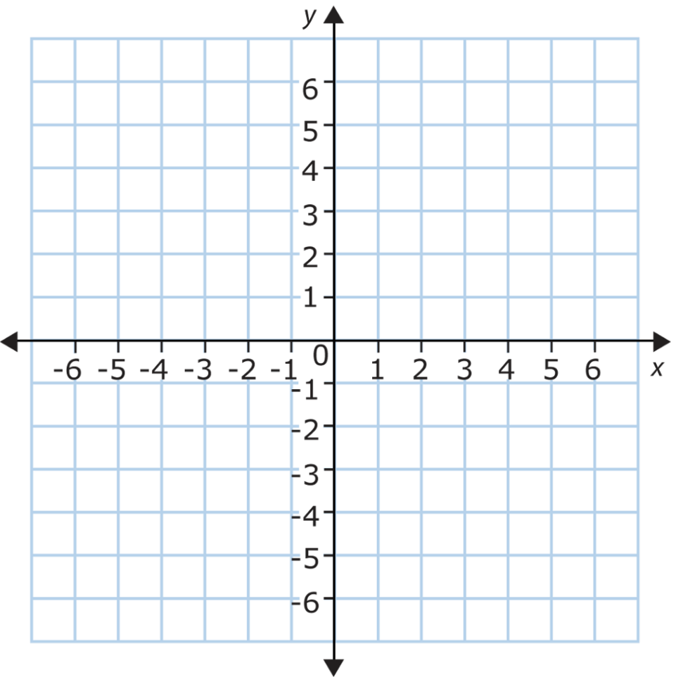

- By first completing the square, sketch $y=x^{2}+4x-3$ labelling axes intercepts (3)
and the axis of symmetry.

…………………………………………………………………………………………………..

…………………………………………………………………………………………………...

……………………………………………………………………………………………………

…………………………………………………………………………………………………..

…………………………………………………………………………………………………...

……………………………………………………………………………………………………

…………………………………………………………………………………………………..

…………………………………………………………………………………………………...

……………………………………………………………………………………………………
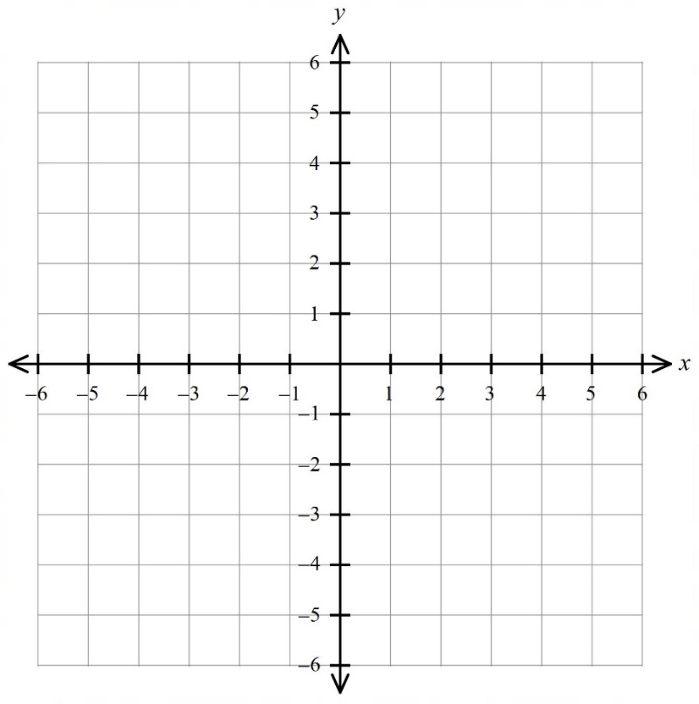

- Sketch the graph $y=2^{-x}-2$, labelling $x$ and y-intercepts, and the horizontal (3)
asymptote.

…………………………………………………………………………………………………..

…………………………………………………………………………………………………...

……………………………………………………………………………………………………

…………………………………………………………………………………………………..

…………………………………………………………………………………………………...

……………………………………………………………………………………………………

…………………………………………………………………………………………………..

…………………………………………………………………………………………………...

……………………………………………………………………………………………………

END OF EXAM

Norwest Christian School
Mathematics Formulas (Stage 5)

Indices
$$a^{m}×a^{n}=a^{m+n}$$
$$a^{m}÷a^{n}=a^{m-n}$$
$${\left(a^{m}\right)}^{n}=a^{m×n}$$
$$a^{-m}=\frac{1}{a^{m}}$$
$$a^{0}=1$$
$$a^{\frac{1}{m}}=\sqrt[m]{a}$$

Surds
$$\sqrt{a}×\sqrt{b}=\sqrt{a×b}$$
$$\sqrt{a}÷\sqrt{b}=\sqrt{\frac{a}{b}}$$

Equation of straight line
$$y=mx+c$$
$$y-y_{1}=m(x-x_{1})$$

Right angled triangle
$$a^{2}+b^{2}=c^{2}$$

Distance and Midpoint
$$d=\sqrt{{\left(x_{2}-x_{1}\right)}^{2}+{\left(y_{2}-y_{1}\right)}^{2}}$$
$M=\left(\frac{x_{1}+x_{2}}{2} , \frac{y_{1}+y_{2}}{2}\right)$
Quadratic Formula
$x=\frac{-b±\sqrt{b^{2}-4ac}}{2a}$

