

Student Name: ____________________________________

Year 10 MATHEMATICS 5.2/5.3 2023
TASK 2 – Half Yearly Examination

General Instructions  - Reading time – 5 minutes  - Working time – 90 minutes  - Show all necessary working / units  - Board approved calculators are allowed  - Exam guidelines  - Use black pen for your working  - Use a pencil and ruler for diagrams  - Marks may be lost for poorly organised written work. | Total Marks – 80  Section 1 5.2 – 40 marks  Suggested time: 40 mins  Section 2 5.3 – 40 marks  Suggested time: 50 mins
Examiner’s use only D.Hua, V.Chan, B.Su, B. Vincent, J. Barter
Question | Indices and Algebra | Equations and Formulas | Linear and non-linear relations | Total
Section 1 (5.2) |  |  |  | /40
1-3,13-15 | /12
7-8,11-12 |  | /12
4-6,9-10,16-18 |  |  | /16
Section 2 (5.3) |  |  |  | /40
2,6 | /7
3,7 |  | /8
1,4,5,8,9 |  |  | /25
 |  |  |  | /80

Section 1 – 5.2 (40 marks)
Attempt Questions 1 to 18
Allow approximately 40 minutes for this section

Multiple Choice Questions 1-10

1. | The expanded form of $5a(4a+3)$ is:
 | A. $20a^{2}+3$ | B. $20a+15$
 | C. $9a^{2}+8a$ | D. $20a^{2}+15a$
2. | When simplified, $x^{3}y^{6}×xy^{7}$ is:
 | A. $x^{3}y^{42}$ | B. $x^{3}y$
 | C. $x^{4}y^{13}$ | D. $x^{4}y^{14}$
3. | ${\left(5a^{3}b^{2}\right)}^{2}$ simplifies to:
 | A. $10a^{6}b^{4}$
 | B. $25a^{6}b^{4}$
 | C. $10a^{5}b^{4}$
 | D. $25a^{5}b^{4}$
4. | The gradient of a line parallel to $y=10x+5$ is:
 | A. $0.5$
 | B. $2$
 | C. $10$
 | D. $5$
5. | On which of the following lines does the point $(4, -10)$ lie?
 | A. $y=2x+5$ |  | B. $y=3x-2$
 | C. $y=5-2x$ |  | D. $y=2-3x$
6. | The gradient of the line joining the points $(1, 2)$ and $(3, 6)$ is:
 | A. $-2$ |  | B. $2$
 | C. $3$ |  | D. $-3$
7. | $x≤2$ is a solution to the inequality:
 | A. $x-2<0$ |  | B. $2x+3≥7$
 | C. $-4x≥-8$ |  | D. $x-10>12$
8. | When 3 less than 4 lots of a number is doubled, the result is 12. This translates to which equation?
 | A. $6x-4=12$ |  | B. $2\left(4x-3\right)=12$
 | C. $2\left(3x-4\right)=12$ |  | D. $2x=12$
9. | When the expression $(x+2)(x-5)$ is expanded, the result will be:
 | A. $x^{2}-3x+10$ |  | B. $x^{2}-3x-10$
 | C. $x^{2}+3x-10$ |  | D. $x^{2}+3x+10$
10. | The graph of $y=-x^{2}+3$ will be:
 | A. a straight line
 | B. a concave up parabola
 | C. an exponential curve
 | D. a concave down parabola

Short Answer Questions 11-18
Answer the questions in the spaces provided. Your responses should include relevant mathematical reasoning and/or calculations.
Marks CANNOT be awarded for poorly organised written work.

11. Solve for $x$ in the following equations.
a. $5x=2x+12$ (2 marks)
………………………………………………………………………………………………
………………………………………………………………………………………………
………………………………………………….……………………………………………

b. $\frac{x}{3}-12=4$ (2 marks)

………………………………………………………………………………………………..
……………………………………………………………………………………………….. ……………………………………………………………………………………………… ………………………………………………….……………………………………………

………………………………………………….……………………………………………

c. $3\left(2x+4\right)-4\left(x+2\right)=6$ (3 marks)

………………………………………………………………………………………………..
……………………………………………………………………………………………….. ……………………………………………………………………………………………… ………………………………………………….……………………………………………
………………………………………………….……………………………………………
………………………………………………….……………………………………………

12. Solve the simultaneous equations $4x+3y=-1$ and $y=2x-7$ (3 marks) by using the method of substitution.
………………………………………………………………………………………………..
………………………………………………………………………………………………..
………………………………………………………………………………………………..
………………………………………………………………………………………………..
………………………………………………………………………………………………..
………………………………………………………………………………………………..
………………………………………………………………………………………………..
13. Use index laws to simplify the following and express the solution with positive indices where required:
a. $3x^{2}×{\left(2x\right)}^{3}$ (2 marks)
………………………………………………………………………………………………..
………………………………………………………………………………………………..
………………………………………………………………………………………………..

b. $6p^{4}q÷2pq^{3}$ (2 marks)
………………………………………………………………………………………………..
………………………………………………………………………………………………..
………………………………………………………………………………………………..

14. Simplify $\frac{x}{2}+\frac{x}{3}$ (2 marks)
……………………………………………………………………………………………………
…………………………………………………………………………………………………….
…………………………………………………………………………………………………….
…………………………………………………………………………………………………….
…………………………………………………………………………………………………….
……………………………………………………………………………………………………

15. An initial investment of $5 000 grows every year according to the formula
$A=5 000 {\left(1.01\right)}^{n}$ where A is the value of the investment after n years. Find the value of the investment after 8 years, giving the answer in scientific notation rounded to 2 significant figures.
(3 marks)

…………………………………………………………………………………………………

…………………………………………………………………………………………………

…………………………………………………………………………………………………

…………………………………………………………………………………………………

…………………………………………………………………………………………………

16. For the equation $3x+5y=15:$

- Calculate the$x$ and$y$ intercepts. (2 mark)

………………………………………………………………………………………………..

………………………………………………………………………………………………..

………………………………………………………………………………………………..

………………………………………………………………………………………………..

- Hence, or otherwise, sketch$3x+5y=15.$ (1 mark)
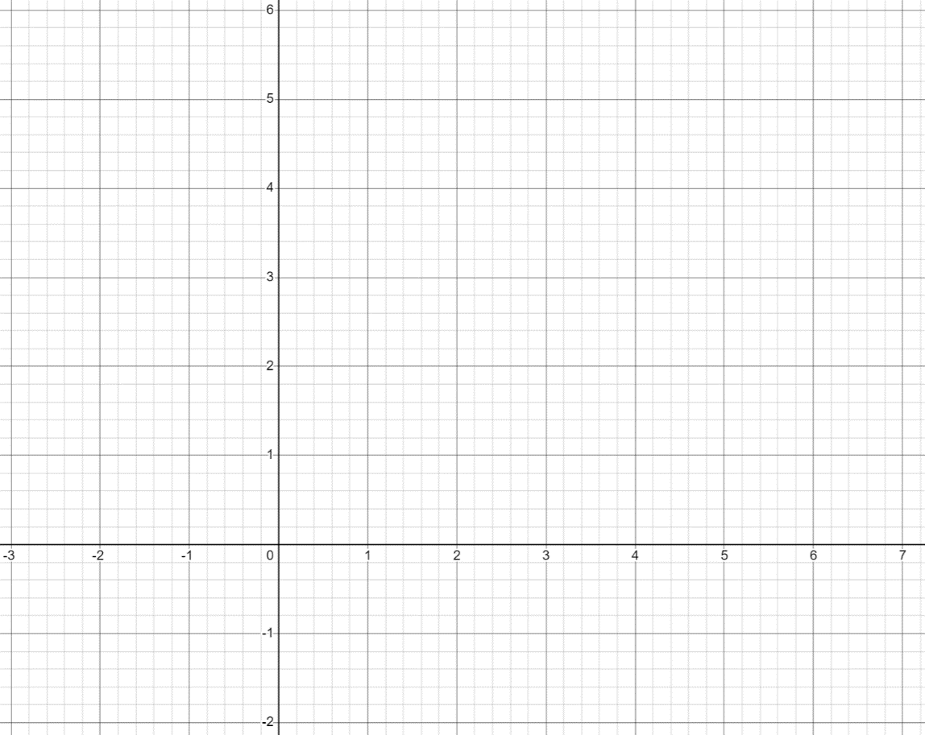

17. a. Fill in the table for the given equation below and then plot the graph of this equation on number plane below. (2 marks)
$$y={-x}^{2}+6x-5$$
$$x$$ | 1 | 2 | 3 | 4 | 5
$$y$$

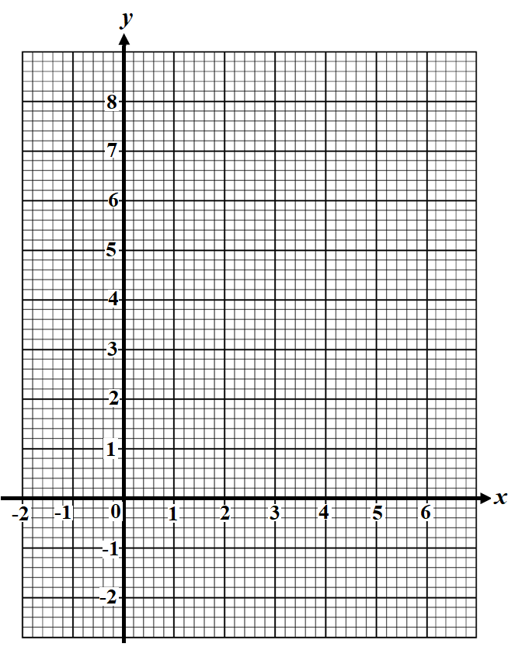

- From the graph sketched, identify:
- The x-intercepts. (1 mark)
……….…………………………………………….…………………………….
- The axis of symmetry. (1 mark)

…………………………………………………………………………………….
- The vertex. (1 mark)

…………………………………………………………………………………….

18. Find the equation of the line that is parallel to$y=2x+3$ and passes through the point (1, 5) .
(3 marks)

………………………………………………………………………………………………...

………………………………………………………………………………………………...

………………………………………………………………………………………………...

………………………………………………………………………………………………...

………………………………………………………………………………………………...

………………………………………………………………………………………………...

………………………………………………………………………………………………...

………………………………………………………………………………………………...

………………………………………………………………………………………………...

Section 2 – 5.3 (40 marks)
Attempt Questions 1 to 9.
Allow approximately 50 minutes for this section

Multiple Choice Questions 1-5

- If $ax^{2}+bx+c=0$ has no solutions then:

(A) $∆ =0$ (B) $∆ >0$

(C) $∆ ≈0$ (D) $∆ <0$

- $\frac{6x^{-2}y^{-1}}{9x^{-5}y^{3}}$ expressed with positive indices is:

(A) $\frac{2x^{3}}{3y^{4}}$

- $\frac{2x^{7}}{3y^{2}}$

- $\frac{2y^{4}}{3x^{3}}$

- $\frac{2y^{3}}{3x^{4}}$

- The gradient and the y-intercept, respectively, of the equation $4x+2y-6=0$ are?

(A) 3 and -2

(B) -2 and 3

(C) 2 and -3

(D) -3 and -2

- Compared to the graph $y=x^{2}$, the graph of $y=4x^{2}$ is:

- translated 2 units left

- translated 2 units right

- narrower

- wider

5 | The rule for a concave up parabola with turning point (1, 1):  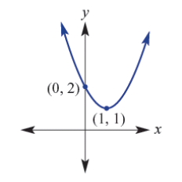  (A) $y={\left(x+1\right)}^{2}$ +1  (B) $y={\left(x-1\right)}^{2}$ +1  (C) $y={\left(x+1\right)}^{2}$ +2  (D) $y={\left(x-1\right)}^{2}$ +2

Short Answer Questions 6-9
Answer the questions in the spaces provided. Your responses should include relevant mathematical reasoning and/or calculations.
Marks CANNOT be awarded for poorly organised written work.

Question 6 (Indices and surds) (6 marks)

- Simplify: (2)

$\sqrt{300}-\sqrt{48}-3\sqrt{27}$

…………………………………………………………………………………………………

…………………………………………………………………………………………………

…………………………………………………………………………………………………

…………………………………………………………………………………………………

…………………………………………………………………………………………………

- Rationalise the denominator of the following expression (2)

$\frac{5}{\sqrt{3}-2}$

………………………………………………………………………………………………….

…………………………………………………………………………………………………

…………………………………………………………………………………………………

…………………………………………………………………………………………………

…………………………………………………………………………………………………

(c) Solve for x: (2)

$5^{2x}={125}^{x+1}$

…………………………………………………………………………………………………….

…………………………………………………………………………………………………….

…………………………………………………………………………………………………….

…………………………………………………………………………………………………….

…………………………………………………………………………………………………….

Question 7 Equations, inequalities, and simultaneous equations (7 marks)

(a)  (b) | Solve for $x$  1) $2\left(x+3\right)-3\left(x-4\right)=19$ (2)  ………………………………………………………………………………………………..  ………………………………………………………………………………………………..  ……………………………………………………………………………………………….  ………………………………………………………………………………………………..  ………………………………………………………………………………………………..  ……………………………………………………………………………………………….  ………………………………………………………………………………………………..  ………………………………………………………………………………………………..  2) $\frac{x+6}{3}=\frac{2x+4}{4}$ (2)  ………………………………………………………………………………………………..  ………………………………………………………………………………………………..  ……………………………………………………………………………………………….  ………………………………………………………………………………………………..  ………………………………………………………………………………………………..  ……………………………………………………………………………………………….  ………………………………………………………………………………………………..  ………………………………………………………………………………………………..  Two lines $l_{1}$and $l_{2}$ have equations $y=2x+1$and $y=-\frac{x}{2}-4$ respectively.  - Show the two lines are perpendicular (1)  ………………………………………………………………………………………………..  ………………………………………………………………………………………………..  ………………………………………………………………………………………………..  ………………………………………………………………………………………………..  - Find the point at which $l_{1}$and $l_{2}$ intersect. (2)  ………………………………………………………………………………………………..  ………………………………………………………………………………………………..  ………………………………………………………………………………………………..  ………………………………………………………………………………………………..  ………………………………………………………………………………………………..  ………………………………………………………………………………………………..  ……………………………………………………………………………………………….  ……………………………………………………………………………………………….
Question 8 Quadratic equations (7 marks)
(a) | Simplify fully (3)  $$\frac{6x+18}{9(x^{2}+4x+4)}×\frac{x^{2}-4}{x+3}$$  ………………………………………………………………………………………………  ………………………………………………………………………………………………  ………………………………………………………………………………………………  ………………………………………………………………………………………………  ………………………………………………………………………………………………  ………………………………………………………………………………………………  ………………………………………………………………………………………………  ………………………………………………………………………………………………  ………………………………………………………………………………………………  ………………………………………………………………………………………………
(b)  (c) | Use the quadratic formula to solve the equation below, leaving your answer in exact values  (2)  $${2x}^{2}-5x-8 =0$$  ………………………………………………………………………………………………  ………………………………………………………………………………………………  ………………………………………………………………………………………………  ………………………………………………………………………………………………  ………………………………………………………………………………………………  ………………………………………………………………………………………………  ………………………………………………………………………………………………  ………………………………………………………………………………………………  For which values of $k$ does the quadratic equation $2x^{2}-3x+k=0$ have 1 solution? (2)  ………………………………………………………………………………………………  ………………………………………………………………………………………………  ………………………………………………………………………………………………  ………………………………………………………………………………………………  ………………………………………………………………………………………………  ………………………………………………………………………………………………  ………………………………………………………………………………………………  ………………………………………………………………………………………………
Question 9 Functions (15 marks)
(a) | Determine whether the following graphs are functions or relations (1)  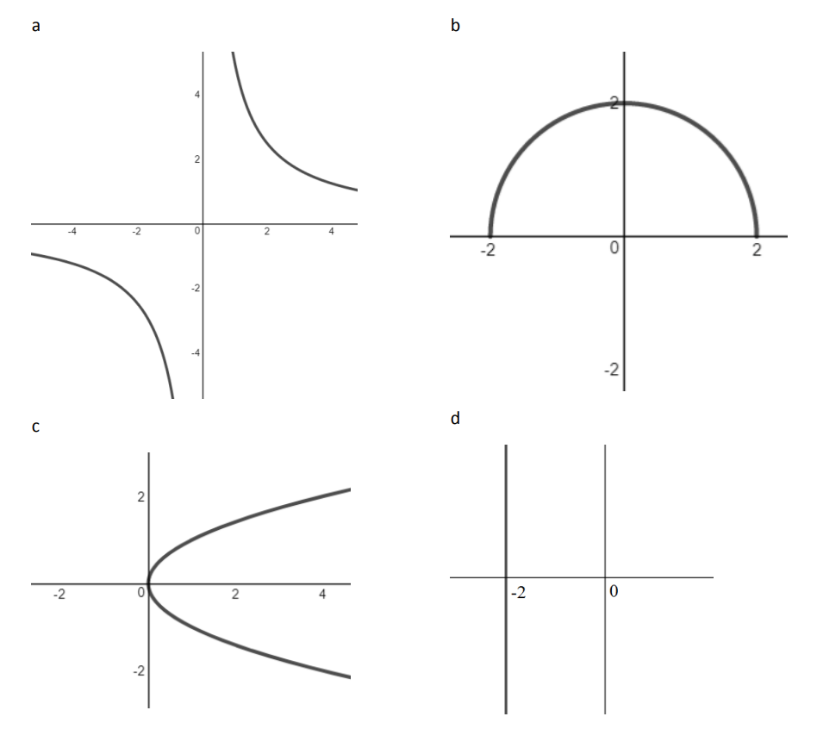
(b) | If $f\left(x\right)=x^{2}-6x$, find $x$ when $f\left(x\right)=-9$. (2)  ………………………………………………………………………………………………  ………………………………………………………………………………………………  ………………………………………………………………………………………………  ………………………………………………………………………………………………
(c) | If $f\left(x\right)=x^{2}-4$ and $g\left(x\right)=3x-6$, find:  - $f\left(0\right)+g(3)$ (2)  ………………………………………………………………………………………………  ………………………………………………………………………………………………  - ${\left(g\left(x\right)\right)}^{2}+g(x^{2})$ (2)  ………………………………………………………………………………………………  ………………………………………………………………………………………………  ………………………………………………………………………………………………  ………………………………………………………………………………………………
(d) | - By completing the square, show that $f\left(x\right)=x^{2}-2x-3$ can be written as (2)  $$f\left(x\right)={\left(x-1\right)}^{2}-4$$  ………………………………………………………………………………………………  ………………………………………………………………………………………………  ………………………………………………………………………………………………  ………………………………………………………………………………………………  ………………………………………………………………………………………………  ………………………………………………………………………………………………  ………………………………………………………………………………………………  - Draw the graph of $y={\left(x-1\right)}^{2}-4$, showing clearly the coordinates of the (2)  vertex and the $x$ and $y$ intercepts.  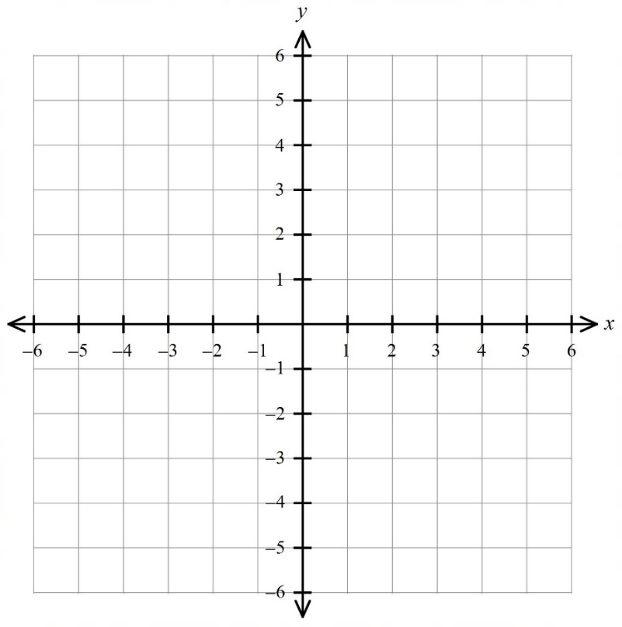
(e) | The area of a particular rectangle, R, in square centimetres can be expressed as $A=8l-l^{2}$, where $l$ is the length of the rectangle.  - Explain why the length of the rectangle cannot be greater than 8cm. (1)  ………………………………………………………………………………………………  ………………………………………………………………………………………………  ………………………………………………………………………………………………  ………………………………………………………………………………………………  - By finding the axis of symmetry, or otherwise, show that the (2)  maximum area of the rectangle is $16cm^{2}$.  ………………………………………………………………………………………………  ………………………………………………………………………………………………  ………………………………………………………………………………………………  ………………………………………………………………………………………………  - What are the dimensions of the rectangle that give a maximum area of$16cm^{2}$? (1)  ………………………………………………………………………………………………  ………………………………………………………………………………………………  ………………………………………………………………………………………………  ………………………………………………………………………………………………
END OF EXAM

Norwest Christian School
Mathematics Formulas (Stage 5)

Indices
$$a^{m}×a^{n}=a^{m+n}$$
$$a^{m}÷a^{n}=a^{m-n}$$
$${\left(a^{m}\right)}^{n}=a^{m×n}$$
$$a^{-m}=\frac{1}{a^{m}}$$
$$a^{0}=1$$
$$a^{\frac{1}{m}}=\sqrt[m]{a}$$

Surds
$$\sqrt{a}×\sqrt{b}=\sqrt{a×b}$$
$$\sqrt{a}÷\sqrt{b}=\sqrt{\frac{a}{b}}$$

Equation of straight line
$$y=mx+c$$
$$y-y_{1}=m(x-x_{1})$$

Right angled triangle
$$a^{2}+b^{2}=c^{2}$$

Distance and Midpoint
$$d=\sqrt{{\left(x_{2}-x_{1}\right)}^{2}+{\left(y_{2}-y_{1}\right)}^{2}}$$
$M=\left(\frac{x_{1}+x_{2}}{2} , \frac{y_{1}+y_{2}}{2}\right)$
Quadratic Formula
$x=\frac{-b±\sqrt{b^{2}-4ac}}{2a}$

