

Student Name: ____________________________________

Maths Teacher: ___________________________________

Year 10 MATHEMATICS Advanced 2025
TASK 2 – Half Yearly Examination

General Instructions  - Reading time – 5 minutes  - Working time – 90 minutes  - Show all necessary working / units  - Board approved calculators are allowed  - Exam guidelines  - Use black pen for your working  - Use a pencil and ruler for diagrams  - Marks may be lost for poorly organised written work. | Total Marks – 80  Section I Standard – 40 marks  Suggest tine: 40 mins  Section II Advanced – 40 marks  Suggested time: 50 mins
Examiner’s use only K. Duncan, J. Han
 | Indices and Algebra | Equations and Formulas | Linear and non-linear relations | Total
Standard |  |  |  | /40
1-4, 11-13 | /12
4-7, 14-16 |  | /12
8-10, 17-19 |  |  | /16
Advanced |  |  |  | /40
1, 6-9 | /9
2, 10-13 |  | /9
3-5, 14-21 |  |  | /22
 | /21 | /21 | /38 | /80

Section I – Standard (40 marks)
Attempt Questions 1 to 18
Allow approximately 40 minutes for this section

Multiple Choice Questions 1-10
ANSWER ON THE MULTIPLE CHOICE ANSWER SHEET

 | When simplified, $\frac{4x^{5}y^{3}}{12xy^{5}}$ is:
 | - $\frac{x^{4}y^{2}}{3}$ | - $\frac{x^{4}}{{3y}^{2}}$
 | - ${3x}^{4}y^{2}$ | - $3x^{6}y^{8}$
 | When simplified, ${\left(3p^{3}q\right)}^{2}$ is:
 | - $9p^{6}q^{2}$ | - $9p^{5}q^{2}$
 | - $3p^{6}q^{2}$ | - $3p^{5}q^{2}$
 | The expression $-2\left(3x+5\right)-x$ is equal to:
 | - $5x-10$ | - $-5x+10$
 | - $7x+10$ | - $-7x-10$
 | The expression 18$b^{2}-12b$ when fully factorised is:
 | - $6b(3b-2)$ | - $6b(2b-3)$
 | - $3b(6b-4)$ | - $3b(4b-6)$
 | The solution to the equation $4x=2x+6$ is:
 | - $x=1$ | - $x=-3$
 | - $x=3$ | - $x=-1$
 | When $A=lw$ is rearranged to make $w$ the subject, the answer is:
 | - $w=A-l$ | - $w=\frac{A}{l}$
 | - $w=lA$ | - $w=\frac{l}{A}$
Using the graph below, the solution to the simultaneous equations $y=-2x-5$ and $y=x+1$ is:
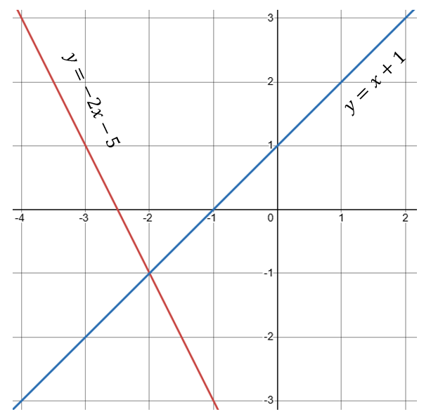

 | - $(-1, -2)$ | - $(-2, 1)$
 | - $(1, -2)$ | - $(-2,-1)$
 | The gradient of a line that is perpendicular to a line with gradient of $\frac{2}{5}$ is:
 | - $\frac{5}{2}$ | - $\frac{2}{5}$
 | - $-\frac{5}{2}$ | - $-\frac{2}{5}$
 | Which of the following could be the graph of $y=-3x+2$?
 | A.  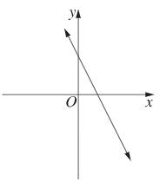 | B.  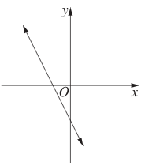
 | C.  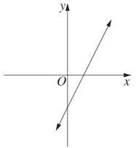 | D.  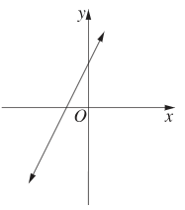
 | Which of the following equations represents a parabola that has a minimum turning point?
 | - $y=-x^{2}-1$ | - $-y=1-x^{2}$
 | - $y=1-x^{2}$ | - $-y=1+x^{2}$

Short Answer Questions
Answer the questions in the spaces provided. Your responses should include relevant mathematical reasoning and/or calculations.
Marks CANNOT be awarded for poorly organised written work.

 | Simplify the following:
 | - $\frac{{\left(c^{4}\right)}^{6}}{c^{10}}$  ……………………………………………………………………………………………………………………………………………………………………………………………………………………………………………………… | 2
 | - $\frac{2a}{5b}×\frac{25b^{2}}{4a}$  ……………………………………………………………………………………………………………………………………………………………………………………………………………………………………………………… | 2
 | Expand and simplify: $\left(3x-2\right)(2x+5)$  ………………………………………………………………………………………………………………………………………………………………………………………………………………………………………………………………………………………………………………………………………… | 2
 | Fully simplify: $\frac{5x}{4}+\frac{3x}{6}$  ……………………………………………………………………………………………………………………………………………………………………………………………………………………………………………………….. | 2
 | Solve the following equations for $x$:
 | - $5x+6=3x-8$  …………………………………………………………………………………………………………………………………………………………………………………………………………………………………………………………………………………………………………………………………………………………………………………………………………………………… | 2
 | - $\frac{3x+5}{7}=2$  …………………………………………………………………………………………………………………………………………………………………………………………………………………………………………………………………………………………………………………………………………………………………………………………………………………………… | 2
 | $3$ times the sum of a number and 2 is equal to 2 more than this number$.$  By letting $x$ be this unknown number, form an equation and solve it to find the value of $x$  ……………………………………………………………………………………………………………………………………………………………………………………………………………………………………………………………………………………………………………………………………………………………………………………………………………………………………………………………………………………………………………… | 2
 | Solve the following pair of simultaneous equations using either the elimination or substitution method.  $$\left\{\begin{aligned}4x-y=11 \\ x+y=9\end{aligned}\right.$$  ………………………………………………………………………………………………………………………………………………………………………………………………………………………………………………………………………………………………………………………………………………………………………………………………………………………………………………………………………………………………………………………………………………………………………………………………… | 3
 | For the linear equation $2x-3y=6$:
 | - Calculate the $x$ and $y$ intercepts  ………………………………………………………………………………………………………………………………………………………………………………………………………………………………………………………………………………………………………………………………………… | 2
 | - Hence, use the intercepts to sketch $2x-3y=6$  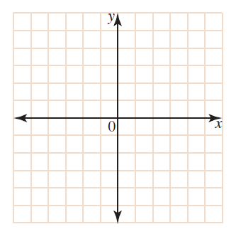 | 1
Consider the graph of the line shown below:

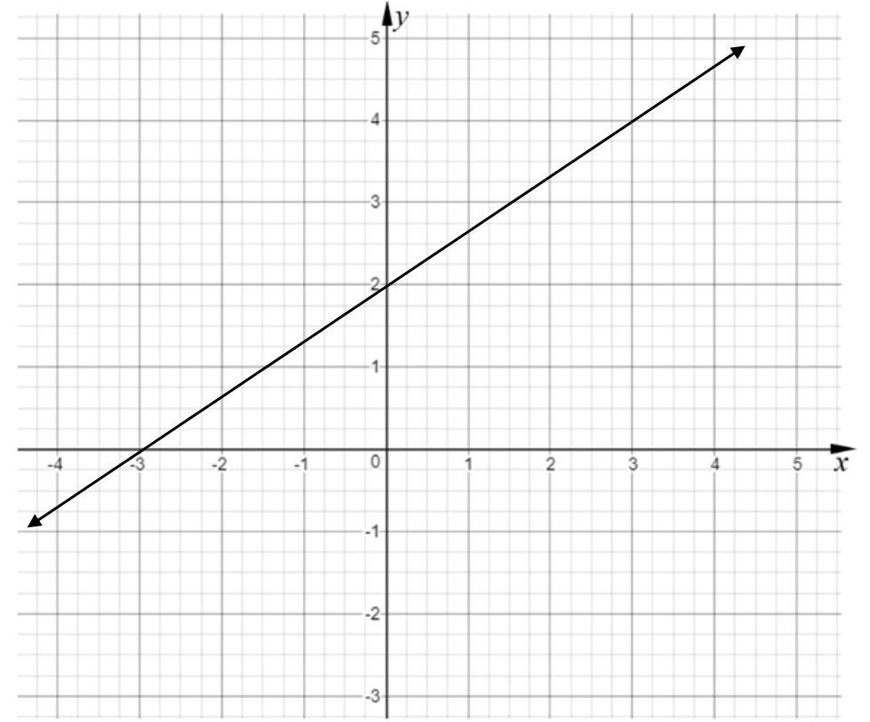

 | - Find the gradient.  ………………………………………………………………………………… | 1
 | - Find the $y$-intercept.  ………………………………………………………………………………… | 1
 | - Hence, find the equation of the line in gradient-intercept form.  ………………………………………………………………………………… | 1
 | Find the equation of the line that has gradient of $-2$and passes through the point $(2, 5)$.  ……………………………………………………………………………………………………………………………………………………………………………………………………………………………………………………………………………………………………………………………………………………………………………………………………………………………………………………………………………………………………………… | 2
 | The line joining the points $A\left(1,2\right)$ and $B\left(5,y\right)$ is parallel to the line  $y=3x+1.$ What is the value of $y$?  …………………………………………………………………………………………………………………………………………………………………………………………………………………………………………………………………………………………………………………………………………………………………………………………………………………………………………………………………………………………………………………………………………………………………………………………………………………………………………………………………………………….. | 2
A scene from the Minecraft movie featuring a Chicken Jockey chase goes viral online. Initially, the clip is viewed by 3000 people. The number of views increases by 70% every hour.

Using the exponential growth model $A=A_{0}{\left(1+r\right)}^{n}$, where:
$A$ is the amount
$A_{0}$ is the initial amount
$r$ is the percentage rate of increase
$n$ is time

 | - Determine the rule for the number of views, $V$, after $h$ hours.  ……………………………………………………………………………………………………………………………………………………………………………………………………………………………………………………… | 2
 | - Calculate the number of views the clip had after one day.  ……………………………………………………………………………………………………………………………………………………………………. | 1

End of Section I
Section II – Advanced (40 marks)
Attempt Questions 1 to 18
Allow approximately 50 minutes for this section

Multiple Choice Questions 1-5
ANSWER ON THE MULTIPLE CHOICE ANSWER SHEET

 | $2^{x+1}×2^{x-1}$ is equivalent to:
 | - $4$ | - $2^{2x}$
 | - $4^{2x}$ | - 1
 | Fully factorised, $x^{4}-13x^{2}+36$is:
 | - $(x^{2}-9)(x^{2}-4)$ | - ${\left(x-3\right)}^{2}(x^{2}+4)$
 | - $(x+3)(x-3)(x+2)(x-2)$ | - $x^{2}(x^{2}-13)+36$
 | The equation $ax^{2}+bx+c=0$ has exactly one solution when:
 | - $∆ =0$ | - $∆ <0$
 | - $∆ >0$ | - $∆ ≠0$
Which equation best describes the graph below?
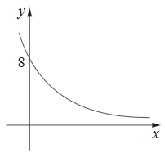
 | - $y=8×2^{x}$ | - $y=8×2^{-x}$
 | - $y=-8×2^{x}$ | - $y=-8×2^{-x}$
 | Which diagram best represents the graph of $y=2-{\left(x+1\right)}^{2}$?
 | 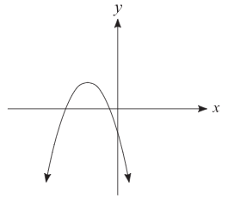 | 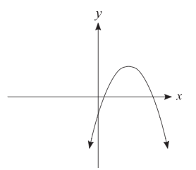
 | 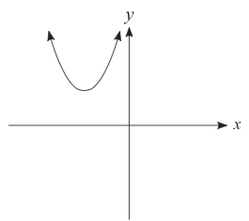 | 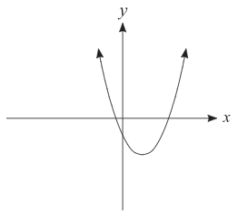

Short Answer Questions
Answer the questions in the spaces provided. Your responses should include relevant mathematical reasoning and/or calculations.
Marks CANNOT be awarded for poorly organised written work.

 | Simplify fully: $9\sqrt{48}+3\sqrt{27}$  ………………………………………………………………………………………………………………………………………………………………………………………………………………………………………………………………………………………………………………………………………… | 2
 | Show, by providing full working, that:  $\frac{\sqrt{12}}{\sqrt{6}-2}=3\sqrt{2}+2\sqrt{3}$  …………………………………………………………………………………………………………………………………………………………………………………………………………………………………………………………………………………………………………………………………………………………………………………………………………………………… | 2
 | Simplify the following, expressing your answer with positive indices:  $$\frac{2m^{-3}n^{4}}{{\left(5m\right)}^{2}}×\frac{10m}{3n^{-4}}$$  …………………………………………………………………………………………………………………………………………………………………………………………………………………………………………………………………………………………………………………………………………. | 2
 | Solve for $x$ given ${100}^{x-2}={1000}^{x}$  ……………………………………………………………………………………………………………………………………………………………………………………………………………………………………………………………………………………………………………………………………………………………………………………………………………………………..………………………………………………………………………………….. | 2
 | Solve for $x$:  $$\frac{2x-1}{3}-2=\frac{x+3}{4}$$  ……………………………………………………………………………………………………………………………………………………………………………………………………………………………………………………………………………………………………………………………………………………………………………………………………………………………………………………………………………………………………………….. | 2
 | Rearrange the formula ${\left(v+w\right)}^{2}+5={\left(v-t\right)}^{2}$ to make $v$ the subject.  ……………………………………………………………………………………………………………………………………………………………………………………………………………………………………………………………………………………………………………………………………………………………………………………………………………………………………………………………………….……………………………………… | 2
 | A triangular banner has a base of $20$ cm and height $h$ cm. The area must be at least $120 cm^{2}$ to be visible from a distance.  Write an inequality to represent this situation and solve it to find the smallest possible height the banner must have.  …………………………………………………………………………………………………………………………………………………………………………………………………………………………………………………………………………………………………………………………………………………………………………………………………………………………… | 2
 | Factorise and simplify:  $$\frac{x^{2}-9}{2x^{2}-2x-12} × \frac{6x+12}{-3x^{2}-9x}$$  ………………………………………………………………………………………………………………………………………………………………………………………………………………………………………………………………………………………………………………………………………………………………………………………………………………………………………………………………………………………………………………..…………………………………………………………………………………  ………………………………………………………………………………… | 2
 | Find the value of $a$, if the line perpendicular to $y=\left(\frac{a+1}{4}\right)x-3$ has a gradient of $\frac{2}{3}$.  …………………………………………………………………………………………………………………………………………………………………………………………………………………………………………………………………………………………………………………………………………………………………………………………………………………………… | 2
 | Solve $3x^{2}-7x+2=0$ by using the quadratic formula.  ………………………………………………………………………………………………………………………………………………………………………………………………………………………………………………………  ……………………………………………………………………………………………………………………………………………………………………  ……………………………………………………………………………………………………………………………………………………………………………………………………………………………………………………… | 2
 | Solve $2x^{2}-9x+9=0$ by first factorising.  …………………………………………………………………………………………………………………………………………………………………………………………………………………………………………………………………………………………………………………………………………………………………………………………………………………………… | 2
 | Sketch the graph of $y={\left(\frac{1}{2}\right)}^{x}$ on the number plane below, clearly showing all features.  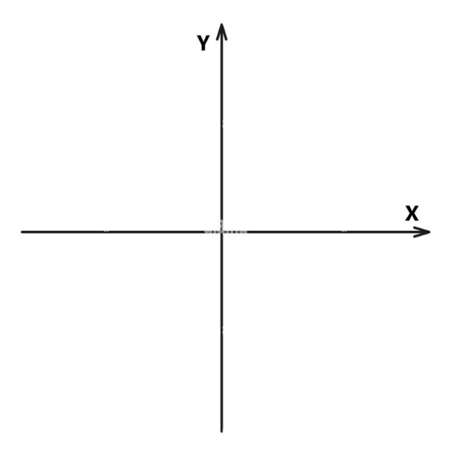 | 2
 | What is the equation of a circle with centre (0,0) and radius $\sqrt{3}$?  …………………………………………………………………………………………………………………………………………………………………… | 1
 | Sketch $y=\frac{1}{x-3}+1$ on the number plane below, by clearly showing all asymptotes and $x$ and $y$ intercepts.  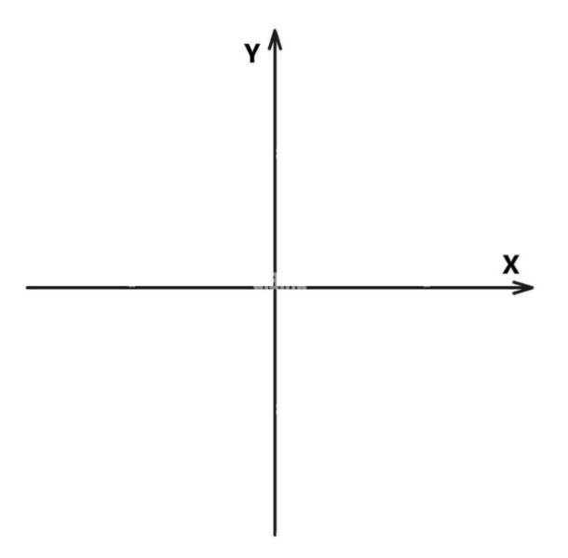 | 3
 | Consider the parabola $y=x^{2}-6x-4$  - By completing the square, determine the coordinates of the vertex.  ……………………………………………………………………………………………………………………………………………………………………………………………………………………………………………………………………………………………………………………………………………………………………………………………………………………………………………………………………………………………………………………………………………………………………………………………………………………………………………………………………………………. | 2
 | - Hence, sketch the parabola, showing clearly the coordinates of the vertex and the $x$ and $y$ intercepts. | 2
 | - Sketch the graph of the circle with equation ${\left(x-2\right)}^{2}+{\left(y-1\right)}^{2}=4$ on the Cartesian plane below.  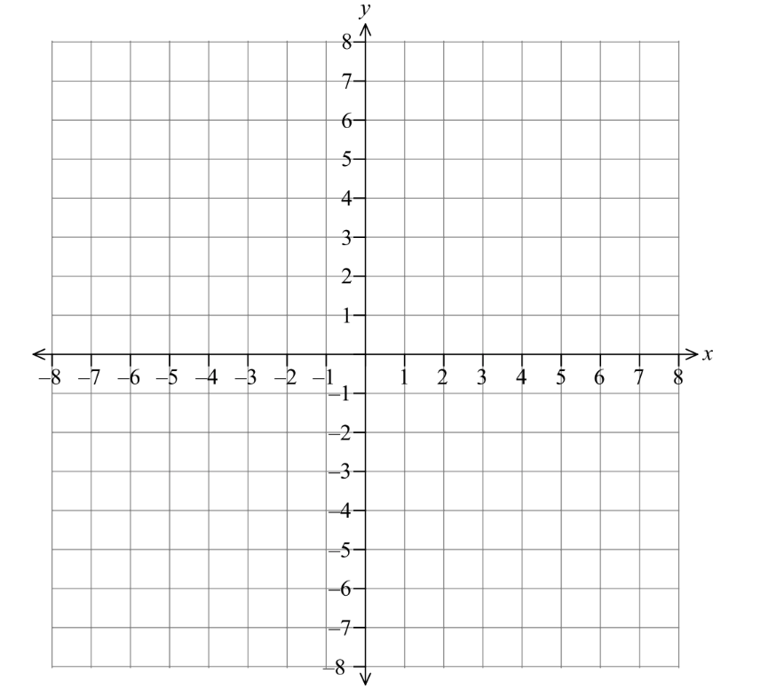 | 2
 | - If the circle above is translated 3 units left and 4 units up, what is the equation of the new circle?  ……………………………………………………………………………………………………………………………………………………………………………………………………………………………………………………… | 1

End of Exam

NAME: _____________________________________

Multiple Choice Answer Sheet for Mathematics Advanced

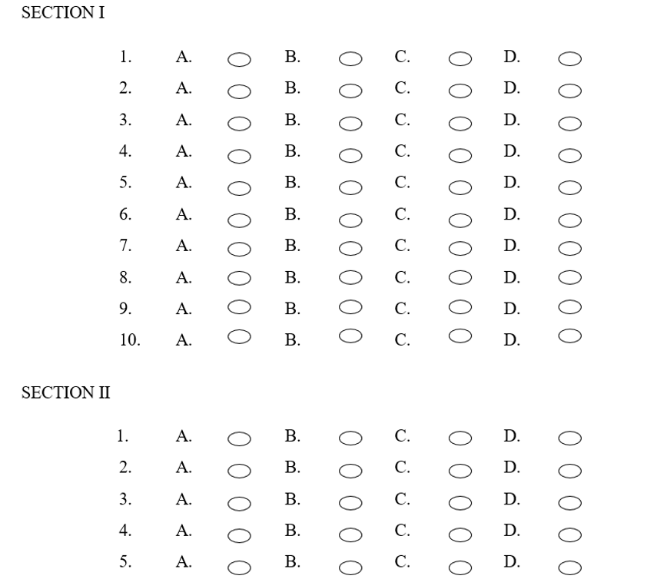

Norwest Christian School
Mathematics Formulas (Stage 5)

Indices
$$a^{m}×a^{n}=a^{m+n}$$
$$a^{m}÷a^{n}=a^{m-n}$$
$${\left(a^{m}\right)}^{n}=a^{m×n}$$
$$a^{-m}=\frac{1}{a^{m}}$$
$$a^{0}=1$$
$$a^{\frac{1}{m}}=\sqrt[m]{a}$$

Surds
$$\sqrt{a}×\sqrt{b}=\sqrt{a×b}$$
$$\sqrt{a}÷\sqrt{b}=\sqrt{\frac{a}{b}}$$

Equation of straight line Gradient
$y=mx+c$ $m=\frac{y_{2}-y_{1}}{x_{2}-x_{1}}$
$$y-y_{1}=m(x-x_{1})$$

Right angled triangle
$$a^{2}+b^{2}=c^{2}$$

Distance and Midpoint
$$d=\sqrt{{\left(x_{2}-x_{1}\right)}^{2}+{\left(y_{2}-y_{1}\right)}^{2}}$$
$M=\left(\frac{x_{1}+x_{2}}{2} , \frac{y_{1}+y_{2}}{2}\right)$
Quadratic Formula
$x=\frac{-b±\sqrt{b^{2}-4ac}}{2a}$

