

Student Name: ____________________________________

Year 10 MATHEMATICS Advanced 2024
TASK 2 – Half Yearly Examination

General Instructions  - Reading time – 10 minutes  - Working time – 90 minutes  - Show all necessary working / units  - Board approved calculators are allowed  - Exam guidelines  - Use black pen for your working  - Use a pencil and ruler for diagrams  - Marks may be lost for poorly organised written work. | Total Marks – 80  Standard – 40 marks  Suggested time: 40 mins  Advanced – 40 marks  Suggested time: 50 mins
Examiner’s use only T.Enviah, B. Vincent
 | Indices and Algebra | Equations and Formulas | Linear and non-linear relations | Total
Standard |  |  |  | /40
1-4,11-12 | /14
5-7,13-15 |  | /12
8-10,16-20 |  |  | /14
Advanced |  |  |  | /40
1-5,11-13 | /14
6-7,14-16 |  | /12
8-10,17-20 |  |  | /14
 |  |  |  | /80

Section 1 – Standard (40 marks)
Attempt Questions 1 to 20
Allow approximately 40 minutes for this section

Multiple Choice Questions 1 – 10

- Simplify $y^{3}+y^{3}+y^{3}$

  - $y^{9}$

  - $y^{27}$

  - $3y^{3}$

  - $3y^{9}$

- The value of if a = 4, b = −2 and c = −3 is:

  - 5

  - -11

  - -5

  - 11

- When the expression is factorised, it becomes:

- Which of the following statements is true?

  - $x^{2}\left(2-x\right)=2x^{2}-x^{3}$

  - $8xy-8=xy$

  - $(2x^{2})^{3}=6x^{5}$

  - $(3x)^{3}=3x^{3}$

- What is the solution to $4\left(x+3\right)=24$?

A. 17

B. 3

C. -3

D. 21

- The formula for converting a speed for k km/h to M metres per second (m/s) is 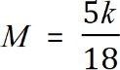 . A speed of 80 km/h is closest to which of the following speeds?
  - 22 m/s
  - 32 m/s
  - 35 m/s
  - 47 m/s

- What is the solution to $8-x<7$
  - $x<1$
  - $x>1$
  - $x>-1$
  - $x<-1$

- A line has equation 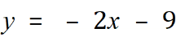 . Which statement is true?
  - The gradient is -2 and the y intercept is -9.
  - The gradient is -2 and the y intercept is 9.
  - The gradient is 2 and the y intercept is -9.
  - The gradient is 2 and the y intercept is 9.

- Line n has a gradient of -4.

Line p has a gradient of 4.

Line q has a gradient of $\frac{1}{4}$.

Which statement is true?

  - Line n is perpendicular to line q.
  - Line p is perpendicular to line q.
  - Line p is perpendicular to line n.
  - Line p is parallel to line n.

- Which is the graph of the line 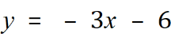 ?

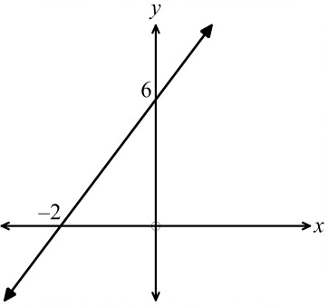  A. | 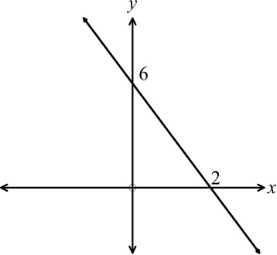  B.
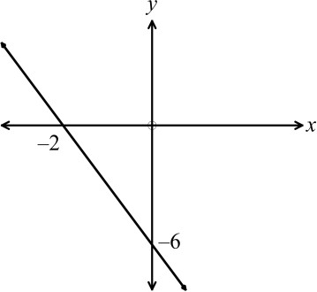  C. | 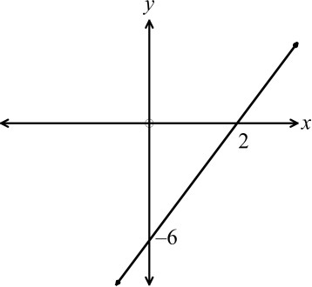  D.

Short Answer Questions
Answer the questions in the spaces provided. Your responses should include relevant mathematical reasoning and/or calculations.
Marks CANNOT be awarded for poorly organised written work.

11. Use index laws to simplify the following and express the solution with positive indices where required:
(i) $12y^{0}$ 1
………………………………………………………………………………………………….
(ii) $4ab^{9}×2a^{3}b^{-2}$ 1
………………………………………………………………………………………………….
………………………………………………………………………………………………….
(iii) $(5a^{3}b^{2})^{2}$ 1
…………………………………………………………………………………………………..
…………………………………………………………………………………………………..
(iv) $\frac{63x^{6}y^{5}}{9xy^{5}}$ 2
…………………………………………………………………………………………………
………………………………………………………………………………………………….
…………………………………………………………………………………………………..

12. Simplify the following:
(i) $4a\left(b+a\right)-a(b-4a)$ 2
…………………………………………………………………………………………………..
…………………………………………………………………………………………………..
………………………………………………………………………………………………….
………………………………………………………………………………………………….
(ii) $\frac{6m}{25}÷\frac{3m}{10}$ 2
…………………………………………………………………………………………………..
…………………………………………………………………………………………………..
…………………………………………………………………………………………………..
(iii) $\frac{2a}{5}+\frac{a}{3}$ 1
…………………………………………………………………………………………………..
…………………………………………………………………………………………………..
…………………………………………………………………………………………………..

13. Solve the following equations:
(i) 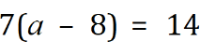 1
........................................................................................................................................................

……................................................................................................................................................
…………………………………………………………………………………………………

(ii) 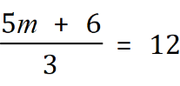 2

........................................................................................................................................................
........................................................................................................................................................

........................................................................................................................................................

………………………………………………………………………………………………………………………………….

(iii) 2

........................................................................................................................................................
.......................................................................................................................................................

........................................................................................................................................................
………………………………………………………………………………………………………………………………….

14. i) Solve the inequality $\frac{1-3x}{2}≤5$ 2
…………………………………………………………………………………………………
…………………………………………………………………………………………………..
…………………………………………………………………………………………………..
…………………………………………………………………………………………………..
…………………………………………………………………………………………………..

15. Using x for the unknown number, write down an equation and then solve it to find the number, given:

12 more than triple a number is equivalent to 3 less than double this number. 2

…………………………………………………………………………………………………

…………………………………………………………………………………………………..

………………………………………………………………………………………………….

………………………………………………………………………………………………….

16. In the diagram below, A is the point (–4, 1) and B is the point (0, 5).
- What is the gradient of line AB? 1
…………………………………………………………………………………………………..
…………………………………………………………………………………………………..
…………………………………………………………………………………………………..

- Find the y intercept of AB 1
…………………………………………………………………………………………………..
…………………………………………………………………………………………………..

- Determine the equation for line AB 1
…………………………………………………………………………………………………
………………………………………………………………………………………………….
………………………………………………………………………………………………….

17. For the rule $y=-\frac{4}{3}x+2$, use the y-intercept and the gradient to plot and then sketch the graph. 2
…………………………………………………………………………………………………
………………………………………………………………………………………………….
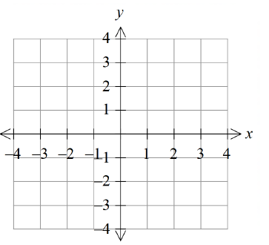
18. Solve the simultaneous equations using the substitution method. 2
$y=5x-13$
$2x+3y=12$
…………………………………………………………………………………………………
………………………………………………………………………………………………….
…………………………………………………………………………………………………..
…………………………………………………………………………………………………..
…………………………………………………………………………………………………..
…………………………………………………………………………………………………..
…………………………………………………………………………………………………..
…………………………………………………………………………………………………..
…………………………………………………………………………………………………..
19. Find the equation of a line that is parallel to the line $y=2x-3$ and passes through the point (1,3) 2
…………………………………………………………………………………………………
………………………………………………………………………………………………….
………………………………………………………………………………………………….
…………………………………………………………………………………………………..
………………………………………………………………………………………………….
…………………………………………………………………………………………………..
20. Determine the key features of the graph below, by completing the table. 2

 | Turning point (x,y) | Axis of symmetry | x-intercepts. | y-intercept
Graph A

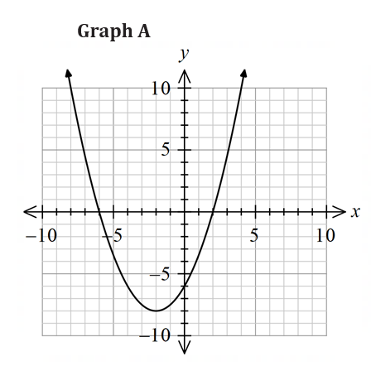

Section 2 – Advanced (40 marks)
Attempt Questions 1 to 18
Allow approximately 50 minutes for this section

Multiple Choice Questions 1 – 10

- The simplified form of $4a^{3}b^{2}×2b^{10}$ is:

- $8a^{3}b^{12}$

- $8a^{3}b^{9}$

- $40a^{3}b^{9}$

- $128a^{3}b^{12}$

- Factorise: 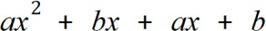

A.

B. 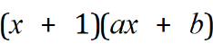
C. 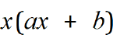
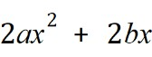
D.

- Fully factorised, 𝑥⁴ − 2𝑥² − 8 is:
  - (𝑥² + 2)(𝑥² − 4)
  - (𝑥 − 2)²(𝑥² + 2)
  - (𝑥 − 2)(𝑥 + 2)(𝑥² + 2)
  - (𝑥² + 2)(𝑥² − 2)

- $16m^{-8}÷4m^{2}=$

- $4m^{-10}$

- $4m^{-6}$

- $4m^{-4}$

- $4m^{6}$

- If $x=2at$, then $x^{2}-tx=$

- 0

- $2{at}^{2}$

- $2a^{2}t^{2}-2at^{2}$

- ${4a}^{2}t^{2}-2at^{2}$

- Solve the equation $4x-2\left(x-3\right)=14$

- $x=4$

- $x=5\frac{1}{2}$

- $x=8\frac{1}{2}$

- $x=10$

- How many solutions does the quadratic equation $2x^{2}-2x-3=0$ have?

- 0

- 1

- 2

- 3

- The line $2x+y=6$ cuts the x axis at the point given by

- (3, 0)

- (6, 0)

- (0, 3)

- (0, 6)

- A line perpendicular to $8x-2y-12=0$ is:

- $y=-\frac{1}{4}x$

- $y=4x+8$

- $y=-\frac{1}{4}$

- $y=\frac{1}{4}x+8$

- Which translations are required to change $y=x^{2}$ into $y=(x-3)^{2}+2$?

- left 3, up 2

- left 3, down 2

- right 3, down 2

- right 3, up 2

Short Answer Questions
Answer the questions in the spaces provided. Your responses should include relevant mathematical reasoning and/or calculations.
Marks CANNOT be awarded for poorly organised written work.

- Expand and simplify $(3\sqrt{2}+5)(3-\sqrt{2})$ 2

………………………………………………………………………………………………..

……………………………………………………………………………………………….

………………………………………………………………………………………………..

- Simplify
- $\frac{2x^{2}-18}{2x^{2}+3x-9}$ 2

………………………………………………………………………………………………..

………………………………………………………………………………………………..

………………………………………………………………………………………………..

………………………………………………………………………………………………..

………………………………………………………………………………………………..

……………………………………………………………………………………………….

………………………………………………………………………………………………..

………………………………………………………………………………………………

……………………………………………………………………………………………….

- $\frac{4-x^{2}}{x^{2}+x-6}÷\frac{x^{2}-x-12}{x^{2}+6x+9}$ 3

…………………………………………………………………………………………………..

…………………………………………………………………………………………………..

…………………………………………………………………………………………………..

…………………………………………………………………………………………………..

…………………………………………………………………………………………………..

………………………………………………………………………………………………….

…………………………………………………………………………………………………..

…………………………………………………………………………………………………..

…………………………………………………………………………………………………..

- Rationalise the denominator of $\frac{6}{3-\sqrt{5}}$ 2

…………………………………………………………………………………………………..

…………………………………………………………………………………………………..

…………………………………………………………………………………………………..

…………………………………………………………………………………………………..

…………………………………………………………………………………………………..

…………………………………………………………………………………………………..

…………………………………………………………………………………………………..

- Solve each of the following:

- $2x^{2}-7x+6=0$ 2

…………………………………………………………………………………………………..

…………………………………………………………………………………………………..

…………………………………………………………………………………………………..

- $3^{2x-1}=243$ 2

…………………………………………………………………………………………………..

…………………………………………………………………………………………………..

………………………………………………………………………………………………….

…………………………………………………………………………………………………..

…………………………………………………………………………………………………..

- $\frac{1}{x}+\frac{1}{x+1}=\frac{5}{6}$ 2

…………………………………………………………………………………………………..

…………………………………………………………………………………………………..

…………………………………………………………………………………………………..

…………………………………………………………………………………………………..

…………………………………………………………………………………………………..

…………………………………………………………………………………………………..

…………………………………………………………………………………………………..

…………………………………………………………………………………………………..

- Solve $(3x^{2}-2x)^{x^{2}-3x}=1$ 2
Hint: There are 4 solutions.

…………………………………………………………………………………………………..

…………………………………………………………………………………………………..

…………………………………………………………………………………………………..

…………………………………………………………………………………………………..

………………………………………………………………………………………………….

- Use the quadratic formula to solve $3x^{2}-2x-7=0.$ Give your answers correct to two decimal places. 2

………………………………………………………………………………………………..

………………………………………………………………………………………………..

………………………………………………………………………………………………..

………………………………………………………………………………………………

- Arjun discovers that he has a large collection of coins in his piggy bank. Of the 80 coins inside, some of them are 20-cent pieces, and some are 50-cent pieces.
The total value of these coins is $31.90. By forming a pair of simultaneous equations, calculate how many of each coin he has. 2

…………………………………………………………………………………………………..

…………………………………………………………………………………………………..

………………………………………………………………………………………………….

………………………………………………………………………………………………….

………………………………………………………………………………………………….

………………………………………………………………………………………………….

………………………………………………………………………………………………….
- Consider the parabola $y=2x^{2}-3x+8$

- By completing the square, Determine the coordinates of the vertex. 2

…………………………………………………………………………………………………..

…………………………………………………………………………………………………..

…………………………………………………………………………………………………..

…………………………………………………………………………………………………..

…………………………………………………………………………………………………..

………………………………………………………………………………………………….

- Sketch the parabola, showing all important points 2

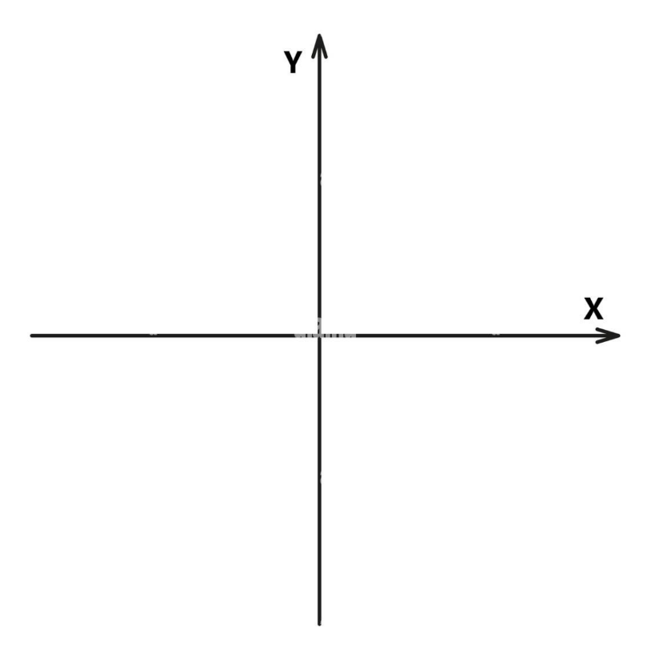

- A parabola has equation $y=mx^{2}-2mx$, where $m$ is a constant.

The line $y=mx-9$ meets the parabola at exactly one point.

Show that $m=4$ 3
…………………………………………………………………………………………………..

…………………………………………………………………………………………………..

…………………………………………………………………………………………………..

…………………………………………………………………………………………………..

…………………………………………………………………………………………………..

…………………………………………………………………………………………………..

………………………………………………………………………………………………….

…………………………………………………………………………………………………..

- State the equation of the quadratic function sketched below. 2
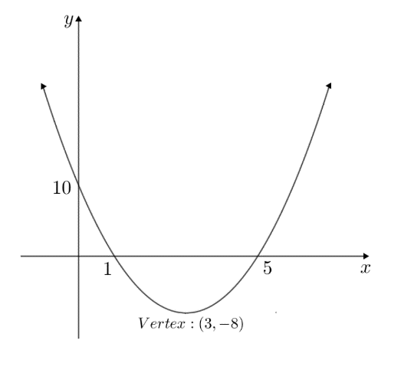

………………………………………………………………………………………………

………………………………………………………………………………………………

………………………………………………………………………………………………

………………………………………………………………………………………………

End of Exam

Student Name ____________________________

Year 10 Mathematics Advanced
Completely fill the response oval representing the most correct answer.

Standard section
1. A B C D | 6. A B C D
2. A B C D | 7. A B C D
3. A B C D | 8. A B C D
4. A B C D | 9. A B C D
5. A B C D | 10. A B C D

Advanced section
1. A B C D | 6. A B C D
2. A B C D | 7. A B C D
3. A B C D | 8. A B C D
4. A B C D | 9. A B C D
5. A B C D | 10. A B C D

Norwest Christian School
Mathematics Formulas (Stage 5)

Indices
$$a^{m}×a^{n}=a^{m+n}$$
$$a^{m}÷a^{n}=a^{m-n}$$
$${\left(a^{m}\right)}^{n}=a^{m×n}$$
$$a^{-m}=\frac{1}{a^{m}}$$
$$a^{0}=1$$
$$a^{\frac{1}{m}}=\sqrt[m]{a}$$

Surds
$$\sqrt{a}×\sqrt{b}=\sqrt{a×b}$$
$$\sqrt{a}÷\sqrt{b}=\sqrt{\frac{a}{b}}$$

Equation of straight line
$$y=mx+c$$
$$y-y_{1}=m(x-x_{1})$$

Right angled triangle
$$a^{2}+b^{2}=c^{2}$$

Distance and Midpoint
$$d=\sqrt{{\left(x_{2}-x_{1}\right)}^{2}+{\left(y_{2}-y_{1}\right)}^{2}}$$
$M=\left(\frac{x_{1}+x_{2}}{2} , \frac{y_{1}+y_{2}}{2}\right)$
Quadratic Formula
$x=\frac{-b±\sqrt{b^{2}-4ac}}{2a}$

