Student Name: ____________________________________



Year 10 MATHEMATICS 5.1/5.2 2022
TASK 1

General Instructions  - No reading time given  - Working time – 55 minutes  - Show all necessary working / units  - Board approved calculators are allowed  - Exam guidelines  - Use black pen for your working  - Use a pencil and ruler for diagrams  - Marks may be lost for poorly organised written work. | Total Marks – 40  Section 1 5.1 – 20 marks  Allow 25 mins  Section 2 5.2 – 20 marks  Allow 30 mins

Examiner’s use only B.Su, D.Luo, E.Shing
Question | Indices and Algebra | Equations | Total
Section 1 (5.1) |  |  | /20
1,2,5, 6-10 | /11
3,4, 11-13 |  | /9
Section 2 (5.2) |  |  | /20
1,2,5 | /3
3,4, 6-9 |  | /17
Total | /14 | /26 | /40

Section 1 – 5.1 (20 marks)
Attempt Questions 1 to 13
Allow approximately 25 minutes for this section

Multiple Choice Questions

1. The coefficient of $x$ in $4y+5x+7$ is:
A. 3 B. $-4$
C. 5 D. 7

2. Simplify $7a+3b-2a$
A. $2ab$ B. $8a+b$
C. $5a+3b$ D. $7a+3b$

3. If M = 5, the value of 4M – 3 is equal to:
A. 2 B. 5
C. 17 D. 20

4. The solution to $y-3=5$ is:
A. $15$ B. $8$
C. $5$ D. $2$

5. $3a^{2}×2a^{3}$ can be written as:
A. $6a$ B. $5a$
C. $a^{6}$ D. $6a^{5}$

Short Answer Questions
Answer the questions in the spaces provided. Your responses should include relevant mathematical reasoning and/or calculations.

Marks CANNOT be awarded for poorly organised written work.

6. Find the value of the following and correct to 3 significant figures.
$5.9×6.2$ (1 mark)

……………………………………………………………………………………………………..

……………………………………………………………………………………………………..

7. Write the number below in scientific notation correct to 3 significant figures. (2 marks)

2164000

……………………………………………………………………………………………………..
……………………………………………………………………………………………………..

8. Apply index laws to simplify the following algebraic expressions.

a. $x^{10}÷x^{4}$ (1 mark)
………………………………………………………………………………………………..

………………………………………………………………………………………………..

b. ${\left(x^{2}\right)}^{3}$ (1 mark)

………………………………………………………………………………………………..
………………………………………………………………………………………………..

9. Find the exact value of $x^{0}$. (1 mark)

……………………………………………………………………………………………………..

……………………………………………………………………………………………………..

10. Expand the following:

a. $3\left(x+1\right)$ (1 mark)

………………………………………………………………………………………………..

………………………………………………………………………………………………..

b. $5\left(2-y\right)$ (1 mark)

………………………………………………………………………………………………..
………………………………………………………………………………………………..

11. Find the answers of the following equations:

a. $\frac{5x}{2}=10$ (2 marks)

………………………………………………………………………………………………..

………………………………………………………………………………………………..

b. $5x-3=12$ (2 marks)

………………………………………………………………………………………………..
………………………………………………………………………………………………..

12. From the graph below, find the point of intersection of the 2 lines: (1 mark)
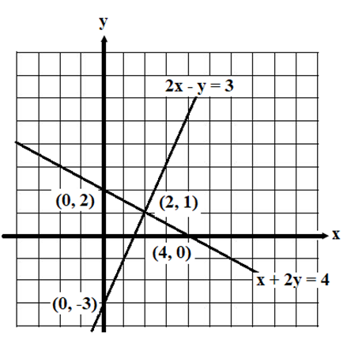
2$x-y=3 and$
$x+2y=4$

…………………………………………………..

…………………………………………………..

13. If $F=ma$and $m=$10 and $a=5, f$ind the value of $F:$ (2 marks)
…….………………………………………………………………………………………………..
…….………………………………………………………………………………………………..

…….………………………………………………………………………………………………..
…….………………………………………………………………………………………………..

Section 2 – 5.2 (20 marks)
Attempt Questions 1 to 10.
Allow approximately 25 minutes for this section

Multiple Choice Questions

1. Simplify $\frac{{14x}^{5}}{{2x}^{3}}$ :
A. $7x$ B. $7x^{2}$
C. $x^{14}$ D. $x^{2}$

2. $2×4^{-3}$ expressed with a positive index is:
A. $24$ B. ${12}^{3}$
C. $\frac{2}{4^{3}}$ D. $\frac{1}{{2×4}^{3}}$
3. If $2(x-5)=12$, $x$ is equal to:

A. $12$ B. 11
C. 10 D. $1$

4. If 4 is subtracted from $2x$, the result is 12, which of the following is correct?
A. $4+2x=12$ B. $4-x=12$
C. $x-4=12$ D. $2x-4=12$

5. ${\left(-a^{3}b^{2}\right)}^{3}$ is equivalent to:
A. $-a^{9}b^{6}$ B. $a^{9}b^{6}$
C. $-a^{6}b^{5}$ D. $a^{6}b^{5}$

Short Answer Questions
Answer the questions in the spaces provided. Your responses should include relevant mathematical reasoning and/or calculations.
Marks CANNOT be awarded for poorly organised written work.

6. Solve for $x$:
(a) $5x-29=11$ (2 marks)
………………………………………………………………………………………………..
………………………………………………………………………………………………..
………………………………………………………………………………………………..
………………………………………………………………………………………………..
(b) $\frac{5m+6}{3}=12$ (3 marks)
………………………………………………………………………………………………..
………………………………………………………………………………………………..
………………………………………………………………………………………………..
………………………………………………………………………………………………..
………………………………………………………………………………………………..

7. The cost (in dollars) of a taxi is $C=4+1.2d$, where $d$is the distance travelled in kilometres.

a. What is the cost of a 15 km trip? (1 mark)
………………………………………………………………….…………………………..

- How many kilometres can be travelled for $\$40?$ (2 marks)

………………………………………………………………………………………………..

………………………………………………………………………………………………..

………………………………………………………………………………………………..

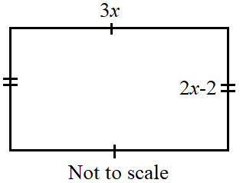
8. The dimensions of a rectangle room are measured in metres (m).

The length and the width of the room are 3x and 2x – 2.

a. If $P$ is the perimeter of the room, show that the simplified expression for $P$ is:
$$P=10x-4$$
.
(2 marks)

………………………………………………………………………………………………..

………………………………………………………………………………………………..

………………………………………………………………………………………………..

………………………………………………………………………………………………..

………………………………………………………………………………………………..

………………………………………………………………………………………………..

b. If P = 34 m, find the value of x in metre. (1 mark)

………………………………………………………………………………………………..

………………………………………………………………………………………………..

………………………………………………………………………………………………..

9. a. Fill in the tables below for the 2 equations. Then plot the two equations on the same
graph paper provided below. (3 marks)

$$y=-2x+6$$
$$x$$ | 0 | 1 | 2
$$y$$

$$y=3x+1$$

$$x$$ | 0 | 1 | 2
$$y$$
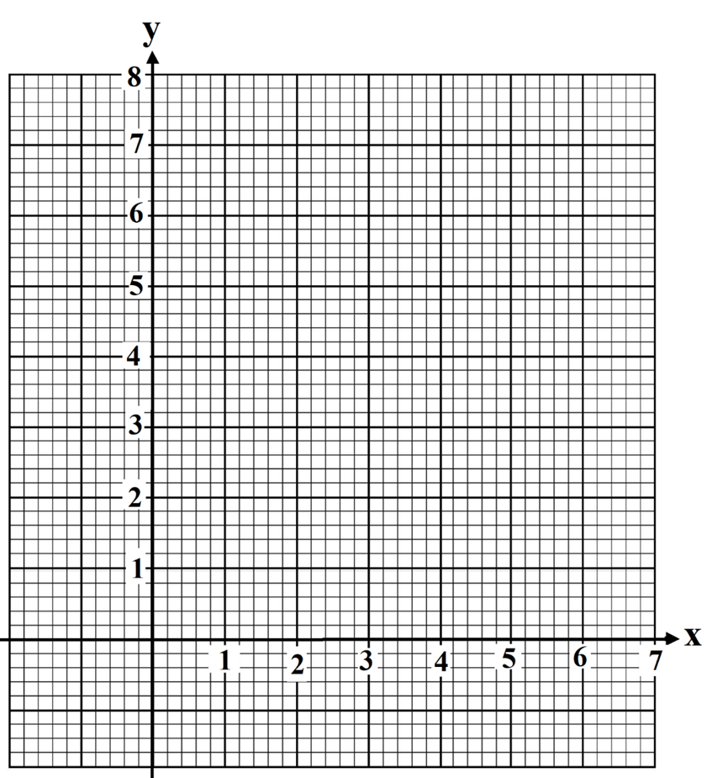

- From the graphs drawn in (a) above, find the solution to the simultaneous equations.
(1 mark)
………………………………………………………………………………………………..

………………………………………………………………………………………………..

End of task

