

Student Name: ____________________________________

Year 10 MATHEMATICS 5.1/5.2 2022
TASK 2 – Half Yearly Examination

General Instructions  - Reading time – 5 minutes  - Working time – 90 minutes  - Show all necessary working / units  - Board approved calculators are allowed  - Exam guidelines  - Use black pen for your working  - Use a pencil and ruler for diagrams  - Marks may be lost for poorly organised written work. | Total Marks – 80  Section 1 5.1 – 40 marks  Suggested time: 40 mins  Section 2 5.2 – 40 marks  Suggested time: 50 mins
Examiner’s use only B.Su, D.Luo, E.Shing
Question | Indices and Algebra | Equations and Formulas | Linear and non-linear relations | Right-angled triangles | Total
Section 1 (5.1) |  |  |  |  | /40
1-2,9-11 | /8
4-5,12-13,15 |  | /11
3,6,8,14,16-18 |  |  | /18
7,19 |  |  |  | /3
Section 2 (5.2) |  |  |  |  | /40
2-4,10,11 | /10
1,9,12 |  | /7
5-7,13-15,17 |  |  | /20
8,16 |  |  |  | /3
 |  |  |  |  | /80
Section 1 – 5.1 (40 marks)
Attempt Questions 1 to 19
Allow approximately 40 minutes for this section

Multiple Choice Questions

1. The coefficient of $y$ in $4x^{2}+5xy-6y+7$ is:
A. $-$6 B. $7$
C. $15$ D. 18

2. If $x=5$ and $y=1$, the value of $2x-y$is equal to:
A. 5 B. 7
C. 9 D. 10

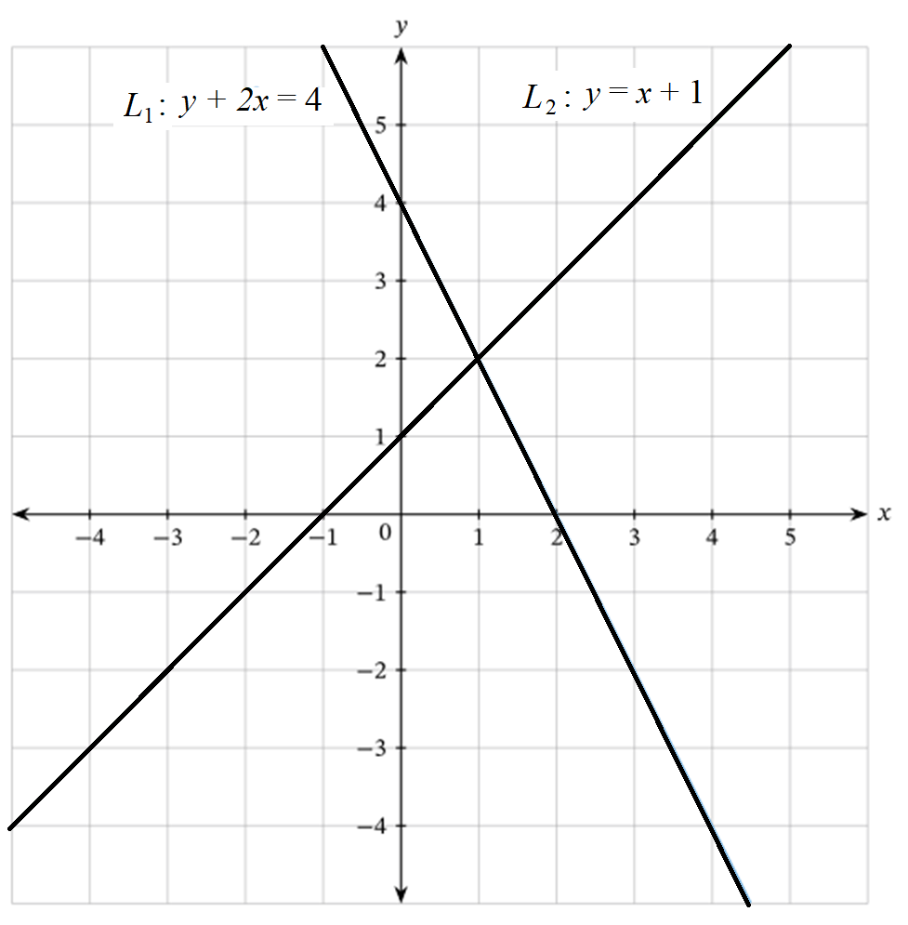
3. From the graph below, the solution to the simultaneous equations L₁ : $y+2x=4$ and
L₂: $y=x+1$ is:

A. $x=-1, y=0$
B. $x=0, y=4$
C. $x=1, y=2$
D. $x=2, y=0$

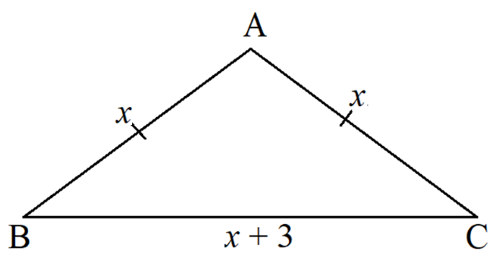
4. The perimeter of the triangle ABC is:
A. $x^{2}+x+3$
B. $x^{3}+3$
C. $2x^{2}+3$
D. $3x+3$

5. If $y-3=4$, $y$ is:
A. $-3$ B. $1$
C. $4$ D. $7$

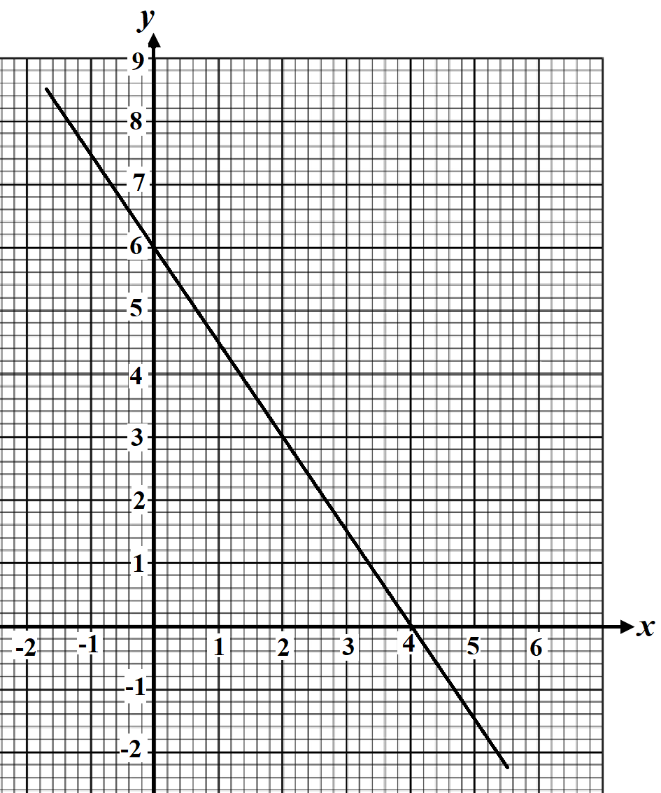
6. For the linear relationship below, the x-intercept of the graph is:
A. 6
B. 4
B. $2$
C. 0

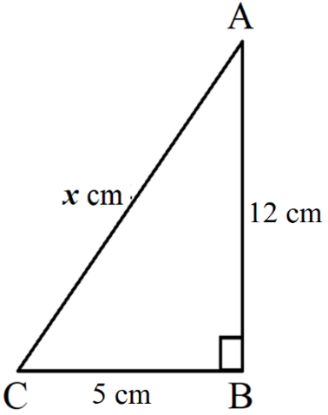
7. Using Pythagoras theorem, find the value of x in the right angled-triangle below:
A. 5
B. 12
C. 13
D. 17

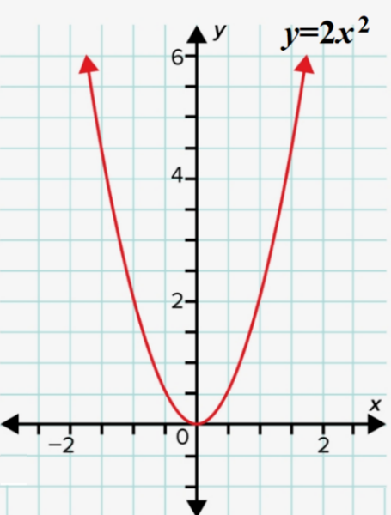
8. In the graph $y=2x^{2}$, when $x=3$, the value of $y$ is:
A. $6$
B. 1$2$
C. 14
D. 18

Short Answer Questions
Answer the questions in the spaces provided. Your responses should include relevant mathematical reasoning and/or calculations.

Marks CANNOT be awarded for poorly organised written work.

9. Find the simplest form of the expression $y+7x-3x+5y.$ (1 mark)

……………………………………………………………………………………………………..

……………………………………………………………………………………………………..

10. Rewrite the number below in scientific notation to 3 significant figures. (2 marks)
$475490$

……………………………………………………………………………………………………..

……………………………………………………………………………………………………..

11. Apply index laws to simplify the following expressions.

a. $x^{9}÷x^{2}$ (1 mark)
………………………………………………………………………………………………..

………………………………………………………………………………………………..

b. ${\left(y^{2}\right)}^{3}$ (1 mark)

………………………………………………………………………………………………..
………………………………………………………………………………………………..

c. ${2x}^{3}×x^{2}$ (1 mark)
………………………………………………………………………………………………..

………………………………………………………………………………………………..

………………………………………………………………………………………………..

12. Expand
a. 2 (3x + 5) (1 mark)

………………………………………………………………………………………………..
………………………………………………………………………………………………..

b. – 4 (y – 3) (1 mark)

………………………………………………………………………………………………..

………………………………………………………………………………………………..

13. Solve for the pronumerals in the following equations:

a. $x+5=8$ (1 mark)

………………………………………………………………………………………………..

………………………………………………………………………………………………..

b. $4-2x=0$ (2 mark)

………………………………………………………………………………………………..
………………………………………………………………………………………………..

………………………………………………………………………………………………..
………………………………………………………………………………………………..

………………………………………………………………………………………………..

c. $\frac{x-2}{3}=1$ (2 marks)

………………………………………………………………………………………………..
………………………………………………………………………………………………..

………………………………………………………………………………………………..
………………………………………………………………………………………………..

………………………………………………………………………………………………..

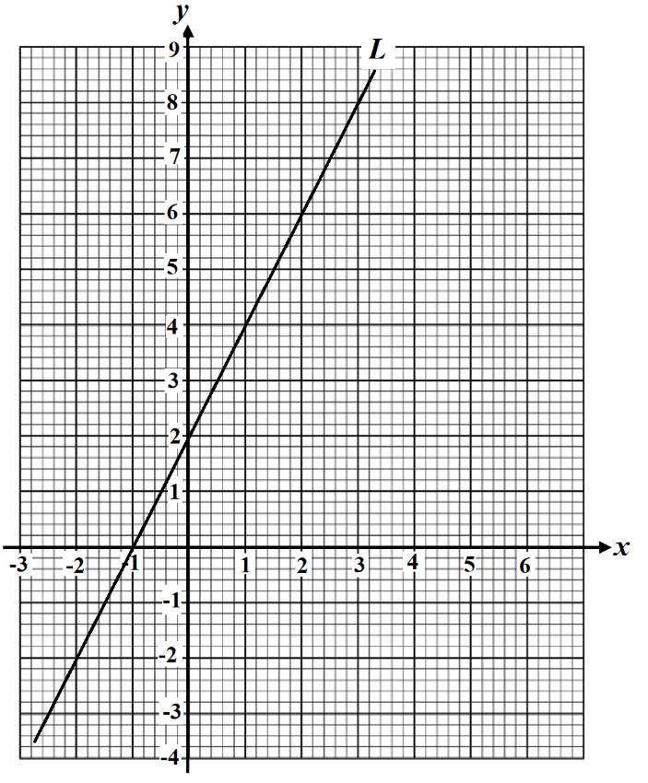
14. From the linear relationship as shown, find:
a. the y-intercept $(b)$ of L. (1 mark)
………………………………………
………………………………………
b. the gradient $(m)$ of L. (2 marks)
………………………………………
………………………………………
………………………………………
………………………………………
……………………………………………………………………………………………….. ………………………………………………………………………………………………..
c. the equation of L. (1 mark)
………………………………………………………………………………………………..
………………………………………………………………………………………………..

15. If $v=u+at$and $u=4$, $a=10, t=3, f$ind the value of $v:$ (2 marks)
…….………………………………………………………………………………………………..
…….………………………………………………………………………………………………..

…….………………………………………………………………………………………………..
…….………………………………………………………………………………………………..

16. The graph below shows a shopper’s short walk in a shopping mall.
a. What is the total distance the shopper travelled? (1 mark)
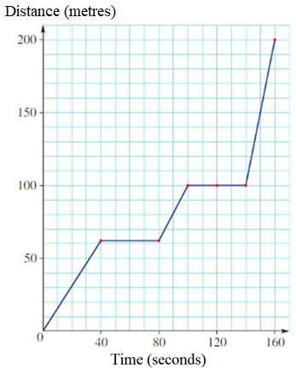
…………………………………………
…………………………………………

b. How long was the shopper not walking? (1 mark)

…………………………………………
.…………………………………………

c. What was the total distance the shopper travelled after
i. 20 seconds (1 mark)
………………………………………………………………………………………….
ii. 1.5 minutes (1 mark)
………………………………………………………………………………………….
………………………………………………………………………………………….
………………………………………………………………………………………….

17. The unknown y is directly proportional to x. When x equals 5, y is 15.

- Find the value of k and write the directly proportional equation. (2 marks)

………………………………………………………………………………………………….

………………………………………………………………………………………………….

………………………………………………………………………………………………….

………………………………………………………………………………………………….

………………………………………………………………………………………………….

- Find the value of y if x = 8. (1 mark)

………………………………………………………………………………………………….

………………………………………………………………………………………………….

………………………………………………………………………………………………….

- Find the value of x if y = 45. (1 mark)

………………………………………………………………………………………………….

………………………………………………………………………………………………….

………………………………………………………………………………………………….

18. John is paid A$25 per hour to work in a supermarket.
a. How much will John receive for 6 hours of work? (1 mark)
………………………………………………………………………………………………
………………………………………………………………………………………………..
b. If he received A$350 last week, how many hours did he work last week? (2 marks)
………………………………………………………………………………………………..
………………………………………………………………………………………………..
………………………………………………………………………………………………..
………………………………………………………………………………………………..

19, Peter bought a TV of 129 cm long and 80 cm high. Calculate the length of the diagonal of this TV, correct to 1 decimal point. (2 marks)
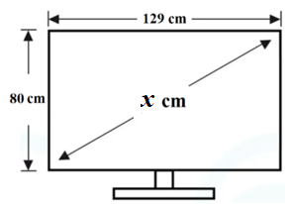
………………………………………………………
………………………………………………………
……………………………………………………….
………………………………………………………
………………………………………………………
………………………………………………………

Section 2 – 5.2 (40 marks)
Attempt Questions 1 to 17.
Allow approximately 50 minutes for this section

Multiple Choice Questions. Circle the correct answer on the question paper.

1. A number is decreased by 8 and then doubled. The result is equal to 24. This can be written as:
A. $2x-8=24$ B. $2\left(x-8\right)=24$
C. $x-8=2×24$ D. $x-8×2=24$

2. $2×{4a}^{3}$ is equal to:
A. ${24a}^{3}$ B. ${8a}^{3}$
C. ${64a}^{3}$ D. ${128a}^{3}$

3. ${\left(a^{2}b^{3}\right)}^{3}$ is equivalent to:
A. $a^{6}b^{9}$ B. $a^{5}b^{6}$
C. $a^{3}b^{9}$ D. $a^{2}b^{6}$

4. ${4x}^{0}+3$ is equal to:
A. $3$ B. $4$
C. $6$ D. $7$

5. Which ONE of the following lines is parallel to $y=2x+4$?
A. $y=-2x+4$
B. $y=\frac{1}{2}x+4$
C. $y=4x+2$
D. $y=2x-5$
6. The non-linear relationship, $y=x^{2}+2$ can be represented by
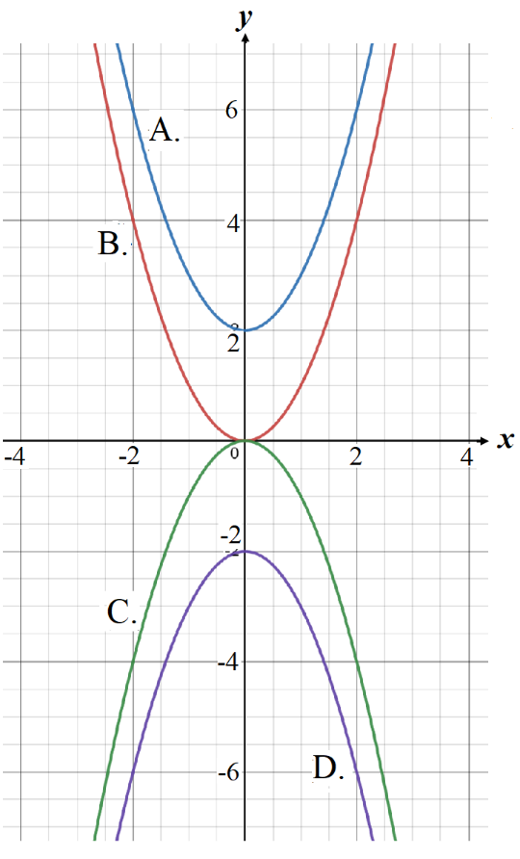

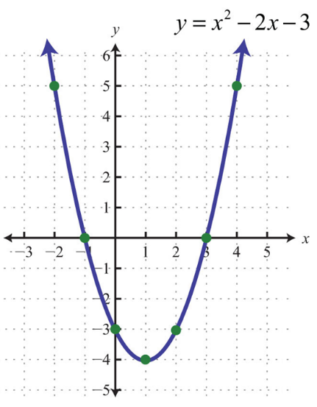
7. The turning point of the parabola below is:
A. $(-1, 0)$
B. $(0, -3)$
C. $(1, -4)$
D. $(3, 0)$

8. Which ONE of the following is a right-angled triangle? (All diagrams are not in scale.)
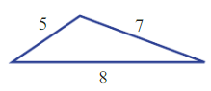
A.

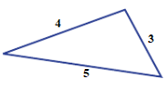
B.

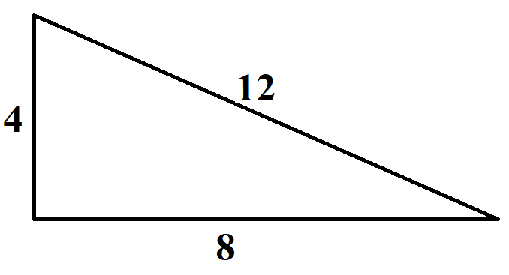
C.

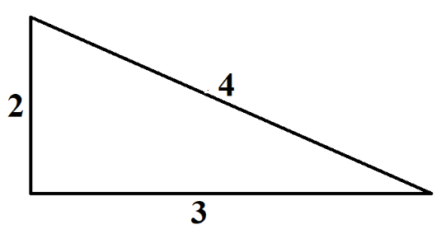
D.

Short Answer Questions
Answer the questions in the spaces provided. Your responses should include relevant mathematical reasoning and/or calculations.
Marks CANNOT be awarded for poorly organised written work.

9. Find $x$ in the following equations.
a. $3\left(x+1\right)=9$ (2 marks)
………………………………………………………………………………………………
………………………………………………………………………………………………
………………………………………………….……………………………………………

b. $\frac{x}{2}-1=4$ (2 marks)

………………………………………………………………………………………………..
……………………………………………………………………………………………….. ……………………………………………………………………………………………… ………………………………………………….……………………………………………
10. Expand and simplify:
a. $5+4(x-2)$ (1 mark)
………………………………………………………………………………………………..
………………………………………………………………………………………………..
………………………………………………………………………………………………..
………………………………………………………………………………………………..

b. $3\left(2x+y\right)-2x$ (2 marks)
………………………………………………………………………………………………..
………………………………………………………………………………………………..
………………………………………………………………………………………………..
………………………………………………………………………………………………..
11. Using index laws to simplify the following:
a. $3x^{2}×({2x)}^{3}$ (2 marks)
………………………………………………………………………………………………..
………………………………………………………………………………………………..
………………………………………………………………………………………………..

b. ${(x-4x)}^{0}+2×7^{0}$ (2 marks)
………………………………………………………………………………………………..
………………………………………………………………………………………………..
………………………………………………………………………………………………..

12. If $S=ut+\frac{1}{2}at^{2}$, if $u=2$, $a=10$ and $t=3$, find the value of $S$. (2 mark)
……………………………………………………………………………………………………
…………………………………………………………………………………………………….
…………………………………………………………………………………………………….
…………………………………………………………………………………………………….
…………………………………………………………………………………………………….
…………………………………………………………………………………………………….
…………………………………………………………………………………………………….

13. Solve the following simultaneous equations using suitable methods.

- $x=y$ (2 marks)
$3y=x+4$
…………………………………………………………………………………………………

…………………………………………………………………………………………………

…………………………………………………………………………………………………

…………………………………………………………………………………………………

…………………………………………………………………………………………………

…………………………………………………………………………………………………

…………………………………………………………………………………………………

…………………………………………………………………………………………………

- $x+y=11$ (2 marks)
$x-y=5$
…………………………………………………………………………………………………

…………………………………………………………………………………………………

…………………………………………………………………………………………………

…………………………………………………………………………………………………

…………………………………………………………………………………………………

…………………………………………………………………………………………………

…………………………………………………………………………………………………

…………………………………………………………………………………………………

…………………………………………………………………………………………………

…………………………………………………………………………………………………

…………………………………………………………………………………………………

14. a. Fill in the tables below for the given equation and then plot the graph of this equation on number plane below. (2 marks)
$$L_{1} : y=2x+6$$
$$x$$ | -2 | -1 | 0 | 1
$$y$$

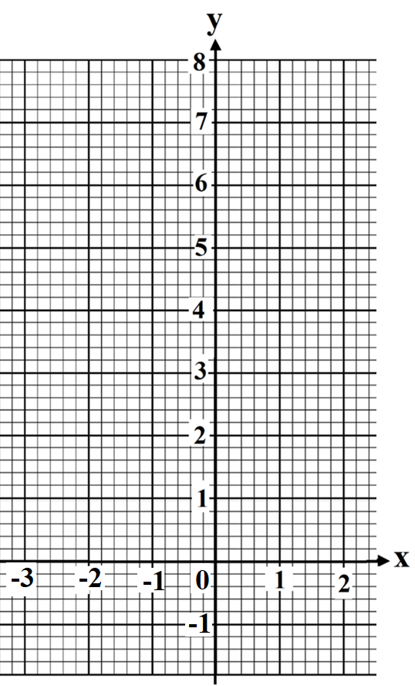

- On the number plane above, draw a line L₂ which is parallel to L₁ and with y-intercept equals 3. (1 mark)

- Find the equation of L₂. (1 mark)

………………………………………………………………………………………………..

………………………………………………………………………………………………..

15. a. Fill in the tables for the given equation below and then plot the graph of this equation on number plane below. (2 marks)
$$y=x^{2}-4x+3$$
$$x$$ | -1 | 0 | 1 | 2 | 3 | 4 | 5
$$y$$

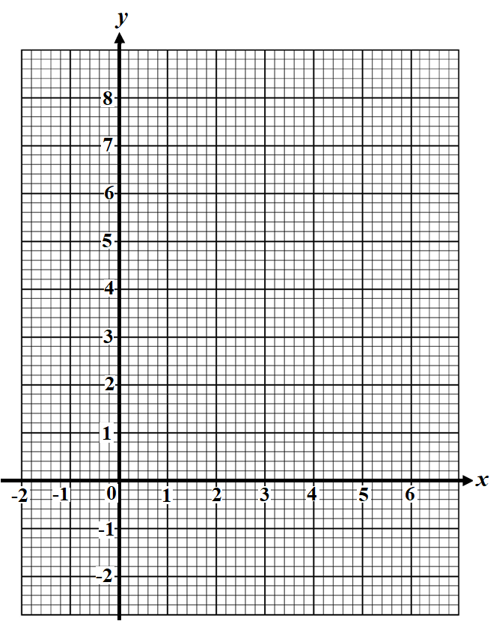

- From the number plane above, find
- The y-intercept. (1 mark)
……….…………………………………………….…………………………….
- The axis of symmetry. (1 mark)

…………………………………………………………………………………….

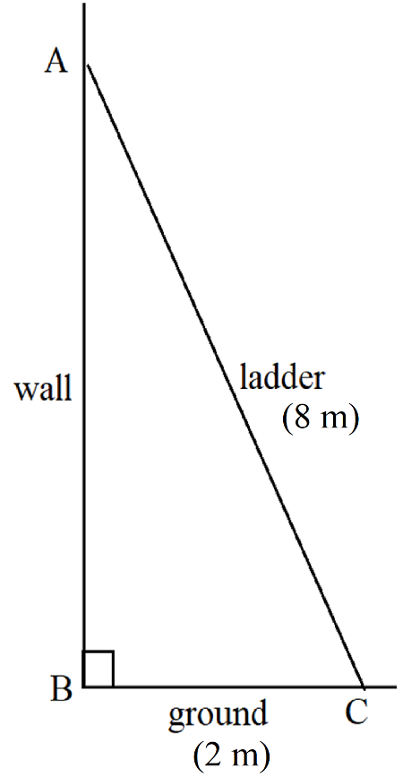
16. A 8 m ladder leans against a vertical wall. If the base of the ladder is 2 m from the wall, determine how high the ladder is up the wall, correct to 2 decimal ponits. (2 marks)

………………………………………………………………….

………………………………………………………………….

………………………………………………………………….

………………………………………………………………….

………………………………………………………………….

………………………………………………………………….

………………………………………………………………….

………………………………………………………………….

………………………………………………………………….

………………………………………………………………….

………………………………………………………………….

………………………………………………………………….

17. Peter delivers pizza for a fast-food restaurant. He is paid $25 a shift plus $3 per delivery.

- Complete the table of values below. (1 mark)
No. of deliveries (d) | 0 | 5 | 10 | 15 | 20
Wages (W)

- Plot a graph of Peter’s wages (W) against number of deliveries (d). (1 mark)

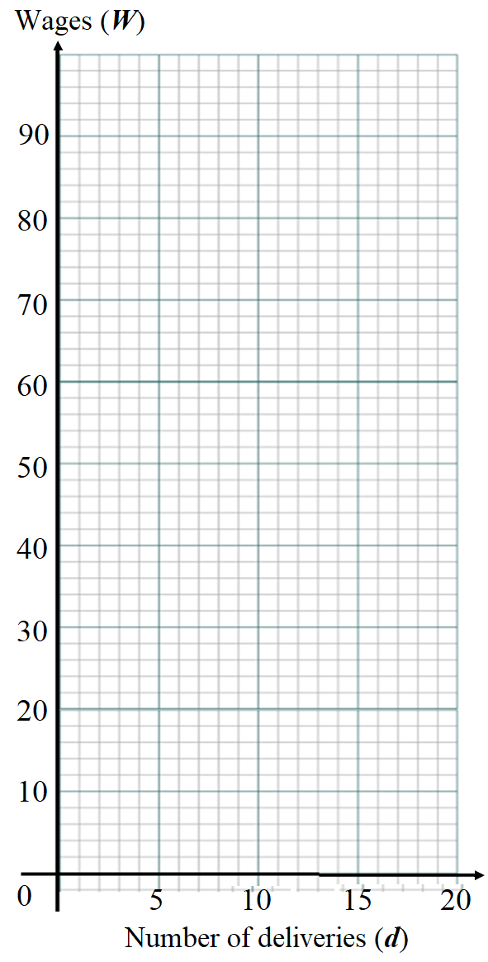

- Find the linear relationship between his wages (W) and the number of deliveries (d).
(1 mark)
………………………………………………………………………………………………...

………………………………………………………………………………………………...

………………………………………………………………………………………………...

- Use the graph to determine: (2 marks)

- Peter’s wages for 8 deliveries. (1 mark)

…………………………………………………………………………………………

………………………………………………………………………………………….

………………………………………………………………………………………….

- The minimum number of deliveries made if Peter wants to earn more than $60.
(1 mark)

…………………………………………………………………………………………

………………………………………………………………………………………….

………………………………………………………………………………………….

End of Exam

Norwest Christian School
Mathematics Formulas (Stage 5)

Indices
$$a^{m}×a^{n}=a^{m+n}$$
$$a^{m}÷a^{n}=a^{m-n}$$
$${\left(a^{m}\right)}^{n}=a^{m×n}$$
$$a^{-m}=\frac{1}{a^{m}}$$
$$a^{0}=1$$
$$a^{\frac{1}{m}}=\sqrt[m]{a}$$

Surds
$$\sqrt{a}×\sqrt{b}=\sqrt{a×b}$$
$$\sqrt{a}÷\sqrt{b}=\sqrt{\frac{a}{b}}$$

Equation of straight line
$$y=mx+c$$
$$y-y_{1}=m(x-x_{1})$$

Right angled triangle
$$a^{2}+b^{2}=c^{2}$$

Distance and Midpoint
$$d=\sqrt{{\left(x_{2}-x_{1}\right)}^{2}+{\left(y_{2}-y_{1}\right)}^{2}}$$

$$M=\left(\frac{x_{1}+x_{2}}{2} , \frac{y_{1}+y_{2}}{2}\right)$$

