

Student Name: ____________________________________

Year 10 MATHEMATICS 5.1/5.2 2023
TASK 2 – Half Yearly Examination

General Instructions  - Reading time – 5 minutes  - Working time – 90 minutes  - Show all necessary working / units  - Board approved calculators are allowed  - Exam guidelines  - Use black pen for your working  - Use a pencil and ruler for diagrams  - Marks may be lost for poorly organised written work. | Total Marks – 80  Section 1 5.1 – 40 marks  Suggested time: 40 mins  Section 2 5.2 – 40 marks  Suggested time: 50 mins
Examiner’s use only D.Hua, V.Chan, B.Su, B. Vincent, J. Barter
Question | Indices and Algebra | Equations and Formulas | Linear and non-linear relations | Total
Section 1 (5.1) |  |  |  | /40
1-4,11-14 | /11
5-7,15 |  | /10
8-10,16-19 |  |  | /19
Section 2 (5.2) |  |  |  | /40
1-3,13-15 | /12
7-8,11-12 |  | /12
4-6,9-10,16-18 |  |  | /16
 |  |  |  | /80

Section 1 – 5.1 (40 marks)
Attempt Questions 1 to 19
Allow approximately 40 minutes for this section

Multiple Choice Questions 1-10

1. | Which expression cannot be simplified?
 | A. $7x+5y$ | B. $7x×5y$
 | C. $3x-9x$ | D. $3x÷9x$
2. | If $x=3$ and $y=1$, the value of $5x-y$ is equal to:
 | A. $10$ | B. $7$
 | C. $52$ | D. 14
3. | $2^{3}×2^{5}$ simplifies to:
 | A. $2^{2}$
 | B. $2^{8}$
 | C. $2^{15}$
 | D. $4^{8}$
4. | $7m^{0}$ simplifies to:
 | A. $7$
 | B. $7m$
 | C. $1$
 | D. $m$
5. | If $y-14=8$, $y$ is?
 | A. $-6$ |  | B. $6$
 | C. 22 |  | D. $-22$
6. | $S=2πr(r+h)$ is the formula for the surface area of a cylinder with radius $r$ and height $h$. What is the surface area of a cylinder with radius 5.5cm and height 12cm?
 | A. $604.76cm^{2}$ |  | B. $603.76cm^{2}$
 | C. $186.23cm^{2}$ |  | D. $187.23cm^{2}$
7. | What is the inequality shown on the number line below?  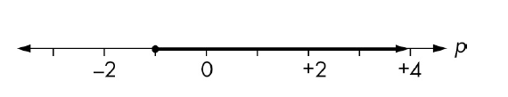
 | A. $p>-1$ |  | B. $p≥-1$
 | C. $p<-1$ |  | D. $p≤-1$
8. | A coordinate that does NOT lie on the line $y=-3x$ is:
 | A. $(2,-6)$ |  | B. $(1, -3)$
 | C. $(0, 0)$ |  | D. $(-9, 3)$
9. | The midpoint of the line interval AB is:  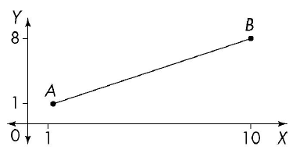
 | A. $(5.5,4.5)$ |  | B. $(4.5, 3.5)$
 | C. $(4.5, 5.5)$ |  | D. $(5.5, 3.5)$
10. | Which of the following equations would produce a parabolic graph?
 | A. $y=3x^{3}$
 | B. $y=10x^{2}$
 | C. $y=5x-2$
 | D. $y=2^{x}$
Short Answer Questions 11-19
Answer the questions in the spaces provided. Your responses should include relevant mathematical reasoning and/or calculations.

Marks CANNOT be awarded for poorly organised written work.

11. Find the simplest form of the expression $2m-3n-5m+n.$ (1 mark)
……………………………………………………………………………………………………..

……………………………………………………………………………………………………..

12. Expand and simplify $6\left(2x-1\right)-3x$ (2 marks)
……………………………………………………………………………………………………..

……………………………………………………………………………………………………..
……………………………………………………………………………………………………..

13. Write the following numbers in scientific notation:
a. 901 200 (1 mark)

………………………………………………………………………………………………..
………………………………………………………………………………………………..

b. 0.00304 (1 mark)

………………………………………………………………………………………………..

………………………………………………………………………………………………..

14. Apply the index laws to simplify the following expressions

a. $2p^{2}×5p^{4}$ (1 mark)
………………………………………………………………………………………………..

………………………………………………………………………………………………..

b. $10d^{6}÷30d^{2}$ (1 mark)

………………………………………………………………………………………………..
………………………………………………………………………………………………..

15. Solve for the pronumerals in the following equations:

a. $w+2=10$ (1 mark)

………………………………………………………………………………………………..

………………………………………………………………………………………………..

b. $7x-3=-24$ (2 marks)

………………………………………………………………………………………………..
………………………………………………………………………………………………..

………………………………………………………………………………………………..
………………………………………………………………………………………………..

………………………………………………………………………………………………..

c. $\frac{x}{3}-1=11$ (2 marks)

………………………………………………………………………………………………..
………………………………………………………………………………………………..

………………………………………………………………………………………………..
………………………………………………………………………………………………..

………………………………………………………………………………………………..
d. $4(a-2)=12$ (2 marks)

………………………………………………………………………………………………..
………………………………………………………………………………………………..

………………………………………………………………………………………………..
………………………………………………………………………………………………..

………………………………………………………………………………………………..

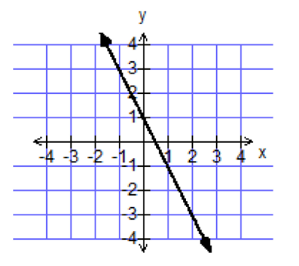
16. From the linear relationship as shown, find:
a. the y-intercept $(c)$ (1 mark)
………………………………………
………………………………………
b. the gradient $(m)$ (2 marks)
………………………………………
………………………………………
………………………………………
……………………………………………………………………………………………….
……………………………………………………………………………………………….. ………………………………………………………………………………………………..
c. the equation of the straight line using $y=mx+c$ (1 mark)
………………………………………………………………………………………………..
………………………………………………………………………………………………..

17. Joseph travelled from his home to his friend’s house 15km away. Joseph stayed for some time then returns home. The distance-time graph is below.
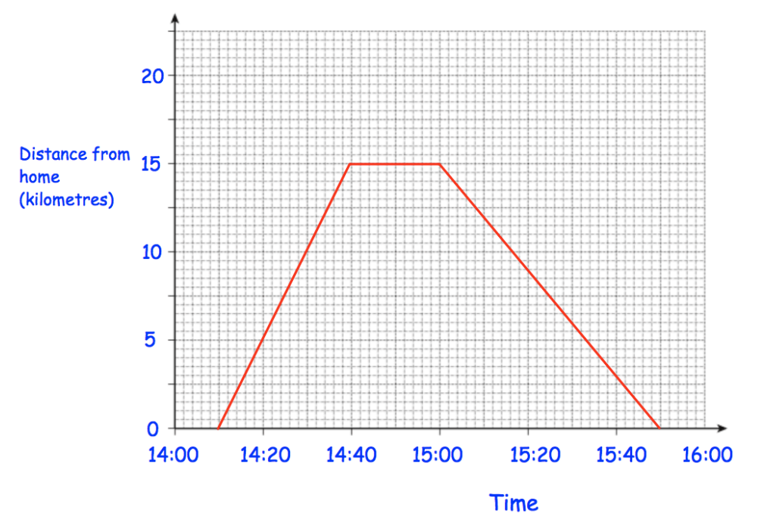
a. How far was Joseph from home at 14:30? (1 mark)

……………………………………………………………………………………………….
b. How long did Joseph stay at his friend’s house? (1 mark)

………………………………………….…………………………………………………….
c. How far did Joseph travel in total? (1 mark)
………………………………………….…………………………………………………….
d. Was Joseph’s speed faster getting to his friend’s house or going home? (2 marks)
Give a reason for your conclusion.
………………………………………….…………………………………………………….
………………………………………….…………………………………………………….
………………………………………….…………………………………………………….
18. Dominic works for a pizza shop and each day earns a base pay of $64 plus $4 for each pizza he delivers.

- If Dominic delivers 19 pizzas on Tuesday, how much did he earn? (1 mark)

………………………………………………………………………………………………….

………………………………………………………………………………………………….

- How many pizzas does Dominic need to deliver to earn $236 in a day? (2 marks)

………………………………………………………………………………………………….

………………………………………………………………………………………………….

………………………………………………………………………………………………….
19. A lawn mowing company earns $45 for every lawn they mow.
a. Fill out the table below. (1 mark)
Number of lawns mowed (n) | 1 | 3 | 5 | 7 | 9
Earnings (E) | $45

b. Label the axes below then plot a graph of the values from part a. (2 marks)
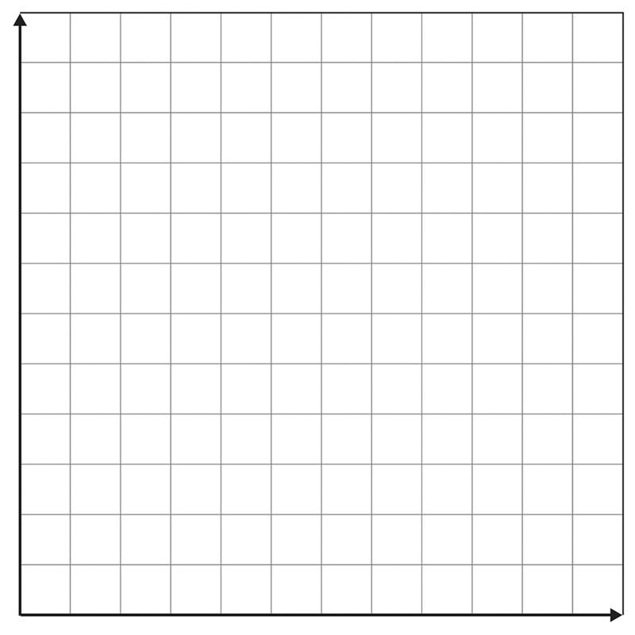
- Determine how many lawns must be mowed to earn $270. (1 mark)
………………………………………………………………………………………………….
………………………………………………………………………………………………….

Section 2 – 5.2 (40 marks)
Attempt Questions 1 to 18
Allow approximately 50 minutes for this section

Multiple Choice Questions 1-10

1. | The expanded form of $5a(4a+3)$ is:
 | A. $20a^{2}+3$ | B. $20a+15$
 | C. $9a^{2}+8a$ | D. $20a^{2}+15a$
2. | When simplified, $x^{3}y^{6}×xy^{7}$ is:
 | A. $x^{3}y^{42}$ | B. $x^{3}y$
 | C. $x^{4}y^{13}$ | D. $x^{4}y^{14}$
3. | ${\left(5a^{3}b^{2}\right)}^{2}$ simplifies to:
 | A. $10a^{6}b^{4}$
 | B. $25a^{6}b^{4}$
 | C. $10a^{5}b^{4}$
 | D. $25a^{5}b^{4}$
4. | The gradient of a line parallel to $y=10x+5$ is:
 | A. $0.5$
 | B. $2$
 | C. $10$
 | D. $5$
5. | On which of the following lines does the point $(4, -10)$ lie?
 | A. $y=2x+5$ |  | B. $y=3x-2$
 | C. $y=5-2x$ |  | D. $y=2-3x$
6. | The gradient of the line joining the points $(1, 2)$ and $(3, 6)$ is:
 | A. $-2$ |  | B. $2$
 | C. $3$ |  | D. $-3$
7. | $x≤2$ is a solution to the inequality:
 | A. $x-2<0$ |  | B. $2x+3≥7$
 | C. $-4x≥-8$ |  | D. $x-10>12$
8. | When 3 less than 4 lots of a number is doubled, the result is 12. This translates to which equation?
 | A. $6x-4=12$ |  | B. $2\left(4x-3\right)=12$
 | C. $2\left(3x-4\right)=12$ |  | D. $2x=12$
9. | When the expression $(x+2)(x-5)$ is expanded, the result will be:
 | A. $x^{2}-3x+10$ |  | B. $x^{2}-3x-10$
 | C. $x^{2}+3x-10$ |  | D. $x^{2}+3x+10$
10. | The graph of $y=-x^{2}+3$ will be:
 | A. a straight line
 | B. a concave up parabola
 | C. an exponential curve
 | D. a concave down parabola

Short Answer Questions 11-18
Answer the questions in the spaces provided. Your responses should include relevant mathematical reasoning and/or calculations.
Marks CANNOT be awarded for poorly organised written work.

11. Solve for $x$ in the following equations.
a. $5x=2x+12$ (2 marks)
………………………………………………………………………………………………
………………………………………………………………………………………………
………………………………………………….……………………………………………

b. $\frac{x}{3}-12=4$ (2 marks)

………………………………………………………………………………………………..
……………………………………………………………………………………………….. ……………………………………………………………………………………………… ………………………………………………….……………………………………………

………………………………………………….……………………………………………

c. $3\left(2x+4\right)-4\left(x+2\right)=6$ (3 marks)

………………………………………………………………………………………………..
……………………………………………………………………………………………….. ……………………………………………………………………………………………… ………………………………………………….……………………………………………
………………………………………………….……………………………………………
………………………………………………….……………………………………………

12. Solve the simultaneous equations $4x+3y=-1$ and $y=2x-7$ (3 marks) by using the method of substitution.
………………………………………………………………………………………………..
………………………………………………………………………………………………..
………………………………………………………………………………………………..
………………………………………………………………………………………………..
………………………………………………………………………………………………..
………………………………………………………………………………………………..
………………………………………………………………………………………………..
13. Use index laws to simplify the following and express the solution with positive indices where required:
a. $3x^{2}×{\left(2x\right)}^{3}$ (2 marks)
………………………………………………………………………………………………..
………………………………………………………………………………………………..
………………………………………………………………………………………………..

b. $6p^{4}q÷2pq^{3}$ (2 marks)
………………………………………………………………………………………………..
………………………………………………………………………………………………..
………………………………………………………………………………………………..

14. Simplify $\frac{x}{2}+\frac{x}{3}$ (2 marks)
……………………………………………………………………………………………………
…………………………………………………………………………………………………….
…………………………………………………………………………………………………….
…………………………………………………………………………………………………….
…………………………………………………………………………………………………….
……………………………………………………………………………………………………

15. An initial investment of $5 000grows every year according to the formula
$A=5 000 {\left(1.01\right)}^{n}$ where A is the value of the investment after n years. Find the value of the investment after 8 years, giving the answer in scientific notation rounded to 2 significant figures.
(3 marks)

…………………………………………………………………………………………………

…………………………………………………………………………………………………

…………………………………………………………………………………………………

…………………………………………………………………………………………………

…………………………………………………………………………………………………

16. For the equation $3x+5y=15:$

- Calculate the$x$ and$y$ intercepts. (2 marks)

………………………………………………………………………………………………..

………………………………………………………………………………………………..

………………………………………………………………………………………………..

………………………………………………………………………………………………..

- Hence or otherwise, sketch$3x+5y=15.$ (1 mark)
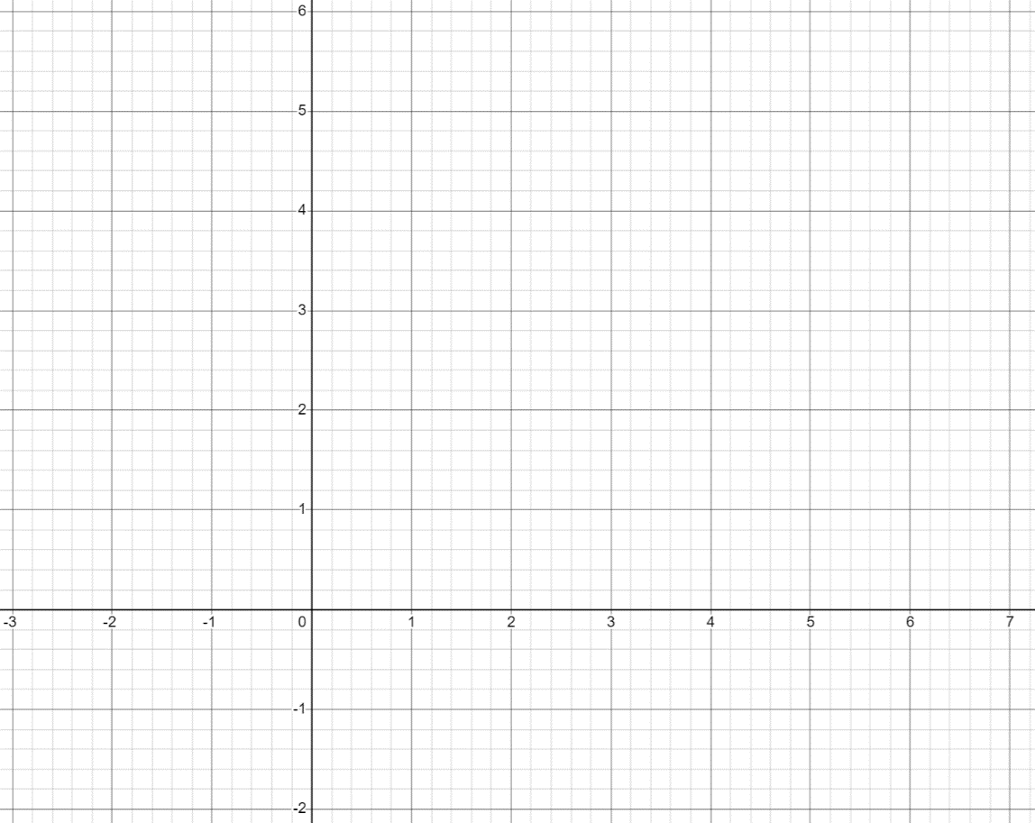

17. a. Fill in the table for the given equation below and then plot the graph of this equation on number plane below. (2 marks)
$$y={-x}^{2}+6x-5$$
$$x$$ | 1 | 2 | 3 | 4 | 5
$$y$$

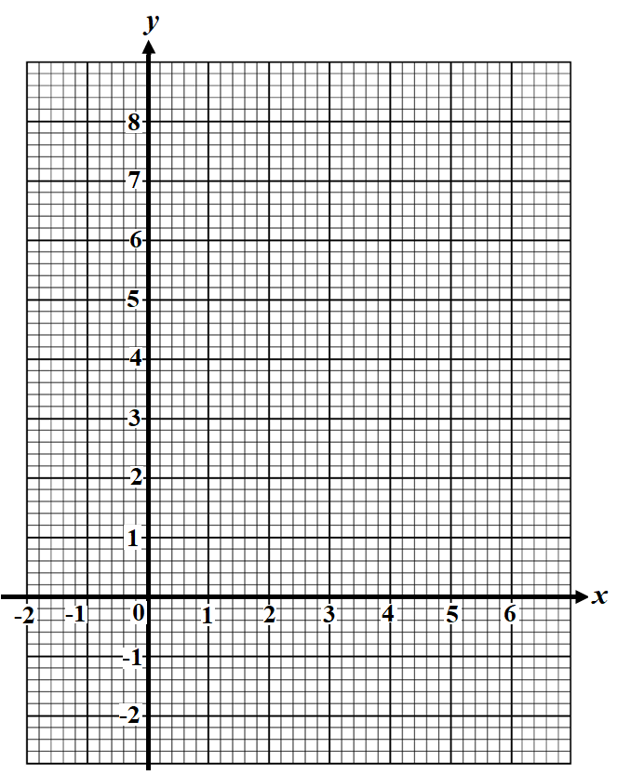

- From the graph sketched, identify:
- The x-intercepts. (1 mark)
……….…………………………………………….…………………………….
- The axis of symmetry. (1 mark)

…………………………………………………………………………………….
- The vertex. (1 mark)

…………………………………………………………………………………….

18. Find the equation of the line that is parallel to$y=2x+3$ and passes through the point (1, 5) .
(3 marks)

………………………………………………………………………………………………...

………………………………………………………………………………………………...

………………………………………………………………………………………………...

………………………………………………………………………………………………...

………………………………………………………………………………………………...

………………………………………………………………………………………………...

………………………………………………………………………………………………...

………………………………………………………………………………………………...

………………………………………………………………………………………………...

End of Exam

Norwest Christian School
Mathematics Formulas (Stage 5)

Indices
$$a^{m}×a^{n}=a^{m+n}$$
$$a^{m}÷a^{n}=a^{m-n}$$
$${\left(a^{m} \right)}^{n}=a^{m×n}$$
$$a^{-m}=\frac{1}{a^{m}}$$
$$a^{0}=1$$
$$a^{\frac{1}{m}}=\sqrt[m]{a}$$

Surds
$$\sqrt{a}×\sqrt{b}=\sqrt{a×b}$$
$$\sqrt{a}÷\sqrt{b}=\sqrt{\frac{a}{b}}$$

Equation of straight line
$$y=mx+c$$
$$y-y_{1}=m\left(x-x_{1}\right)$$

Right angled triangle
$$a^{2}+b^{2}=c^{2}$$

Distance and Midpoint
$$d=\sqrt{{\left(x_{2}-x_{1}\right)}^{2}+{\left(y_{2}-y_{1}\right)}^{2}}$$

$$M=\left(\frac{x_{1}+x_{2}}{2} ,\frac{y_{1}+y_{2}}{2}\right)$$

