

Student Name: ____________________________________

Maths Teacher: ___________________________________

Year 10 MATHEMATICS Standard 2025
TASK 2 – Half Yearly Examination

General Instructions  - Reading time – 5 minutes  - Working time – 90 minutes  - Show all necessary working / units  - Board approved calculators are allowed  - Exam guidelines  - Use black pen for your working  - Use a pencil and ruler for diagrams  - Marks may be lost for poorly organised written work. | Total Marks – 80  Section I Core – 40 marks  Suggest time: 40 mins  Section II Standard – 40 marks  Suggested time: 50 mins
Examiner’s use only M. Dunn, J. Han, B. Su
 | Indices and Algebra | Equations and Formulas | Linear and non-linear relations | Total
Core |  |  |  | /40
1-4, 11-14 | /12
5-7, 15-17 |  | /12
8-10, 18-20 |  |  | /16
Standard |  |  |  | /40
1-4, 11-13 | /12
5-7, 14-16 |  | /12
8-10, 17-19 |  |  | /16
 | /24 | /24 | /32 | /80

Section I – Core (40 marks)
Attempt Questions 1 to 18
Allow approximately 40 minutes for this section

Multiple Choice Questions 1-10
ANSWER ON THE MULTIPLE CHOICE ANSWER SHEET

 | The coefficient of x in the expression $-2x^{2}+3xy-x+5$ is:
 | - $-2$ | - $3$
 | - $-1$ | - $5$
 | The expression $4a+3b-a+2b$ can be simplified to:
 | A. $3a+5b$ | B. $4a+5b$
 | C. $8ab$ | D. 9$ab$
 | $y^{3}×y^{6}$ simplifies to:
 | - $y^{3}$ | - $y^{18}$
 | - $y^{9}$ | - $2y^{9}$
 | $(8{n)}^{0}$ simplifies to:
 | - $1$ | - $8n$
 | - $n$ | - $8$
 | Solve $\frac{x-1}{2}=5$, for $x$
 | - $x=3$ | - $x=11$
 | - $x=9$ | - $x=12$
 | For the formula $t=a+\left(n-1\right)d$, the value of $t$ when $a=7,$ n$=3$ and $d=-3$ is:
 | - $6$ | - $1$
 | - $-2$ | - $-16$
 | A number is doubled then increased by 5. The result is 13. This translates to:
 | - $2x+5=13$ | - $2\left(x+5\right)=13$
 | - $5x+2=13$ | - $2\left(x-5\right)=13$
 | The $y$-intercept of the line $y=3x-5$is:
 | - $-5$ | - $5$
 | - $3$ | - $-3$
The gradient of the line shown below is:
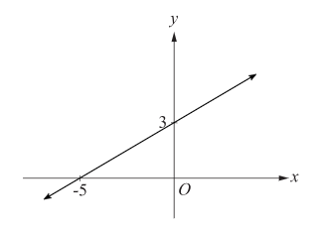
 | - $\frac{3}{5}$ | - $-\frac{3}{5}$
 | - $\frac{5}{3}$ | - $-\frac{5}{3}$
 | Which of the following equation would be a parabola when graphed?
 | - $y=2x^{2}$ | - $y=\frac{2}{x}$
 | - $y=2^{x}$ | - $y=x^{-2}$
Short Answer Questions
Answer the questions in the spaces provided. Your responses should include relevant mathematical reasoning and/or calculations.
Marks CANNOT be awarded for poorly organised written work.

 | By using index laws, simplify the following:
 | - $d^{7}÷d^{3}$  ……………………………………………………………………………………………………………………………………………………………………………………………………………………………………………………….. | 1
 | - ${\left(y^{3}\right)}^{4}$  ………………………………………………………………………………………………………………………………………………………………………………………………………………………………………………………. | 1
 | - $8m^{2}n^{3}×2m^{3}n$  …………………………………………………………………………………………………………………………………………………………………… | 2
 | Expand: $3(x-2)$  ……………………………………………………………………………………………………………………………………………………………………. | 1
13. | Factorise: $9a-15b$  ………………………………………………………………………………………………………………………………………………………………… | 1
 | Simplify the following:
 | - $\frac{2\left(x+3\right)}{4\left(x+3\right)}$  …………………………………………………………………………………………………………………………………………………………………… | 1
 | - $\frac{4x}{7}+\frac{2x}{7}$  ……………………………………………………………………………………………………………………………………………………………………. | 1
 | Solve the following equations for $x$
 | - $6x-1=23$  ……………………………………………………………………………………………………………………………………………………………………………………………………………………………………………………… | 1
 | - $3\left(x+4\right)=-6$  …………………………………………………………………………………  …………………………………………………………………………………………………………………………………………………………………… | 2
 | - $13x=4x+27$  ……………………………………………………………………………………………………………………………………………………………………………………………………………………………………………………….  Question 15 continues next page  Question 15 continued | 2
 | - $\frac{x}{5}+2=12$  ……………………………………………………………………………………………………………………………………………………………………………………………………………………………………………………….. | 2
 | If $C=2πr$, find$r$ when $C=30$, correct to 2 decimal places.  …………………………………………………………………………………………………………………………………………………………………………………………………………………………………………………………………………………………………………………………………………. | 2
 | Fill in the blanks in the table below: | 3
  Equation | Gradient | $y$-intercept
  $$y=3x-1$$ | 3
  $$y=-4x+5$$ |  | $$(0, 5)$$
   | $$-1$$ | $$(0, 2)$$
Consider the number plane below, showing points $A$ and $B.$

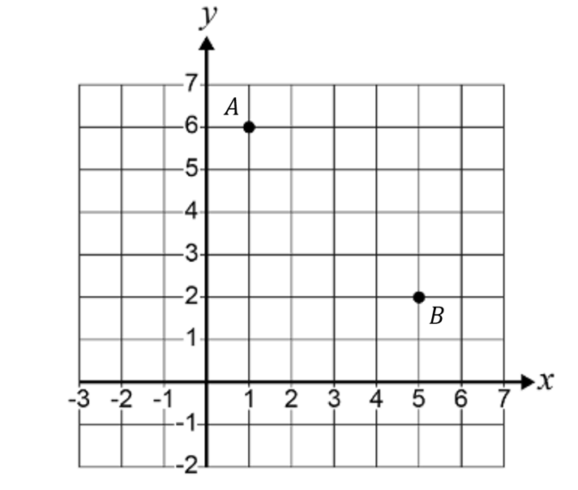

 | - By forming a right-angled triangle and using Pythagoras’ theorem, or otherwise, find the distance between the interval $AB$. Give your answer correct to 1 decimal place.  …………………………………………………………………………………………………………………………………………………………………………………………………………………………………………………………………………………………………………………………………………. | 2
 | - Find the midpoint of the interval $AB$.  ………………………………………………………………………………….………………………………………………………………………………….…………………………………………………………………………………. | 1
 | - Find the gradient of interval $AB$.  …………………………………………………………………………………………………………………………………………………………………… | 1
 | The cost, $C,$ of buying tomatoes varies directly with the weight,$w,$ of the tomatoes in kilograms. That is, $C=kw$
 | - Calculate the constant of proportionality, $k$, given that $6$ kg costs $\$42.$  …………………………………………………………………………………………………………………………………………………………………… | 1
 | - Calculate the cost of purchasing $12.5$ kg of tomatoes.  …………………………………………………………………………………………………………………………………………………………………… | 1
 | - How many kilograms of tomatoes can be purchased with $\$147$?  …………………………………………………………………………………………………………………………………………………………………… | 1
 | Determine the key features of the graph below, by completing the table  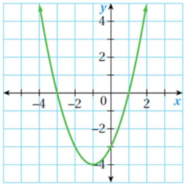 | 3
  Concave up or down | Turning point  $$(x,y)$$ | Axis of symmetry | x-intercepts | y-intercept

End of Section I
Section II – Standard (40 marks)
Attempt Questions 1 to 18
Allow approximately 50 minutes for this section

Multiple Choice Questions 1-10
ANSWER ON THE MULTIPLE CHOICE ANSWER SHEET

 | When simplified, $\frac{4x^{5}y^{3}}{12xy^{5}}$ is:
 | - $\frac{x^{4}y^{2}}{3}$ | - $\frac{x^{4}}{{3y}^{2}}$
 | - ${3x}^{4}y^{2}$ | - $3x^{6}y^{8}$
 | When simplified, ${\left(3p^{3}q\right)}^{2}$ is:
 | - $9p^{6}q^{2}$ | - $9p^{5}q^{2}$
 | - $3p^{6}q^{2}$ | - $3p^{5}q^{2}$
 | The expression $-2\left(3x+5\right)-x$ is equal to:
 | - $5x-10$ | - $-5x+10$
 | - $7x+10$ | - $-7x-10$
 | The expression 18$b^{2}-12b$ when fully factorised is:
 | - $6b(3b-2)$ | - $6b(2b-3)$
 | - $3b(6b-4)$ | - $3b(4b-6)$
 | The solution to the equation $4x=2x+6$ is:
 | - $x=1$ | - $x=-3$
 | - $x=3$ | - $x=-1$
 | When $A=lw$ is rearranged to make $w$ the subject, the answer is:
 | - $w=A-l$ | - $w=\frac{A}{l}$
 | - $w=lA$ | - $w=\frac{l}{A}$
Using the graph below, the solution to the simultaneous equations $y=-2x-5$ and $y=x+1$ is:
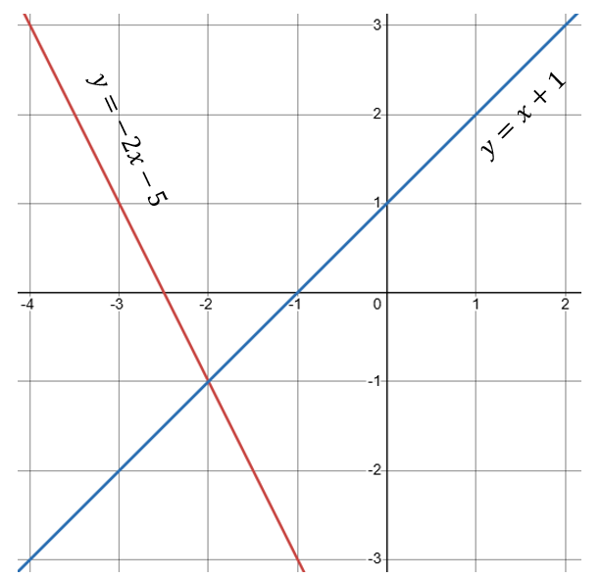

 | - $(-1, -2)$ | - $(-2, 1)$
 | - $(1, -2)$ | - $(-2,-1)$
 | The gradient of a line that is perpendicular to a line with gradient of $\frac{2}{5}$ is:
 | - $\frac{5}{2}$ | - $\frac{2}{5}$
 | - $-\frac{5}{2}$ | - $-\frac{2}{5}$
 | Which of the following could be the graph of $y=-3x+2$?
 | A.  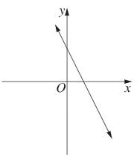 | B.  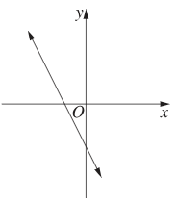
 | C.  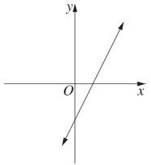 | D.  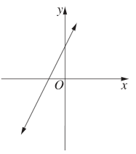
 | Which of the following equations represents a parabola that has a minimum turning point?
 | - $y=-x^{2}-1$ | - $-y=1-x^{2}$
 | - $y=1-x^{2}$ | - $-y=1+x^{2}$

Short Answer Questions
Answer the questions in the spaces provided. Your responses should include relevant mathematical reasoning and/or calculations.
Marks CANNOT be awarded for poorly organised written work.

 | Simplify the following:
 | - $\frac{{\left(c^{4}\right)}^{6}}{c^{10}}$  ……………………………………………………………………………………………………………………………………………………………………………………………………………………………………………………… | 2
 | - $\frac{2a}{5b}×\frac{25b^{2}}{4a}$  ……………………………………………………………………………………………………………………………………………………………………………………………………………………………………………………… | 2
 | Expand and simplify: $\left(3x-2\right)(2x+5)$  ………………………………………………………………………………………………………………………………………………………………………………………………………………………………………………………………………………………………………………………………………… | 2
 | Fully simplify: $\frac{5x}{4}+\frac{3x}{6}$  ……………………………………………………………………………………………………………………………………………………………………………………………………………………………………………………….. | 2
 | Solve the following equations for $x$:
 | - $5x+6=3x-8$  …………………………………………………………………………………………………………………………………………………………………………………………………………………………………………………………………………………………………………………………………………………………………………………………………………………………… | 2
 | - $\frac{3x+5}{7}=2$  …………………………………………………………………………………………………………………………………………………………………………………………………………………………………………………………………………………………………………………………………………………………………………………………………………………………… | 2
 | $3$ times the sum of a number and 2 is equal to 2 more than this number$.$  By letting $x$ be this unknown number, form an equation and solve it to find the value of $x$  ……………………………………………………………………………………………………………………………………………………………………………………………………………………………………………………………………………………………………………………………………………………………………………………………………………………………………………………………………………………………………………… | 2
 | Solve the following pair of simultaneous equations using either the elimination or substitution method.  $$\left\{\begin{aligned}4x-y=11 \\ x+y=9\end{aligned}\right.$$  ………………………………………………………………………………………………………………………………………………………………………………………………………………………………………………………………………………………………………………………………………………………………………………………………………………………………………………………………………………………………………………………………………………………………………………………………… | 3
 | For the linear equation $2x-3y=6$:
 | - Calculate the $x$ and $y$ intercepts  ………………………………………………………………………………………………………………………………………………………………………………………………………………………………………………………………………………………………………………………………………… | 2
 | - Hence, use the intercepts to sketch $2x-3y=6$  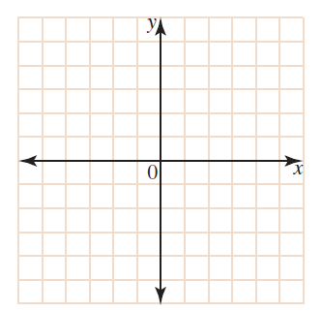 | 1
Consider the graph of the line shown below:

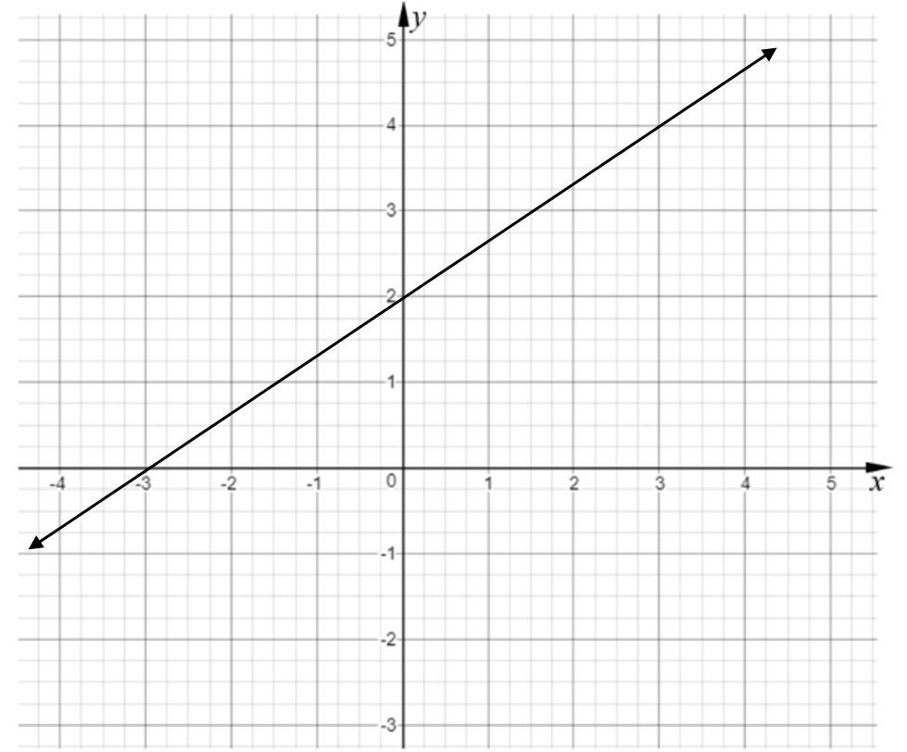

 | - Find the gradient.  ………………………………………………………………………………… | 1
 | - Find the $y$-intercept.  ………………………………………………………………………………… | 1
 | - Hence, find the equation of the line in gradient-intercept form.  ………………………………………………………………………………… | 1
 | Find the equation of the line that has gradient of $-2$and passes through the point $(2, 5)$.  ……………………………………………………………………………………………………………………………………………………………………………………………………………………………………………………………………………………………………………………………………………………………………………………………………………………………………………………………………………………………………………… | 2
 | The line joining the points $A\left(1,2\right)$ and $B\left(5,y\right)$ is parallel to the line  $y=3x+1.$ What is the value of $y$?  …………………………………………………………………………………………………………………………………………………………………………………………………………………………………………………………………………………………………………………………………………………………………………………………………………………………………………………………………………………………………………………………………………………………………………………………………………………………………………………………………………………….. | 2
A scene from the Minecraft movie featuring a Chicken Jockey chase goes viral online. Initially, the clip is viewed by 3000 people. The number of views increases by 70% every hour.

Using the exponential growth model $A=A_{0}{\left(1+r\right)}^{n}$, where:
$A$ is the amount
$A_{0}$ is the initial amount
$r$ is the percentage rate of increase
$n$ is time

 | - Determine the rule for the number of views, $V$, after $h$ hours.  ……………………………………………………………………………………………………………………………………………………………………………………………………………………………………………………… | 2
 | - Calculate the number of views the clip had after one day.  ……………………………………………………………………………………………………………………………………………………………………. | 1

END OF EXAM
NAME: _____________________________________

Multiple Choice Answer Sheet for Mathematics Standard

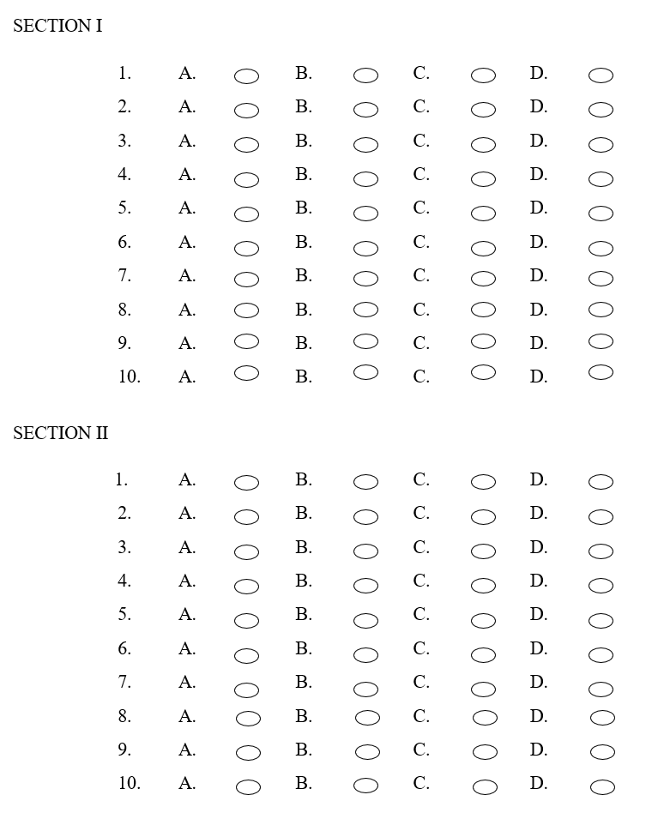

Norwest Christian School
Mathematics Formulas (Stage 5)

Indices
$$a^{m}×a^{n}=a^{m+n}$$
$$a^{m}÷a^{n}=a^{m-n}$$
$${\left(a^{m}\right)}^{n}=a^{m×n}$$
$$a^{-m}=\frac{1}{a^{m}}$$
$$a^{0}=1$$
$$a^{\frac{1}{m}}=\sqrt[m]{a}$$

Surds
$$\sqrt{a}×\sqrt{b}=\sqrt{a×b}$$
$$\sqrt{a}÷\sqrt{b}=\sqrt{\frac{a}{b}}$$

Equation of straight line Gradient
$y=mx+c$ $m=\frac{y_{2}-y_{1}}{x_{2}-x_{1}}$
$$y-y_{1}=m(x-x_{1})$$

Right angled triangle
$$a^{2}+b^{2}=c^{2}$$

Distance and Midpoint
$$d=\sqrt{{\left(x_{2}-x_{1}\right)}^{2}+{\left(y_{2}-y_{1}\right)}^{2}}$$

$$M=\left(\frac{x_{1}+x_{2}}{2} , \frac{y_{1}+y_{2}}{2}\right)$$

