

Student Name: ____________________________________

Maths Teacher: ___________________________________

Year 10 MATHEMATICS Core 2026
TASK 2 – Half Yearly Examination

General Instructions  - Reading time – 5 minutes  - Working time – 90 minutes  - Show all necessary working / units  - Board approved calculators are allowed  - Exam guidelines  - Use black pen for your working  - Use a pencil and ruler for diagrams  - Marks may be lost for poorly organised written work. | Total Marks – 80  Section I Core – 40 marks  Suggested time: 40 mins  Section II Standard – 40 marks  Suggested time: 50 mins
Examiner’s use only J. Han, H. Jang, C. Le, B. Vincent
Questions | Indices and Algebra | Equations and Formulas | Linear  and non-linear relations | Total
1-4,  11-14 | /15
5-7,  15-16 |  | /11
8-10,  17-19 |  |  | /14
 |  |  |  | /40

Section I – Core (40 marks)
Attempt Questions 1 to 19
Allow approximately 40 minutes for this section

Multiple Choice Questions 1-10
ANSWER ON THE MULTIPLE CHOICE ANSWER SHEET

 | The lowest common denominator (LCD) of the expression $\frac{a}{2}+\frac{2a}{3}$ is:
 | - $2$ | - $a$
 | - $5$ | - $6$
 | The expression $3b+2a-b+7a$ can be simplified to:
 | A. $3a+5b$ | B. 9$a+2b$
 | C. 11$ab$ | D. $11+ab$
 | $y^{2}×y^{6}$ simplifies to:
 | - $y^{12}$ | - $y^{8}$
 | - $y^{3}$ | - $2y^{6}$
 | $(-2)^{2}$ simplifies to:
 | - $1$ | - $-4$
 | - $-2^{2}$ | - $4$
 | Solve $\frac{x-2}{2}=4$, for $x$
 | - $x=3$ | - $x=4$
 | - $x=-4$ | - $x=10$
 | How many terms does the following expression have? $\frac{xy}{2}-4x+3y^{2}-2$
 | - $2$ | - $3$
 | - $4$ | - $5$
 | A number is halved and then increased by 10. The result is 5. This translates to:
 | - $2÷x+10=5$ | - $\left(x-2\right)+10=5$
 | - $(10+x)÷2=5$ | - $\frac{x}{2}+10=5$
 | The gradient of the line $y=x-5$is:
 | - $-5$ | - $5$
 | - $1$ | - $-1$
The $y$-intercept of the line shown below is:
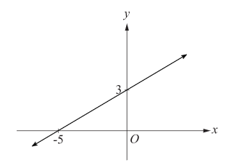
 | - $3$ | - $-\frac{3}{5}$
 | - $-5$ | - $-3$
 | The graph of $y=3^{x}$ crosses the $y$-axis at:
 | - $(0,3)$ | - $(3,0)$
 | - $(3,1)$ | - $(0,1)$

Short Answer Questions
Answer the questions in the spaces provided. Your responses should include relevant mathematical reasoning and/or calculations.

Marks CANNOT be awarded for poorly organised written work.

 | By using index laws, simplify the following:
 | - $x^{7}÷x^{2}$ | 1
 | - ${\left(y^{3}\right)}^{0}$ | 1
 | - $4×5^{-3}$ | 2
 | Expand: $10(x-1)$ | 1
13. | Factorise the following expressions:
 | - $3a-21y$ | 1
 | - $2abc+4a^{2}$ | 2
 | Simplify the following:
 | - $\frac{2x}{5}-\frac{x}{5}$ | 1
 | - $\frac{4x+6}{2}$ | 2
 | Solve the following equations for $x$
 | - $6x=30$ | 1
 | - $x^{2}=100$ | 2
 | - $2\left(x-3\right)=4$ | 2
 | If $E=mc^{2}$, find$m$ when $E=300$ and $c=6$, correct to 2 decimal places. | 3
 | Fill in the blanks in the table below: | 2
  Equation | Gradient | $y$-intercept
  $$y=-3x+4$$ |  | $$(0, 4)$$
   | $$-2$$ | $$(0, 10)$$
 | Determine the key features of the graph below, by completing the table:  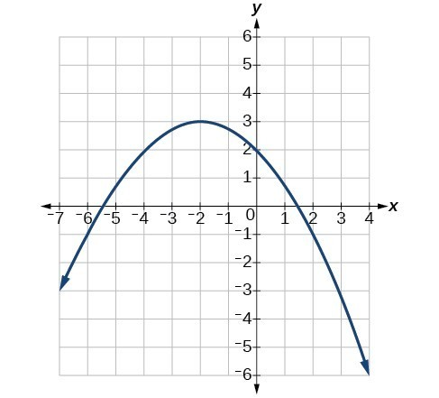 | 3
  - Turning point $(x, y)$
  - Is the turning point a maximum or minimum?
  - Is the graph concave up or concave down?
  - Axis of symmetry
  - $x$-intercepts
  - $y$-intercepts
 | The formula $C=100n+2000$ is used to calculate the cost of producing laptops, where $C$ is the cost in dollars and $n$ is the number of laptops produced.
 | - Complete the following table of values for this formula. | 2
  $$n$$ | 0 | 2 |  | 6
  $$C$$ |  |  | 2500
 | - Sketch the graph of $C=100n+2000$ using the table values on the Cartesian plane provided below:  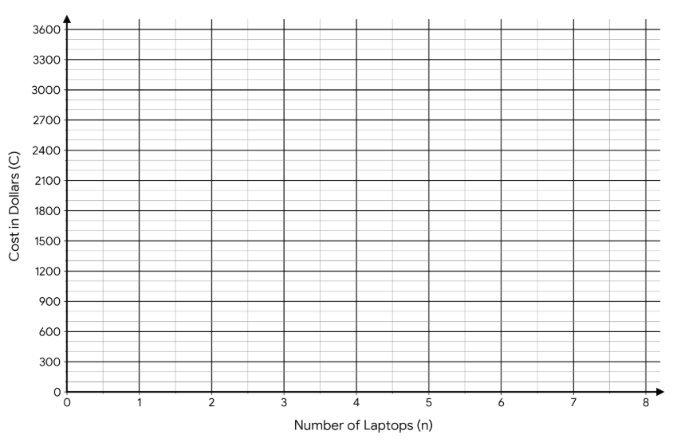 | 1
 | - What is the cost of producing $0$ laptops? | 1
 | - Find the cost of producing $4$ laptops. | 1
 | - Is it profitable to sell 4 laptops for $2500? Why, or why not? | 1
End of Core Section
Additional writing space

