

Student Name: ____________________________________

Maths Teacher: ___________________________________

Year 10 MATHEMATICS Standard 2026
TASK 2 – Half Yearly Examination

General Instructions  - Reading time – 5 minutes  - Working time – 90 minutes  - Show all necessary working / units  - Board approved calculators are allowed  - Exam guidelines  - Use black pen for your working  - Use a pencil and ruler for diagrams  - Marks may be lost for poorly organised written work. | Total Marks – 80  Section I Core- 40 marks  Suggest time: 40 mins  Section II Standard- 40 marks  Suggested time: 50 mins
Examiner’s use only J. Han, H. Jang, C. Le, B. Vincent
Questions | Indices and Algebra | Equations and Formulas | Linear and non-linear relations | Total
4,  11d | /3
1-3, 5  11abce,  12-17 |  | /27
6-10,  18-19 |  |  | /10
TOTAL |  |  |  | /40

Standard Section (40 marks)
Attempt Questions 1 to 19
Allow approximately 40 minutes for this section

Multiple Choice Questions 1-10
ANSWER ON THE MULTIPLE CHOICE ANSWER SHEET

 | The algebraic expression for the sum of $a$ and $b$ is divided by 5, is:
 | - $a+b÷5$ | - $5÷\left(a+b\right)$
 | - $\left(a+b\right)÷5$ | - ${\left(a+b\right)}^{\frac{1}{5}}$
 | The value of the expression $3z-xy$ when $x=6, y=-2$and $z=4$, is:
 | - $0$ | - $4$
 | - $-1$ | - $24$
 | The expression $-3\left(2x+3\right)-x$ is equal to:
 | - $5x-6$ | - $-7x-9$
 | - $-6x+9$ | - $7x-9$
 | When simplified, ${\left(2b\right)}^{2}$ is:
 | - $4b^{6}$ | - $2b^{2}$
 | - $4b^{2}$ | - $4b$
 | The solution to 4$a^{2}=64$ is:
 | - $4$ | - $4 or-4$
 | - $8 or-8$ | - $\frac{1}{4}$
Consider the following distance-time graph of a bicycle journey.
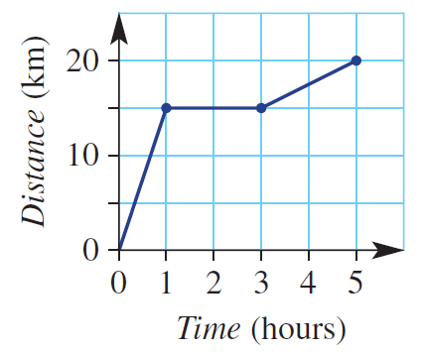
Which of the following statements are true?
- The cyclist rested for 2h.
- The total distance travelled is 20km
- The gradient during the second hour is 15.
- The gradient during the second hour is 0.
- The cyclist cycled the fastest in the last hour of the journey.

 | - Only I and II are true. | - I, II and IV are true.
 | - No options are true. | - All options are true.
The parabola shown could have the equation:
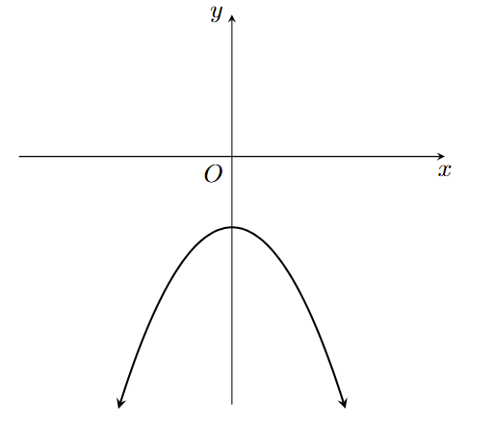
 | - $y=-x^{2}-3$ | - $y=-x^{2}+3$
 | - $y=x^{2}-3$ | - $y=x^{2}+3$

 | Which graph shows that $y$ is directly proportional to $x$?
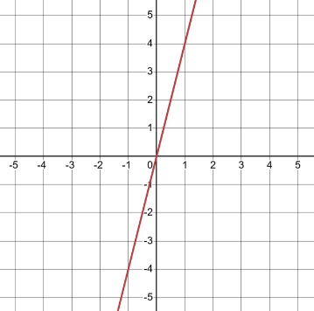 | 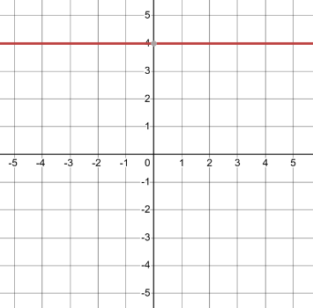
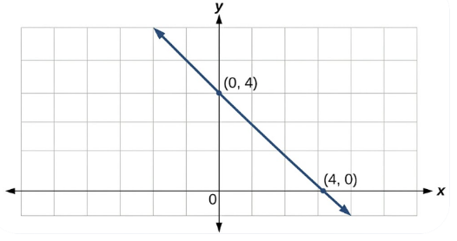 | 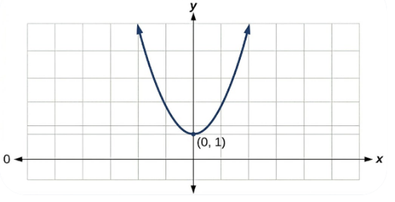

 | The gradient of a line perpendicular to a line with a gradient of $\frac{2}{5}$ is:
 | - $\frac{5}{2}$ | - $\frac{2}{5}$
 | - $-\frac{5}{2}$ | - $-\frac{2}{5}$
 | If $\left(2x-3\right)\left(x+4\right)=2x^{2}+bx+c$, then $b=$
 | - $-12$ | - $5$
 | - $5x$ | - $7$

Short Answer Questions
Answer the questions in the spaces provided. Your responses should include relevant mathematical reasoning and/or calculations.

Marks CANNOT be awarded for poorly organised written work.

 | Fully simplify the following expressions:
 | - $\frac{4x^{5}}{x}$ | 1
 | - $\frac{6x}{2}-\frac{3x}{6}$ | 2
 | - $\frac{2a}{5}÷\frac{8a}{20 }$ | 2
 | - $\frac{3{\left(x^{3}y^{-1}\right)}^{0}}{y^{5}x^{-1}}$ | 2
 | - $\frac{5-x}{12}×\frac{24x}{5-x}$ | 2
 | Expand and simplify:  $$\left(5x-2\right)(-x+1)$$ | 2
 | Factorise the following expression: | 2
 | $$36{ab}^{2}-9ab$$
 | Solve the following equations for $x$:
 | - $5x+2=6x+8$ | 2
 | - $\frac{5x+5}{10}=2$ | 2
 | Solve the following pair of simultaneous equations using either the elimination or substitution method.  $$\left\{\begin{aligned}4x-y=11 \\ x+y=9\end{aligned}\right.$$ | 3
Consider the following linear equation:
$$-2x+y=-4$$
 | - Write this equation in the gradient-intercept form. | 1
 | - Calculate the $x$- and $y$-intercepts. | 1
 | - Hence, use these intercepts to sketch $-2x+y=-4$ on the Cartesian plane below.  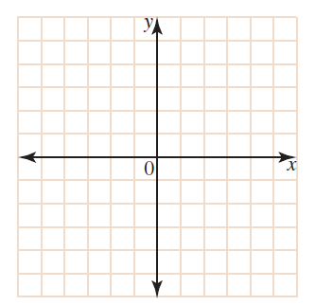 | 1
 | Beatrix has twice as much money as Sue. If I give Sue $1.25, she will have three times as much as Beatrix. How much does Beatrix have? | 2
 | The line $3x+2y-8=0$ passes through $(a, 10)$. Find the value of $a$. | 2
 | A square is positioned on the Cartesian plane such that its opposite vertices stretch from point $A(-4,-2)$ to point $B\left(6,8\right)$ and from point $C(-4,8)$ to point $D\left(6,-2\right)$. Given that the diagonals of the square meet at their exact centre point, calculate the coordinates of the centre of the square. | 3

END OF STANDARD SECTION

Additional writing space

