

Student Name: ____________________________________

Year 10 MATHEMATICS Standard 2024
TASK 2 – Half Yearly Examination

General Instructions  - Reading time – 5 minutes  - Working time – 90 minutes  - Show all necessary working / units  - Board approved calculators are allowed  - Exam guidelines  - Use black pen for your working  - Use a pencil and ruler for diagrams  - Marks may be lost for poorly organised written work. | Total Marks – 80  Core – 40 marks  Suggested time: 40 mins  Standard – 40 marks  Suggested time: 50 mins
Examiner’s use only D. Hua, K. Duncan, B. Vincent
 | Indices and Algebra | Equations and Formulas | Linear and non-linear relations | Total
Core |  |  |  | /40
1- 4,11-12 | /14
5-6,13-15 |  | /12
7-10,16-18 |  |  | /14
Standard |  |  |  | /40
1-4, 11-12 | /14
5-7, 13-15 |  | /12
8-10, 16-20 |  |  | /14
 |  |  |  | /80

Section 1 – Core (40 marks)
Attempt Questions 1 to 18
Allow approximately 40 minutes for this section

Multiple Choice Questions 1 – 10

- The coefficient of $y$ in $4x^{2}+7xy-8y+7$ is:

- - 6

- - 8

- 7

- 4

- If $x=3$ and $y=2$, the value of $3x-y$is equal to:

- 5

- 7

- 9

- 4

- Find $y^{6}÷y^{3}$

- $y^{2}$

- $y^{3}$

- $3$

- y

- Simplify $2\left(x+5\right)$

- 7x

- $2x+10$

- $2x+5$

- $2x+7$

- The solution to $\frac{5x}{9}=5$ is:

- $x=6$

- $x=-9$

- $x=-5$

- $x=9$

- A number is increased by 6 and then doubled. The result is 36. This translates to:

- $6x+2=36$

- $2x+6=36$

- $2\left(x+6\right)=36$

- $2\left(x-6\right)=36$

Question 7 and 8 refer to the following graph of Lucy’s walk one afternoon.

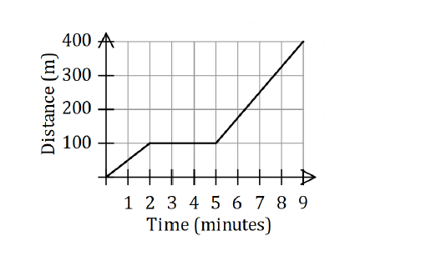

- The number of minutes that Lucy was stationary is:

- 2

- 3

- 9

- 4

- The speed that Lucy walked during the first 2 minutes was:

- 50 m/minute

- 400 m/minute

- 75 m/minute

- 44.4 m/minute

- The y- intercept of the rule: $y=3x-6$ is

- $(-2,0)$

- $\left(0,-6\right)$

- $\left(0, 3\right)$

- $(0,6)$

- The gradient of a line parallel to the line with equation $y=\frac{2}{3}x+9$ is:

- $\frac{2}{3}$

- $\frac{3}{2}$

- $-\frac{3}{2}$

- $-\frac{2}{3}$

Short Answer Questions
Answer the questions in the spaces provided. Your responses should include relevant mathematical reasoning and/or calculations.
Marks CANNOT be awarded for poorly organised written work.

11. Simplify the following:

- 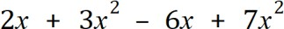 1

…………………………………………………………………………………………………..

…………………………………………………………………………………………………..

- $(x^{4})^{3}$ 1

…………………………………………………………………………………………………..

…………………………………………………………………………………………………..

- 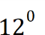 1

…………………………………………………………………………………………………..

- 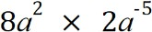 (leave your answer with positive indices) 2

…………………………………………………………………………………………………..

…………………………………………………………………………………………………..

………………………………………………………………………………………………….

- $\frac{x}{2}×\frac{x}{3}$ 2

…………………………………………………………………………………………………..

…………………………………………………………………………………………………..

…………………………………………………………………………………………………..

12. Expand the following algebraic expressions and simplify if possible.

- $3(x+5)$ 1

…………………………………………………………………………………………………..

…………………………………………………………………………………………………..

- $2\left(x+3\right)-3(x-1)$ 2

…………………………………………………………………………………………………..

………………………………………………………………………………………………….

…………………………………………………………………………………………………..

13. Solve the following equations

- $a-4=24$ 1

…………………………………………………………………………………………………

………………………………………………………………………………………………….

- $-3a+6=15$ 2

…………………………………………………………………………………………………..

…………………………………………………………………………………………………..

- $\frac{p}{2}+2=7$ 2

…………………………………………………………………………………………………..

…………………………………………………………………………………………………..

…………………………………………………………………………………………………..

…………………………………………………………………………………………………..

14. The cost (in dollars) of a taxi is 𝐶 = 3 + 1.5𝑑, where 𝑑 is the distance travelled in kilometres.

- What is the cost of a 25 km trip? 1

…………………………………………………………………………………………………..

…………………………………………………………………………………………………..

- How many kilometers can be travelled for $93? 2

…………………………………………………………………………………………………..

…………………………………………………………………………………………………..

…………………………………………………………………………………………………..

15. Solve the following inequality.

- $2x<4$ 1

…………………………………………………………………………………………………..

- Plot the solution above on the number line. 1

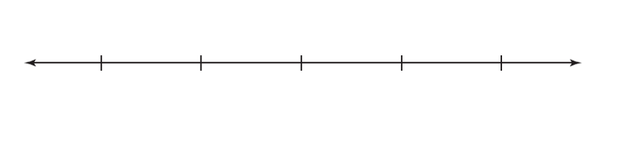

16. (i) For the given equation $y=x-3$, complete the table of values below. 1

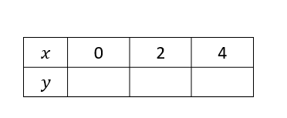

- Hence, draw and label the above equation on the number plane below.
The equation $y=2x+3$ is already drawn on the number plane 1

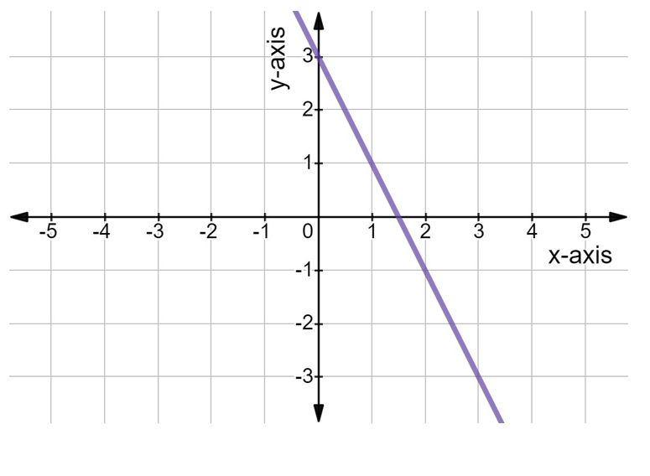
- Write down the coordinates of the point of intersection of $y=2x+3$ and $y=x-3$, which is the solution to both the linear equations. 1

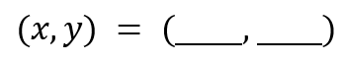

17. Jack’s wages earned are in direct proportion $(W=kn)$ to the hours he works as a baker.
(i) Find the constant of proportionality, k, given that Jack earned $192 in 8 hours. 1
…………………………………………………………………………………………………
………………………………………………………………………………………………….
(ii) Write the direct proportion equation relating Jack’s wages (W) in dollars and the number of hours (n) worked 1
…………………………………………………………………………………………………..
………………………………………………………………………………………………..
- Calculate the wage earned for 12 hours of work. 1
…………………………………………………………………………………………………
………………………………………………………………………………………………….
- Calculate the number of hours that Jack must work to earn $288 1
………………………………………………………………………………………………….
…………………………………………………………………………………………………..

18. Complete this table and grid to plot the graph of $y=x^{2}+1$ 3

x | -2 | -1 | 0 | 1 | 2
y

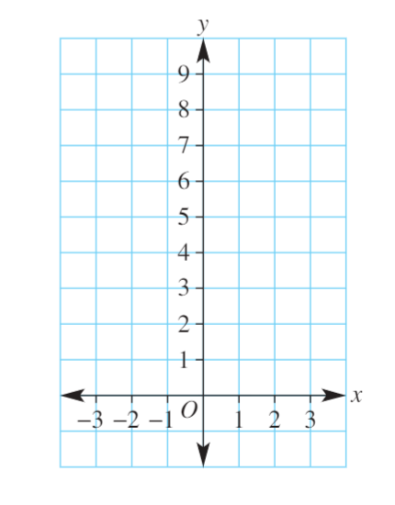

Section 1 – Standard (40 marks)
Attempt Questions 1 to 20
Allow approximately 40 minutes for this section

Multiple Choice Questions 1 – 10

- Simplify $y^{3}+y^{3}+y^{3}$

  - $y^{9}$

  - $y^{27}$

  - $3y^{3}$

  - $3y^{9}$

- The value of if a = 4, b = −2 and c = −3 is:

  - 5

  - -11

  - -5

  - 11

- When the expression is factorised, it becomes:

- Which of the following statements is true?

  - $x^{2}\left(2-x\right)=2x^{2}-x^{3}$

  - $8xy-8=xy$

  - $(2x^{2})^{3}=6x^{5}$

  - $(3x)^{3}=3x^{3}$

- What is the solution to $4\left(x+3\right)=24$?

A. 17

B. 3

C. -3

D. 21

- The formula for converting a speed for k km/h to M metres per second (m/s) is 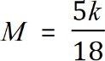 . A speed of 80 km/h is closest to which of the following speeds?
  - 22 m/s

  - 32 m/s

  - 35 m/s

  - 47 m/s

- What is the solution to $8-x<7$

  - $x<1$

  - $x>1$

  - $x>-1$

  - $x<-1$

- A line has equation 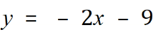 . Which statement is true?
  - The gradient is -2 and the y intercept is -9.

  - The gradient is -2 and the y intercept is 9.

  - The gradient is 2 and the y intercept is -9.

  - The gradient is 2 and the y intercept is 9.

- Line n has a gradient of -4.

Line p has a gradient of 4.

Line q has a gradient of $\frac{1}{4}$.

Which statement is true?

  - Line n is perpendicular to line q.

  - Line p is perpendicular to line q.

  - Line p is perpendicular to line n

  - Line p is parallel to line n.

- Which is the graph of the line 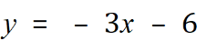 ?

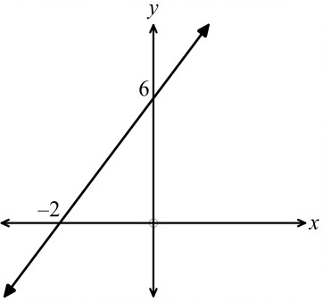  A. | 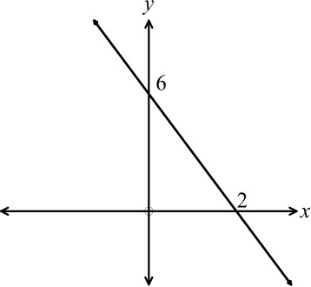  B.
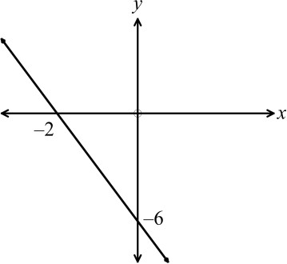  C. | 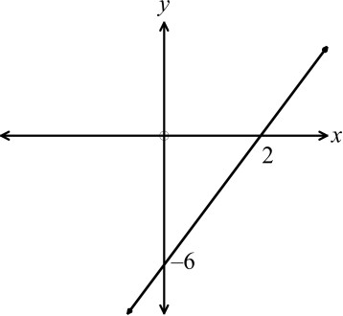  D.

Short Answer Questions
Answer the questions in the spaces provided. Your responses should include relevant mathematical reasoning and/or calculations.
Marks CANNOT be awarded for poorly organised written work.

11. Use index laws to simplify the following and express the solution with positive indices where required:
(i) $12y^{0}$ 1
………………………………………………………………………………………………….
(ii) $4ab^{9}×2a^{3}b^{-2}$ 1
………………………………………………………………………………………………….
………………………………………………………………………………………………….
(iii) $(5a^{3}b^{2})^{2}$ 1
…………………………………………………………………………………………………..
…………………………………………………………………………………………………..
(iv) $\frac{63x^{6}y^{5}}{9xy^{5}}$ 2
…………………………………………………………………………………………………
………………………………………………………………………………………………….
…………………………………………………………………………………………………..

12. Simplify the following:
(i) $4a\left(b+a\right)-a(b-4a)$ 2
…………………………………………………………………………………………………..
…………………………………………………………………………………………………..
………………………………………………………………………………………………….
………………………………………………………………………………………………….
(ii) $\frac{6m}{25}÷\frac{3m}{10}$ 2
…………………………………………………………………………………………………..
…………………………………………………………………………………………………..
…………………………………………………………………………………………………..
(iii) $\frac{2a}{5}+\frac{a}{3}$ 1
…………………………………………………………………………………………………..
…………………………………………………………………………………………………..
…………………………………………………………………………………………………..

13. Solve the following equations:
(i) 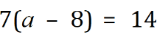 1
........................................................................................................................................................

……................................................................................................................................................
…………………………………………………………………………………………………

(ii) 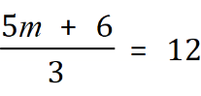 2

........................................................................................................................................................
........................................................................................................................................................

........................................................................................................................................................

………………………………………………………………………………………………………………………………….

(iii) 2

........................................................................................................................................................
.......................................................................................................................................................

........................................................................................................................................................
………………………………………………………………………………………………………………………………….

14. Solve the inequality $\frac{1-3x}{2}≤5$ 2
…………………………………………………………………………………………………
…………………………………………………………………………………………………..
…………………………………………………………………………………………………..
…………………………………………………………………………………………………..
…………………………………………………………………………………………………..

15. Using x for the unknown number, write down an equation and then solve it to find the number, given:

12 more than triple a number is equivalent to 3 less than double this number. 2

…………………………………………………………………………………………………

…………………………………………………………………………………………………..

………………………………………………………………………………………………….

………………………………………………………………………………………………….

16. In the diagram below, A is the point (–4, 1) and B is the point (0, 5).

- What is the gradient of line AB? 1
…………………………………………………………………………………………………..
…………………………………………………………………………………………………..
…………………………………………………………………………………………………..

- Find the y intercept of AB 1
…………………………………………………………………………………………………..
…………………………………………………………………………………………………..

- Determine the equation for line AB 1
…………………………………………………………………………………………………
………………………………………………………………………………………………….
………………………………………………………………………………………………….
17. For the rule $y=-\frac{4}{3}x+2$, use the y-intercept and the gradient to plot and then sketch the graph. 2
…………………………………………………………………………………………………
………………………………………………………………………………………………….
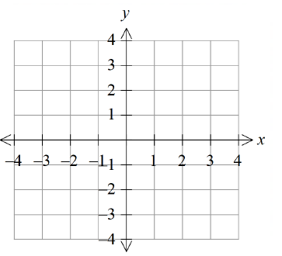
18. Solve the simultaneous equations using the substitution method. 2
$y=5x-13$
$2x+3y=12$
…………………………………………………………………………………………………
………………………………………………………………………………………………….
…………………………………………………………………………………………………..
…………………………………………………………………………………………………..
…………………………………………………………………………………………………..
…………………………………………………………………………………………………..
…………………………………………………………………………………………………..
…………………………………………………………………………………………………..
…………………………………………………………………………………………………..
19. Find the equation of a line that is parallel to the line $y=2x-3$ and passes through the point (1,3) 2
…………………………………………………………………………………………………
………………………………………………………………………………………………….
………………………………………………………………………………………………….
…………………………………………………………………………………………………..
………………………………………………………………………………………………….
…………………………………………………………………………………………………..
20. Determine the key features of the graph below, by completing the table. 2

 | Turning point (x,y) | Axis of symmetry | x-intercepts. | y-intercept
Graph A

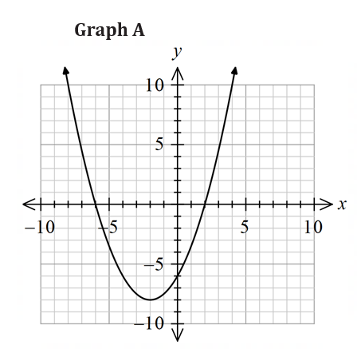

NAME: _____________________________________

Multiple Choice Answer Sheet for Mathematics Standard

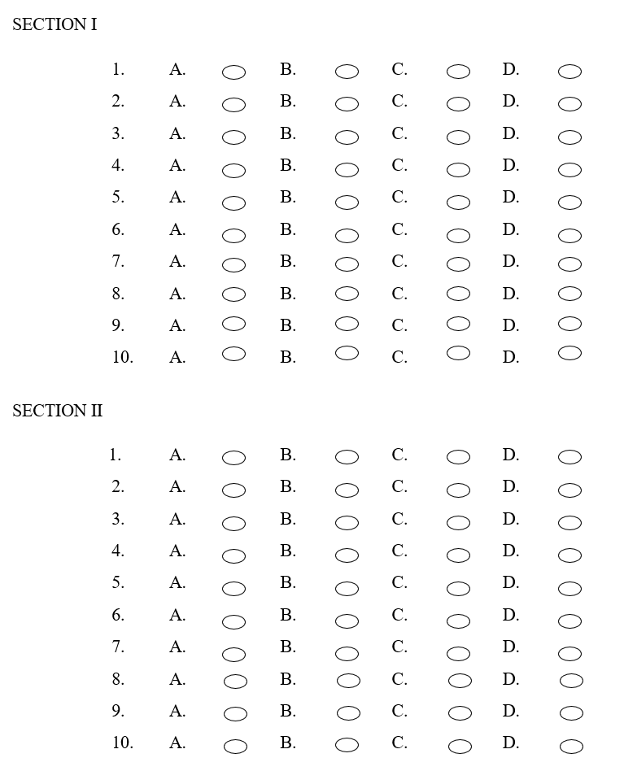

Norwest Christian School
Mathematics Formulas (Stage 5)

Indices
$$a^{m}×a^{n}=a^{m+n}$$
$$a^{m}÷a^{n}=a^{m-n}$$
$${\left(a^{m}\right)}^{n}=a^{m×n}$$
$$a^{-m}=\frac{1}{a^{m}}$$
$$a^{0}=1$$
$$a^{\frac{1}{m}}=\sqrt[m]{a}$$

Surds
$$\sqrt{a}×\sqrt{b}=\sqrt{a×b}$$
$$\sqrt{a}÷\sqrt{b}=\sqrt{\frac{a}{b}}$$

Equation of straight line
$$y=mx+c$$
$$y-y_{1}=m(x-x_{1})$$

Right angled triangle
$$a^{2}+b^{2}=c^{2}$$

Distance and Midpoint
$$d=\sqrt{{\left(x_{2}-x_{1}\right)}^{2}+{\left(y_{2}-y_{1}\right)}^{2}}$$

$$M=\left(\frac{x_{1}+x_{2}}{2} , \frac{y_{1}+y_{2}}{2}\right)$$

