Distance, Speed, and Time
- A car travels at 15 m/s for 8 s. Find the distance.

- A cyclist travels at 9 m/s for 20 s. Find the distance.

- A train travels 600 m in 25 s. Find the speed.

- A skateboarder travels 90 m at 5 m/s. Find the time.

- A car travels 1.2 km in 2 minutes. Find the speed in m/s.
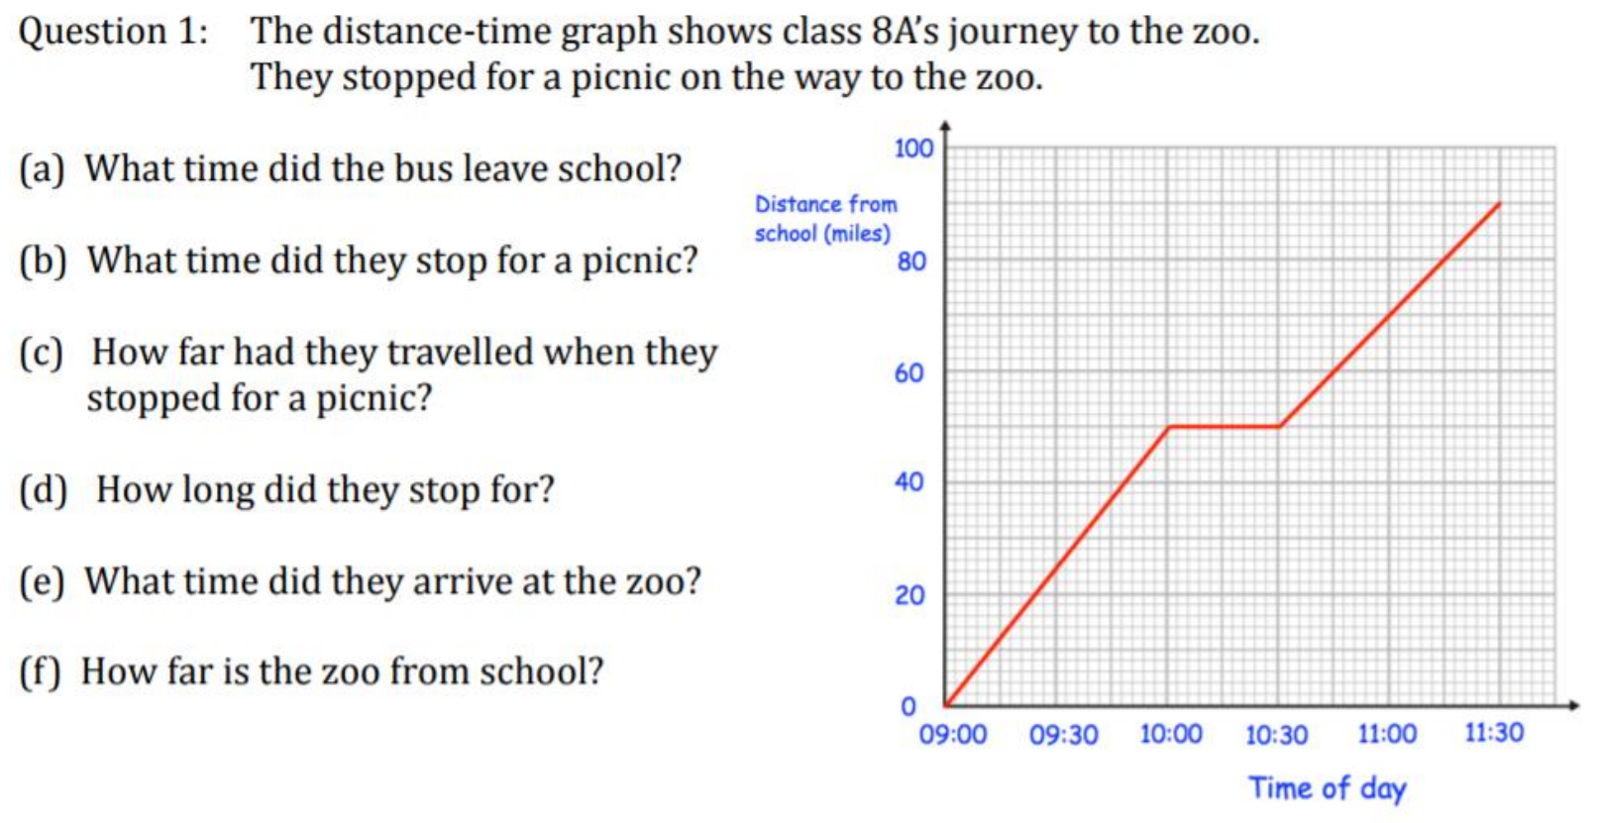
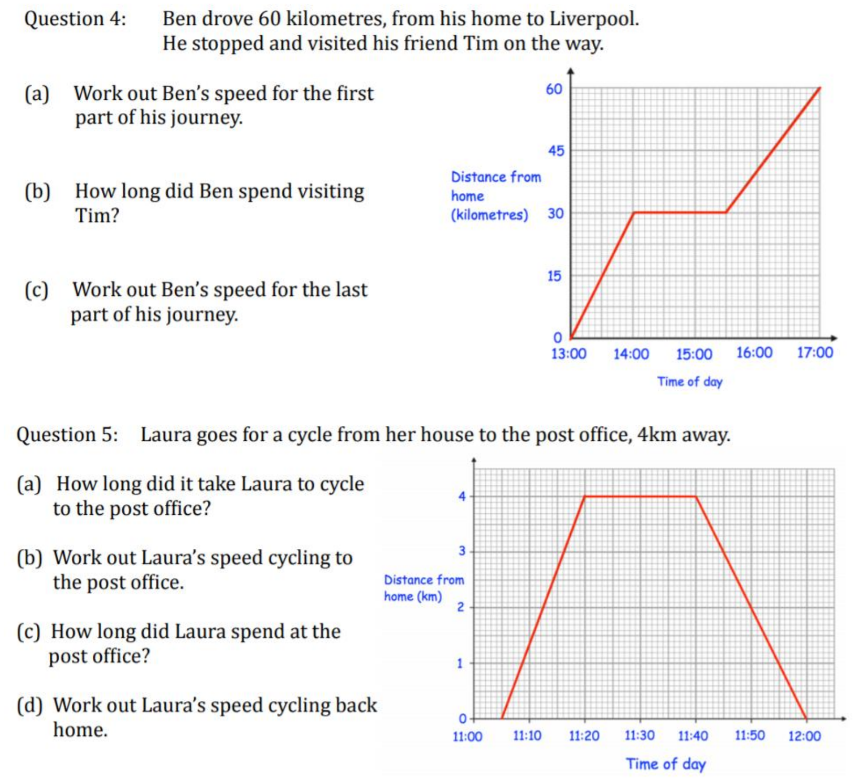
Some more challenging questions:
This graph shows the journey of a family holiday in NSW. The maximum speed limit in NSW is 110km/h. Did the family break the law at any point in their holiday?

An athlete completes a 10 hour ride for a competition. They ride on a bike at 10km/h in one direction, then they walk back to the starting line on the exact same path at 3km/h. What is the total distance travelled by the athlete?

A car travels from A to B at an average speed of 40km/h. They then immediately turn around and travel from B to A at an average speed of 60km/h. What was their average speed for the journey? (Hint: The answer is not 50km/h)

Train X is 100m long and is travelling at 10m/s. Train Y is 150m long and is travelling at 15m/s in the opposite direction. How long would it take the two trains to completely pass each other?

