2023  Australian Curriculum for NSW  Year 10  Final Examination  Science | General Instructions  Total marks – 50  - Reading time: 10 minutes  - Working time: 1 hour  - Attempt ALL questions  - Use a pencil and ruler to complete diagrams and  graphs  - Calculators may be used  - Write using black pen  - Write your student number and/or name at the  top of every page  Section I – Pages 2–18  30 marks  This section has two parts, Part A and Part B  Allow about 35 minutes for this section  Part A – 20 marks  - Attempt Questions 1–20  Part B – 10 marks  - Attempt Questions 21–30  Section II – Pages 19–25  20 marks  - Attempt Questions 31–35  - Allow 25 minutes for this section
This paper MUST NOT be removed from the examination room

Section I
Allow about 35 minutes for this section

Part A – 20 marks
Attempt Questions 1–20

Select the alternative A, B, C or D that best answers the question and indicate your choice with a cross (X) in the appropriate space on the grid below.

 | A | B | C | D |  |  | A | B | C | D
1 |  |  |  |  |  | 11
2 |  |  |  |  |  | 12
3 |  |  |  |  |  | 13
4 |  |  |  |  |  | 14
5 |  |  |  |  |  | 15
6 |  |  |  |  |  | 16
7 |  |  |  |  |  | 17
8 |  |  |  |  |  | 18
9 |  |  |  |  |  | 19
10 |  |  |  |  |  | 20

- The diagram shows the structure of the Periodic Table of elements.

P |  |  |  |  |  |  |  |  |  |  |  | Q
 | R |  |  |  |  |  |  |  |  |  |  |  |  |  |  |  | S
 |  |  |  |  |  |  |  |  |  |  |  |  |  |  |  | T

Which is the letter of the element most likely to react with element P forming ions and ionic bonds?

- Q
- R
- S
- T

- Three electric circuits are shown below. The three batteries are identical and the five globes are also identical.

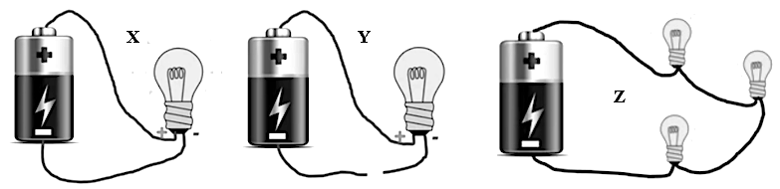
X Y
Z

Which statement about the intensity of the globes in these circuits is correct?

- The globes in circuit Z will glow most brightly.
- The globes in circuits X and Y will glow equally brightly.
- The globe in circuit Y will not glow.
- The globes in circuit Z will be brighter closer to the positive terminal of the battery.

- The diagram below shows stages in the replication of DNA.

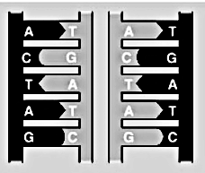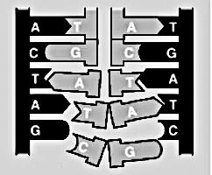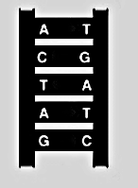
W
X
Y
Z

What is the correct replication sequence?

- Y X Z W
- W X Z Y
- Y Z W X
- X W Z Y

- The diagram provides genetic information about the inheritance of eye colour.

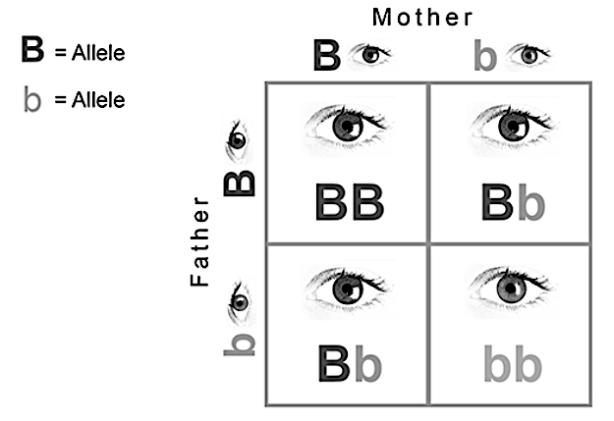

Allele for brown =

Allele for blue =

What does this diagram tell us?

- The allele for brown eyes is dominant and 75% of offspring will have brown
eyes.
- The allele for brown eyes is recessive and 25% of offspring will have brown
eyes.
- The allele for blue eyes is dominant and 25% of offspring will have blue eyes.
- The allele for blue eyes is dominant and 75% of offspring will have blue eyes.

- Consider the cartoon.

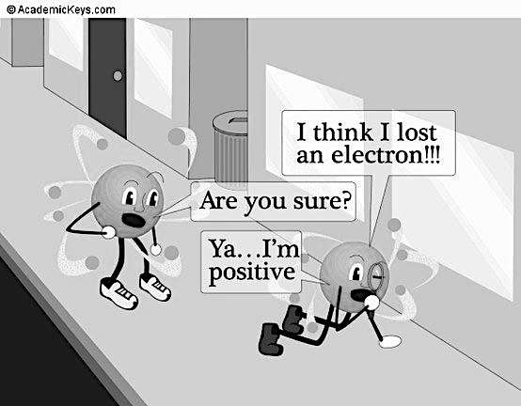

In what process do atoms transfer electrons?

- Formation of covalent bonds
- All chemical reactions
- Changing state
- Formation of ionic bonds

- The diagram depicts two chemicals before and after being reacted together.

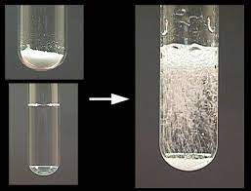
Sodium carbonate
Dilute acid

Which statement is correct?

- If the acid is hydrochloric acid, the gas given off is hydrogen.
- If the acid is hydrochloric acid, the gas given off is carbon dioxide.
- If the acid is sulfuric acid, the gas given off is sulfur dioxide.
- If the acid is sulfuric acid, the gas given off is hydrogen.

- Which of the following is NOT evidence for Darwin’s theory of evolution?

- The fossil record in rock
- The similarities in embryo structure
- The decrease in global chimpanzee numbers
- The geographic distribution of related species

- Why is genetic variation an advantage for the long-term survival of a species?

- It allows choice for a mate to find the best partner.
- It means a species can get stronger and stronger over generations.
- If offspring are different, then parents can choose the strongest to survive.
- If conditions change, some will have features suited to the new conditions.

- The diagram shows a section of the Periodic Table of the elements.

Which of the elements shown in this section is most chemically active?

- He
- O
- F
- P

- The diagram shows world usage of different energy sources.

Wind
Hydro
Nuclear
Fossil fuel

What percentage of the pie graph is nuclear sources?

- About 6%
- About 11%
- About 17%
- About 25%

- The graphs show information about global changes in temperature, CO₂ gas concentration and sea level over a long period of time until the present day.

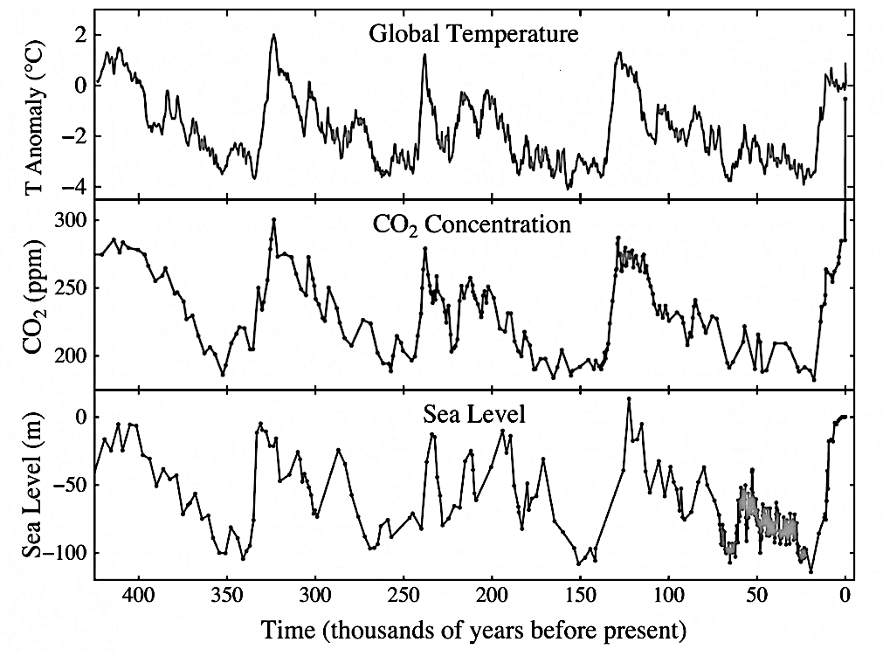

According to the data, which of the following is a valid statement?

- Sea level rises are closely related to global temperature.
- The three variables correlate as they have the same cause.
- Rises in sea levels soon lead to rises in the other two variables.
- The CO₂ levels in modern times have been inaccurately recorded.
- The diagram shows zinc granules reacting with hydrochloric acid.

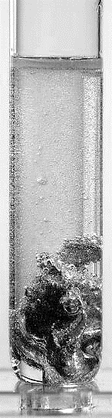

Which variable will NOT affect the rate of this reaction?

- The concentration of the acid
- The temperature of the reaction mixture
- The size of the zinc granules
- The size of the test tube

- The table shows the results of an experiment.

 | Amount of X (g) | Concentration of Y (units) | Amount of XY formed after 5 minutes (g)
 | 5 | 0.5 | 0.5
 | 5 | 1.0 | 1.5
 | 5 | 1.5 | 3.5
 | 5 | 2.0 | 7.0
 | 5 | 2.5 | 11.0

Which graph best shows these results?
Amount of XY
Concentration of Y
Amount of XY
Concentration of Y
Amount of XY
Concentration of Y
Amount of XY
Concentration of Y
- B.

C. D.

- The cartoon shows a science teacher attempting to demonstrate a law of physics.

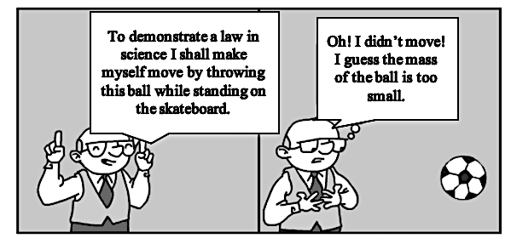

Which law was the teacher wanting to demonstrate?

- Newton’s first law
- Newton’s second law
- Newton’s third law
- The law of conservation of energy

- The diagram shows steps in human reproduction.

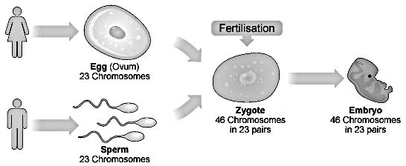
W
X
Y
Z
Which alternative correctly identifies W, X, Y and Z?

 | W | X | Y | Z
A. | Ovum | Zygote | Embryo | Sperm
B. | Ovum | Embryo | Zygote | Sperm
C. | Embryo | Ovum | Zygote | Sperm
D. | Sperm | Zygote | Embryo | Ovum
- Use the information below to answer Question 16.

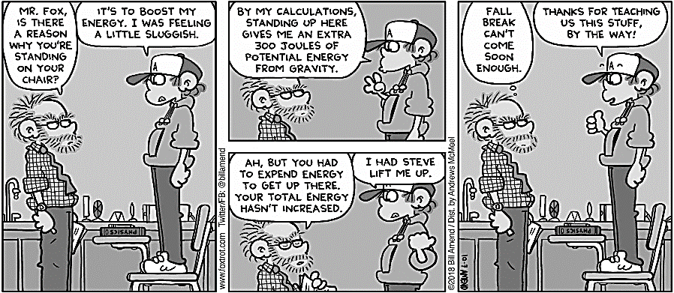
Smith! Why are you standing on that chair?
I was feeling tired and needed to boost my energy, sir.
I calculate I have an extra 350 joules of energy up here.
Noooo! You had to use energy to get up there!!!
No, Sir! Bill lifted me up.
Holidays can’t come soon enough.
Physics is good, eh Sir!

Which alternative states the physics correctly applied by both the teacher and the student?

 | From the teacher’s comments | From Smith’s comments
A. | Movement decreases kinetic energy. | Higher objects have more energy.
B. | Work done against gravity requires energy. | The needed work was done by an external source.
C. | Energy changes don’t always involve increases in kinetic energy. | Moving upwards always involves an increase in energy.
D. | Your energy changes if you change position. | Energy must be conserved.

- Which graph shows the motion of an accelerating object?
Distance
Time
K
Distance
Time
L
Distance
Time
M
Distance
Time
N

- Graph K
- Graph L
- Graph M
- Graph N

- The diagram below shows the variation in brightness of two objects observed by an astronomer through a telescope. The smaller object orbits the larger one. It was determined that this could either a binary star system or a star/planet system.

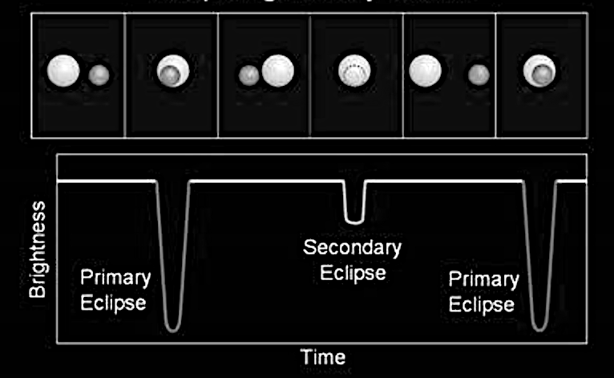
X
W
Y
Z

- It is a planet/star system as the planet is seen orbiting the star in photo 1 and 5.
- It is a binary star because the brightness decreases when the smaller object is eclipsed by the larger star (position Y) and when the larger star is partially eclipsed
by the smaller star (position X and Z).
- It is a planet/star system as stars do not orbit each other.
- It is a binary star because the brightness increases when the smaller object is eclipsed by the larger star (position Y) and when the larger star is partially eclipsed
by the smaller star (position X and Z).

- The diagram shows a simple electric circuit.

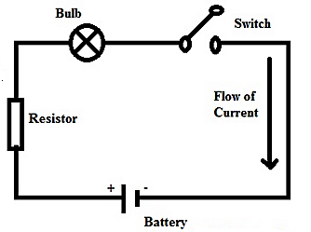

The light bulb is removed from the circuit, the wires reconnected and the switch is closed.

Which of the following is correct?

- The circuit current will increase.
- The voltage of the battery will decrease.
- The circuit current does not change.
D. The battery will no longer lose energy.

- Four students make statements about the energy changes in a rear end car collision.

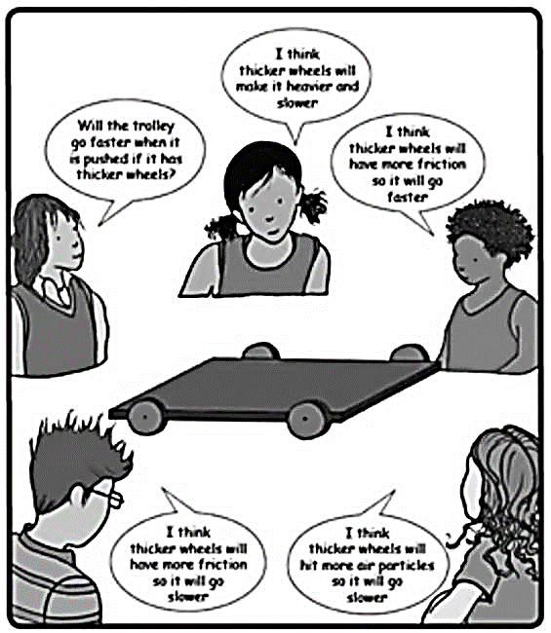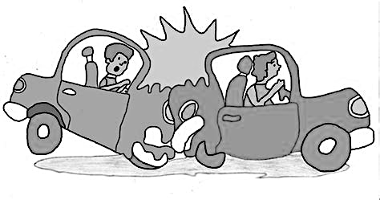
Energy is not conserved because the cars slow down.
Energy is conserved because the rear car transfers all its energy to the front car.
Total energy is always conserved in interactions like this.
Energy is not conserved because the cars stop.
I have no idea!
Bria
Ian
Rebecca
Sue
Fay

Who makes a correct statement?

- Rebecca
- Sue
- Fay
- Ian

Section I – continued

Part B – 10 marks
Attempt Questions 21–30

Answer the questions in the spaces provided.

21 What is biodiversity? 1

22 How would we classify the reaction type represented by this equation? 1

CaCO₃(s) $\underset{→}{\text{Heat}}$ CaO(s) + CO₂(g)

23 What type of bond connects the atoms in the compound shown in the diagram below? 1

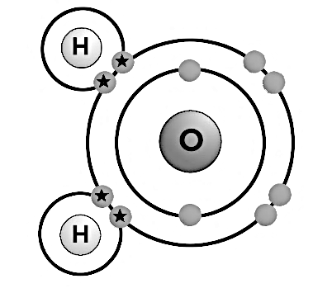

24 Where does an important chemical reaction involving acid occur in the bodies of 1
humans?

25 Energy transfers are never 100% efficient. 1

What is usually the cause?

Use the information in the diagram below to answer Questions 26 and 27.

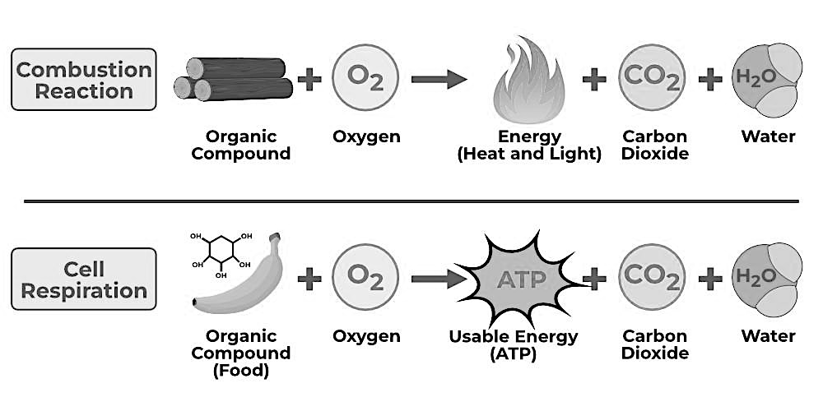

26 What is the missing product in both chemical reactions shown? 1

27 What important difference between the reactions is not shown in the diagram? 1

28 What type of heat transfer cooks the food in this BBQ? 1

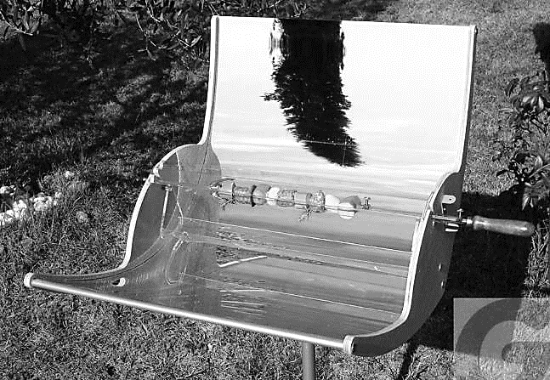

29 What theory is the diagram below modelling? 1

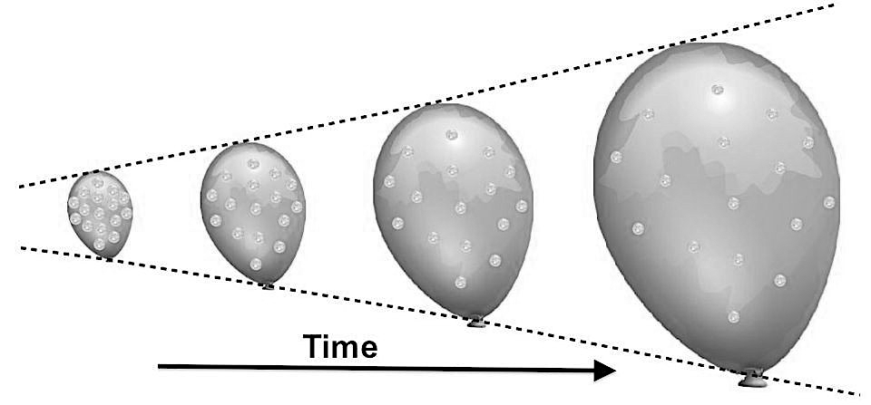

30 What happens to the kinetic energy of a ball thrown upwards into the air? 1

Section II

20 marks
Attempt Questions 31–35
Allow about 25 minutes for this section

Answer the questions in the spaces provided.

Question 31 (3 marks)
The diagram shows the plotted results and graph drawn for a liquid heated at a constant rate.

(a) Identify any errors in the graph drawn. 2

(b) Draw the correct graph on the same axes above. 1

Question 32 (3 marks)

Read the article below about deforestation. 3

Deforestation or forest clearance is the removal of a forest or stand of trees from land that is then converted to non-forest use. The United Nations Food and Agriculture Organization estimates that humans— that is, the corporations and industries they manage—cleared over 1 billion acres of forest to make way for mines, cattle grazing, and industrial sprawl. And, out of all the industries that drive global deforestation, animal agriculture is one of the biggest culprits.

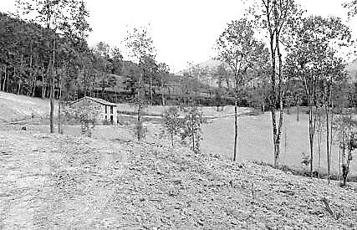 | 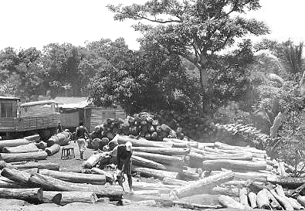
Land clearing | Illegal logging
Trees absorb and store carbon dioxide. In one year, a mature tree will absorb more than 20 kilograms of carbon dioxide from the atmosphere and release oxygen in exchange. As a consequence, forest loss and damage is the cause of around 10% of the global warming that has occurred. Other consequences are changes in the water cycle, soil erosion and the loss of biodiversity through damage to natural habitats.

Discuss the reasons why THREE different groups of people in society may differ in their evaluation of the consequences caused by deforestation of a particular area of forest.

Question 33 (4 marks)

Scientists developing antibiotics did an experiment to test the effectiveness of three new antibiotics X, Y and Z against a bacterium. They grew the bacteria on agar jelly in 20 petri dishes until the bacteria formed a “carpet” of bacteria totally covering the agar. They then took small identical filter paper discs, four for each Petri dish and treated them as shown in the table (80 discs in all).

Disc | Disc soaked in solution of
1 | Antibiotic X
2 | Antibiotic Y
3 | Antibiotic Z
4 | None

Four discs were placed on the “carpets” of bacteria in each dish and the 20 identical petri dishes were placed in an incubator for three days. The results were similar for each petri dish, as shown below.

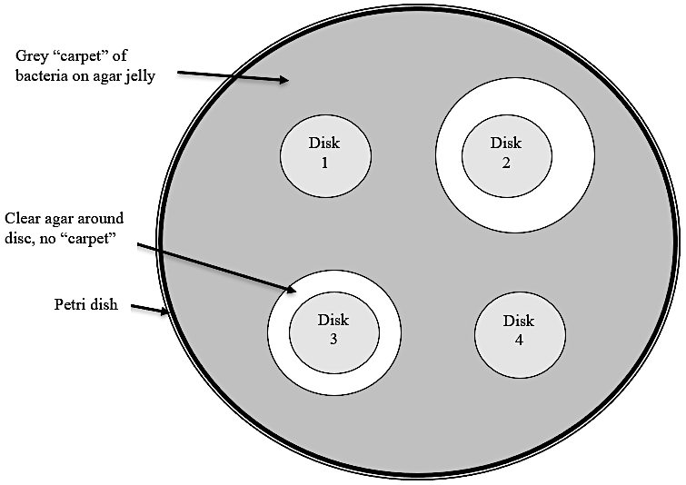

Question 33 continues on page 22

Question 33 (continued)

(a) Write a conclusion for the experiment. 2

(b) What was the purpose of disc 4? Justify your answer. 1

(c) Why were 20 dishes used? 1

End of Question 33

Question 34 (4 marks)

The diagram shows an electrical circuit diagram of a student’s experiment.

X
Y
A
12 V

(a) Describe this circuit so that someone else could connect it without having the circuit 2
diagram.

(b) In the box next to the circuit above, draw another circuit diagram with resistors X and 2
Y connected in parallel, and the ammeter connected so that it measures the current
through resistor X.

Question 35 (6 marks)

Students investigated the growth of lichen on trees. They placed a 10 cm × 10 cm transparent grid (area 100 cm²) on the trunks of 10 trees in the school grounds and counted how many 1 cm squares of the grid had lichen growing in them. Students took 10 readings on the north facing sides of ten different trees and another 10 readings on the south facing sides of the same trees.

The table shows their results.

Tree number | Percentage cover of grid square on north side | Percentage cover of grid square on south side
1  2  3  4  5  6  7  8  9  10 | 55  64  73  43  56  49  67  48  50  58 | 22  48  32  37  43  41  36  28  25  18

Question 35 continues on page 25

Question 35 (continued)

(a) What difference in the environment of the lichen on the north and south side of the 1
trees could be responsible for the difference in the percentage cover of the grid squares on the two sides?

(b) The grid shown below is for a tree not included in the 10 trees above. 2

Bark with lichen over it
Bark with no lichen over it

On which side of the tree was the grid most likely to have been? Justify your answer.

(c) How could the experiment be improved? 3

End of paper

