

Student Name:

Mathematics Year 7 2023
Assessment Task 2

General Instructions  - 5 minutes reading time given.  - Working time – 70 minutes.  - Show all necessary working / units.  - Exam guidelines  - Use black pen for your working.  - Use a pencil and ruler for diagrams.  - Do not use liquid paper/white out tape.  - Marks may be lost for poorly organised written work. | Total Marks – 60 marks  Section 1  Calculator work – 15 marks  Section 2  Multiple Choice - 10  Basic Number Review and Integers - 16  Angle relationships - 9  Fractions, Decimals and  Percentages - 10

Examiner’s Use Only Luo, Hua, Chan, Vincent, Le, Barter
Question | Basic Number Review | Positive & Negative Integers | Angle relationships | Fractions, decimals and percentages | Total
1, 2, 5, 7, 11a, 11f | /7
4, 11b, 11e |  | /6
6, 9, 11g, 12 |  |  | /13
3, 8, 10, 11c, 11d, 13 |  |  |  | /19
Calculator work |  |  |  |  | /15
Total |  |  |  |  | /60

Section 2 – Multiple Choice
10 marks
Attempt Questions 1-10

1. Add the product of 14 and 3 to the sum of 11 and 9. What is the answer?

(A) 27
(B) 47
(C) 52
(D) 62

2. What is the place value of 6 in the number 346 799?
(A) ones
(B) tens
(C) hundreds
(D) thousands

3. Round off 431.875 to two decimal places.
(A) 432.00
(B) 431.90
(C) 431.86
(D) 431.88

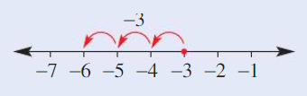
4. The matching problem to this number line is:

(A) - 6 + (-3) = -9

(B) -3 + (-3) = -6

(C) −6 + (−2) = −4

(D) −4 + (– 2) = −6

5. Which expression is equal to 23 × 23 – 7 × 23?

(A) 7 × 16

(B) 9 × 23

(C) 23 × 23

(D) 16 × 23

6. What type of angle is ∠AOB ?

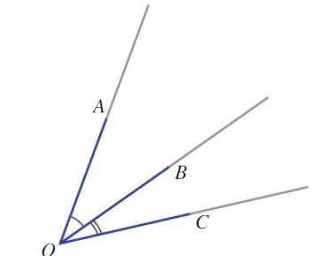

(A) acute

(B) revolution

(C) reflex

(D) obtuse

7. What is the lowest common multiple of 8 and 20?

(A) 2

(B) 4

(C) 40

(D) 120

8. Which of the following numbers is the largest?

(A) $\frac{7}{10}$

(B) $\frac{3}{5}$

(C) $\frac{2}{7}$

(D) $\frac{2}{3}$

9. Co-interior angles are:

(A) the same as right angles.

(B) always different.

(C) equal to 180° when added together.

(D) equal to 360° when added together.

10. In which diagram is five-twelfths shaded?

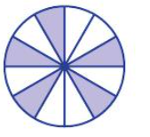
(A)

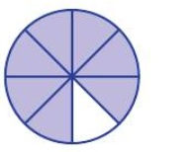

(B)

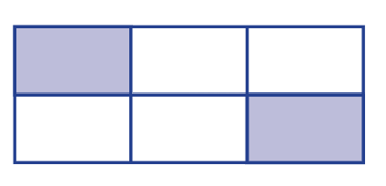
(C)

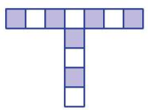
(D)

Short answer questions
Answer the questions in the spaces provided. Your responses should include relevant mathematical reasoning and/or calculations.
Marks cannot be awarded for poorly organised written work.

Question 11 (Number theory and integers) (16)

(a) Arrange these numbers in ascending order. (1)
- 5 , 12 , 0 , - 8 , 5

…………………………………………………………………………………………………..

…………………………………………………………………………………………………..

(b) Solve these problems: (2)

- Start with an integer, 3, subtract 9 from it and multiply the result by -2. What is the answer?

………………………………………………………………………………………………….

………………………………………………………………………………………………….

…………………………………………………………………………………………………..

- I am a negative number divisible by 5 and greater than -7. What am I?
………………………………………………………………………………………………….

………………………………………………………………………………………………….

………………………………………………………………………………………………….

(c) What percentage is $7 of $20? (1)

…………………………………………………………………………………………………..

…………………………………………………………………………………………………..

…………………………………………………………………………………………………..

…………………………………………………………………………………………………..

………………………………………………………………………………………………….

(d) Evaluate the following expressions

i) $\frac{1}{3} ×36.9$ (1)

…………………………………………………………………………………………………..

…………………………………………………………………………………………………..

ii) $101+\left(-25\right) ÷5$ (1)

…………………………………………………………………………………………………..

…………………………………………………………………………………………………..

iii) $- 16 ÷\left(7-3\right)+8 ×2$ (1)

………………………………………………………………………………………………….

………………………………………………………………………………………………….

iv) What is the Highest Common Factor of 6, 15 and 42? (2)

………………………………………………………………………………………………….

…………………………………………………………………………………………………

(e) i) Insert < , = or > to make the following equation true. (1)

9 × 2 20 – 2 × 3

ii) Find the value of $(- 2-5) ×(8 ÷ -1)+\left(-4\right)+(-7)$ (2)

………………………………………………………………………………………………….

…………………………………………………………………………………………………

………………………………………………………………………………………………….

(f) i) Emma earns $20.80 per hour. How much does she earn in 3 hours? (1)

………………………………………………………………………………………………….

………………………………………………………………………………………………….

ii) Emma uses her earnings to buy a t-shirt that costs $31.50. How much money does she have left? (1)

………………………………………………………………………………………………….

………………………………………………………………………………………………….

(g) i) Plot the points listed on the number plane below.
A (−1, 4), B (1, 1), C (- 1, - 2), D (−3, 1) (1)

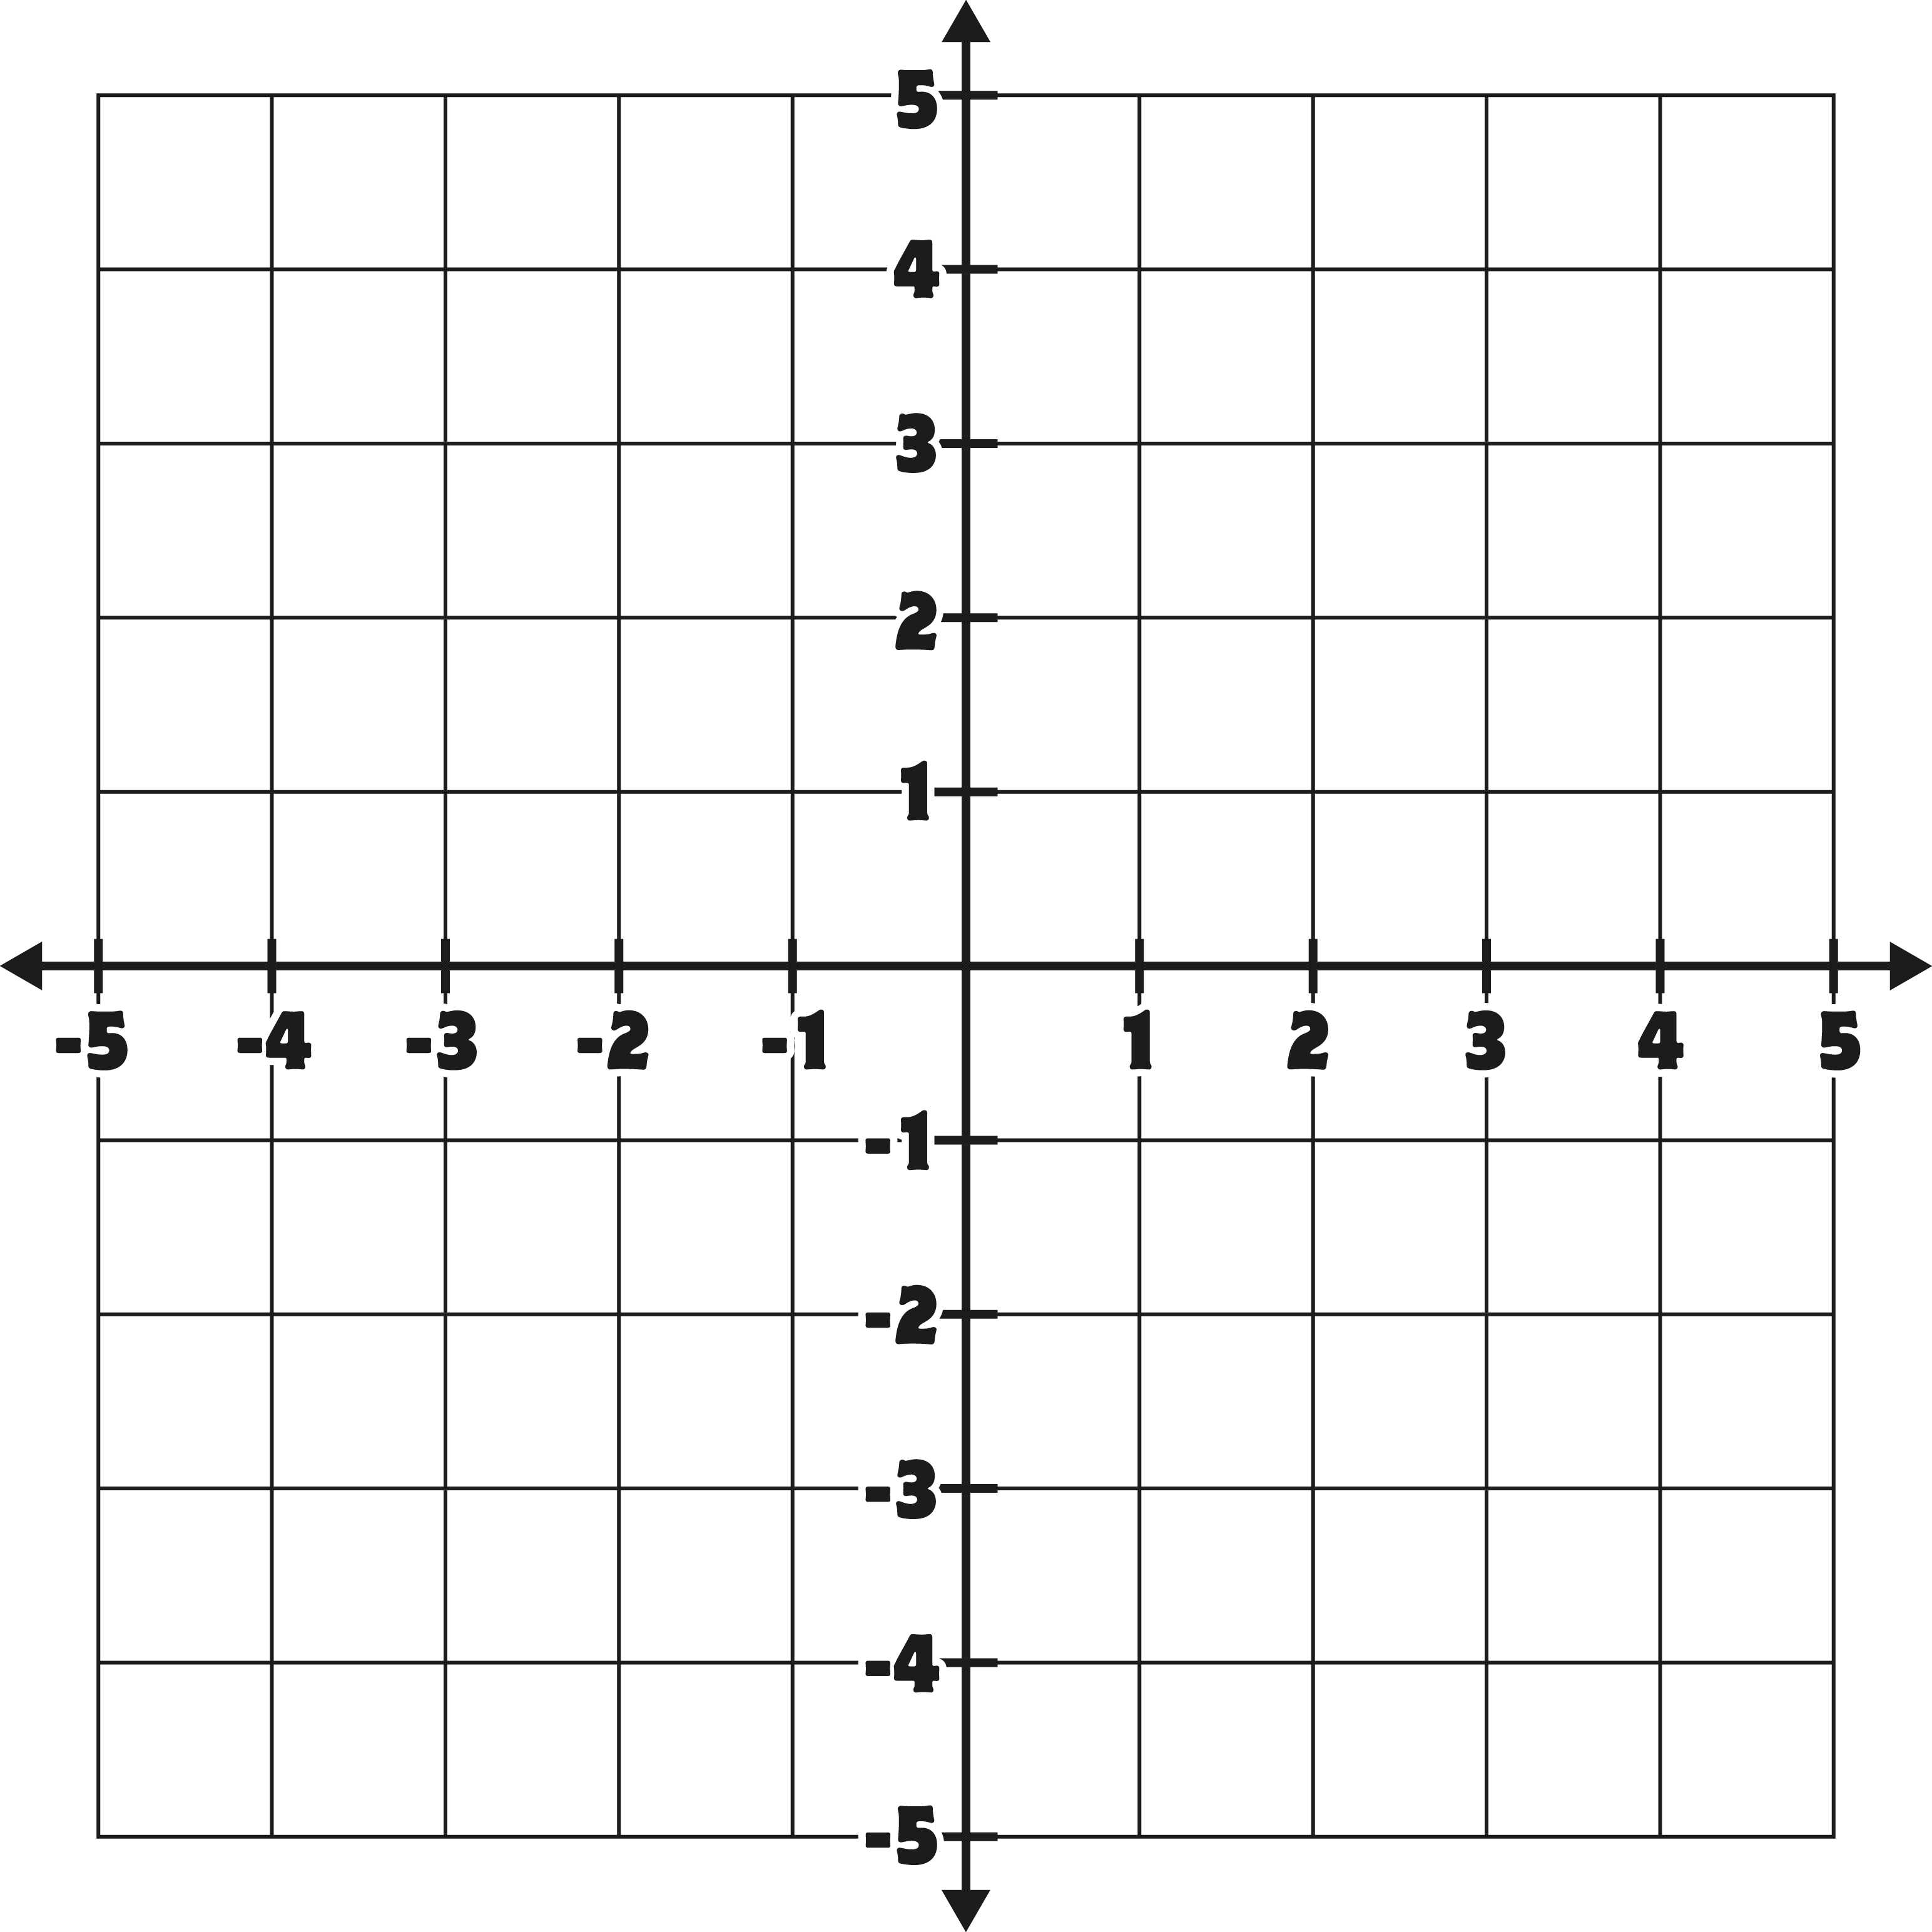

ii) Connect the points from A to B to C to D to A and name the shape that is formed (1)

………………………………………………………………………………………….

Question 12 (Angle relationships) (9)

(a) Consider this diagram:

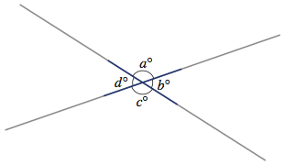

i) If a° is 110°, name another angle that is equal to a°. (1)

_____________________________________________________________

ii) Why are b° and d° equal? Give one reason. (1)

_____________________________________________________________

(b) Determine the size of the unknown angle shown in the diagram. Reasons must be provided.
- What is the value of the angle $x°$ ? Give a reason for your answer. (2)

118°
B
C
D
E
A

$$x°$$

…………………………………………………………………………………………………

………………………………………………………………………………………………….

………………………………………………………………………………………………..

- What is the value of the angle $y°$? Give a reason for your answer. (2)

A
B
C
D
E
F
G
H
$$110°$$

$$y°$$

…………………………………………………………………………………………………

………………………………………………………………………………………………….

………………………………………………………………………………………………..

iii) What is the value of the angle $a°$? Give reasons for your answer (3)

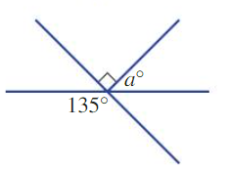

…………………………………………………………………………………………………

………………………………………………………………………………………………….

………………………………………………………………………………………………..

…………………………………………………………………………………………………

………………………………………………………………………………………………….

………………………………………………………………………………………………..

Question 13 (Fractions, decimals and percentages) (10)

(a) Write the following fraction in simplest form

i) $\frac{70}{14}$ (1)

…………………………………………………………………………………………………..

…………………………………………………………………………………………………..

…………………………………………………………………………………………………..

ii) Place the following fractions in descending order. (2)
$\frac{5}{6},\frac{1}{3},\frac{2}{9}$
………………………………………………………………………………………………….

…………………………………………………………………………………………………..

…………………………………………………………………………………………………..

(b) Convert $106 \%$into a fraction in its simplest form. (1)

…………………………………………………………………………………………………..

…………………………………………………………………………………………………..

(c) Write $\frac{6}{8}$as a decimal. (1)

…………………………………………………………………………………………………..

…………………………………………………………………………………………………..

…………………………………………………………………………………………………..

(d) One fraction is subtracted from another. The answer is $\frac{7}{15}$ . If one fraction is $\frac{1}{3}$ , what is the other fraction? (2)

………………………………………………………………………………………………….

………………………………………………………………………………………………….

…………………………………………………………………………………………………

(e) Find $30\%$ of 120 kg (1)

…………………………………………………………………………………………………..

…………………………………………………………………………………………………..

…………………………………………………………………………………………………..

…………………………………………………………………………………………………..

(f) i) Convert $\frac{1}{8}$ to a decimal. Round your answer off to 2 decimal places. (1)

…………………………………………………………………………………………………..

…………………………………………………………………………………………………

…………………………………………………………………………………………………

ii) Arrange these from smallest to largest: ½, 0.75, $\frac{5}{8}$, 0.74, 0.99, ¼ (1)

…………………………………………………………………………………………………

…………………………………………………………………………………………………

End of Exam

