

Student Name:

Teacher:

Mathematics Year 7 2022
Assessment Task 2

General Instructions  - No reading time given  - Working time – 75 minutes  - Show all necessary working / units  - Exam guidelines  - Use black pen for your working  - Use a pencil and ruler for diagrams  - Do not use liquid paper/white out tape  - Marks may be lost for poorly organised written work. | Total Marks – 60  Section 1  Calculator work  Section 2  Multiple Choice  Basic Number Review and integers  Angle relationships  Fractions, decimals and  Percentages

Examiner’s Use Only B Vincent,S Ying, E Shing & B Su
Question | Basic Number Review | Positive & Negative Integers | Angle relationships | Fractions, decimals and percentages | Total
1,2,3,4,11a, b, c | /8
5,11, d,e,f |  | /13
6,12 |  |  | /10
7,8,9,10,13 |  |  |  | /14
 |  |  |  | /15
Total |  |  |  |  | /40

Section 2 – Multiple Choice
10 marks
Attempt Questions 1-10
Circle the correct answer on the answer paper for the multiple choice section.

1. The place value of the 4 in the number 5 487 is?

(A) ones
(B) tens
(C) hundreds
(D) thousands

2. Which of these is a multiple of 3?
(A) 12
(B) 19
(C) 35
(D) 71

3. Which one of these numbers is a prime number?
(A) 9
(B) 21
(C) 23
(D) 27

4. The matching problem to this number line is:
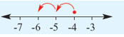

(A) 6 – 4 = 2

(B) −4 − 6 = −10

(C) −6 + (−2) = −4

(D) −4 + (– 2) = −6

5. 8 + (−9) ÷ (−3) evaluates to:

(A) 11

(B) −11

(C) 8

(D)

6. What type of angle is shown in the picture below?

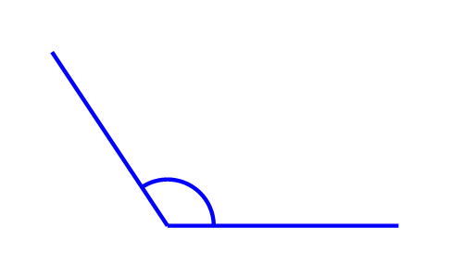

(A) acute

(B) revolution

(C) reflex

(D) obtuse

7. The equivalent fraction of $\frac{4}{24}$ is:

(A) $\frac{1}{2}$

(B) $\frac{1}{6}$

(C) $\frac{2}{48}$

(D) $\frac{4}{14}$

8. $\frac{4}{5}$ is the same as:

(A) $75\%$

(B) $80\%$

(C) $120\%$

(D) $65\%$

9. $\frac{Δ}{3}$ is a fraction between $2\frac{1}{3}$ and $4\frac{2}{3}$. The largest whole number that $∆$ can be is:

(A) 13

(B) 26

(C) 15

(D) 16

10. In which diagram is one-third shaded?

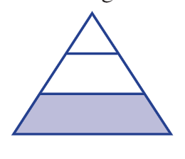

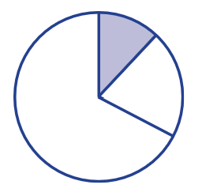
(B)

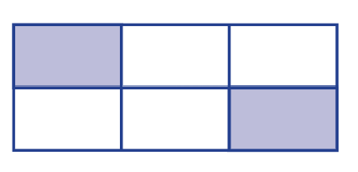
(C)

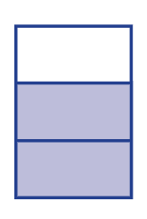
(D)

Short answer questions
Answer the questions in the spaces provided. Your responses should include relevant mathematical reasoning and/or calculations.
Marks cannot be awarded for poorly organised written work.

Question 11 (Number theory and integers) (16)

(a) Write the following numbers in descending order. (1)
3678, 873, 7008, 387

…………………………………………………………………………………………………..

…………………………………………………………………………………………………..

(b) Arrange these numbers in columns, then add them (2)

$465+4012+72$

………………………………………………………………………………………………….

………………………………………………………………………………………………….

…………………………………………………………………………………………………..

………………………………………………………………………………………………….

………………………………………………………………………………………………….

………………………………………………………………………………………………….

(c) Evaluate $846÷3$ (1)

…………………………………………………………………………………………………..

…………………………………………………………………………………………………..

…………………………………………………………………………………………………..

…………………………………………………………………………………………………..

………………………………………………………………………………………………….

(d) Evaluate the following expressions

i) $-3×5$ (1)

…………………………………………………………………………………………………..

…………………………………………………………………………………………………..

ii) $-84÷\left(-12\right)+14$ (1)

…………………………………………………………………………………………………..

…………………………………………………………………………………………………..

iii) $-21-\left(-9\right)$ (1)

………………………………………………………………………………………………….

………………………………………………………………………………………………….

iv) Find the value of $8-(1-7×3)÷4$ (2)

………………………………………………………………………………………………….

…………………………………………………………………………………………………

(e) i) Insert brackets to make the following equations true. (1)

$8+7×6-3×4=78$

ii) Find the value of $10+(45÷\left(7+2\right))×8$ (2)

………………………………………………………………………………………………….

…………………………………………………………………………………………………

………………………………………………………………………………………………….

(f) i) The temperature one morning in Antarctica is –27°C. During the day, the temperature reaches a maximum of –16°C. By how much has the temperature risen? (1)

………………………………………………………………………………………………….

………………………………………………………………………………………………….

ii) After a maximum of –16°C, the temperature then drops by 14°C. What is the temperature now? (1)

………………………………………………………………………………………………….

………………………………………………………………………………………………….

(g) i) Plot the points listed on the number plane below.
A (−3, 0), B (−2, 2), C (3, 0), D (−2, −2) (1)

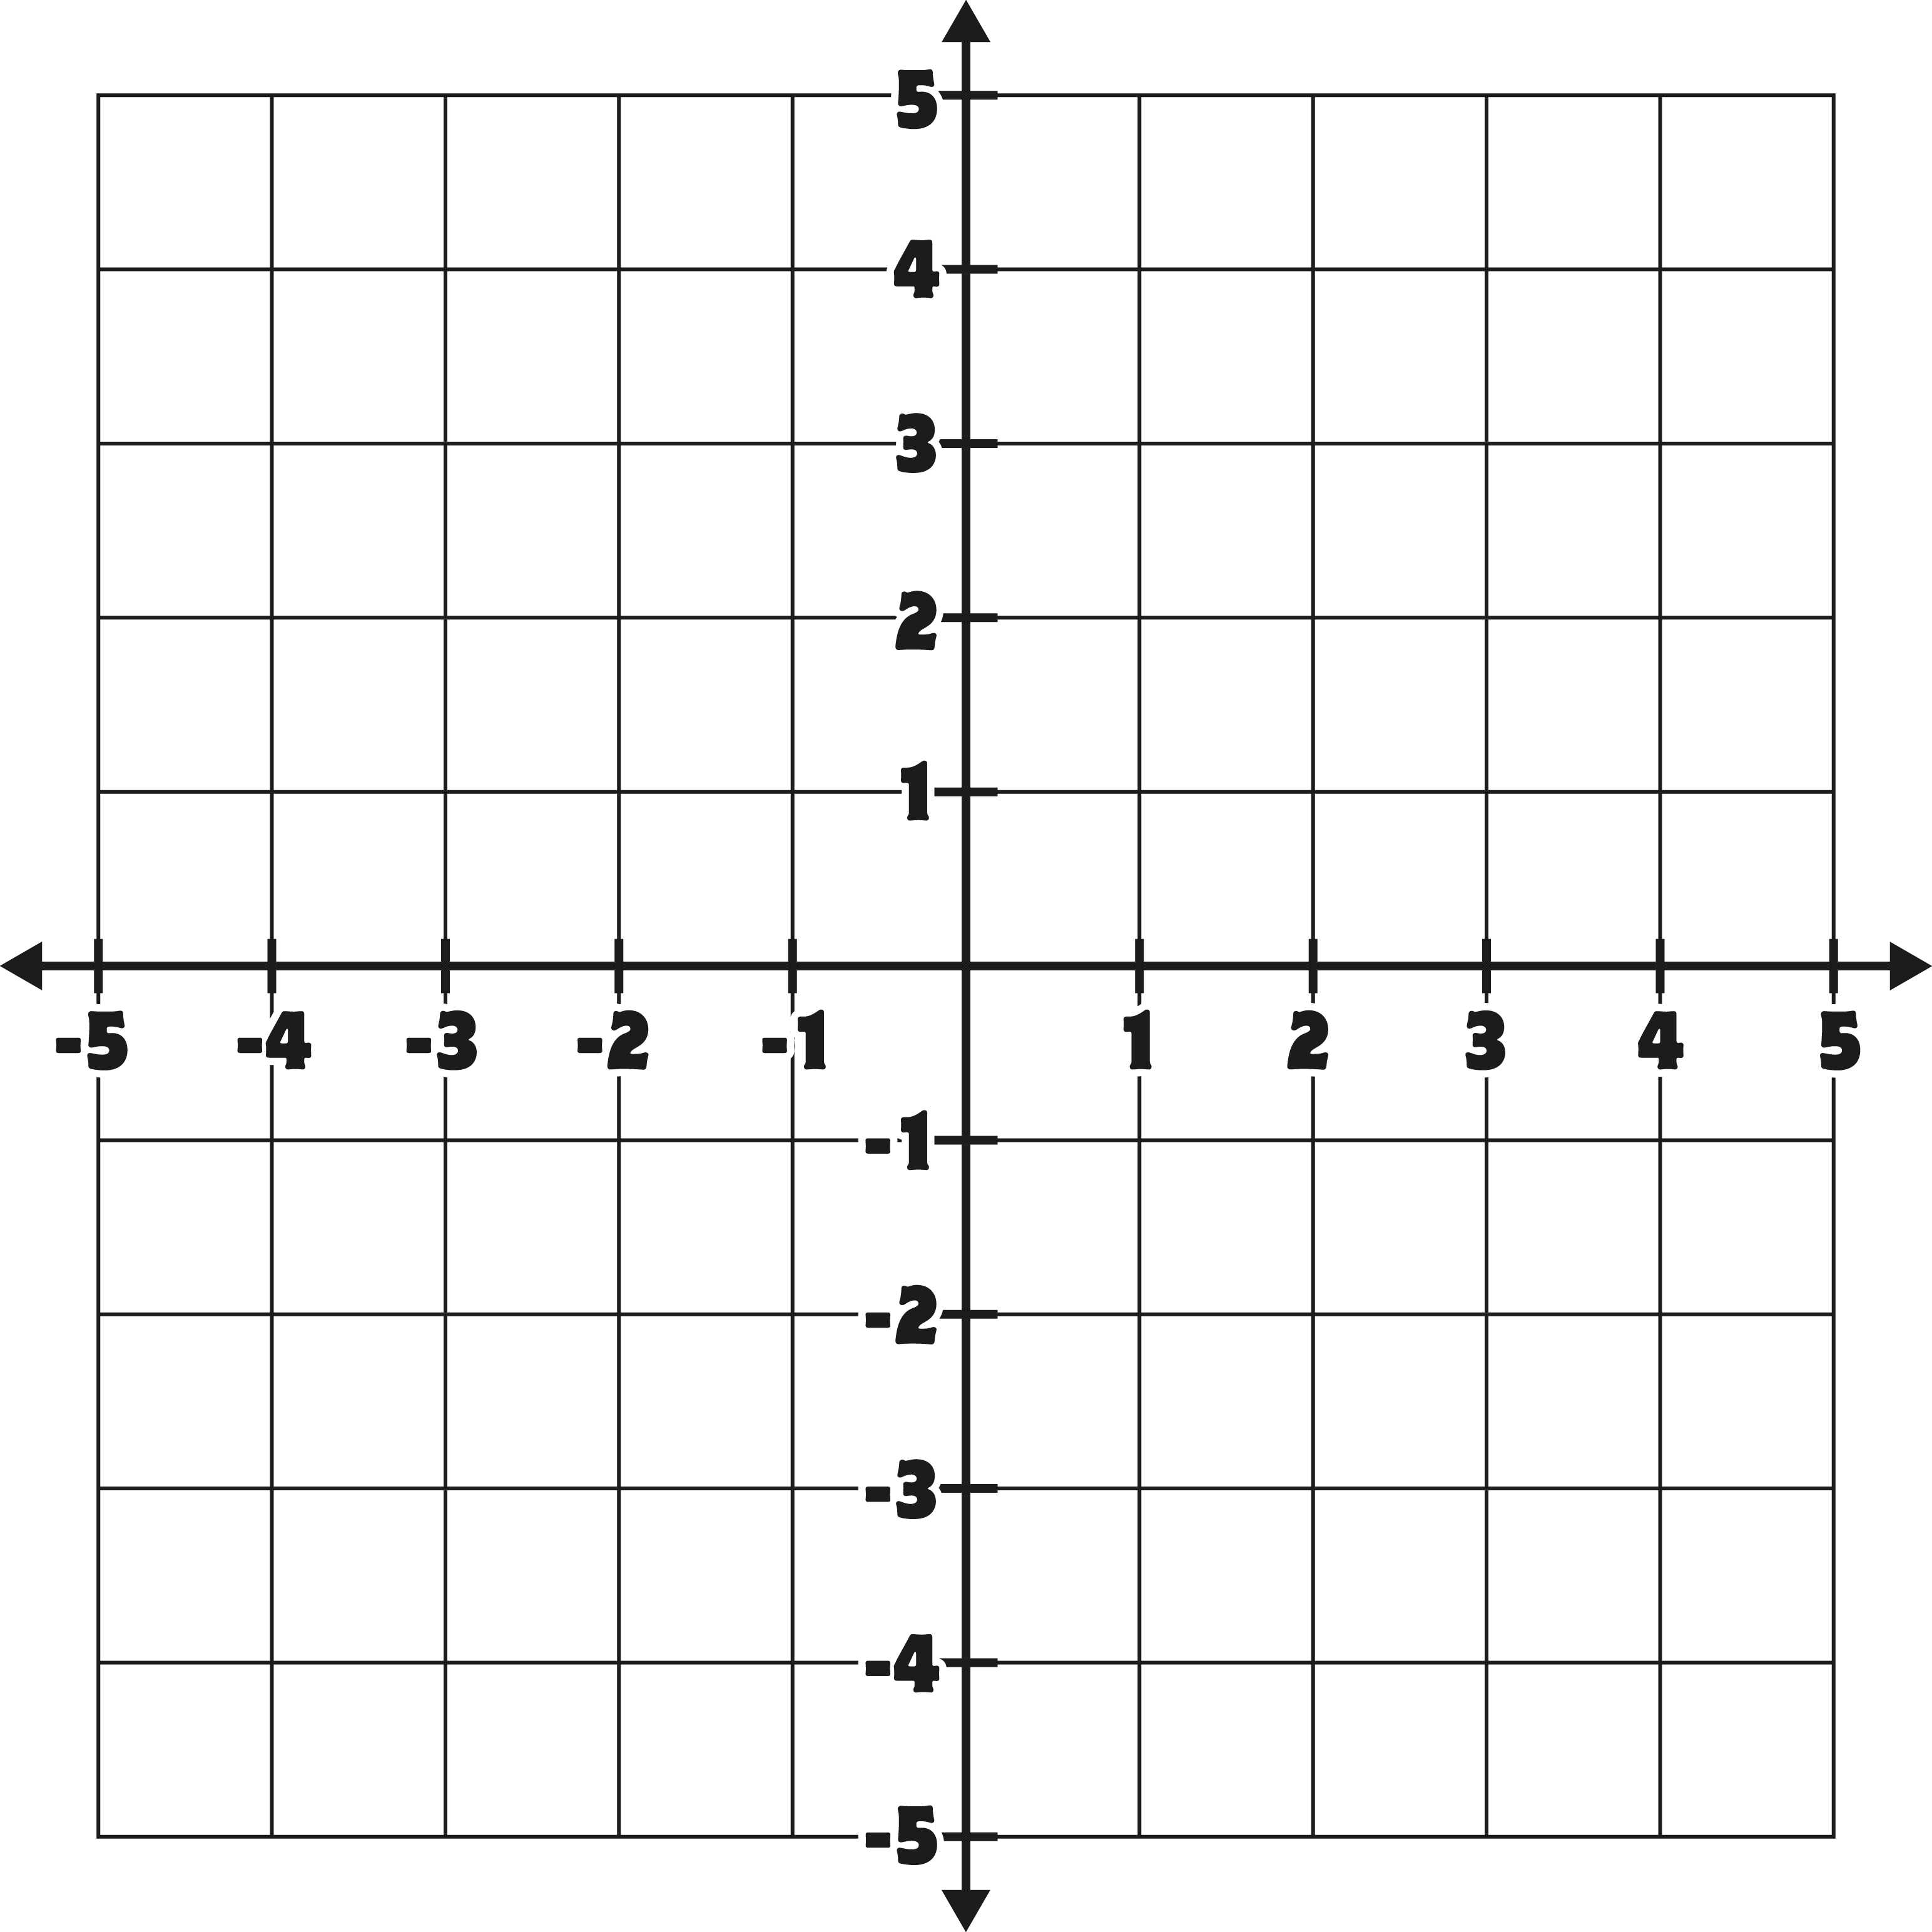

ii) Connect the points from A to B to C to D to A and name the shape that is formed (1)

………………………………………………………………………………………….

Question 12 (Angle relationships) (9)

(a) Consider this diagram:

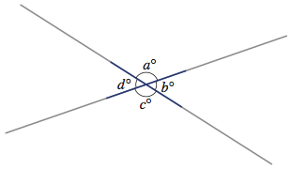

i) Name the angle that is complementary to a°. (1)

_____________________________________________________________

ii) Name the angle that is vertically opposite b°. (1)

_____________________________________________________________

(b) Determine the size of the unknown angle shown in the diagram. Reasons must be provided.
- What is the value of the angle $x°$ ? Give a reason for your answer. (2)

$$115°$$
$$x°$$
B
C
D
E
F
G
H
A

…………………………………………………………………………………………………

………………………………………………………………………………………………….

………………………………………………………………………………………………..

- What is the value of the angle $y°$? Give a reason for your answer. (2)

$$y°$$

A
B
C
D
E
F
G
H
$$110°$$

…………………………………………………………………………………………………

………………………………………………………………………………………………….

………………………………………………………………………………………………..

iii) What is the value of the angle $b°$? Give reasons for your answer (3)

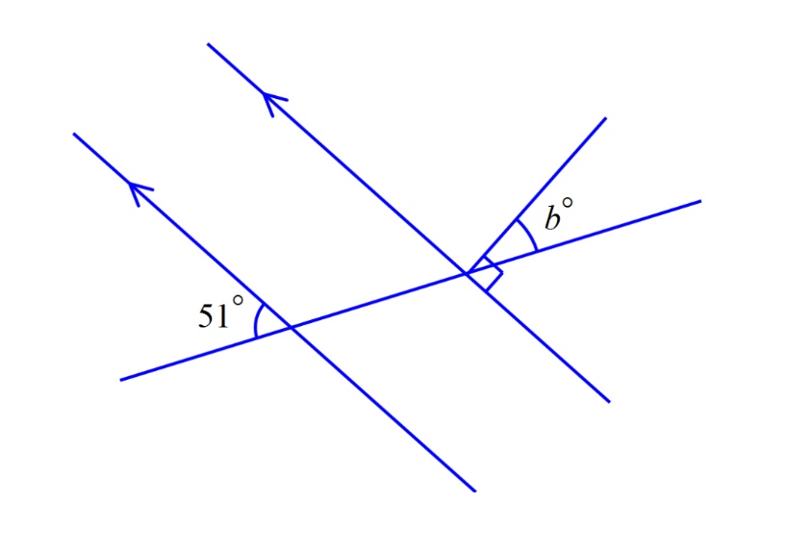

…………………………………………………………………………………………………

………………………………………………………………………………………………….

………………………………………………………………………………………………..

…………………………………………………………………………………………………

………………………………………………………………………………………………….

………………………………………………………………………………………………..

Question 13 (Fractions, decimals and percentages) (10)

(a) Evaluate the following, giving your answer in simplest form

i) $\frac{3}{4}+\frac{5}{12}$ (1)

…………………………………………………………………………………………………..

…………………………………………………………………………………………………..

…………………………………………………………………………………………………..

ii) $2\frac{1}{3}÷1\frac{1}{6}$ (2)

………………………………………………………………………………………………….

…………………………………………………………………………………………………..

…………………………………………………………………………………………………..

(b) Convert $65\%$into a fraction in its simplest form. (1)

…………………………………………………………………………………………………..

…………………………………………………………………………………………………..

(c) Write $0.025$as a fraction in its simplest form. (1)

…………………………………………………………………………………………………..

…………………………………………………………………………………………………..

…………………………………………………………………………………………………..

(d) The sum of two fractions is $\frac{12}{15}$ . If one fraction is $\frac{1}{3}$ , what is the second fraction? (2)

………………………………………………………………………………………………….

………………………………………………………………………………………………….

…………………………………………………………………………………………………

(e) Find $15\%$ of 500 kg (1)

…………………………………………………………………………………………………..

…………………………………………………………………………………………………..

…………………………………………………………………………………………………..

…………………………………………………………………………………………………..

(e) i) Convert $\frac{3 }{11}$ to a decimal. Round your answer off to 4 decimal places. (1)

…………………………………………………………………………………………………..

…………………………………………………………………………………………………

…………………………………………………………………………………………………

iii) Given that $\frac{3}{11}$ converts to a recurring decimal, what is the digit which is in the 15th decimal place? (1)

…………………………………………………………………………………………………

…………………………………………………………………………………………………

End of Exam

