
Map Skills - Bearing and Direction practice
Use the following Map to answer the questions.
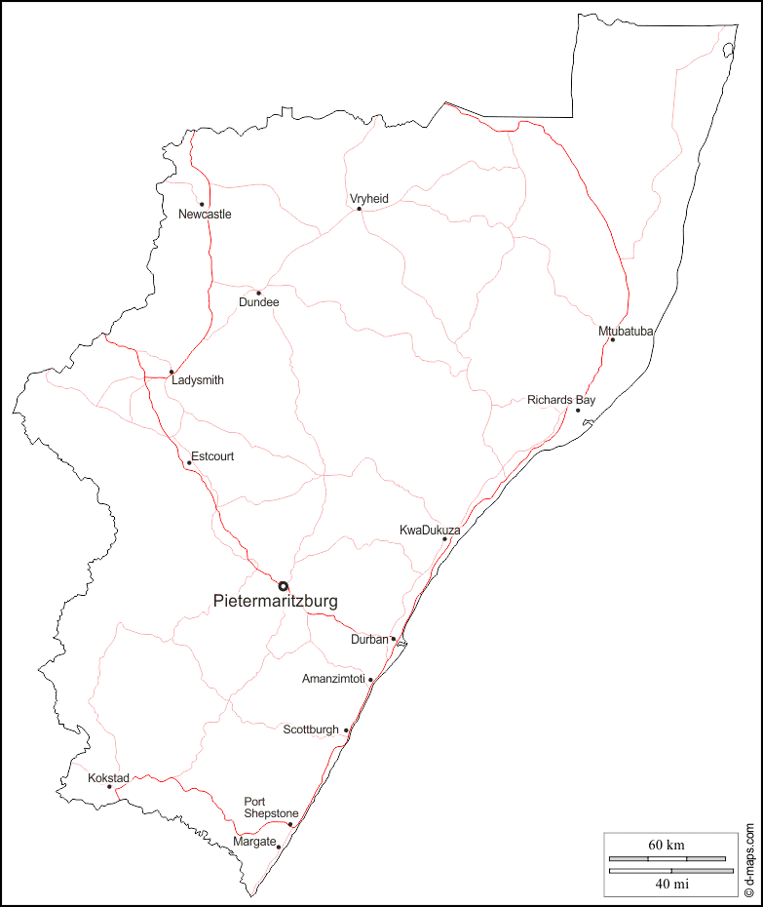
Bearing
- Calculate the bearing of Richards Bay from Durban.
- Calculate the bearing from Dundee to Ladysmith.
- Calculate the bearing from Mtubatuba to KwaDukuza.
- Calculate the bearing to Kokstad from Port Shepstone.
- Calculate the bearing from Escourt to Richards Bay.
- Calculate the bearing of Scottburgh from Kokstad.
Direction
- Calculate the direction of Richards Bay from Durban.
- Calculate the direction from Dundee to Ladysmith.
- Calculate the direction from Mtubatuba to KwaDukuza.
- Calculate the direction to Kokstad from Port Shepstone.
- Calculate the direction from Escourt to Richards Bay.
- Calculate the direction of Scottburgh from Kokstad.

