Map Skills Practice
Bearing, Direction, Distance, Map interpretation

Use Figure 1: Map of North America, to answer the questions which follow. Remember to show ALL your working.
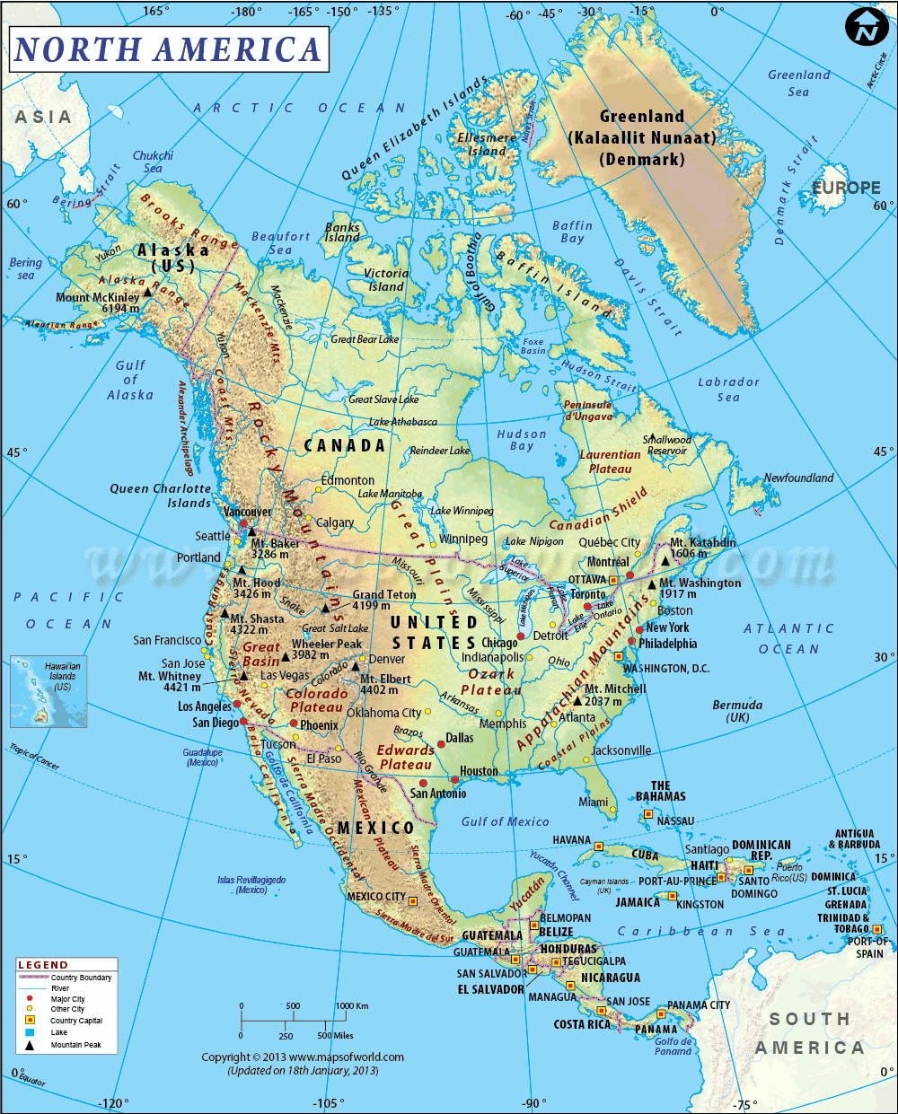
Figure 1
1:50 000 000

- On the map of North America, label the elements of BOLTSS.
- Give the direction of Houston from Phoenix
- Give the direction of Chicago from Los Angeles
- Give the direction from Vancouver to Toronto
- Give the direction of Mexico City from Panama
- State the bearing of Detroit from New York
- State the bearing of San Antonio from SanDiego
- State the bearing of Jacksonville from Denver
- State the bearing from Havana to Jamaica
- State the bearing of Winnipeg from Ottawa
- Name two types of scales shown on the map
- Write the scale as a word scale
- Name the continent South of North America
- State the country capital of U.S.A
- State the country capital of Jamaica
- Managua is the country capital of
- Name the major mountain range found in North America
- Name the ocean to the east of North America
- Name the continent to the west of North America
- Give the height of Mt. Elbert
- Name the river that runs in to the Beaufort Sea
- Give the height of Mt. Whitney (West Coast)

Distance (show ALL your working)
- Calculate the distance from Dallas to Los Angeles
- Calculate the distance from Ottawa to Washington, D.C
- Calculate the distance from Vancouver to Toronto
- Calculate the distance from Phoenix to New York
- Calculate the distance from San Diego to San Antonio
- Calculate the distance from Havana to Kingston

Use Figure 2 below to answer the questions which follow.
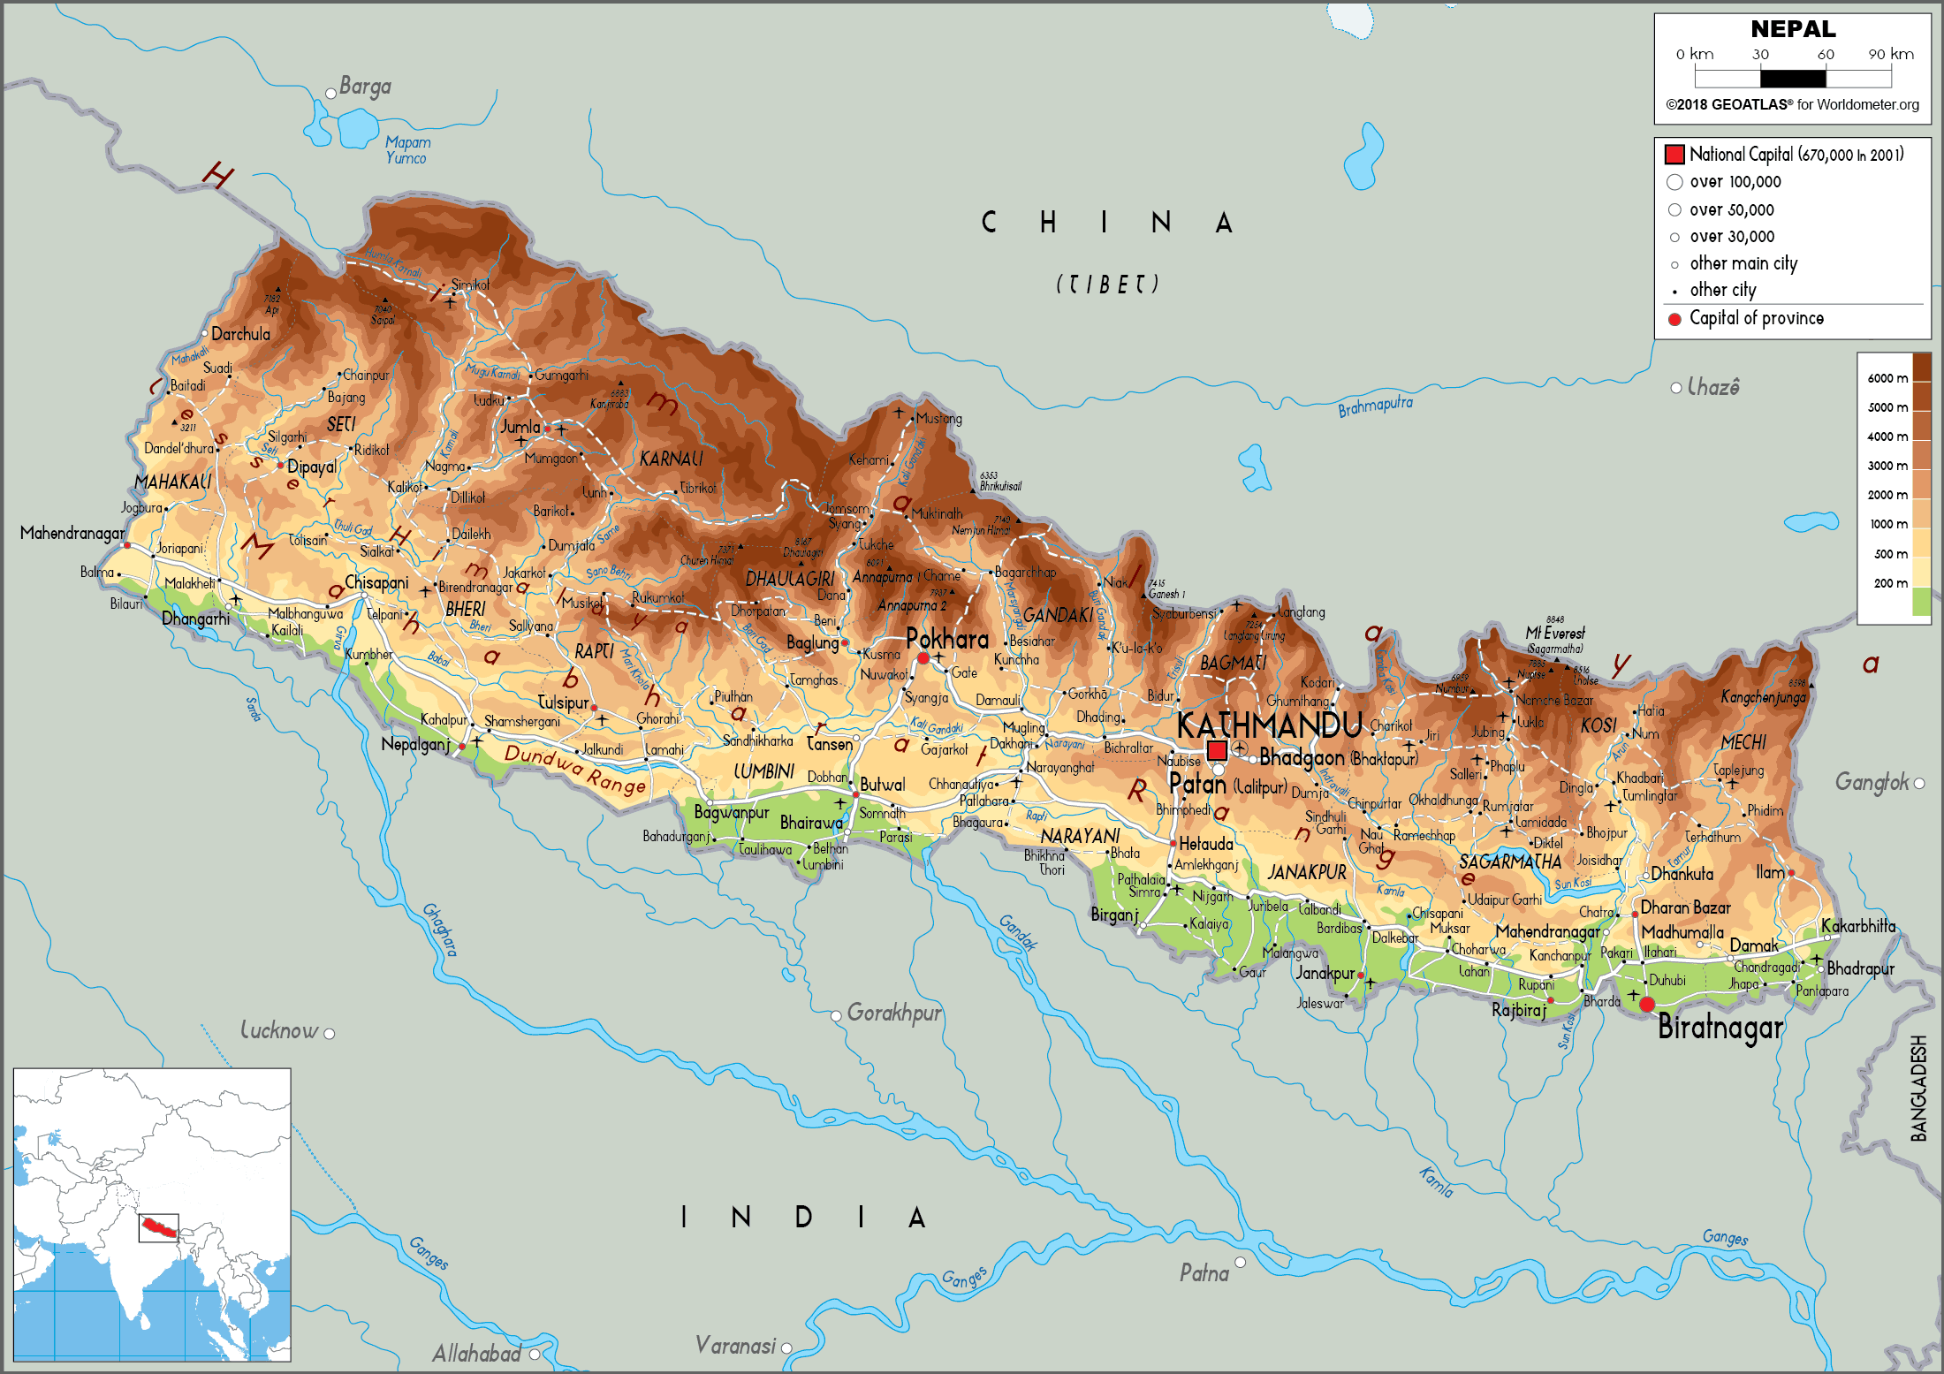
Figure 2
N↑
A
1. Give the name of Country A
2. State the national capital of country A
3. Give the name of the major mountain range found on the northern edge of this country.
4. State the name of the country to the south of country A
5. Complete the following (Remember to show ALL your working):
 | Direction | Bearing
Pokhara to Mahendranagar (in the west)
Kathmandu to Biratnagar
Pokhara from Kathmandu

6. Name the scale shown on the map
7. Write the scale as a ratio scale
8. Write the scale as a word scale

Distance (Show ALL your working)
1. Calculate the distance from Pokhara to Mahendrangar (in the west)
2. Calculate the distance from Biratnagar to Kathmandu
3. Calculate the distance from Kathmandu to Pokhara

