Map Skills Revision
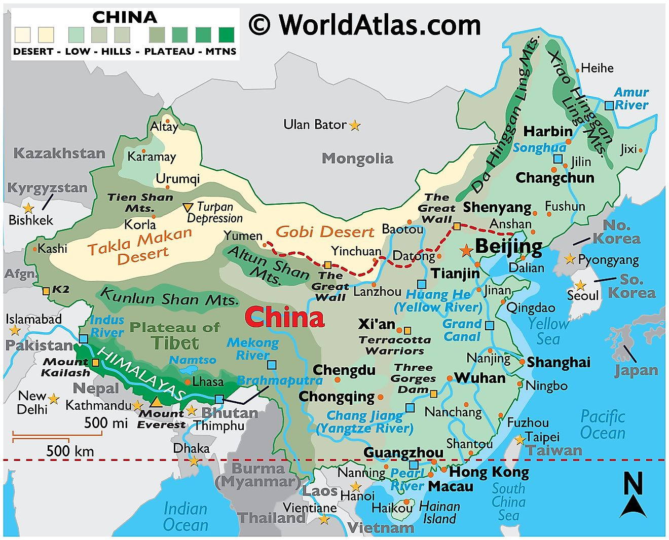
Study the map of China below and answer the questions that follow.
C
B
1: 50 000 000
- What element/s of BOLTSS is missing from the map of China?
- State the name of the type of scale shown on the map.
- Write this scale down as a word scale
- In the space below, draw the scale of the map as a line scale.

- (a) State the capital city of China
(b) How do you know that this is the capital city?
6. State the name of two deserts that are found in China

7. Name the mountain range found in the South West of China
8. Complete the following questions on direction and bearing (Show ALL your working):
 | Direction | Bearing
From Kashi to Altay
To Chengdu from Wuhan
From Macau to Harbin
To Chongqing from Hong Kong
From Shenyang to Chengdu
To Xi’an from Shanghai?

9. Calculate the distance between the following places. Remember to show ALL your working.
(a) Harbin to Tianjin
(b) Chengdu to Shanghai
(c) Hong Kong to Wishan
(d) Changchun to Tianjin
10. Give the name of the dam found along the Yangtze River
11. State the line of latitude labeled B on the map
12. State the name of the feature labeled C on the map

