Map Skills Revision
- Using the map of Egypt below, answer the questions which follow.
Remember to show ALL of your working.
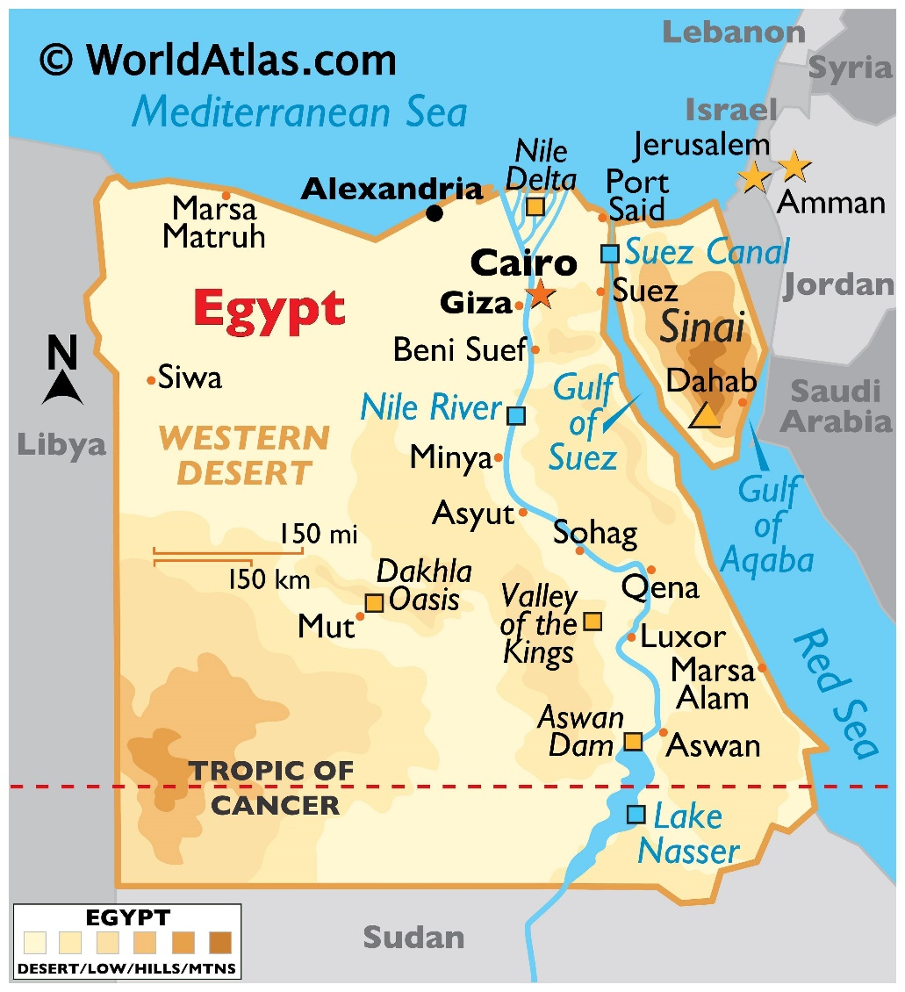
Map of Egypt

B

A

C

- Name the Sea at A
- Name the country to the west of Egypt
- Name the country to the south of Egypt
- State the capital city of Egypt
- Name the features of BOLTSS that are missing from the map
- What type of scale is shown above
- Write this scale as a ratio scale
- Write this scale as a word scale
- Name the major river that runs through Egypt
- Does this river run north or south? How do you know this?
- Circle the highest area in Egypt found on the map.

- Complete the following:
 | Direction | Bearing
From Siwa to Alexandria
Marsa Matruh from Aswan
Minya from Cairo
From Mut to Dahab
Valley of the Kings from Beni Suef
From Luxor to Marsa Matruh
From Dahab to Mut

- Calculate the distance from Siwa to Aswan
- Calculate the distance from Mut to Beni Suef
- Calculate the distance from Sohag to Qena ________________________
- The line of latitude marked at C is
- Name the continent Egypt is found
- Name the continent that is located North of Egypt

