

Name ______________

Date ______________

Year 8 MATHEMATICS
Yearly Examination
General Instructions  - No reading time given  - Working time – 90 minutes  - Show all necessary working / units  - Board approved calculators are allowed  - Exam guidelines  - Use black pen for your working  - Use a pencil and ruler for diagrams  - Marks may be lost for poorly organised written work. | Total Marks – 80  Section I 40 marks  Allow 40 mins  Section II 40 marks  Allow 50 mins
Question | Number | Algebra | Measurement | Total

Section I
Allow approximately 40 minutes for this section

Multiple Choice (5 marks)
Attempt Questions 1 to 5

1. If $x-10=-2,$ then x equals:
(A) -12
(B) -8
(C) 8
(D) 12

2. What is the value of $2\left(x+4\right)$ if $x=-1$ ?
(A) -10
(B) -8
(C) 3
(D) 6

3. ${10}^{6}$ means:
(A) 1 000 000
(B) $10×6$
(C) $10+10+10+10+10+10$
(D) 106

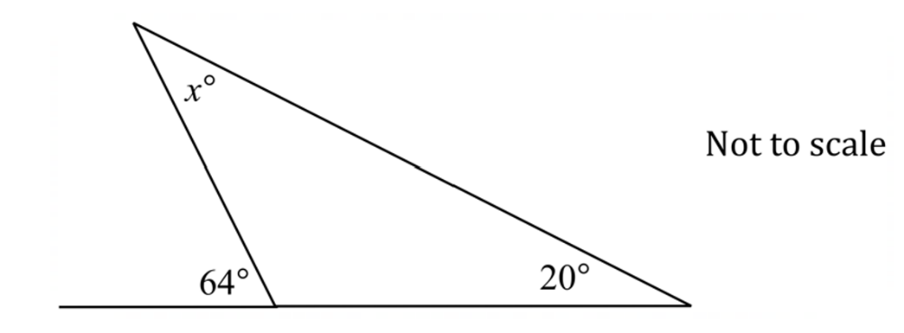
4.

What is the value of x ?
(A) 20
(B) 44
(C) 64
(D) 84

5. What is 15% expressed as a fraction?

(A) $15\frac{1}{5}$
(B) $\frac{1}{5}$
(C) $\frac{1}{3}$
(D) $\frac{3}{20}$

6. A mobile phone is bought for $550 including a 10% GST. How much is the GST?

(A) $\$5.00$

(B) $\$5.50$

(C) $\$50.00$

(D) $\$55.00$

7. In Georgia’s class, the ratio of boys to girls is 4 : 5. How many girls are in the class if there are 16 boys ?

(A) 17

(B) 18

(C) 20

(D) 25

8. Bailey, Chris and David are given $100 between them. $Chris is given \frac{2}{5} of the money and David is given \frac{1}{4} of the money.$
How much money is left for Bailey?

(A) $\$35.00$

(B) $\$65.00$

(C) $\$66.67$

(D) $\$50.00$

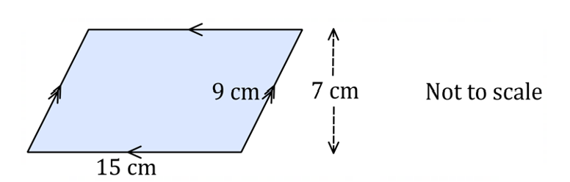
9.

What is the area of this parallelogram?
(A) $63cm^{2}$

(B) $105cm^{2}$

(C) $135cm^{2}$

(D) $676.5cm^{2}$

10. $What is the solution to the equation \frac{2x}{3}-4=5 ?$
(A) 1.5

(B) 5.5

(C) 9.5

(D) 13.5

11. A rectangular backyard contains a square garden. The rest of the backyard is lawn.

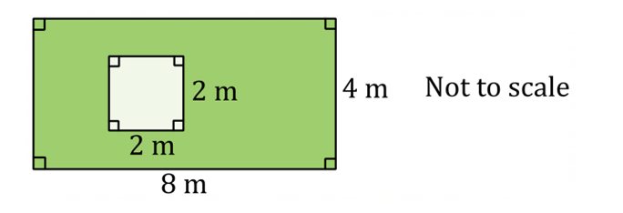
What is the ratio of the garden to the lawn ?

(A) $1:7$

(B) $1:8$

(C) $7:1$

(D) $8:1$

12. What is the circumference (to the nearest whole number) of a circle with a radius of 7cm?

(A) 21cm

(B) 22cm

(C) 43cm

(D) 44cm

13. What is the gradient of the line below?

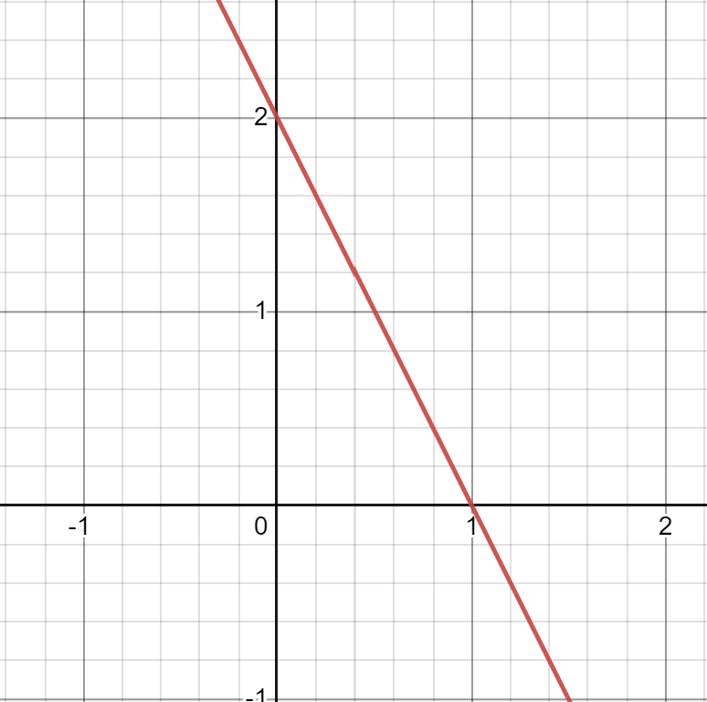

(A) 2

(B) $\frac{1}{2}$

(C) -2

(D) $-\frac{1}{2}$

14. A semicircle has been cut from a quadrant of a circle, as shown in the diagram.
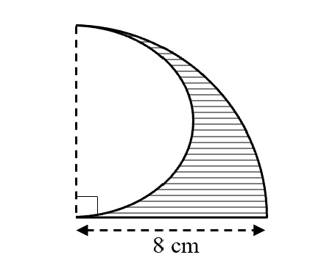

What is the perimeter (in cm) of the shaded section?
(A) 8π + 8
(B) 6π + 16
(C) 12π + 12
(D) 6π + 8
15. Simplify $3\left(x+2\right)-5$

(A) $3x-3$
(B) $3x-3$
(C) $3x-11$
(D) $3x+1$

Short Response (60 Marks)
Answer the questions in the spaces provided. Your responses should include relevant mathematical reasoning and/or calculations.

Question 16 Number [15 marks]

a. Simplify the ratio 6 h: 1 day. (2 mark)

…………………………………………………………………………………………………

…………………………………………………………………………………………………

…………………………………………………………………………………………………

b. Increase $960 by 8%. (1 mark)

…………………………………………………………………………………………………

…………………………………………………………………………………………………

…………………………………………………………………………………………………

c. Express $\frac{3}{4}$ as a percentage. (1 mark)

…………………………………………………………………………………………………

…………………………………………………………………………………………………

d. Change 0.125 to a percentage. (1 mark)

…………………………………………………………………………………………………..

………………………………………………………………………………………………….

e. A painting is sold at a profit of 20% on the cost price.
What is the cost price if the painting sold for $960? (1 mark)

…………………………………………………………………………………………………

………………………………………………………………………………………………..

…………………………………………………………………………………………………

…………………………………………………………………………………………………

f. A car uses 30 litres of petrol to travel 510 km.
What is the distance the car can travel on 45 litres of petrol? (1 mark)

…………………………………………………………………………………………………

…………………………………………………………………………………………………

…………………………………………………………………………………………………

…………………………………………………………………………………………………

g. Express 12 minutes as a percentage of 5 hours. (1 mark)

…………………………………………………………………………………………………

…………………………………………………………………………………………………

h. Decrease $48 by 5%. (1 mark)

…………………………………………………………………………………………………

…………………………………………………………………………………………………

i. A jacket costs $140 with 10% GST. What is the cost of the jacket without GST?
(2 marks)

…………………………………………………………………………………………………

…………………………………………………………………………………………………

k. At a party the ratio of girls to boys was 4: 3.

- If there were 24 girls, how many boys were there? (1 marks)

…………………………………………………………………………………………………..
…………………………………………………………………………………………………..
(ii) How many people were there at the party? (1 mark)

……………………………………………………………………………………………………
……………………………………………………………………………………………………
l. Greg has 99 marbles in his marble collection. He has red and blue coloured marbles in the ratio 5 : 4. How many more red marbles than blue marbles are there? (2 marks)
…………………………………………………………………………………………………..

………………………………………………………………………………………………….

………………………………………………………………………………………………….

Question 17 Algebra [15 marks]

a. Solve the following equations.

(i) $4x=36$ (1 mark)

…………………………………………………………………………………………………

………………………………………………………………………………………………..

(ii) $6m+3=51$ (1 mark)

…………………………………………………………………………………………………

…………………………………………………………………………………………………

(iii) $3\left(2d-4\right)=18$ (2 mark)

…………………………………………………………………………………………………

…………………………………………………………………………………………………

………………………………………………………………………………………………….

b. Simplify $24a^{3}÷12a^{9}$ (1 mark)

…………………………………………………………………………………………………

…………………………………………………………………………………………………

…………………………………………………………………………………………………

c. Simplify fully . (2 marks)

…………………………………………………………………………………………………………………………………………….

…………………………………………………………………………………………………………………………………………….

……………………………………………………………………………………………………………………………………………

……………………………………………………………………………………………………………………………………………

……………………………………………………………………………………………………………………………………………

d. Grace is g years old. Ethan is 1 year more than double Grace’s age and Lara is triple Ethan’s age.
(i) Write an expression for the sum of each of their ages and simplify it. (2 marks)

………………………………………………………………………………………………………….
…………………………………………………………………………………………………………..
…………………………………………………………………………………………………………..
(ii) If the sum of their ages is 40, how old is Grace? (1 mark)
………………………………………………………………………………………………….
e.
 | (i) | Complete the table of values for $y=2x-1$ (1 mark)
x | –1 | 0 | 1 | 3
y

 | (ii) | Graph the line $y=2x-1.$ (1 mark)
 |  | 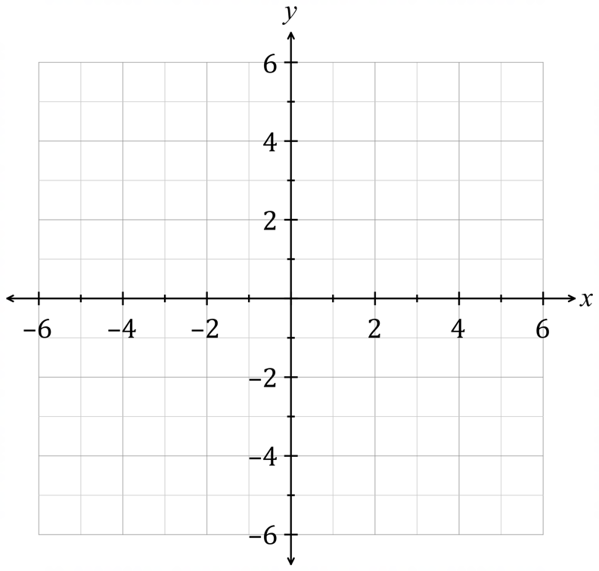

c. (i) Draw the graph of $y=-\frac{1}{2}x+1$ on the number plane below. (2 marks)

(ii) Where does the graph cut the x-axis? (1 mark)

…………………………………………………………………………………………………

………………………………………………………………………………………………..

Question 18 Measurement [15 marks]

a.

Find the value of x in the triangle above. (1 mark)

…………………………………………………………………………………………………

………………………………………………………………………………………………….
b. Find the value of the pronumeral in each triangle. Answer correct to two decimal places.
(i) (1 mark)

……………………………………………………………………………………………………………………………………………………………

……………………………………………………………………………………………………………………………………………………………

……………………………………………………………………………………………………………………………………………………………
(ii) (1 mark)

…………………………………………………………………………………………………………………………………………………………….

…………………………………………………………………………………………………………………………………………………………….

…………………………………………………………………………………………………………………………………………………………….

c. Find the area of this shape. (2 marks)

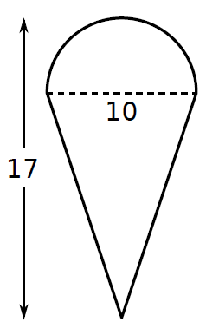

…………………………………………………………………………………………………………………………………………………………….

…………………………………………………………………………………………………………………………………………………………..

……………………………………………………………………………………………………………………………………………………………

d. Find the value of the pronumerals in these diagrams, stating reasons. (3 marks)
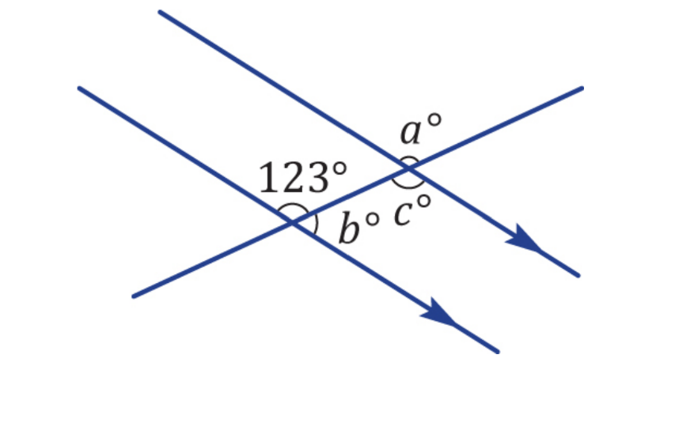
(i)

……………………………………………………………………………………………………………………………………………………………

…………………………………………………………………………………………………………………………………………………………..

……………………………………………………………………………………………………………………………………………………………

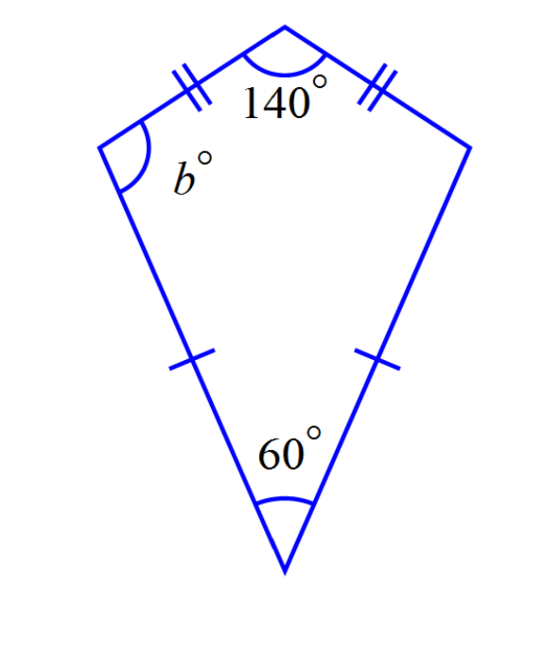
(ii) (2 marks)

……………………………………………………………………………………………………………………………………………………………

…………………………………………………………………………………………………………………………………………………………..

…………………………………………………………………………………………………………………………………………………………..

e. Find the perimeter of the shape below (1 mark)
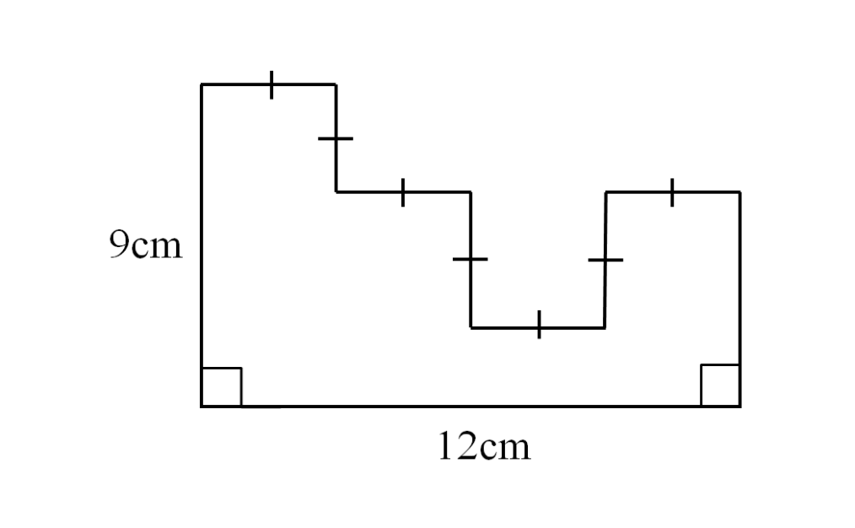
…………………………………………………………………………………………………

…………………………………………………………………………………………………

…………………………………………………………………………………………………

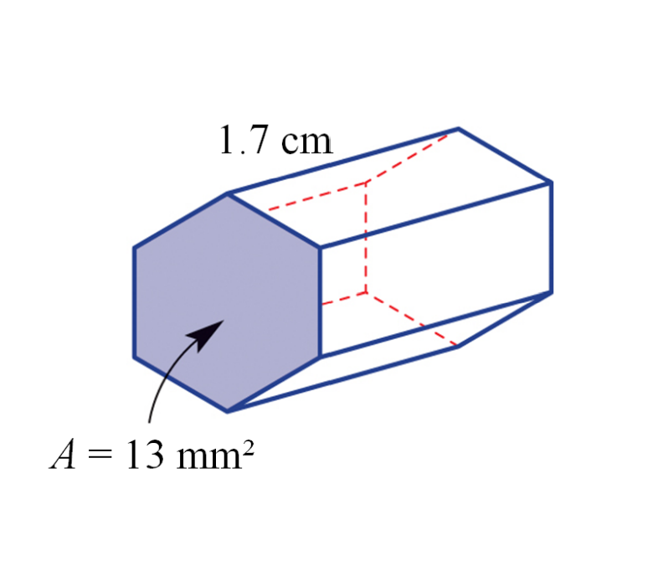
f. Find the volume of the prism below (2 marks)

…………………………………………………………………………………………………

………………………………………………………………………………………………….

………………………………………………………………………………………………….

g. Determine the area of the sector below (2 marks)









