Student Name: Solutions


Year 8 MATHEMATICS
2023 Yearly Examination
General Instructions  - Reading time – 10 minutes  - Working time – 90 minutes  - Show all necessary working / units  - Board approved calculators are allowed  - Exam guidelines  - Use black pen for your working  - Use a pencil and ruler for diagrams  - Marks may be lost for poorly organised written work. | Total Marks – 80  Section I – Multiple choice  (10 marks)  Allow 12 mins  Section II - Short answer  (70marks)  Allow 78 mins
Question | Number | Algebra | Measurement | Total
5,8,11 | /23
1,3,4,6,10,12 |  | /30
2,7,9,13 |  |  | /27
 |  |  |  | /80

Section I
Allow approximately 12 minutes for this section.

Multiple Choice (10 marks)
Attempt Questions 1 to 10
Use the multiple-choice answer sheet for Question 1 - 10

1. Which of the following is equivalent to $5^{0}$?
(A) 50
(B) 1
(C) 5
(D) $\frac{1}{5}$

2. The perimeter of a rectangle with a length of 5 cm and a width of 3 cm is:
(A) 16 cm
(B) 26 cm
(C) 8 cm
(D) 40 cm

3. $4^{3}$ means:
(A) $4×4×4$
(B) $4÷3$
(C) $4+4+4$
(D) 43

4. If $x=3$, then the value of the expression $2x^{2}-5x+7$ is:

(A) 10
(B) 26
(C) 14
(D) 18

5. 6% of $495 is equal to:

(A) $\$29.70$
(B) $297.00
(C) $489.00
(D) $36.50

6. Simplify .

(A) $9y$

(B) $54y^{2}$

(C) $20y$

(D) $20y^{2}$

7. What is the name given to the angles marked with ?

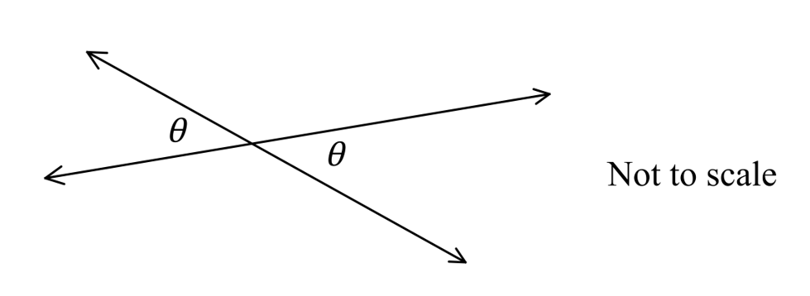

(A) Adjacent angles

(B) Complementary angles

(C) Corresponding angles

(D) Vertically opposite angles

8. $18 is divided in the ratio 2:3. The smaller part is:

(A) $\$10.80$

(B) $\$7.20$

(C) $\$3.60$

(D) $\$12.00$

9. The area of a kite with diagonals of length 34 cm and 55 cm, is equal to:

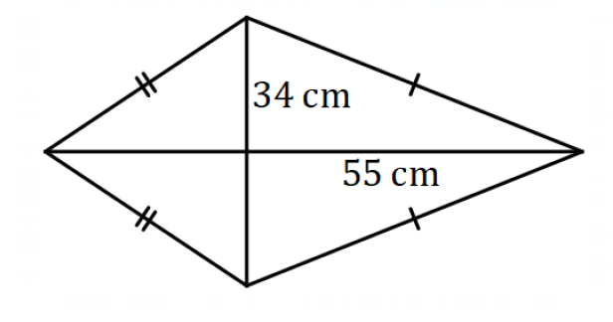

(A) $935cm^{2}$

(B) $880cm^{2}$

(C) $940cm^{2}$

(D) $985cm^{2}$

10. $What is the solution to the equation \frac{3x}{4}-4=6 ?$
(A) 10

(B) 12

(C) $13\frac{1}{3}$

(D) 13.5

Section II
Allow 78 minutes for this section.
Short Response (70 Marks)
Attempt Question 11 to 13
Answer the questions in the spaces provided. Your responses should include relevant mathematical reasoning and/or calculations.

Question 11 Number [21 marks]

a. Simplify the ratio 6 : 15 (1 mark)

…………………………………………………………………………………………………

…………………………………………………………………………………………………

b. The ratio of blue butterflies to yellow butterflies in the valley of Wiesenthal is 5:4, and there are estimated to be about 54 000 butterflies in the valley. How many are there of each colour? (2 marks)

…………………………………………………………………………………………………..

………………………………………………………………………………………………….

………………………………………………………………………………………………….

………………………………………………………………………………………………….

c. A labourer lays 20 tiles in 50 minutes. How many tiles can he lay in 250 minutes?
(1 mark)

………………………………………………………………………………………………….

………………………………………………………………………………………………….

d. Anne cycles from Bristol to Salisbury. The diagram shows the distance-time graph of her journey.

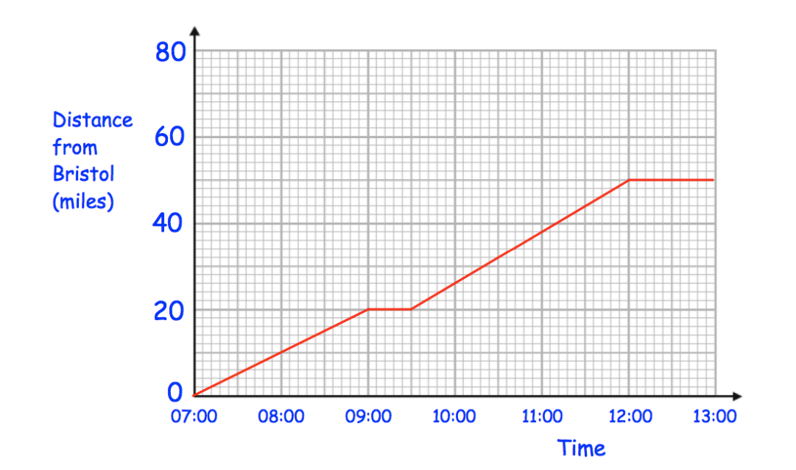

- How far from Bristol is Anne at 08:00? (1 mark)

………………………………………………………………………………………..

- Describe what is happening between 09:00 and 09:30. (1 mark)

…………………………………………………………………………………………

- Calculate Anne’s speed for the first two hours of her journey. (1 mark)

………………………………………………………………………………………….

………………………………………………………………………………………….

e. A train travels at a constant speed of 94km/h. How long will it take to travel 423km? (1 mark)

…………………………………………………………………………………………..

…………………………………………………………………………………………

f. Some of the squares in the diagram below are shaded. More squares need to be shaded if the ratio (number of unshaded squares) : (number of shaded squares) is to be 2 : 1. How many squares need to be shaded? (2 marks)

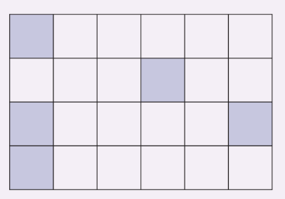

…………………………………………………………………………………………………

………………………………………………………………………………………………..

g. Complete this table of decimals, fractions, and percentages. (2 mark)

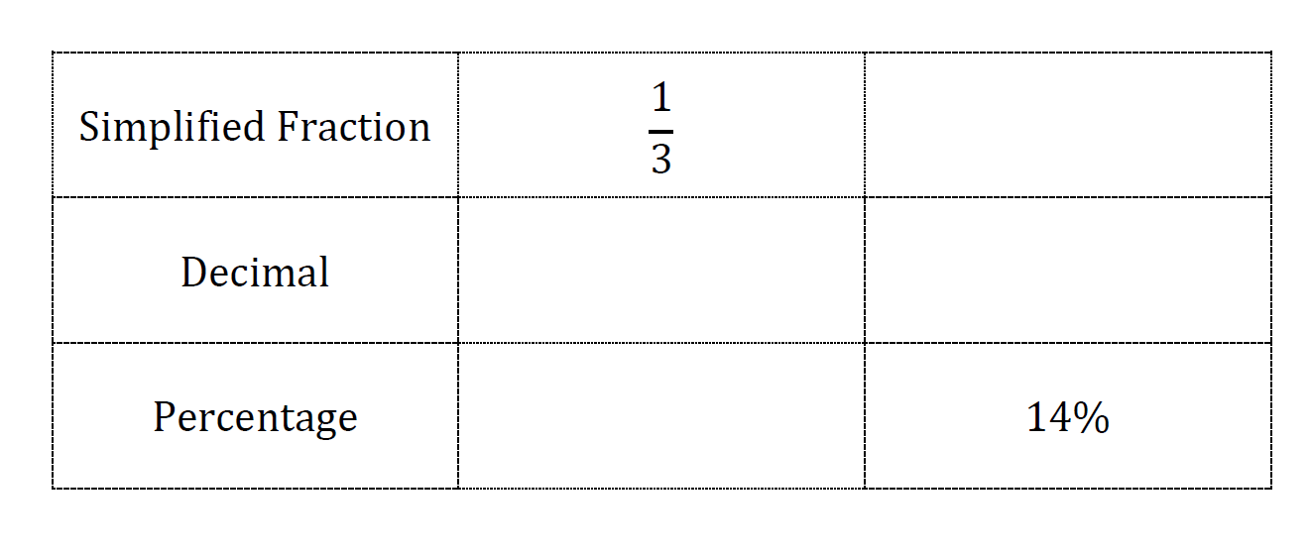

h. Express 18 minutes as a percentage of 4 hours. (2 mark)

…………………………………………………………………………………………………

…………………………………………………………………………………………………

i. Increase $520 by 15% (1 mark)

…………………………………………………………………………………………………

…………………………………………………………………………………………………

j. Michelle bought a block of land 4 years ago for $720 000 and sold it this year for $1 152 000. Calculate:

- The profit. (1 mark)

…………………………………………………………………………………………………

…………………………………………………………………………………………………

- the profit as a percentage of its cost price. (1 mark)

………………………………………………………………………………………………….

…………………………………………………………………………………………………..

…………………………………………………………………………………………………..

k. Find the GST payable on an item that has a pre-GST price of $600.
(GST=10%) (2 marks)

…………………………………………………………………………………………………..

…………………………………………………………………………………………………..

………………………………………………………………………………………………….

l. A tennis player serves a ball at a speed of 120 km/h towards his opponent on the other side of a 25 m long court. (2 mark)

How long (in seconds) does the opponent have to return the serve?

…………………………………………………………………………………………………..

………………………………………………………………………………………………….

………………………………………………………………………………………………….

………………………………………………………………………………………………….

Question 12 Algebra [25 marks]

a. Solve the following equations.

(i) $6m-1=29$ (1 mark)

…………………………………………………………………………………………………

…………………………………………………………………………………………………

(ii) $3\left(x-4\right)=12$ (2 marks)

…………………………………………………………………………………………………

…………………………………………………………………………………………………

………………………………………………………………………………………………….

(iii) $\frac{k+3}{5}=4$ (2 marks)

…………………………………………………………………………………………………..

…………………………………………………………………………………………………..

…………………………………………………………………………………………………..

b. When $x=-3$, determine the value of the expression $7\left(x+2\right)-(4+x)$. (1 mark)

………………………………………………………………………………………………….

…………………………………………………………………………………………………..

…………………………………………………………………………………………………..

c. Simplify

- $7a-2a$ (1 mark)
…………………………………………………………………………………………………

- $5x\left(2+9y\right)$ (2 marks)

………………………………………………………………………………………………….

………………………………………………………………………………………………….

d. Simplify the following using the index laws

- $x^{7}÷x^{4}$ (1 mark)

…………………………………………………………………………………………………

- $2x^{4}×3x^{2}$ (1 mark)

…………………………………………………………………………………………………

- $(4x)^{0}$ (1 mark)

…………………………………………………………………………………………………..

…………………………………………………………………………………………………..

- $(2a^{2})^{3}$ (1 mark)

…………………………………………………………………………………………………..

………………………………………………………………………………………………….

- $\frac{7x^{2}y^{3}}{2}÷\frac{21xy}{8}×\frac{8}{21xy}$ (2 marks)

…………………………………………………………………………………………………..

…………………………………………………………………………………………………..

…………………………………………………………………………………………………..

e. Anthony goes to the fair with his family. They ride together on the ferris wheel. They buy one adult ticket and three child tickets for $12. If the child tickets are half the cost of the adult tickets, how much does one child ticket cost? (2 marks)

……………………………………………………………………………………………………………

……………………………………………………………………………………………………………

……………………………………………………………………………………………………………

f. Factorise $12a+4$ (1 mark)

………………………………………………………………………………………………………………………………………………..

g.
 | i) | Complete the table of values for $y=2x+1$ (2 marks)
x | –2 | -1 | 0 | 1 | 2
y

 | ii) | Graph the line $y=2x+1.$ (1 mark)
 |  | 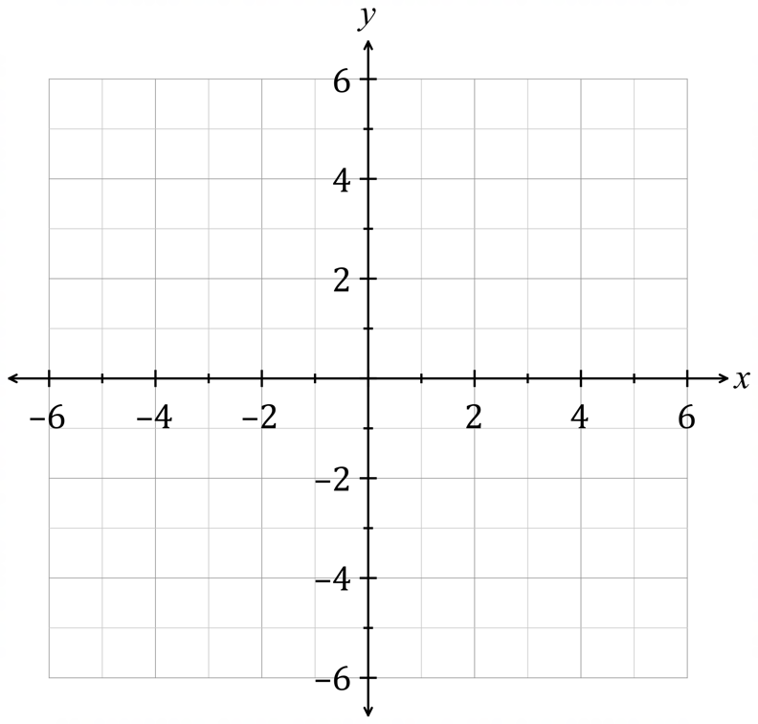

h. Does the point ( -2, 1) lie on the graph of $y=3x-5$? (1 mark)
Show all your working.

…………………………………………………………………………………………………
…………………………………………………………………………………………………..

i. Write down the coordinates for the y-intercept. (1 mark)

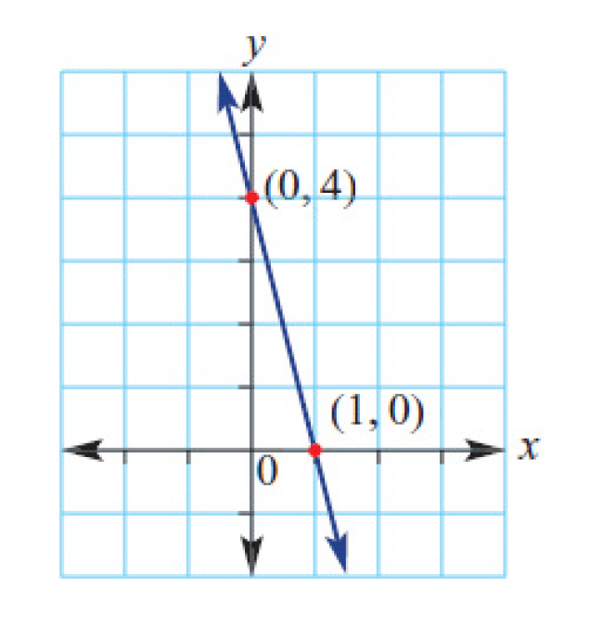
…………………………………………………………………………………………………..

j. Find the rule for the table of values below. (2 marks)

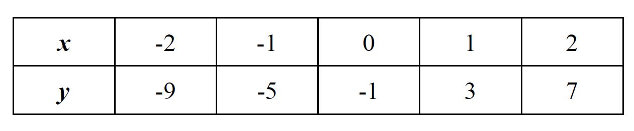

………………………………………………………………………………………………….
………………………………………………………………………………………………….
………………………………………………………………………………………………….

Question 13 Measurement [24 marks]

a. Find the value of a in the following diagrams. Choose the correct reasoning from the table below.

Reasoning
Angles in a right angle add to 90$°$
Angles on a straight line add up to 180$°$
Vertically opposite angles are equal
Alternate angles in parallel lines are equal.
Corresponding angles in parallel lines are equal
Cointerior angles in parallel lines sum to 180$°$
The angle sum of a triangle is 180$°$

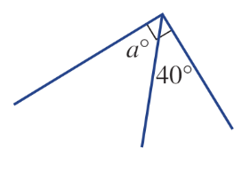
- (1 mark)

Solution | Reason

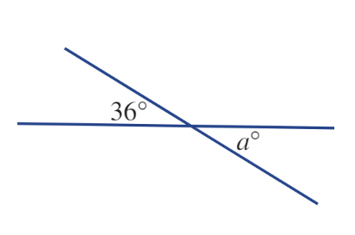
ii) (1 mark)

Solution | Reason

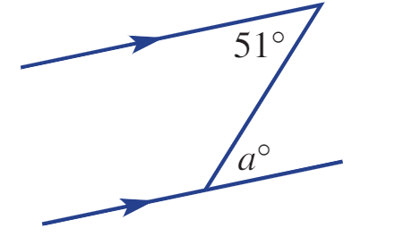
- (1 mark)

Solution | Reason

- (2 marks)
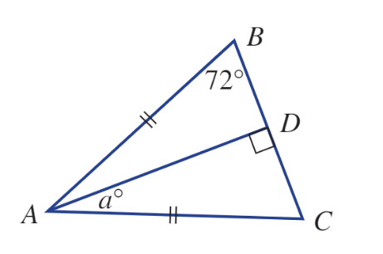

Solution | Reason

b. What is the value of a in the diagram below? (2 marks)
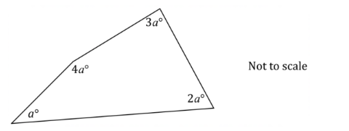
…………………………………………………………………………………………

…………………………………………………………………………………………

…………………………………………………………………………………………

…………………………………………………………………………………………

c. Draw in all the lines of symmetry on the diagram below. (2 mark)
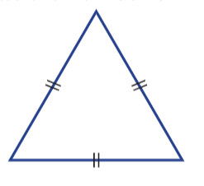
d. Convert the measurements below to the units given in brackets.
i) 2m (cm) (1 mark)
…………………………………………………………………………………………..
- $400{0cm}^{2} (m^{2})$ (1 mark)
…………………………………………………………………………………………..

e. Find the perimeter of this shape. Answer correct to the nearest metre. (2 mark)
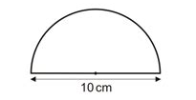
…………………………………………………………………………………………..
………………………………………………………………………………………….
………………………………………………………………………………………….
f. Find the value of x, correct to one decimal place. (2 marks)
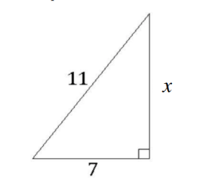
…………………………………………………………………………………………..
…………………………………………………………………………………………..
………………………………………………………………………………………….

g. An outdoor adventure park is installing a Flying Fox (zip wire). They find a vertical tree and build a platform 20 metres up the tree. The finish point will be on the horizontal ground 60 metres from the tree. How long will the zip wire need to be?
i) Fill in the given information on the diagram below. (1 marks)
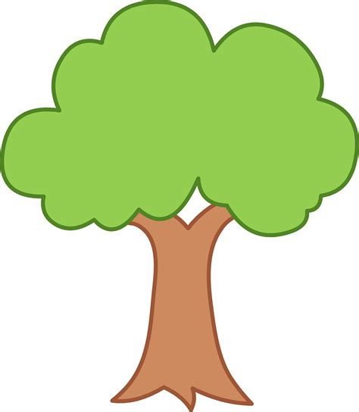

- How long will the zip wire need to be? Round you answer to 2 decimal places (1 mark)
…………………………………………………………………………………………..
…………………………………………………………………………………………..
…………………………………………………………………………………………..
………………………………………………………………………………………….

h. Find the value of x in the shape below given that the perimeter is 39 m. (1 mark)
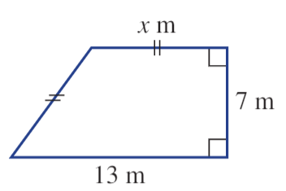
………………………………………………………………………………………..
……………………………………………………………………………………….

i. i) Calculate the volume of the prism given below. (1 mark)
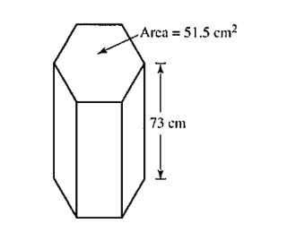
…………………………………………………………………………………………
…………………………………………………………………………………………
…………………………………………………………………………………………

ii) Calculate the capacity of the prism above. Answer to the nearest litre.(1 mark)

…………………………………………………………………………………………
…………………………………………………………………………………………
………………………………………………………………………………………..
j. Find the area of the shapes below.

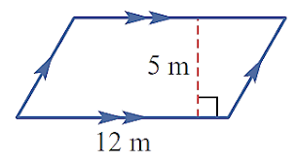
- (1 mark)

……………………………………………………………………………………………………………………………………………….
……………………………………………………………………………………………………………………………………………….
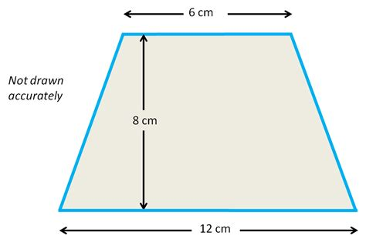
- (1 marks)

…………………………………………………………………………………………..
…………………………………………………………………………………………..
…………………………………………………………………………………………..

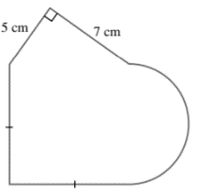
iii) (2 marks)

…………………………………………………………………………………………..
…………………………………………………………………………………………..
…………………………………………………………………………………………..
…………………………………………………………………………………………..
…………………………………………………………………………………………..

End of Exam

