

Student Name: ____________________________________

Year 9 MATHEMATICS 5.2/5.3 2023
TASK 2 – Half Yearly Examination

General Instructions  - Reading time – 5 minutes  - Working time – 90 minutes  - Show all necessary working / units  - Board approved calculators are allowed  - Exam guidelines  - Use black pen for your working  - Use a pencil and ruler for diagrams  - Marks may be lost for poorly organised written work. | Total Marks – 85  Section 1 5.2 – 40 marks  Suggested time: 40 mins  Section 2 5.3 – 45 marks  Suggested time: 50 mins
Question | Indices and Algebra | Equations and Formulas | Linear relationships | Pythagoras’ theorem | Total
Section 1 (5.2) |  |  |  |  | /40
1,2,3,11 - 12 | /11
4,5,6,7,13 - 16 |  | /16
8,9,10,17 - 18 |  |  | /13
Section 2 (5.3) |  |  |  |  | /45
1,2,3,11 - 12 | /10
4,5,6,13 - 17 |  | /14
7,8,9,18 - 21 |  |  | /15
10,22 - 23 |  |  |  | /6
 | 21 | 30 | 28 | 6 | /85

Section 1 – 5.2 (40 marks)
Attempt Questions 1 to 18
Allow approximately 40 minutes for this section.

Multiple Choice Questions [10]

Circle the correct answer on a separate multiple choice answer sheet.

1. The expression $3a^{2}×5a^{4}$ simplifies to:
A. $15a^{6}$
B. $15a^{8}$
C. $8a^{6}$
D. $8a^{8}$
2. The expression simplifies to $\frac{m^{8}b}{m^{4}b^{4}}$ equals
A. $\frac{m^{2}}{b^{3}}$
B. $\frac{m^{4}}{b^{3}}$
C. $m^{2}b$
D. $m^{4}b^{3}$

3. simplifies to:
A. -2
B. -1
C. 0
D. 2

4. The solution to the equation $3x-2=7$ is:

A. $x=3$
B. $x=5$
C. $x=6$
D. $x=9$

5. $4\left(4y-3\right)$ expands to:

A. $11y-3$
B. $8y-7$
C. $16y-12$
D. $11y-10$

6. If $A=\frac{1}{2}bh$ with $A=360$ and $h=40$, then b is:

A. 90
B. 4.5
C. 20
D. 18

7. An algebraic expression that represents double the difference of m and 5 is:

A. $2×m-5$
B. $2\left(m-5\right)$
C. $2m-5$
D. $2-3×5$

8. The graph of $y=3x-6$ is represented by:

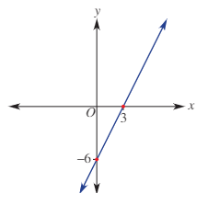
A.

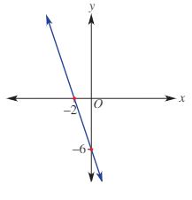
B.

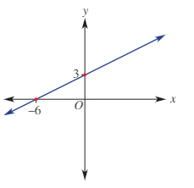
C.

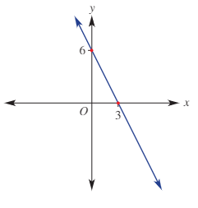
D.

9. Which line is parallel to $y=5-2x$?

A. $y=5-3x$
B. $y=5x-2$
C. $y=-2x+3$
D. $y=2x-5$

10. Which equation is correct for this table?

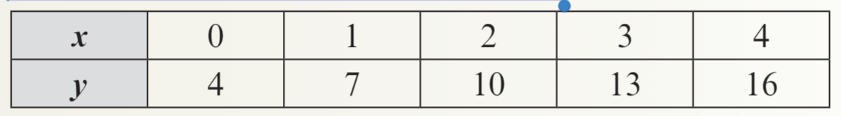

A. $y=-x+4$
B. $y=x+6$
C. $y=3x+4$
D. $y=4x+4$

Short Answer Questions
Answer the questions in the spaces provided. Your responses should include relevant mathematical reasoning and/or calculations.
Marks CANNOT be awarded for poorly organised written work.

Indices [8]
11. Simplify each of the following.
i) $b×(b^{2})^{3}$ (2)
……………………………………………………………………………………………………...
……………………………………………………………………………………………………...
ii) $\frac{6a^{7}b^{5}}{3a^{2}b^{8}}$ (2)
……………………………………………………………………………………………………...
……………………………………………………………………………………………………...
……………………………………………………………………………………………………...
iii) ${\left(4q^{3}r^{-2}\right)}^{2}$ (2)
……………………………………………………………………………………………………...
……………………………………………………………………………………………………..
……………………………………………………………………………………………………..
12. Write the following value in scientific notation, using three significant figures: (2)
The time taken for light to travel 1 kilometre is 0.00000303356 seconds.
……………………………………………………………………………………………………..
……………………………………………………………………………………………………..
Expressions and Equations [12]

13. Evaluate $x(y+z)$ if x = 2, y = −1 and z = 5. (1)

…………………………………………………………………………………………………….
…………………………………………………………………………………………………….

14. Solve the following linear equations for x.

i) $\frac{7x-3}{2}=4$ (2)
……………………………………………………………………………………………………
……………………………………………………………………………………………………
……………………………………………………………………………………………………

ii) $2\left(2x-3\right)=2$ (2)
…………………………………………………………………………………………………….
…………………………………………………………………………………………………….
…………………………………………………………………………………………………….

iii) $3-4x=7x-8$ (2)
…………………………………………………………………………………………………….
…………………………………………………………………………………………………….
…………………………………………………………………………………………………….

15. The formula $F=\frac{9}{5}C+32$ converts degrees Celsius, C, to degrees Fahrenheit, F.
i) What is the temperature in degrees Fahrenheit if it is $100°C$ (1)
…………………………………………………………………………………………………….
…………………………………………………………………………………………………….

ii) What is the temperature in degrees Celsius if it is $14°F$.
(2)
……………………………………………………………………………………………………
……………………………………………………………………………………………………

16. Rewrite $p=m(x+n)$ to make n the subject of the equation. (2)
……………………………………………………………………………………………………
……………………………………………………………………………………………………
……………………………………………………………………………………………………

Linear relationships [10]

17. Consider the graph below.
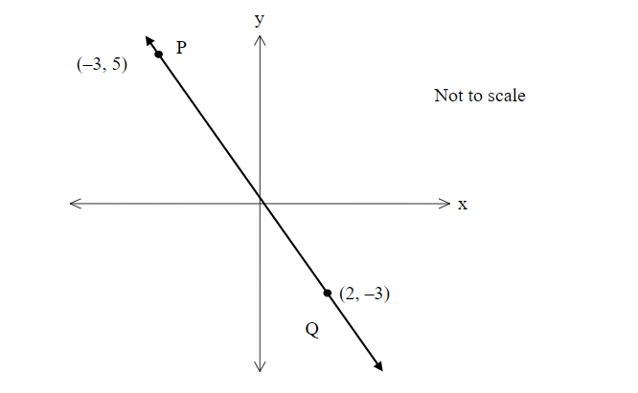
i) Find the gradient of the line. (2)
…………………………………………………………………………………………………..
…………………………………………………………………………………………………..
………………………………………………………………………………………………….
ii) Find the midpoint of the interval between P and Q. (2)
…………………………………………………………………………………………………
…………………………………………………………………………………………………
………………………………………………………………………………………………….
iii) Find the distance between P and Q. Leave your answer correct to 2 decimal places. (2)
…………………………………………………………………………………………………..
…………………………………………………………………………………………………..
…………………………………………………………………………………………………..

18. i) Sketch the graph of the line $y=\frac{2}{3}x-1$ and the line $x=-2$ on the number plane below.
(2)
………………………………………………………………………………………………….
………………………………………………………………………………………………….
…………………………………………………………………………………………………..

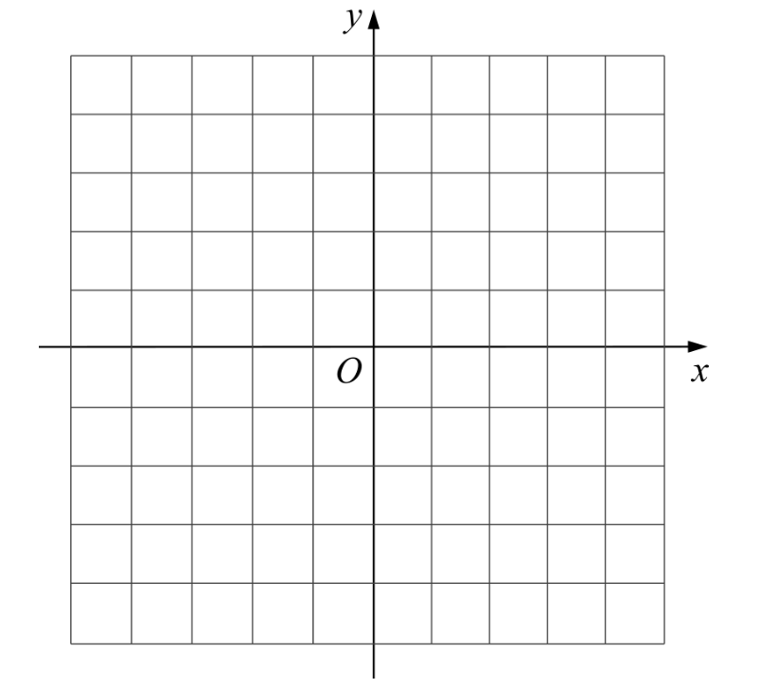
ii) Show algebraically that the point $(1,-\frac{1}{3})$ lies on the line $y=\frac{2}{3}x-1$ (2)
………………………………………………………………………………………………..
………………………………………………………………………………………………..
………………………………………………………………………………………………..

Section 2 – 5.3 (45 marks)
Attempt Questions 1 to 23
Allow approximately 50 minutes for this section

Multiple Choice Questions [10]

Circle the correct answer on a separate multiple choice answer sheet.

1. $\frac{32x^{2}y×2xy}{8xy^{2}}$

A. $4x^{3}$

B. $8x^{2}$

C. $4x^{3}y$

D. ${8x}^{3}y$

2. $\frac{3}{(2x)^{-2}}$ is equivalent to:

A. $\frac{-3}{(2x)^{2}}$

B. $\frac{3x^{2}}{2}$

C. $6x^{2}$

D. $12x^{2}$

3. $2\sqrt{7}-5\sqrt{7}+3\sqrt{5}$ simplifies to:

A. $\sqrt{7}+3\sqrt{5}$

B. $-3\sqrt{7}+3\sqrt{5}$

C. $3\sqrt{7}+3\sqrt{5}$

D. 0

4. The formula $m=\sqrt{\frac{b-1}{a}}$ with $b$ as the subject is:

A. $b=a\sqrt{m}+1$

B. $b=\frac{m^{2}}{a}+1$

C. $b=am^{2}+1$

D. $b=m^{2}\sqrt{a}+1$

5. Identify the inequality that can be represented by the given number line below:
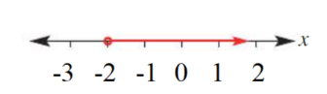
A. 𝑥 – 3 ≥ −5
B. − 3 – 𝑥 ≥ 2
C. 2 − 𝑥≥ − 5
D. 𝑥 – 2 ≥ −3
6. If $3\left(x-6\right)-5=-2$, the value of 𝑥 is

A. 2

B. 4

C. 7

D. 13

7. A linear relation gives the following table of values:
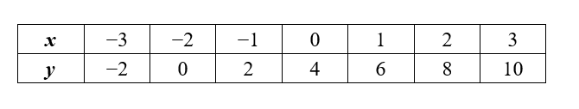
The x- and y- intercepts of the graph of this linear relation are respectively:
A. $(4,0)$ and $(0,2)$

B. $\left(-2,0\right)$ and $\left(0,4\right)$

C. $\left(0,2\right)$ and $\left(-4,0\right)$

D. $(-4,0)$ and $(0,2)$

8. The point of intersection of the vertical line passing through the point $(4,-3)$ and the line
$y=-2$ is:

A. $(-2,-3)$

B. $(4,-3)$

C. $(4,-2)$

D. $(-2, 3)$

9. The gradient of the line $6y+3x=30$is:

A. -2

B. -3

C. $-\frac{1}{2}$

D. 2

10. For the right angled triangle shown, which of the following is not the correct expression for x:

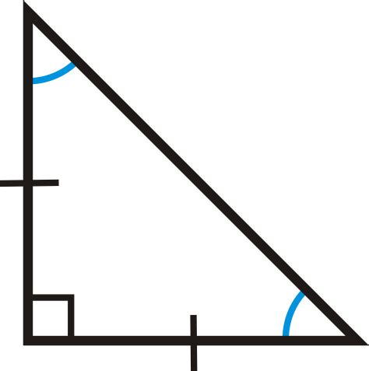

5
x

A. $x^{2}=\frac{25}{2}$

B. ${2x}^{2}=25$

C. $x=\frac{5}{\sqrt{2}}$

D. $x=\sqrt{\frac{5}{2}}$

Short Answer Questions
Answer the questions in the spaces provided. Your responses should include relevant mathematical reasoning and/or calculations.
Marks CANNOT be awarded for poorly organised written work.

Indices and surds [7]

11. Simplify the following operations with surds:

i) $\sqrt{51}÷\sqrt{3}$ (1)
……………………………………………………………………………………………………
……………………………………………………………………………………………………

ii) $\sqrt{18}-\sqrt{8}$ (2)
…………………………………………………………………………………………………….
…………………………………………………………………………………………………….

iii) $\sqrt[4]{x^{3}}×\sqrt[3]{x^{2}}$ (2)
…………………………………………………………………………………………………….
……………………………………………………………………………………………………
…………………………………………………………………………………………………….
o
12. Solve for x if $9^{2x}=\frac{1}{27}$ (2)

…………………………………………………………………………………………………….
…………………………………………………………………………………………………….
…………………………………………………………………………………………………….
…………………………………………………………………………………………………….

Expressions, equations, and inequalities [11]

13. Solve the following equation: $5+\frac{3d}{2}=-7$ (2)
……………………………………………………………………………………………………
…………………………………………………………………………………………………….
……………………………………………………………………………………………………. …………………………………………………………………………………………………….
14. Solve $3\left(2a-1\right)≤-2(4a+3)$ (2)
…………………………………………………………………………………………………….
…………………………………………………………………………………………………….
…………………………………………………………………………………………………….

15. Solve the following equations simultaneously. (3)
$3x+4y=7$
$5x+2y=-7$
…………………………………………………………………………………………………….
…………………………………………………………………………………………………….
……………………………………………………………………………………………………. …………………………………………………………………………………………………….
…………………………………………………………………………………………………….
…………………………………………………………………………………………………….
…………………………………………………………………………………………………….
…………………………………………………………………………………………………….
…………………………………………………………………………………………………….
…………………………………………………………………………………………………….
…………………………………………………………………………………………………….
…………………………………………………………………………………………………….

16. Noah receives m dollars pocket money per week. His younger brother Jake gets half of
three dollars less than Noah’s amount. If Jake receives $6:

i) write an equation to represent the problem (1)
…………………………………………………………………………………………………..
…………………………………………………………………………………………………..

ii) solve the equation in part i) to determine how much Noah receives each week (1)
……………………………………………………………………………………………………
……………………………………………………………………………………………………
……………………………………………………………………………………………………

17. Solve for m if $2m^{2}-4=28$ (2)
…………………………………………………………………………………………………….
…………………………………………………………………………………………………….. …………………………………………………………………………………………………….

Linear relationships [12]

18. State the x and y intercepts of the following rule $2y=8x+16$ (2)
…………………………………………………………………………………………………..
……………………………………………………………………………………………………
……………………………………………………………………………………………………

19. Find the equation of the line perpendicular to the line with the equation $y=2x-1$ that passes through the point (-2,4). (3)
……………………………………………………………………………………………………
……………………………………………………………………………………………………
……………………………………………………………………………………………………
……………………………………………………………………………………………………
…………………………………………………………………………………………………….
…………………………………………………………………………………………………….

20. Graph the simultaneous equations $3x-y-4=0$ and $y=x$ and find the coordinates of the point of intersection. (4)
……………………………………………………………………………………………………
…………………………………………………………………………………………………….
…………………………………………………………………………………………………….

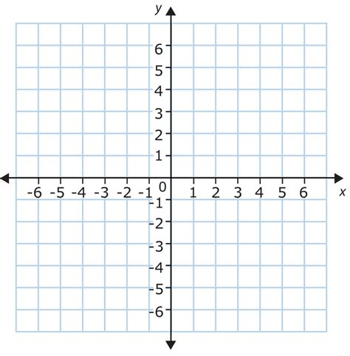

21. Doug works as a labourer. He is digging a trench and has 180 kg of soil to remove. He has
taken 3 hours to remove 36 kg.
i) What is the rate at which he is removing soil? (1)
…………………………………………………………………………………………………..
…………………………………………………………………………………………………..

ii) If he maintains this rate, write a rule for the amount of soil, S (kg), remaining after t hours. (1)
………………………………………………………………………………………………….
…………………………………………………………………………………………………...

iii) How long will it take to remove all the soil? (1)
…………………………………………………………………………………………………..
…………………………………………………………………………………………………..
…………………………………………………………………………………………………..

Right angles [5]

22. Consider the diagram below:

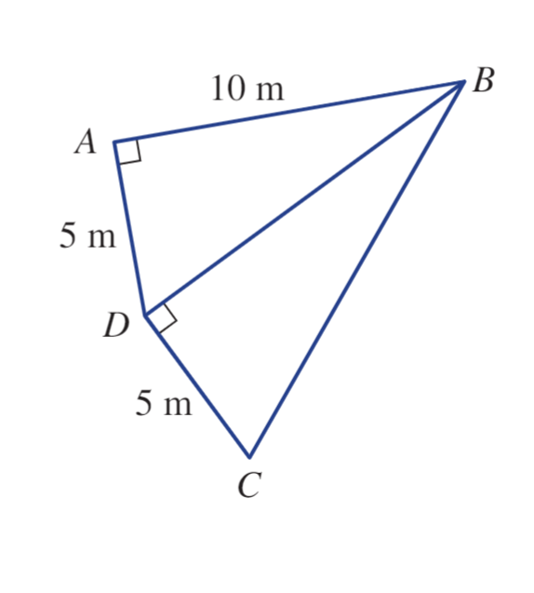
15 m
Find the length of DC. (2)
…………………………………………………………………………………………………….
…………………………………………………………………………………………………….
…………………………………………………………………………………………………….

23. Shown below is a cuboid.
$AB=8cm$, $BC=3cm$ and $CG=4cm$
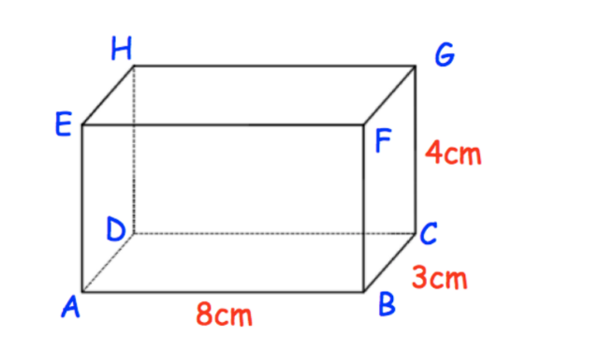

Find the length $AG$ , leave your answer correct to 2 decimal places. (3)
……………………………………………………………………………………
……………………………………………………………………………………………………………………………………………………………………………………………………………………………………………………………………………………………………………………………………………………………………………………………………………………………………………………………………………………………………………………………..
………………………………………………………………………………….
End of exam

