
Name: ____________________________________

Teacher: __________________________________

Year 9 MATHEMATICS ADVANCED 2024
TASK 2 – Half Yearly Examination

General Instructions  - Reading time – 5 minutes  - Working time – 90 minutes  - Show all necessary working / units  - Board approved calculators are allowed  - Exam guidelines  - Use black pen for your working  - Use a pencil and ruler for diagrams  - Marks may be lost for poorly organised written work. | Total Marks – 80  Section 1 – 40 marks  Allow 40 minutes  Section 2 – 40 marks  Allow 50 minutes
Question | Indices and Surds | Expressions, Equations and Inequalities | Linear Relationships | Total
Section I  Standard |  |  |  | /40
1,2,7 | /13
3,4,8 |  | /13
5,6,9 |  |  | /14
Section II  Advanced |  |  |  | /40
1,2,7 | /13
3,4,8 |  | /13
5,6,9 |  |  | /14
 | /26 | /26 | /28 | /80

Section 1 – Standard (40 marks)
Attempt questions 1-9
Allow approximately 40 minutes for this section

Multiple Choice Questions (6 marks) – Circle the correct answer on the question paper

- $3×8^{-4}$ expressed with positive indices is:

- ${24}^{4}$ | - $3^{4}8^{4}$ | - $-\frac{3}{8^{4}}$ | - $\frac{3}{8^{4}}$

- ${\left(m^{5}\right)}^{2}÷m^{7}$ simplifies to:

- $1$ | - $m^{3}$ | - $m^{14}$ | - $m$

- $-2x\left(3-5x\right)$ expands to:

- $-6x+10x^{2}$ | - $6x+10x^{2}$ | - $-6x-10x^{2}$ | - $6x-10x^{2}$

- The value of $b^{2}-4ac$when $a=-1, b=-2$and $c=8$is:

- $28$ | - $-36$ | - $-28$ | - $36$

- The gradient of the graph shown below is:

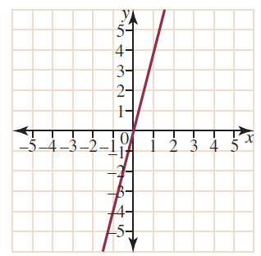

- $\frac{1}{4}$ | - $-4$ | - $4$ | - $-\frac{1}{4}$

- The origin does not lie on which of the following lines?

- $\frac{y}{2}=x$ | - $2y=1-2x$ | - $3y-2x=0$ | - $\frac{x}{4}=-2y$

Short Answer Questions (34 marks)
Answer the questions in the spaces provided. Your responses should include relevant mathematical reasoning and/or calculations.

Marks CANNOT be awarded for poorly organised written work.

Question 7 – Indices (11 marks)

- Simplify each of the following:
- ${\left(2x^{3}\right)}^{2}×2x^{2}$ (2)
………………………………………………………………………………………………………………………………………………………………………………………………………………………………………………………………………………………………
- ${\left(\frac{2x^{5}}{y^{3}}\right)}^{4}$ (2)
………………………………………………………………………………………………………………………………………………………………………………………………………………………………………………………………………………………………
- $3x^{0}+{\left(-3x\right)}^{0}-3$ (2)
………………………………………………………………………………………………………………………………………………………………………………………………………………………………………………………………………………………………
- Express${\left(x^{-2}\right)}^{3}$ with a positive index (2)
………………………………………………………………………………………………………………………………………………………………………………………………………………………………………………………………………………………………
- State the number of significant figures given in the number $3.60×{10}^{-2}$ (1)
………………………………………………………………………………………………………………………………………………………………………………………………

- Seth has incorrectly written his answer in scientific notation as $301.8×{10}^{-7}.$
Explain why Seth’s answer is incorrect and state the correct answer. (2)
………………………………………………………………………………………………………………………………………………………………………………………………………………………………………………………………………………………………………………………………………………………………………………………………

Question 8 – Expressions and Equations (11 marks)
- Expand and simplify the following: $2\left(3x-2\right)+4x$ (2)
………………………………………………………………………………………………………………………………………………………………………………………………………………………………………………………………………………………………
- A rectangular paddock has its area given by the expression $8ab^{2}$. Find the width of the paddock if the length is $2b.$ (1)

………………………………………………………………………………………………………………………………………………………………………………………………………………………………………………………………………………………………
- Solve the following equations:
- $-3\left(x+1\right)=18$ (2)
………………………………………………………………………………………………………………………………………………………………………………………………………………………………………………………………………………………………………………………………………………………………………………………………
- $\frac{2x+3}{11}=1$ (2)
………………………………………………………………………………………………………………………………………………………………………………………………………………………………………………………………………………………………………………………………………………………………………………………………

- $7x-4=9x-6$ (2)
………………………………………………………………………………………………………………………………………………………………………………………………………………………………………………………………………………………………………………………………………………………………………………………………
- The volume of a cone is given by the formula $v=\frac{πr^{2}h}{3}$ where $h$ is the height of the cone and $r$ is the radius of the base of cone. If the volume of the cone is $14m^{3}$ and the radius is 1.5m, find the height, to the nearest whole metre. (2)
………………………………………………………………………………………………………………………………………………………………………………………………………………………………………………………………………………………………………………………………………………………………………………………………………………………………………………………………………………………………

Question 9 – Linear Relationships (12 marks)

- For the graph of the straight line below:
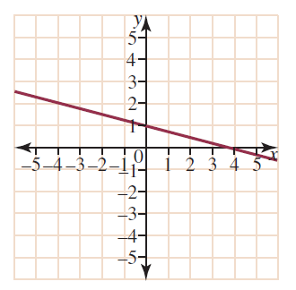
- Find the gradient. (1)

………………………………………………………………………………………………

- Find the $y$-intercept. (1)

………………………………………………………………………………………………

- Hence, find the equation of the line in gradient-intercept form. (1)

………………………………………………………………………………………………

- Sketch the graph of both $y=-2$and $x=3$ on the Cartesian plane provided below: (2)

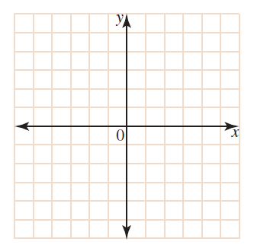
- Eli is draining a bathtub of water. The graph below shows the volume of water (in litres) in the bath after $t$ minutes.

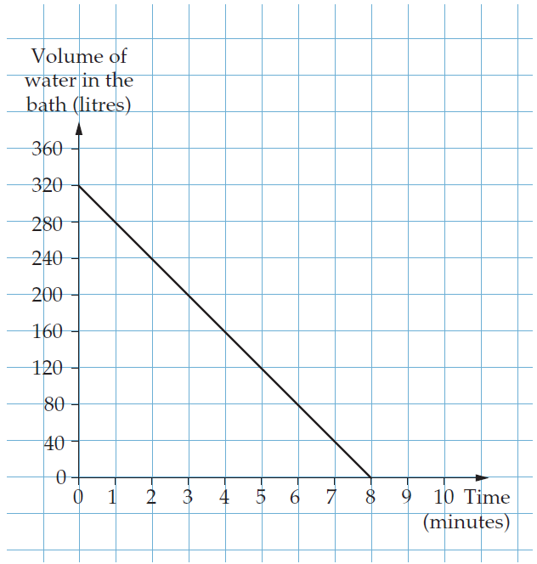

- What was the initial volume of water in the bath? (1)

………………………………………………………………………………………………

- What is the rate at which the water is being drained in L/min? (1)

………………………………………………………………………………………………

- Write down the equation for $V,$the volume of water left in the bathtub, after $t$ minutes. (1)

………………………………………………………………………………………………………………………………………………………………………………………………
- How many litres of water has drained away after 6 minutes? (1)
……………………………………………………………………………………………………………………………………………………………………………………..
- Use the $y$- intercept and gradient to graph the line $y=\frac{2}{3}x-1$on the number plane below. (2)

- Explain why the gradient of a vertical line is undefined. (1)

…………………………………………………………………………………………………..…………………………………………………………………………………………………..
…………………………………………………………………………………………………..

End of Section I (Standard)

Section II (Advanced) begins on the next page

Section II – Advanced (40 marks)
Attempt questions 1-9
Allow approximately 50 minutes for this section

Multiple Choice Questions (6 marks) – Circle the correct answer on the question paper

- Which of the following is a surd?

- $\sqrt[3]{8}$
- $\sqrt{8}$
- $\sqrt{\frac{1}{16}}$
- $\sqrt{16}$
- $\sqrt[4]{\sqrt[3]{\sqrt{x}}}$ written with fractional indices is:

- $x^{\frac{13}{12}}$ | - $x^{\frac{1}{8}}$ | - $x^{\frac{1}{12}}$ | - $x^{\frac{1}{24}}$

- Solve the quadratic equation $2x^{2}=72$

- $x=6$ | - $x=36$ | - $x=±6$ | - $x=±6\sqrt{2}$

- The inequality that correctly describes the number line graph below is:
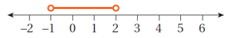

- $-1≤ x≤2$ | - $-1<x<2$
- $-1≥x≥2$ | - $-1>x>2$

- Which of the following is true for the linear equation $3-2x=-y$?

- The gradient is $3$ and $y$-intercept is $-2$
- The gradient is $-3$ and the$y$-intercept is $2$
- The gradient is$2$ and the $y$-intercept is $-3$
- The gradient is $-2$ and the $y$-intercept is $3$

- The equation of the line below is:

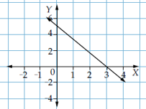

- $y=-\frac{5}{3}x+5$ | - $y=\frac{5}{3}x+5$ | - $y=-\frac{3}{5}x+5$ | - $y=\frac{3}{5}x+5$

Short Answer Questions (34 marks)
Answer the questions in the spaces provided. Your responses should include relevant mathematical reasoning and/or calculations.

Marks CANNOT be awarded for poorly organised written work.

Question 7 – Indices and Surds (11 marks)

- Simplify:
- $\sqrt{56}÷\sqrt{8}$ (1)
………………………………………………………………………………………………………………………………………………………………………………………………

- $4\sqrt{75}+\sqrt{48}$ (you must show full working out) (2)
………………………………………………………………………………………………………………………………………………………………………………………………………………………………………………………………………………………………………………………………………………………………………………………………

- Show that $5\sqrt{6}\left(2\sqrt{6}-3\sqrt{2}\right)=60-30\sqrt{3}$ by expanding and simplifying (you must show full working out). (2)
………………………………………………………………………………………………………………………………………………………………………………………………………………………………………………………………………………………………………………………………………………………………………………………………………………………………………………………………………………………………

- By showing full working, rationalise the denominator of $\frac{\sqrt{3}+1}{\sqrt{6}}$. Write your answer in simplest form. (2)
………………………………………………………………………………………………………………………………………………………………………………………………………………………………………………………………………………………………………………………………………………………………………………………………………………………………………………………………………………………………
- Simplify: $\sqrt[3]{64b^{15}}$ (2)
………………………………………………………………………………………………………………………………………………………………………………………………………………………………………………………………………………………………………………………………………………………………………………………………

(e) Solve for $x$ if $8^{2x}=\frac{1}{4}$ (2)
………………………………………………………………………………………………………………………………………………………………………………………………………………………………………………………………………………………………………………………………………………………………………………………………………………………………………………………………………………………………

Question 8 – Expressions, Equations and Inequalities (11 marks)

- Solve the following equations simultaneously: (3)
$$5x-2y=7$$
$$3x+4y=-1$$
………………………………………………………………………………………………………………………………………………………………………………………………………………………………………………………………………………………………………………………………………………………………………………………………………………………………………………………………………………………………………………………………………………………………………………………………………………………………………………………………………………………………………………………………………………………………………………………………………………………………………………………………………………………………………………………………………….

- Rearrange the formula $d=\sqrt{\frac{3h}{2}}$ to make $h$ the subject. (2)
……………………………………………………………………………………………………………………………………………………………………………………………………………………………………………………………………………………………………………………………………………………………………………………………………………………………………………………………………………………………………………………………………………………………..

- Solve the inequality $\frac{m+1}{-5}≥6$ (2)
…………………………………………………………………………………………………………………………………………………………………………………………………………………………………………………………………………………………………………………………………………………………………………..
- Simplify: $\frac{9bc}{4b}÷\frac{15b^{2}c^{3}}{12cb}$ (2)
…………………………………………………………………………………………………………………………………………………………………………………………………………………………………………………………………………………………………………………………………………………………………………………………………………………………………………………………………………………………………………………………………………………………………………………………………………………………………………………………

- Solve: $\frac{2x+1}{3}+\frac{x+1}{2}=1$ (2)

…………………………………………………………………………………………..……………………………………………………………………………………………………………………………………………………………………………………..
……………………………………………………………………………………………………………………………………………………………………………………………………………………………………………………………………………

Question 9 – Linear Relationships (12 marks)

- Find the $x$ and $y$-intercepts of $2x-3y-6=0$ and then use these to graph the line in the number plane given below. (3)

………………………………………………………………………………………………………………………………………………………………………………………………………………………………………………………………………………………………………………………………………………………………………………………………………………………………………………………………………………………………

- The midpoint $M$ of points $A\left(4,1\right)$ and $B\left(x,y\right)$ is $(-3, 5)$. What are the coordinates of point $B$? (2)
………………………………………………………………………………………………………………………………………………………………………………………………………………………………………………………………………………………………………………………………………………………………………………………………………………………………………………………………………………………………

- Find the equation of the line that is perpendicular to the line $2y=-3x+5$ and passes through the point $(-\frac{1}{2}, 2)$. (3)
………………………………………………………………………………………………………………………………………………………………………………………………………………………………………………………………………………………………………………………………………………………………………………………………………………………………………………………………………………………………………………………………………………………………………………………………

- The gradient of a line joining points $A$ and $B$ is $-1\frac{2}{5}$. Write down a possible pair of coordinates for $A$and $B$. (2)
………………………………………………………………………………………………………………………………………………………………………………………………………………………………………………………………………………………………………………………………………………………………………………………………

- The points $\left(6,-2\right)$and$\left(-3,-4\right)$ lie on the circumference of a circle and join to form the diameter of the circle. Find the length of the radius, leaving your answer in exact form. (2)

………………………………………………………………………………………………………………………………………………………………………………………………………………………………………………………………………………………………………………………………………………………………………………………………………………………………………………………………………………………………

END OF EXAM

This page intentionally left blank

Norwest Christian College
Mathematics Formulas (Stage 5)

Indices

$$a^{m}×a^{n}=a^{m+n}$$
$$\frac{a^{m}}{a^{n}}=a^{m}÷a^{n}=a^{m-n}$$
$${\left(a^{m}\right)}^{n}=a^{m×n}$$
$$a^{0}=1$$
$$a^{-m}=\frac{1}{a^{m}}$$
$${\left(\frac{a}{b}\right)}^{m}=\frac{a^{m}}{b^{m}}$$
$a^{\frac{1}{m}}=\sqrt[m]{a}$

Surds

$$\sqrt{a}×\sqrt{b}=\sqrt{a×b}$$
$$\sqrt{a}÷\sqrt{b}=\sqrt{\frac{a}{b}}$$

Gradient-intercept form of straight line

$$y=mx+c$$
Gradient
$$m=\frac{y_{2}-y_{1}}{x_{2}-x_{1}}$$
Midpoint Distance
$M=\left(\frac{x_{1}+x_{2}}{2} , \frac{y_{1}+y_{2}}{2}\right)$ $d=\sqrt{{\left(x_{2}-x_{1}\right)}^{2}+{\left(y_{2}-y_{1}\right)}^{2}}$

Parallel Lines Perpendicular Lines
$m_{1}=m_{2}$ $m_{1}×m_{2}=-1$

Pythagoras’ theorem
$$a^{2}+b^{2}=c^{2}$$

