

Name ______________

Date ______________

Year 9 MATHEMATICS 5.2/5.3 2022
Yearly Examination
General Instructions  - 5 min reading time given  - Working time – 90 minutes  - Show all necessary working / units  - Board approved calculators are allowed  - Exam guidelines  - Use black pen for your working  - Use a pencil and ruler for diagrams  - Marks may be lost for poorly organised written work. | Total Marks – 80  Section I 5.2 – 40 marks  Allow 40 mins  Section II 5.3 – 40 marks  Allow 50 mins
Question | Number and Algebra | Measurement and Geometry | Statistics and Probability | Total
Section I (5.2) |  |  |  | /40
1, 2, 5, 6 | /17
3, 4, 7 |  | /12
8 |  |  | /11
Section II (5.3) |  |  |  | /40
1-4 |  |  | /4
5 |  | /1
6 | /15
7 |  |  | /5
8 |  | /15
Total | /32 | /28 | /20 | /80

Section II – 5.2 (40 marks)
Allow approximately 50 minutes for this section

Multiple Choice (5 marks)
Attempt Questions 1 to 5

- What is $0.0000113$ in scientific notation?

- $11.3×{10}^{-6}$
- $1.13×{10}^{-5}$
- $1.13×{10}^{5}$
- $1.13×{10}^{4}$

- Simplify: $-12q^{8}÷3q^{5}$
- $4q^{3}$
- $-4q^{3}$
- $\frac{1}{4q^{3}}$
- $-\frac{1}{4q^{3}}$
- Which statement about this triangle is correct?
  - $\tan{67°}=\frac{x}{41}$
  - $\cos{67°}=\frac{x}{41}$
  - $\sin{67°}=\frac{x}{41}$
  - $\cos{67°}=\frac{41}{x}$

- Which of these is the value of $θ$ correct to the nearest minute?

  - $37°{14}^{'}$
  - $37°{15}^{'}$
  - $37°{23}^{'}$
  - $37°{24}^{'}$

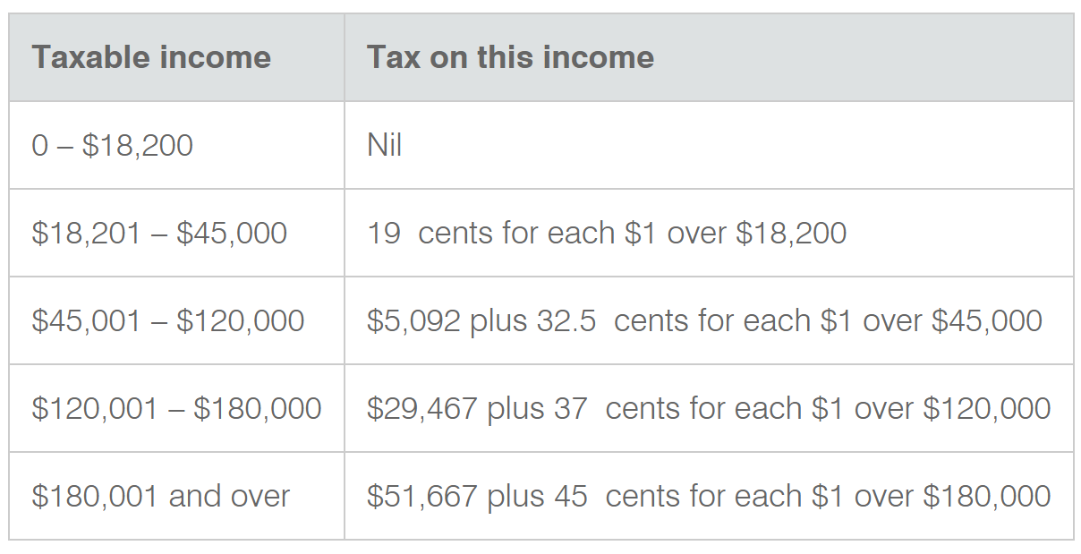
- According to the tax table below, how much tax is payable for Jared who has a taxable income of $95 000?
  - $\$50,000$
  - $\$45, 001$
  - $\$21,342$
  - $\$29,467$

Short Response (40 Marks)
Answer the questions in the spaces provided. Your responses should include relevant mathematical reasoning and/or calculations.
Question 6 (Number and Algebra) (14 marks]
- Factorise the following expressions:
  - $4x-8$ 1
____________________________________________________________________________________________________________________________________________________________________________________________________________________________________________________________
  - $5ab+10b$ 1
____________________________________________________________________________________________________________________________________________________________________________________________________________________________________________________________

- Complete the table for the linear equation $y=\frac{1}{2}x-1$
$$x$$ | -2 | -1 | 0 | 1 | 2
$$y$$
  - 2
  - Draw the graph of $y=\frac{1}{2}x-1$ on the number plane below. 2
- Solve these equations:
  - $-3=5d+12$ 2 ____________________________________________________________________________________________________________________________________________________________________________________________________________________________________________________________

  - $\frac{6p-1}{5}=7$ 2 __________________________________________________________________________________________________________________________________________________________________________________________________________________________________________________________________________________________________________________________________________________________________________________________

- Simplify: $\frac{10x-15}{2x-3}$ 2
_________________________________________________________________________________________________________________________________________________________________________________________________________________________________________________________________________________________________________________________________________________________

- Emile is saving for a holiday and invests $540 into a 2% p.a. compound interest account. How much money will he have in total after 3 years? 2
____________________________________________________________________________________________________________________________________________________________________________________________________________________________________________________________________________________

Question 7 (Measurement and Geometry) (10 marks)

- From a hot air balloon at an altitude of $1500 m$, the angle of depression to a person on the ground measures $15°$.

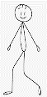
  - Fill out the information from the question onto the diagram below. 1

  - Find the distance from the balloon to the person, correct to 2 decimal places. 2
___________________________________________________________________________________________________________________________________________________________________________________________________________________________________________________________________________________________________________________________

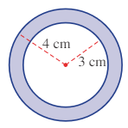
- Find the area of the shaded region of the following shape. Round your answer to 1 decimal place. 2

_________________________________________________________________________________________________________________________________________________________________________________________________________________________________________________________________________________________________________________________________________________________
- Jane purchases a can of spaghetti for her dinner as shown below. Round your answer to 1 decimal place.
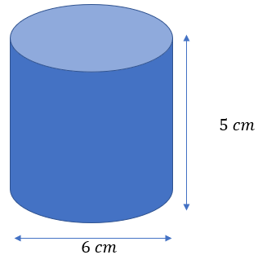

Calculate the surface area of the can. 3
____________________________________________________________________________________________________________________________________________________________________________________________________________________________________________________________________________________
_____________________________________________________________________
_____________________________________________________________________

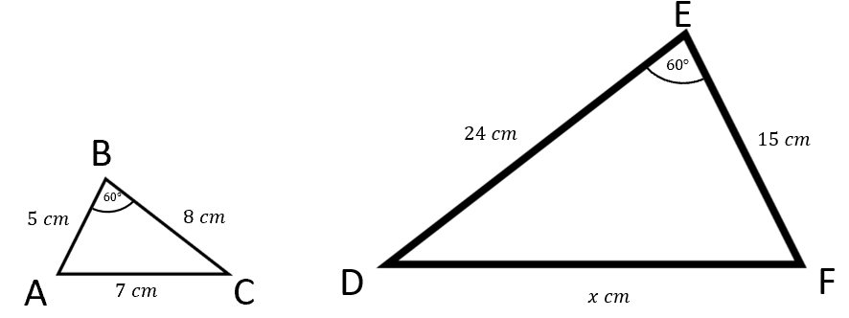
- △ABC ||| △DEF. Calculate the length of side DF. 2
_______________________________________________________________________________________________________________________________________________________________________________________________________________
$$x cm$$
F
D
_______________________________________________________________________________________________________________________________________________________________________________________________________________
Question 8 (Statistics and Probability) (11 marks)
- Two letters are selected from the word TWO without replacement.

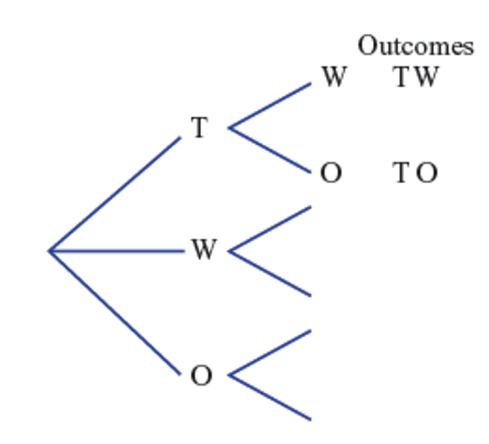
  - Complete the tree diagram below to show each of the possible outcomes and probabilities. 2

  - Find the probability of:
    - Selecting T and O, in any order. 1
___________________________________________________________________________________________________________________________________________________________________________

    - Obtaining an outcome with a W in it. 1
___________________________________________________________________________________________________________________________________________________________________________

    - Not selecting an outcome with W in it. 1
___________________________________________________________________________________________________________________________________________________________________________

- An AFL coach decides to use a stem-and-leaf plot to record his team’s score over the past season.
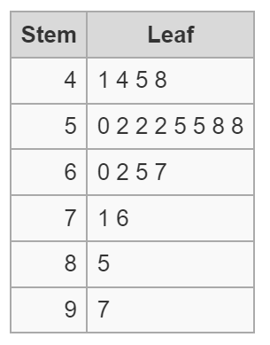
Key: “9|7” means 97

  - Find the median score. 1
______________________________________________________________________________________________________________________________
  - Find the mode score. 1
______________________________________________________________________________________________________________________________

- Vicky plays a game with her friend, Whitney. Vicky rolls first, then Whitney. Whoever rolls the higher number wins. If both dice have the same number, they draw.

  - Complete the table below to show the sample space. 2
 |  | VICKY
 |  | 1 | 2 | 3 | 4 | 5 | 6
WHITNEY | 1 | (1,1)
WHITNEY | 2
WHITNEY | 3 |  | (2,3)
WHITNEY | 4
WHITNEY | 5 |  |  |  |  |  | (6,5)
WHITNEY | 6 |  |  | (3,6)

  - How many possible outcomes are there? 1
______________________________________________________________________________________________________________________________
  - What is the probability of Vicky winning? 1
_____________________________________________________________________________________________________________________________________________________________________________________________

END OF EXAM

Section II – 5.3 (40 marks)
Allow approximately 50 minutes for this section

Multiple Choice
Attempt Questions 1 to 5

1. In the box plot below, what percentage of the total scores are between 21 and 50?
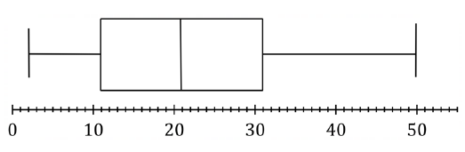
A. 10%
B. 29%
C. 50%
D. 71%

2. A three digit number is formed from the digits $3,5,6$ and 7. What is the probability that the number will be odd?
A. 0.25
B. 0.50
C. 0.75
D. 0.80

3. Consider the data set.
12 15 16 16 20 23
Which row of the table shows how the median and mean are affected when a score of 2 is added to the data set?
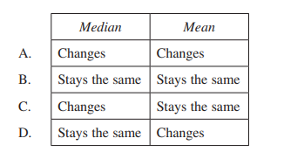

4. In a game Mario draws two marbles from a bag containing two red, one white and one blue marble. The tree diagram shows the possible combinations he could draw.
What is the probability that neither marble is red?
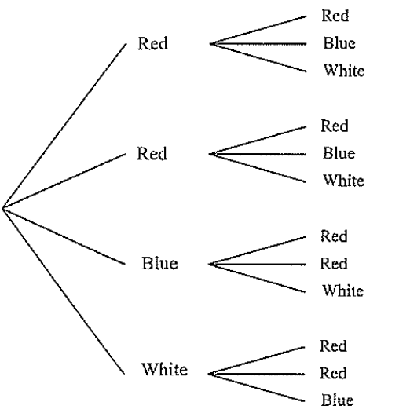
A. $\frac{1}{12}$
B. $\frac{1}{6}$
C. $\frac{1}{4}$
D. $\frac{5}{6}$

5. Four circles, each of diameter $D,$ are placed next to each just touching, as shown.
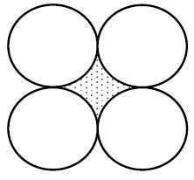
Which expression gives the area of the shaded section between the circles?
A. $\frac{D^{2}\left(4-π\right)}{4}$
B. $4D^{2}(1-π)$
C. $\frac{D^{2}\left(16-π\right)}{4}$
D. $4D^{2}\left(4-π\right)$

Section II Short Response 40 marks
Answer the questions in the spaces provided. Your responses should include relevant mathematical reasoning and/or calculations
Question 6 (Number and Algebra 5.3) (15 marks)
(a) Simplify:
(i) $\sqrt{243}+3\sqrt{75}$ 2
…………………………………………………………………………………………….
…………………………………………………………………………………………….
…………………………………………………………………………………………….
(ii) ${\left(27a^{3}\right)}^{-\frac{2}{3}}$ 2
…………………………………………………………………………………………….
…………………………………………………………………………………………….
…………………………………………………………………………………………….
…………………………………………………………………………………………….
(iv) $\frac{x-1}{x^{2}-1}×\frac{x^{2}-5x-6}{3x-3}$ 2
…………………………………………………………………………………………….
…………………………………………………………………………………………….
…………………………………………………………………………………………….
…………………………………………………………………………………………….
(v) $\frac{12}{x^{2}+6x+8}-\frac{3}{x+2}$ 2
…………………………………………………………………………………………….
…………………………………………………………………………………………….
…………………………………………………………………………………………….
…………………………………………………………………………………………….
(b) Solve $5^{2x-1}=\sqrt{5}$ 1
…………………………………………………………………………………………….
…………………………………………………………………………………………….
…………………………………………………………………………………………….
…………………………………………………………………………………………….
…………………………………………………………………………………………….
(c) Factorise $xy-7+7y-x$ 1
…………………………………………………………………………………………….
…………………………………………………………………………………………….
…………………………………………………………………………………………….
…………………………………………………………………………………………….
(d) Mimi buys two notebooks and three pens for $16, while Joey buys three notebooks and one pen for $17.
Let $x$ dollars be the cost of a notebook and let $y$ dollars be the cost of a pen.
(i) Write two equations to represent this information. 1
…………………………………………………………………………………………….
…………………………………………………………………………………………….
(ii) Solve the simultaneous equations to determine the cost of each item. 2
…………………………………………………………………………………………….
…………………………………………………………………………………………….
…………………………………………………………………………………………….
…………………………………………………………………………………………….
…………………………………………………………………………………………….
(g) Find the equation of the line which is perpendicular to the $y=-\frac{1}{3}x-4$ 2
and passes through the point $(1,4)$. Write your answer in $y=mx+c$ form.

…………………………………………………………………………………………….
…………………………………………………………………………………………….
…………………………………………………………………………………………….
…………………………………………………………………………………………….
…………………………………………………………………………………………….

Question 7 (Statistics and Probability 5.3) (5 marks)
(a) The table below represents the marks in a Year 9 Quiz out of 8.
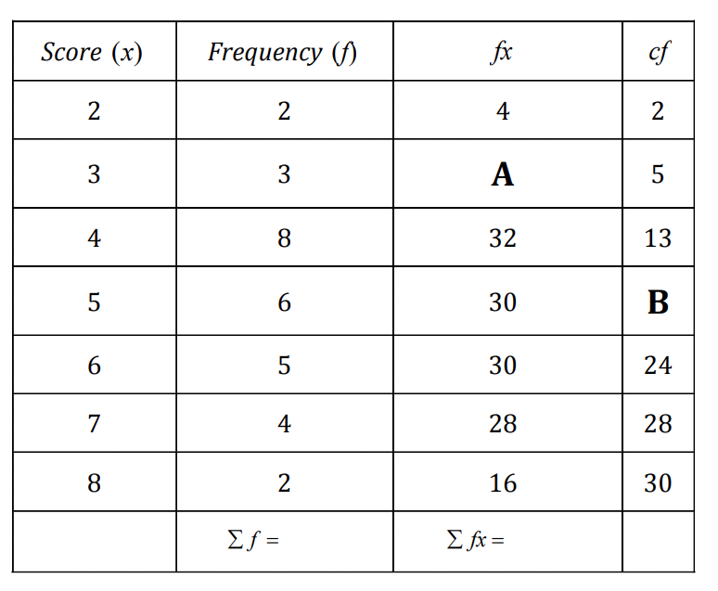
(i) State the missing values $A$ and $B$ 2
…………………………………………………………………………………………….
…………………………………………………………………………………………….
(ii) How many students completed the quiz? 1
…………………………………………………………………………………………….
…………………………………………………………………………………………….
(iii) Calculate the mean, correct to 2 decimal places. 1
…………………………………………………………………………………………….
…………………………………………………………………………………………….
(iv) Calculate the median. 1
…………………………………………………………………………………………….
…………………………………………………………………………………………….

Question 8 (Measurement and Geometry 5.3) (15 marks)
(a) Find the value of $x$ and$y$ in the following diagram below. 2
…………………………………………………………………………………………….
…………………………………………………………………………………………….
…………………………………………………………………………………………….
…………………………………………………………………………………………….
(b) Tom walks from $A$ at a bearing of $135°T$ for $40km$ until he reaches $B.$ Tom stops at $B$ and walks north to $C$ which is directly east of $A.$
(i) By drawing a diagram to represent this information, find $∠CAB.$ 2

(ii) Find the distance Tom walked from $B$ to $C$ correct to the nearest metre. 2
…………………………………………………………………………………………….
…………………………………………………………………………………………….
…………………………………………………………………………………………….
…………………………………………………………………………………………….
…………………………………………………………………………………………….
…………………………………………………………………………………………….
(c) What is the surface area of the solid shown below? Give your answer in exact form. 3
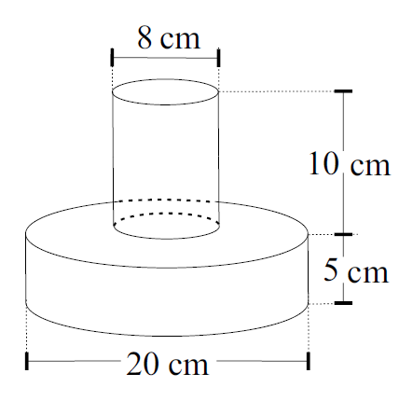
…………………………………………………………………………………………….
…………………………………………………………………………………………….
…………………………………………………………………………………………….
…………………………………………………………………………………………….
…………………………………………………………………………………………….
…………………………………………………………………………………………….
(d) Find the value of CD in the triangle below. 3
Give your answer to the nearest whole number.
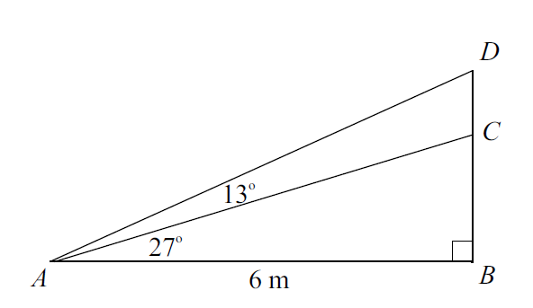
…………………………………………………………………………………………….
…………………………………………………………………………………………….
…………………………………………………………………………………………….
…………………………………………………………………………………………….
…………………………………………………………………………………………….
…………………………………………………………………………………………….
…………………………………………………………………………………………….
…………………………………………………………………………………………….

(e) Find the area of the trapezium below if it has a perimeter of $60 cm$. 3
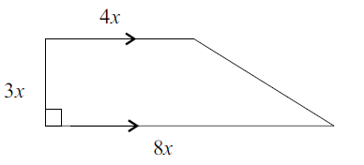
…………………………………………………………………………………………….
…………………………………………………………………………………………….
…………………………………………………………………………………………….
…………………………………………………………………………………………….
…………………………………………………………………………………………….
…………………………………………………………………………………………….
…………………………………………………………………………………………….
…………………………………………………………………………………………….
…………………………………………………………………………………………….
…………………………………………………………………………………………….
…………………………………………………………………………………………….
…………………………………………………………………………………………….

END OF EXAM

Section II – 5.3 (40 marks)
Allow approximately 50 minutes for this section

Multiple Choice
Attempt Questions 1 to 5

1. In the box plot below, what percentage of the total scores are between 21 and 50?
A. 10%
B. 29%
C. 50%
D. 71%

2. A three digit number is formed from the digits $3,5,6$ and 7. What is the probability that the number will be odd?
A. 0.25
B. 0.50
C. 0.75
D. 0.80

3. Consider the data set.
12 15 16 16 20 23
Which row of the table shows how the median and mean are affected when a score of 2 is added to the data set?

4. In a game Mario draws two marbles from a bag containing two red, one white and one blue marble. The tree diagram shows the possible combinations he could draw.
What is the probability that neither marble is red?
A. $\frac{1}{12}$
B. $\frac{1}{6}$
C. $\frac{1}{4}$
D. $\frac{5}{6}$

5. Four circles, each of diameter $D,$ are placed next to each just touching, as shown.
Which expression gives the area of the shaded section between the circles?
A. $\frac{D^{2}\left(4-π\right)}{4}$
B. $4D^{2}(1-π)$
C. $\frac{D^{2}\left(16-π\right)}{4}$
D. $4D^{2}\left(4-π\right)$

Section II Short Response 40 marks
Answer the questions in the spaces provided. Your responses should include relevant mathematical reasoning and/or calculations
Question 6 (Number and Algebra) (15 marks)
(a) Simplify:
(i) $\sqrt{243}+3\sqrt{75}$ 2
…………………………………………………………………………………………….
…………………………………………………………………………………………….
…………………………………………………………………………………………….
(ii) ${\left(27a^{3}\right)}^{-\frac{2}{3}}$ 2
…………………………………………………………………………………………….
…………………………………………………………………………………………….
…………………………………………………………………………………………….
…………………………………………………………………………………………….
(iv) $\frac{x-1}{x^{2}-1}×\frac{x^{2}-5x-6}{3x-3}$ 2
…………………………………………………………………………………………….
…………………………………………………………………………………………….
…………………………………………………………………………………………….
…………………………………………………………………………………………….
(v) $\frac{12}{x^{2}+6x+8}-\frac{3}{x+2}$ 2
…………………………………………………………………………………………….
…………………………………………………………………………………………….
…………………………………………………………………………………………….
…………………………………………………………………………………………….
(b) Solve $5^{2x-1}=\sqrt{5}$ 1
…………………………………………………………………………………………….
…………………………………………………………………………………………….
…………………………………………………………………………………………….
…………………………………………………………………………………………….
…………………………………………………………………………………………….

(c) Factorise $xy-7+7y-x$ 1
…………………………………………………………………………………………….
…………………………………………………………………………………………….
…………………………………………………………………………………………….
…………………………………………………………………………………………….
(d) Mimi buys two notebooks and three pens for $16, while Joey buys three notebooks and one pen for $17.
Let $x$ dollars be the cost of a notebook and let $y$ dollars be the cost of a pen.
(i) Write two equations to represent this information. 1
…………………………………………………………………………………………….
…………………………………………………………………………………………….
(ii) Solve the simultaneous equations to determine the cost of each item. 2
…………………………………………………………………………………………….
…………………………………………………………………………………………….
…………………………………………………………………………………………….
…………………………………………………………………………………………….
…………………………………………………………………………………………….
(g) Find the equation of the line which is perpendicular to the $y=-\frac{1}{3}x-4$ 2
and passes through the point $(1,4)$. Write your answer in $y=mx+c$ form.

…………………………………………………………………………………………….
…………………………………………………………………………………………….
…………………………………………………………………………………………….
…………………………………………………………………………………………….
…………………………………………………………………………………………….

Question 7 (Statistics and Probability 5.3) (5 marks)
(a) The table below represents the marks in a Year 9 Quiz out of 8.
(i) State the missing values $A$ and $B$ 2
…………………………………………………………………………………………….
…………………………………………………………………………………………….
(ii) How many students completed the quiz? 1
…………………………………………………………………………………………….
…………………………………………………………………………………………….
(iii) Calculate the mean, correct to 2 decimal places. 1
…………………………………………………………………………………………….
…………………………………………………………………………………………….
(iv) Calculate the median. 1
…………………………………………………………………………………………….
…………………………………………………………………………………………….

Question 8 (Measurement and Geometry 5.3) (15 marks)
(a) Find the value of $x$ and$y$ in the following diagram below. 2
…………………………………………………………………………………………….
…………………………………………………………………………………………….
…………………………………………………………………………………………….
…………………………………………………………………………………………….
(b) Tom walks from $A$ at a bearing of $135°T$ for $40km$ until he reaches $B.$ Tom stops at $B$ and walks north to $C$ which is directly east of $A.$
(i) By drawing a diagram to represent this information, find $∠CAB.$ 2

(ii) Find the distance Tom walked from $B$ to $C$ correct to the nearest metre. 2
…………………………………………………………………………………………….
…………………………………………………………………………………………….
…………………………………………………………………………………………….
…………………………………………………………………………………………….
…………………………………………………………………………………………….
…………………………………………………………………………………………….
(c) What is the surface area of the solid shown below? Give your answer in exact form. 3
…………………………………………………………………………………………….
…………………………………………………………………………………………….
…………………………………………………………………………………………….
…………………………………………………………………………………………….
…………………………………………………………………………………………….
…………………………………………………………………………………………….
(d) Find the value of CD in the triangle below. 3
Give your answer to the nearest whole number.
…………………………………………………………………………………………….
…………………………………………………………………………………………….
…………………………………………………………………………………………….
…………………………………………………………………………………………….
…………………………………………………………………………………………….
…………………………………………………………………………………………….
…………………………………………………………………………………………….
…………………………………………………………………………………………….

(e) Find the area of the trapezium below if it has a perimeter of $60 cm$. 3
…………………………………………………………………………………………….
…………………………………………………………………………………………….
…………………………………………………………………………………………….
…………………………………………………………………………………………….
…………………………………………………………………………………………….
…………………………………………………………………………………………….
…………………………………………………………………………………………….
…………………………………………………………………………………………….
…………………………………………………………………………………………….
…………………………………………………………………………………………….
…………………………………………………………………………………………….
…………………………………………………………………………………………….


Indices
$$a^{m}×a^{n}=a^{m+n}$$
$$a^{m}÷a^{n}=a^{m-n}$$
$${\left(a^{m}\right)}^{n}=a^{m×n}$$
$$a^{-m}=\frac{1}{a^{m}}$$
$$a^{0}=1$$
$$a^{\frac{1}{m}}=\sqrt[m]{a}$$

Equation of straight line
$$y=mx+c$$
Pythagoras’ Theorem
$$a^{2}+b^{2}=c^{2}$$

Distance and Midpoint
$$d=\sqrt{{\left(x_{2}-x_{1}\right)}^{2}+{\left(y_{2}-y_{1}\right)}^{2}}$$
$$M=\left(\frac{x_{1}+x_{2}}{2} , \frac{y_{1}+y_{2}}{2}\right)$$
$$Gradient=\frac{y_{2}-y_{1}}{x_{2}-x_{1}}$$
$$Gradient=\frac{Rise}{Run}$$

Financial Mathematics
Simple Interest: $I=PRN$
Compound Interest: $A=P{\left(1+R\right)}^{n}$

Norwest Christian School
Mathematics Formulas (Stage 5)

Surface Area
$$Closed cylinder=2πrh+2πr^{2}$$

Data Analysis
Mean: average
Median: middle
Mode: most
Range: $highest-lowest$

Trigonometry
SOH CAH TOA

Probability
$$P\left(event\right)=\frac{number of favourable outcomes}{total number of outcomes}$$

