

Name ______________

Date ______________

Year 9 MATHEMATICS 5.2/5.3 2023
Yearly Examination
General Instructions  - 10 min reading time given  - Working time – 90 minutes  - Show all necessary working / units  - Board approved calculators are allowed  - Exam guidelines  - Use black pen for your working  - Use a pencil and ruler for diagrams  - Marks may be lost for poorly organised written work. | Total Marks – 80  Section I 5.2 – 40 marks  Allow 40 mins  Section II 5.3 – 40 marks  Allow 50 mins
Question | Number and Algebra | Measurement and Geometry | Statistics and Probability | Total
Section I (5.2) |  |  |  | /40
1, 2, 5, 6 | /17
3, 4, 7 |  | /12
8 |  |  | /11
Section II (5.3) |  |  |  | /40
1-4 |  |  | /4
5 |  | /1
6 | /15
7 |  |  | /5
8 |  | /15
Total | /32 | /28 | /20 | /80

Section I – 5.2 (40 marks)
Allow approximately 50 minutes for this section

Multiple Choice (10 marks)
Attempt Questions 1 to 10
Choose the best answer A, B, C or D and fill in the correct circle on the answer sheet.
1. |  | What is the simple interest on $500 invested at 10% p.a. for 2 years?
 | (A) |  | $50
 | (B) |  | $100
 | (C) |  | $600
 | (D) |  | $605
2. |  | What is the gradient of the line $y=-2x+3$ ?
 | (A) |  | –3
 | (B) |  | –2
 | (C) |  | 2
 | (D) |  | 3
3. |  | 0.000 006 734 written in scientific notation is:
 | (A) |  | $$6.743×{10}^{-6}$$
 | (B) |  | $$6.743×{10}^{6}$$
 | (C) |  | $$67.43×{10}^{7}$$
 | (D) |  | $$67.43×{10}^{-7}$$
4. |  | What is the value of $3^{0}+3x^{0}$ ?
 | (A) |  | 1
 | (B) |  | 2
 | (C) |  | 3
 | (D) |  | 4
5. |  | The area of a circle of diameter 28 cm is closest to:
 | (A) |  | 88 cm²
 | (B) |  | 616 cm²
 | (C) |  | 1232 cm²
 | (D) |  | 2463 cm²
6.
 |  | What is the volume of the triangular prism?
 | (A) |  | 500 cm³
 | (B) |  | 750 cm³
 | (C) |  | 1500 cm³
 | (D) |  | 3000 cm³
7. |  | Lucas correctly calculated the size of angle $θ$ using trigonometry.
 |  | 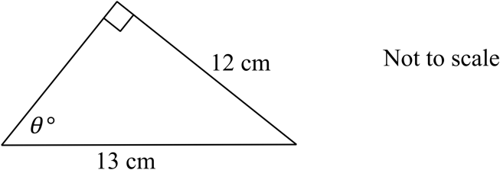
 |  | What was his first line of working?
 | (A) |  | $$cosθ=\frac{12}{13}$$
 | (B) |  | $$cosθ=\frac{13}{12}$$
 | (C) |  | $$sinθ=\frac{12}{13}$$
 | (D) |  | $$sinθ=\frac{13}{12}$$
8.
 |  | What is the area of the above triangle?
 | (A) |  | 24 cm²
 | (B) |  | 60 cm²
 | (C) |  | 84 cm²
 | (D) |  | 168 cm²
9. Toby buys 20 tickets in a raffle in which there are 400 tickets sold.
What is the chance that he does not win first prize?
(A)
(B)
(C)
(D)
10. Which data set has the mode larger than the range?

(A) 0, 5, 7, 7, 7
(B) 3, 5, 6, 6, 8
(C) 4, 5, 5, 5, 10
(D) 5, 5, 6, 8, 11

Short Response (30 Marks)
Answer the questions in the spaces provided. Your responses should include relevant mathematical reasoning and/or calculations.
11. Number and Algebra (14 marks) |  | Marks
a. | Factorise the following expressions:
 | (i) $4x+12$  ………………………………………………………………………………………  ……………………………………………………………………………………… | 1
 | (ii) $5xy+10x$  ………………………………………………………………………………………  ……………………………………………………………………………………… | 1
b. | Complete the table for the linear equation $y=2x-1$ | 2
$$x$$ | $$-2$$ | $$-1$$ | $$0$$ | $$1$$ | $$2$$
$$y$$
(i)

 | (ii) Draw the graph of $y=2x-1$ on the number plane below. | 2
c. | Solve these equations:
 | - $3=5x-12$  ………………………………………………………………………………………  ……………………………………………………………………………………… | 2
 | (ii) $\frac{6x-18}{4}=3$  ………………………………………………………………………………………  ……………………………………………………………………………………… | 2
d. | Henry has a group certificate showing he earned $96000 last year. He had other income of $1400 from investments and has tax deductions totaling $2480.
 | (i) What was his taxable income for last year?  ………………………………………………………………………………………  ……………………………………………………………………………………… | 1
 | (ii) Medicare levy is charged 2% of taxable income. How much should he have paid as his Medicare levy?  ………………………………………………………………………………………  ……………………………………………………………………………………… | 1
 | (iii) Use the table above to determine the amount of income tax he should have paid for the year.  ………………………………………………………………………………………  ………………………………………………………………………………………  ………………………………………………………………………………………  ………………………………………………………………………………………  ………………………………………………………………………………………  ……………………………………………………………………………………… | 2
  Taxable income | Tax payable
  0 – $18 200 | Nil
  $18 201 – $37 000 | Nil + 19 cents for each $1 over $18 200
  $37 001 – $87 000 | $3572 + 32.5 cents for each $1 over $37 000
  $90 001 – $180 000 | $20 797 + 37 cents for each $1 over $90 000
  $180 001 and over | $54 097 + 45 cents for each $1 over $180 000
12. Measurement and Geometry (10 marks) |  | Marks
a. | Find the shaded area correct to the nearest square centimetre.  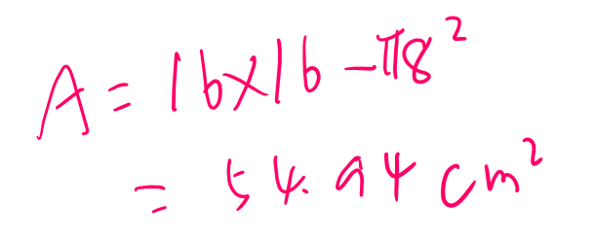  ………………………………………………………………………………………  ……………………………………………………………………………………… | 2
b. | A rectangular swimming pool measures 9 m by 4 m. It is surrounded by a concrete path that is 2 m wide.
 | (i) What is the area of the concrete path?  ………………………………………………………………………………………  ………………………………………………………………………………………  ………………………………………………………………………………………  ……………………………………………………………………………………… | 2
 | (ii) If the concrete is laid to a depth of 20 cm, how many cubic metres of concrete will be needed?  ………………………………………………………………………………………  ……………………………………………………………………………………… | 1
c. | From the top of an 80m high cliff, a boat is sighted at an angle of depression of 35º. How far is the boat from the base of the cliff?
 | 35⁰  80m  ………………………………………………………………………………………  ……………………………………………………………………………………… | 2
d. | A post 1 m high casts a shadow, on level ground, that is 1.3 m long. At the same time a tree casts a shadow 71.5 m long.  ………………………………………………………………………………………  ………………………………………………………………………………………  ………………………………………………………………………………………  ………………………………………………………………………………………  ………………………………………………………………………………………  ……………………………………………………………………………………… | 3
13. Statistics and Probability (6 marks) |  | Marks
a. | For the following scores – 12, 10, 10, 15, 10, 9, 14, 15, 11, 14. Find the:
 | (i) mode  ………………………………………………………………………………………  ……………………………………………………………………………………… | 1
 | (ii) Mean  ………………………………………………………………………………………  ………………………………………………………………………………………  ……………………………………………………………………………………… | 2
b. | The table below shows how many females and males among 85 students are right-handed or left-handed.
   | Left-handed | Right-handed | Total
  Male | 7 | 33 | 40
  Female | 4 | 41 | 45
  Total | 11 | 74 | 85
 | (i) What is the probability of selecting a female student?  ……………………………………………………………………………………… | 1
 | (ii) What is the probability of selecting a right-handed student?  ………………………………………………………………………………………  ……………………………………………………………………………………… | 1
 | (iii) What is the probability of selecting a right-handed male student?  ………………………………………………………………………………………  ……………………………………………………………………………………… | 1

Section II – 5.3 (40 marks)
Allow approximately 50 minutes for this section

Multiple Choice
Attempt Questions 1 to 5

- Stephen the author earns a percentage of the sales of his recent horror novel. Which word best describes this payment?

  - Salary

  - Commission

  - Royalty

  - Wage

- The gradient and the y-intercept, respectively, of the line $2x + y - 3 = 0$ are?

  - 3 and −2

  - −2 and 3

  - 2 and −3

  - −3 and −2

- Carlos took 70% of a whole pie. Maria took one third of the remainder. What percentage of the whole pie is left?

  - 30%

  - 15%

  - 10%

  - 20%

- Simplify 2m² $×$ 3mp² .
  - 5m² p²
  - 5m³ p²
  - 6m² p²
  - 6m³ p²

- Find the size of the angle $θ$ correct to the nearest minute.

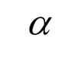
5.2 m
8.7 m

  - 30⁰52 '

  - 30⁰53'

  - 36⁰42 '

  - 36⁰43'

Section II Short Response 35 marks
Answer the questions in the spaces provided. Your responses should include relevant mathematical reasoning and/or calculations
11. Number and Algebra (18 marks) |  | Marks
a. | 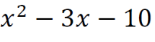  Factorise  ……………………………………………………………………………………  …………………………………………………………………………………… | 1
b. | Simplify:
 | (i) $\sqrt{300}-\sqrt{75}-\sqrt{147}$  ……………………………………………………………………………………  …………………………………………………………………………………… | 2
 | 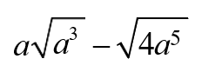  (ii)  ……………………………………………………………………………………  ……………………………………………………………………………………  ……………………………………………………………………………………  ……………………………………………………………………………………  ……………………………………………………………………………………  ……………………………………………………………………………………  ……………………………………………………………………………………  …………………………………………………………………………………… | 2
 | (iii) $\frac{p^{2}-9}{p^{2}-p-12}÷\frac{p^{2}-3p}{p^{2}-9p+20}$  ……………………………………………………………………………………  ……………………………………………………………………………………  ……………………………………………………………………………………  …………………………………………………………………………………… | 3
 | (iii) $\frac{x^{2}+ 4x + 3}{x^{2}+ 2x - 3} +\frac{1}{x-1}$  ……………………………………………………………………………………  ……………………………………………………………………………………  ……………………………………………………………………………………  ……………………………………………………………………………………  ……………………………………………………………………………………  ……………………………………………………………………………………  ……………………………………………………………………………………  …………………………………………………………………………………… | 2
 | 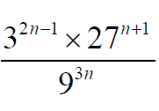  (iv)  ……………………………………………………………………………………  ……………………………………………………………………………………  ……………………………………………………………………………………  ……………………………………………………………………………………  ……………………………………………………………………………………  …………………………………………………………………………………… | 3
c. | If $y = 5x$. Express $5^{2x+1}$in terms of y.  ……………………………………………………………………………………  ……………………………………………………………………………………  ……………………………………………………………………………………  ……………………………………………………………………………………  …………………………………………………………………………………… | 2
d. | The table shows the income tax rates for the 2019−2020 financial year.  (Note: The above rates do not include the Medicare levy of 2%.)  The Medicare levy is calculated as 2% of taxable income.  For the 2019−2020 financial year, Charlotte pays a Medicare levy of $2341.20.  Calculate the tax payable on Charlotte’s taxable income.  ……………………………………………………………………………………  ……………………………………………………………………………………  ……………………………………………………………………………………  ……………………………………………………………………………………  ……………………………………………………………………………………  …………………………………………………………………………………… | 3
  Taxable income | Tax payable on this income
  $0 to $18 200 | Nil
  $18 201 to $37 000 | 19c for each $1 over $18 200
  $37 001 to $90 000 | $3 572 plus 32.5c for each $1 over $37 000
  $90 001 to $180 000 | $20 797 plus 37c for each $1 over $90 000
  $180 001 and over | $54 097 plus 45c for each $1 over $180 000

12. Measurement and Geometry (10 marks) |  | Marks
a. | A flagpole stands at one corner P of a level square field PQRS, each side being 120 m long
 | 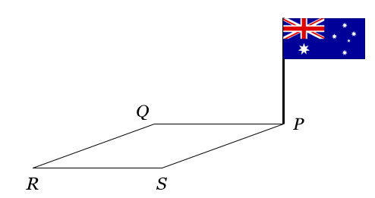  If the angle of elevation to the top of the pole from Q is 13◦19′, find:  (i) the height of the flagpole, correct to the nearest centimeter.  ……………………………………………………………………………………  …………………………………………………………………………………….  ……………………………………………………………………………………  ……………………………………………………………………………………. | 2
 | (ii) its angle of elevation from R.  ……………………………………………………………………………………  …………………………………………………………………………………….  ……………………………………………………………………………………  …………………………………………………………………………………….  ……………………………………………………………………………………  ……………………………………………………………………………………. | 3
b. | Find the radius of a sphere with volume 1 220 cm³ ,correct to 1 decimal place.  ……………………………………………………………………………………  …………………………………………………………………………………….  ……………………………………………………………………………………  ……………………………………………………………………………………. | 2
c. | The diagram below shows a pyramid with perpendicular height 12 cm and rectangular base measuring 18 cm by 10 cm. | 3
Calculate the surface area of the pyramid.

……………………………………………………………………………………
…………………………………………………………………………………….

……………………………………………………………………………………
…………………………………………………………………………………….
……………………………………………………………………………………
…………………………………………………………………………………….

……………………………………………………………………………………
…………………………………………………………………………………….

13. Statistics and Probability (7 marks) |  | Marks
a. | Consider the following scores:  4, 6, 7, 8, 9, 10, 10, 11, 11, 12, 16, 17, 18, 19, 20
 | (i) What is the median.  ……………………………………………………………………………………  …………………………………………………………………………………… | 1
 | (ii) What is the lower quartile Q₁ ?  ……………………………………………………………………………………  …………………………………………………………………………………… | 1
 | (iii) What is the upper quartile Q₃ ?  ……………………………………………………………………………………  …………………………………………………………………………………… | 1
 | (iv) Draw a box-and-whisker plot showing the above information.  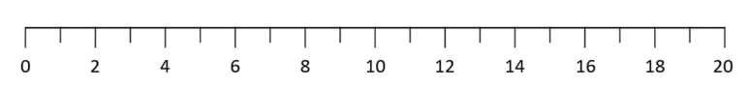 | 2
b. | Max has completed four of the five tasks for the year in English and is presently averaging 73%. Max wishes to improve and would like his average by the end of the year, to be 80%. Is this possible? Clearly explain your answer.  ……………………………………………………………………………………  ……………………………………………………………………………………  ……………………………………………………………………………………  …………………………………………………………………………………… | 2

End of Exam


Indices
$$a^{m}×a^{n}=a^{m+n}$$
$$a^{m}÷a^{n}=a^{m-n}$$
$${\left(a^{m}\right)}^{n}=a^{m×n}$$
$$a^{-m}=\frac{1}{a^{m}}$$
$$a^{0}=1$$
$$a^{\frac{1}{m}}=\sqrt[m]{a}$$

Equation of straight line
$$y=mx+c$$
Pythagoras’ Theorem
$$a^{2}+b^{2}=c^{2}$$

Distance and Midpoint
$$d=\sqrt{{\left(x_{2}-x_{1}\right)}^{2}+{\left(y_{2}-y_{1}\right)}^{2}}$$
$$M=\left(\frac{x_{1}+x_{2}}{2} , \frac{y_{1}+y_{2}}{2}\right)$$
$$Gradient=\frac{y_{2}-y_{1}}{x_{2}-x_{1}}$$
$$Gradient=\frac{Rise}{Run}$$

Financial Mathematics
Simple Interest: $I=PRN$
Compound Interest: $A=P{\left(1+R\right)}^{n}$

Norwest Christian School
Mathematics Formulas (Stage 5)

Surface Area
$$Closed cylinder=2πrh+2πr^{2}$$

Data Analysis
Mean: average
Median: middle
Mode: most
Range: $highest-lowest$

Trigonometry
SOH CAH TOA

Probability
$$P\left(event\right)=\frac{number of favourable outcomes}{total number of outcomes}$$

