

Name ______________

Teacher______________

Year 9 MATHEMATICS Advanced 2024
Yearly Examination
General Instructions  - Reading time – 5 minutes  - Working time – 90 minutes  - Show all necessary working/units  - Board-approved calculators are allowed  - Exam guidelines  - Use black pen for your working  - Use a pencil and ruler for diagrams  - Marks may be lost for poorly organised written work. | Total Marks – 80  Section I Standard – 40 marks  Allow 40 minutes  Section II Advanced – 40 marks  Allow 50 minutes

Question | Number and Algebra | Measurement and Geometry | Statistics and Probability | Total
Section I  Standard |  |  |  | /40
1, 3, 6, 8 | /22
2, 7 |  | /6
4, 5, 9,10 |  |  | /12
Section II  Advanced |  |  |  | /40
1, 3, 6, 8 | /22
2, 7 |  | /7
4, 5, 9, 10 |  |  | /11
Total | /44 | /13 | /23 | /80

Section I – Standard (40 marks)
Allow approximately 40 minutes for this section

Multiple Choice Questions (5 marks) – Circle one correct answer
- Which expression is equivalent to $2\left(3x-4\right)+2$?

- $6x-2$
- $6x-4$
- $6x-6$
- $6x-10$

- Which is the correct expression for the value of $x$ in this triangle?

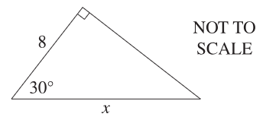

- $\frac{8}{\cos{30}}°$
- $\frac{8}{\sin{30}}°$
- $8×cos{30°}$
- $8×sin{30°}$

- A salesman earns $200 per week plus $40 commission for each item he sells.
How many items does he need to sell to earn a total of $2640 in two weeks?

- 33
- 56
- 61
- 66

- Consider the following set of scores
3, 5, 5, 6, 8, 8, 9, 10, 10, 50
How are the median and mean affected when the score of 50 is removed from the dataset?

- Median changes, mean changes
- Median changes, mean stays the same
- Median stays the same, mean changes
- Median stays the same, mean stays the same

- Which of the following events would be LEAST likely to occur?

- Tossing a fair coin and obtaining a head
- Rolling a standard six-sided die and obtaining a 3
- Randomly selecting the letter “G” from the 26 letters of the alphabet
- Winning the first prize in a raffle of 100 tickets in which you have 4 tickets

Short Answer Questions (35 marks)
Answer the questions in the spaces provided. Your responses should include relevant mathematical reasoning and/or calculations.
Marks CANNOT be awarded for poorly organised written work.
Question 6 - Number and Algebra (14 marks)
- Evaluate $\frac{1}{2.3×{10}^{-4}}$ using a calculator and give your answer in scientific notation, correct to 3 significant figures. (1)

……………………………………………………………………………………………………………………………………………………………………………………………………………………………………………………………………………………………………………………………………………………………………………………………………………………………………………………………………………………………….
- Simplify:${\left(2x^{4}\right)}^{2}$ (2)

……………………………………………………………………………………………………………………………………………………………………………………………………………………………………………………………………………………………………………………………………………………………………………………………………………………………………………………………………………………………………………………………………………………………………………………………………………………………………………………………….
- Express the following using positive indices: $3y^{-3}$ (1)
……………………………………………………………………………………………………………………………………………………………………………………………………………………………………………………………………………………………………………………………….
- Solve the following equations:
  - $4p-20=2p+8$ (2)
………………………………………………………………………………………………………………………………………………………………………………………………………………………………………………………………………………………………………………………………………………………………………………………………………………………………………………………………………………………………………………………………………………………………………………………………………………………………………………………………

  - $\frac{x-2}{5}+8=11$ (2)
……………………………………………………………………………………………………………………………………………………………………………………………………………………………………………………………………………………………………………………………………………………………………………………………………………………………………………………………………………………………………………………………………………………………………………………………………………………………………………………………….
- Consider the following graph below.
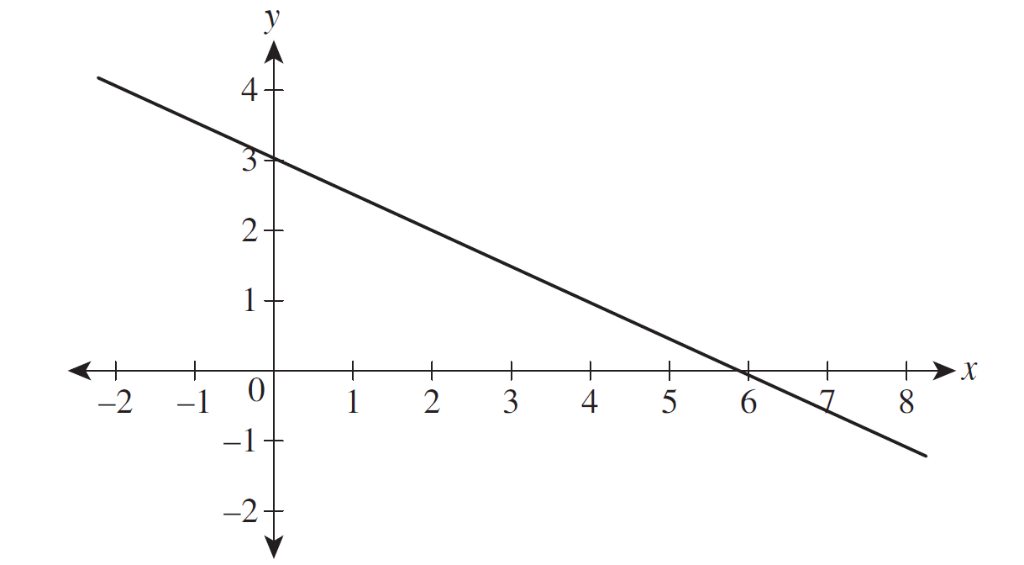
  - What is the $y$-intercept? (1)
……………………………………………………………………………………………………………………………………………………………………………………………………………………………………………………………………………………………………………………………….
  - What is the gradient of the line? (1)
……………………………………………………………………………………………………………………………………………………………………………………………………………………………………………………………………………………………………………………………….
  - Hence, write the equation of the line in the form $y=mx+c$. (1)
……………………………………………………………………………………………………………………………………………………………………………………………………………………………………………………………………………………………………………………………….

- For the linear relationship $x+2y-4=0$
  - Find the $x$- and $y$-intercepts (2)
………………………………………………………………………………………………………………………………………………………………………………………………………………………………………………………………………………………………………………………………………………………………………………………………………………………………………………………………………………………………
  - Use the intercepts found above to sketch the graph of $x+2y-4=0$ in the number plane below. (1)
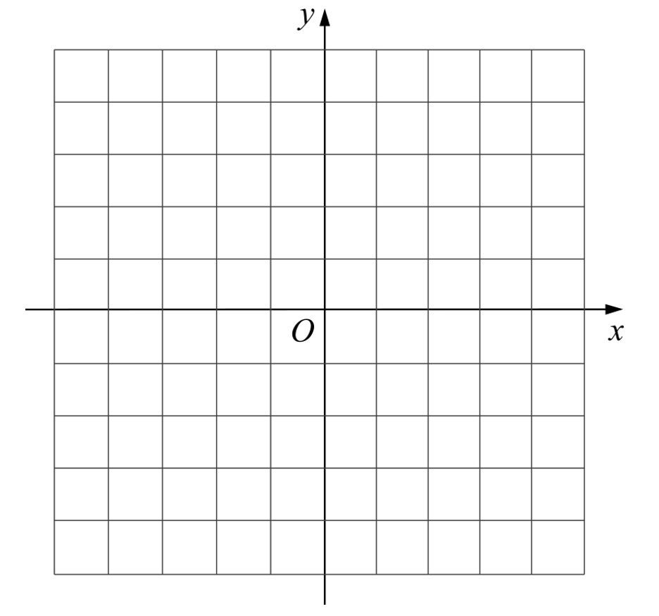

Question 7 – Measurement (5 marks)
- Find the value of $θ$, correct to the nearest minute. (2)
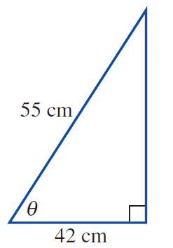
………………………………………………………………………………………………………………………………………………………………………………………………………………………………………………………………………………………………………………………………………………………………………………………………………………………………………………………………………………………………
- The angle of depression from a laser fixed 1.8m up a vertical wall to a mouse on the ground is $20°$.

  - Fill out the information from the question onto the diagram below. (1)
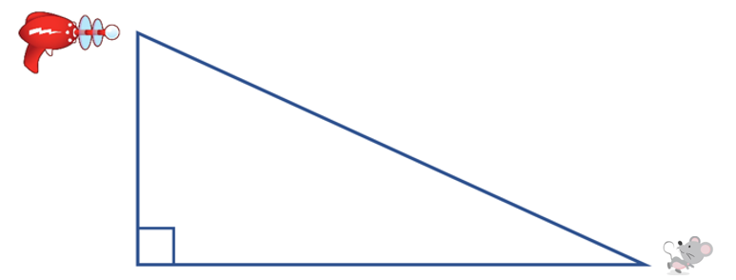
  - Find the distance between the mouse and the base of the wall, correct to two decimal places.
(2)
………………………………………………………………………………………………………………………………………………………………………………………………………………………………………………………………………………………………………………………………………………………………………………………………………………………………………………………………………………………………………………………………………………………………………………………………………………………………………………………………

Question 8 – Finance (6 marks)
Adrika is completing her tax return. She has a gross salary of $134 276 and income from a rental property totalling $12 550. She is claiming $14 320 in allowable tax deductions.
- Calculate Adrika’s taxable income (1)
……………………………………………………………………………………………………………………………………………………………………………………………………………………………………………………………………………………………………………………………….
- Using the tax table below, calculate Adrika’s tax payable. (2)
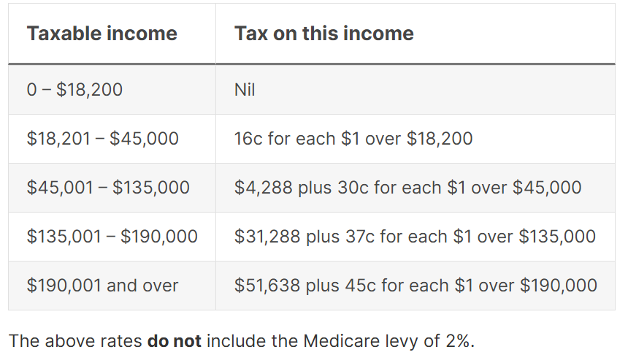
……………………………………………………………………………………………………………………………………………………………………………………………………………………………………………………………………………………………………………………………………………………………………………………………………………………………………………………………………………………………….
- In addition to the above tax, Adrika must also pay Medicare levy of 2% of her taxable income. Calculate the Medicare levy amount she needs to pay. (1)

……………………………………………………………………………………………………………………………………………………………………………………………………………………………………………………………………………………………………………………………….
- Adrika has already paid $35 244 as Pay As You Go (PAYG) tax. Should Adrika receive a tax refund or will she owe more tax? Justify your answer with calculations. (2)

……………………………………………………………………………………………………………………………………………………………………………………………………………………………………………………………………………………………………………………………………………………………………………………………………………………………………………………………………………………………….
Question 9 – Statistics (5 marks)
- Kate’s daily resting heart rates for February are displayed in the following stem-and-leaf plot.
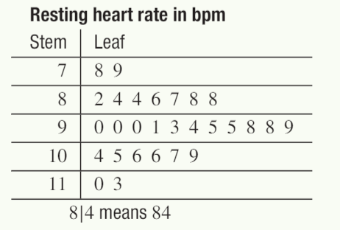
Find Kate’s median resting heart rate. (1)
……………………………………………………………………………………………………………………………………………………………………………………………………………………………………………………………………………………………………………………………….

- Give an example of a data set with a mode of 9 and a mean of 10. (2)
……………………………………………………………………………………………………………………………………………………………………………………………………………………………………………………………………………………………………………………………………………………………………………………………………………………………………………………………………………………………….
- Calculate the mean number of goals scored per game using the frequency histogram shown below. (2)
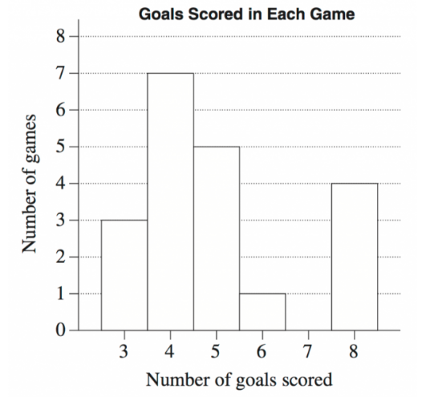

………………………………………………………………………………………………………………………………………………………………………………………………………………………………………………………………………………………………………………………………
Question 10 – Probability (5 marks)
A manufacturer carried out a survey of the defects in their soft toys. It is found that the probability of a toy having poor stitching is $0.04$ and that a toy with poor stitching has a probability of $0.72$ of splitting open.
A toy without poor stitching has a probability of $0.03$ of splitting open.

- Complete the tree diagram below to represent this information. (3)

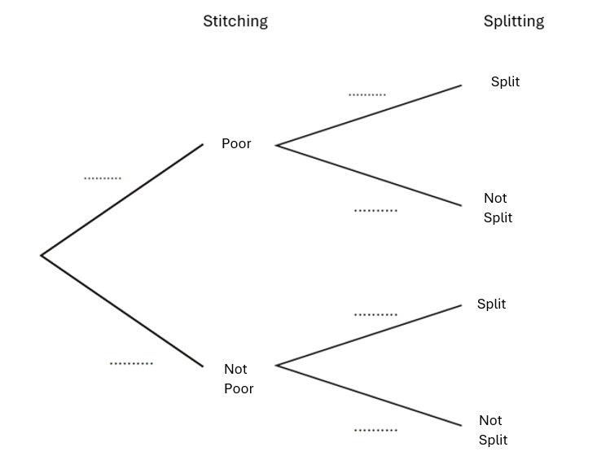

- Find the probability that a randomly chosen soft toy has no defects. (2)

……………………………………………………………………………………………………………………………………………………………………………………………………………………………………………………………………………………………………………………………………………………………………………………………………………………………………………………………………………………………….………………………………………………………………………………………………………………………………………………………………

End of Section I

Section II – Advanced (40 marks)
Allow approximately 50 minutes for this section

Multiple Choice Questions (5 marks) – Circle one correct answer
- What is the value of $p$ so that $\frac{a^{2}a^{-3}}{\sqrt{a}}=a^{p}$ ?
- $-3$
- $-\frac{3}{2}$
- $-\frac{1}{2}$
- $12$
- Which compass bearing is the same as a true bearing of $110°$?
- $S20°E$
- $S20°W$
- $S70°E$
- $S70°W$

- Ethan worked for 35 hours at the normal hourly rate of pay and for five hours at double time. He earned $561.60 in total for his work.
What was the normal hourly rate of pay?
- $7.02
- $12.48
- $14.04
- 16.05

- The mean of 8 scores is 12.5. A new score of 8 is included. What is the new mean?
- $12$
- $12.5$
- $13$
- $13.5$

- What is the correct set notation for the shaded region shown in the Venn diagram?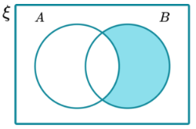

- $A∩B^{'}$
- $A^{'}∪B$
- $A∪B^{'}$
- $A'∩B$

Short Answer Questions (35 marks)
Answer the questions in the spaces provided. Your responses should include relevant mathematical reasoning and/or calculations.
Marks CANNOT be awarded for poorly organised written work.
Question 6 - Number and Algebra (16 marks)
- By showing full working, simplify: $\sqrt{18}-5\sqrt{32}$ (2)

………………………………………………………………………………………………………………………………………………………………………………………………………………………………………………………………………………………………………………………………………………………………………………………………………………………………………………………………………………………………………………………………………………………………………………………………………………………………………………………………

- Expand and simplify: ${\left(x-3\right)}^{2}+(x+3)(x-3)$ (2)

………………………………………………………………………………………………………………………………………………………………………………………………………………………………………………………………………………………………………………………………………………………………………………………………………………………………………………………………………………………………………………………………………………………………………………………………………………………………………………………………

- Factorise: $2m^{2}+15m+25$ (2)
……………………………………………………………………………………………………………………………………………………………………………………………………………………………………………………………………………………………………………………………………………………………………………………………………………………………………………………………………………………………………………………………………………………………………………………………………………………………………………………………………………………………………………………………………………………………………………………………………………………………….

- Factorise and simplify: $\frac{y^{2}-8y+12}{3y-18}×\frac{y^{2}-36}{2y-12}$ (2)
………………………………………………………………………………………………………………………………………………………………………………………………………………………………………………………………………………………………………………………………………………………………………………………………………………………………………………………………………………………………………………………………………………………………………………………………………………………………………………………………………………………………………………………………………………………………………………………………………………………………………………………………………………………………………………………………………………………………………………………………………………………………………………………………………………………………………………………………………………………………

- Solve the equation: $\frac{3x-1}{4}-\frac{x-4}{7}=5$ (2)
………………………………………………………………………………………………………………………………………………………………………………………………………………………………………………………………………………………………………………………………………………………………………………………………………………………………………………………………………………………………………………………………………………………………………………………………………………………………………………………………………………………………………………………………………………………………………………………………………………………………………………………………………………………………………………………………………………………………………………………………………………………………………………………………………………………………………………………………………………………………

- By forming a pair of simultaneous equations, solve the problem below:

A bill totalling $125 was paid with only $5 and $10 notes.
If 18 notes were used in total, how many $5 and $10 notes were used? (3)

………………………………………………………………………………………………………………………………………………………………………………………………………………………………………………………………………………………………………………………………………………………………………………………………………………………………………………………………………………………………………………………………………………………………………………………………………………………………………………………………………………………………………………………………………………………………………………………………………………………………………………………………………………………………………………………………………………………………………………………………………………………………………………………………………………………………………………………………………………………………………………………………………………………………………………………………………………………………………………………………………………………………………………………………………………………………………………………………………………………………

- Find the equation of the line that is perpendicular to $2x-y+5=0$ and passes through the midpoint of $(-3, 2)$ and $(5, 6)$. (3)
………………………………………………………………………………………………………………………………………………………………………………………………………………………………………………………………………………………………………………………………………………………………………………………………………………………………………………………………………………………………………………………………………………………………………………………………………………………………………………………………………………………………………………………………………………………………………………………………………………………………………………………………………………………………………………………………………………………………………………………………………………………………………………………………………………………………………………………………………………………………………………………………………………………………………………………………………………………………………………………………………………………………………………………………………………………………………………………………………………………………………………………………………………………………………………………………………………………………………………………………
Question 7 – Measurement (6 marks)
- Below is a square pyramid with $AB=6$ metres.
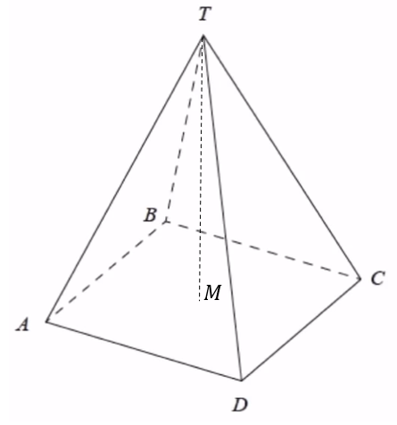
$T$ is $12$metres vertically above the centre, $M$, of square $ABCD$.

  - Calculate the length of $AM,$leaving your answer in exact surd form. (2)
…………………………………………………………………………………………………………………………………………………………………………………………………………………………………………………………………………………………………………………………………………………………………………………………………………………………………………………………………………………………………………………………………………………………………………………………………………………………………………………………………………………………………………………………………………………………………………………………………………………………….

  - Hence, calculate the size of ∠$TAM,$ correct to the nearest degree. (2)

……………………………………………………………………………………………………………………………………………………………………………………………………………………………………………………………………………………………………………………………………………………………………………………………………………………………………………………………………………………………………………………………………………………………………………………………………………………………………………………………………………………………………………………………………………………………………………………………………………………………….

- A helicopter travels on a true bearing of $098°$ so that it is 75km east of its original position.
By first drawing a diagram, calculate how far the helicopter travelled, correct to 2 decimal places. (2)

………………………………………………………………………………………………………………………………………………………………………………………………………………………………………………………………………………………………………………………………………………………………………………………………………………………………………………………………………………………………………………………………………………………………………………………………………………………………………………………………………………………………………………………………………………………………………………………………………………………………………………………………………………………………………………………………………………………………………………………………………………………………………………………………………………………………………………………………………………………………………………………………………………………………………………………………………………………………………………………………

Question 8 – Finance (4 marks)
- $18 000 is invested in an account earning 6% per annum, compounded quarterly. Calculate the interest earned after 3 years. (2)

……………………………………………………………………………………………………………………………………………………………………………………………………………………………………………………………………………………………………………………………………………………………………………………………………………………………………………………………………………………………………………………………………………………………………………………………………………………………………………………………………………………………………………………………………………………………………………………………………………………………….……………………………………………………………………………………………………………………………………………………………………………………………………………………………………………………………………………………………………………………………….

- A car depreciated in value by 25% per annum. Two years after it was purchased it had depreciated to a value of $31 500.
What was the purchase price of the car? (2)

……………………………………………………………………………………………………………………………………………………………………………………………………………………………………………………………………………………………………………………………………………………………………………………………………………………………………………………………………………………………………………………………………………………………………………………………………………………………………………………………………………………………………………………………………………………………………………………………………………………………….………………………………………………………………………………………………………………………………………………………………………………………………………………………………………………………………………………………………………………………………

Question 9 – Data (5 marks)
- Students were surveyed on the number of hours they spent studying on their yearly examinations.
The results are summarised in the box plot below.

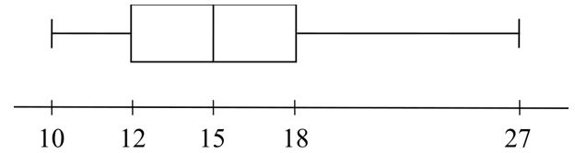

- Describe the shape of the distribution of the box plot. (1)

………………………………………………………………………………………………………………………………………………………………………………………………………………………………………………………………………………………………………………………………

- Calculate the interquartile range. (1)

………………………………………………………………………………………………………………………………………………………………………………………………………………………………………………………………………………………………………………………………

- If 280 students completed the survey, how many of them studied for more than 12 hours for their yearly examinations? (1)

……………………………………………………………………………………………………………………………………………………………………………………………………………………………………………………………………………………………………………………………………………………………………………………………………………………………………………………………………………………………….
- Two groups of students took the same math quiz. The scores are shown below:

Group A: 70, 75, 75, 80, 85
Group B: 50, 70, 80, 90, 100

By observing the scores only, state which group would have a higher standard deviation and briefly explain why. (No need to calculate the standard deviation for each group) (2)

……………………………………………………………………………………………………………………………………………………………………………………………………………………………………………………………………………………………………………………………………………………………………………………………………………………………………………………………………………………………….
Question 10 – Probability (4 marks)
A group of 120 Year 9 parents were surveyed as to the main causes of distraction for their children.

50 parents responded that social media ($S$) was the main cause of distraction, while 80 parents responded that video games ($V$) was the main cause of distraction. 15 parents responded that their children do not get distracted.

- Draw a Venn diagram to represent this information. (2)


- Find $P(S∩V)$ (1)

………………………………………………………………………………………………………………………………………………………………………………………………………………………………………………………………………………………………………………………………
- Given that a child is distracted by social media, what is the probability that the child is also distracted by video games? (1)

………………………………………………………………………………………………………………………………………………………………………………………………………………………………………………………………………………………………………………………………

End of Exam


Norwest Christian School
Mathematics Formulas (Stage 5)

Indices  $$a^{m}×a^{n}=a^{m+n}$$  $$a^{m}÷a^{n}=a^{m-n}$$  $${\left(a^{m}\right)}^{n}=a^{m×n}$$  $$a^{-m}=\frac{1}{a^{m}}$$  $$a^{0}=1$$  $$a^{\frac{1}{m}}=\sqrt[m]{a}$$  $${\left(\frac{a}{b}\right)}^{m}=\frac{a^{m}}{b^{m}}$$  Surds  $$\sqrt{a}×\sqrt{b}=\sqrt{ab}$$  $$\frac{\sqrt{a}}{\sqrt{b}}=\sqrt{\frac{a}{b}}$$  Gradient-intercept form of straight line  $$y=mx+c$$  Pythagoras’ Theorem  $$a^{2}+b^{2}=c^{2}$$  Distance and Midpoint  $$d=\sqrt{{\left(x_{2}-x_{1}\right)}^{2}+{\left(y_{2}-y_{1}\right)}^{2}}$$  $$M=\left(\frac{x_{1}+x_{2}}{2} , \frac{y_{1}+y_{2}}{2}\right)$$  $$Gradient$$  $$m=\frac{y_{2}-y_{1}}{x_{2}-x_{1}}$$ | Parallel lines  $$m_{1}=m_{2}$$  Perpendicular lines  $$m_{1}m_{2}=-1$$  Financial Mathematics  Simple Interest: $I=Prn$  Compound Interest: $FV=PV{\left(1+r\right)}^{n}$  Depreciation: $S=V_{0}{\left(1-r\right)}^{n}$  Trigonometry  $$\sin{θ=\frac{opp}{hyp}, \cos{θ}=\frac{adj}{hyp}, \tan{θ=\frac{opp}{adj}}}$$  Probability  $$P\left(event\right)=\frac{number of favourable outcomes}{total number of outcomes}$$

