

Name ______________

Teacher______________

Year 9 MATHEMATICS Advanced 2025
Yearly Examination
General Instructions  - Reading time – 5 minutes  - Working time – 90 minutes  - Show all necessary working/units  - Board-approved calculators are allowed  - Exam guidelines  - Use black pen for your working  - Use a pencil and ruler for diagrams  - Marks may be lost for poorly organised written work. | Total Marks – 80  Section I Standard – 40 marks  Allow 40 minutes  Section II Advanced – 40 marks  Allow 50 minutes

Question | Number and Algebra | Measurement and Geometry | Statistics and Probability | Total
Section II  Advanced |  |  |  | /40
1,2,6 | /26
4,5,7 |  | /7
3,8 |  |  | /7

Section II – Advanced (40 marks)
Allow approximately 50 minutes for this section

Multiple Choice Questions (5 marks) – Circle one correct answer

1 | Which of the following is parallel to $y=-0.5x+7$
 | (A) $-x+2y+14=0$
 | (B) $2x-y+3=0$
 | (C) $-2x-y=1$
 | (D) $x+2y=-4$
2 | Which of these expressions can be factorised to a perfect square?
 | (A) $x^{2}-7x-1-7x+50$
 | (B) $2x^{2}+x-3x-x^{2}+5x-15$
 | (C) $x^{2}+9$
 | (D) $x^{2}-9$
3 | Which of these values is the Inter Quartile Range (IQR) for the following data set?
 | $$30 31 33 23 29 31 21 15 24 23$$
 | (A) 23
 | (B) 8
 | (C) 31
 | (D) 6.5
4 | Which of the following is closest to the surface area of this square-based pyramid?
 | 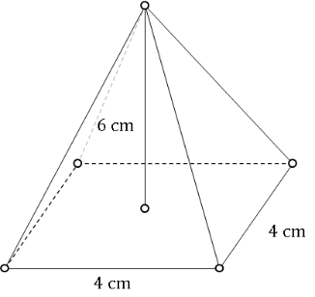
 | (A) $810 {cm}^{2}$
 | (B) $74 {cm}^{2}$
 | (C) $64 {cm}^{2}$
 | (D) $67 {cm}^{2}$

5 | Which similarity test proves these triangles as similar?
$$80°$$
$$40°$$
$$40°$$
$$80°$$
$$48$$
$$72$$
 | (A) SSS
 | (B) SAS
 | (C) AAA
 | (D) RHS

Short Answer Questions (35 marks)
Answer the questions in the spaces provided. Your responses should include relevant mathematical reasoning and/or calculations.
Marks CANNOT be awarded for poorly organised written work.

Question 6 - Number and Algebra (24 marks)
(a) Simplify the following expression with clear working out
$$4\sqrt{2}-6\sqrt{75}+\sqrt{2}-5\sqrt{3}$$ | (1)
(b) Find the integers $a$ and $b$  $${\left(3-\sqrt{2}\right)}^{2}=a-\sqrt{b}$$ | (2)

(c) Show that  $$\frac{8-2\sqrt{6}}{3\sqrt{2}+\sqrt{32}}=\frac{-2\sqrt{3}+4\sqrt{2}}{7}$$ | (3)
(d) Solve the following equation  $$\frac{5\left(x+3\right)}{3}=\frac{x-2}{7}$$ | (2)
(d) Flour comes in bags of 1.5 kilograms or 2 kilograms. A baker has 30 bags of flour, and their total weight is 51.5 kilograms. Find the number of 1.5 kilogram bags, and the number of 2 kilogram bags that the baker has. | (3)

(e) Consider the points $A(-1,3)$ and $B(8,-3)$
- Plot the points on the graph and draw a line through the points  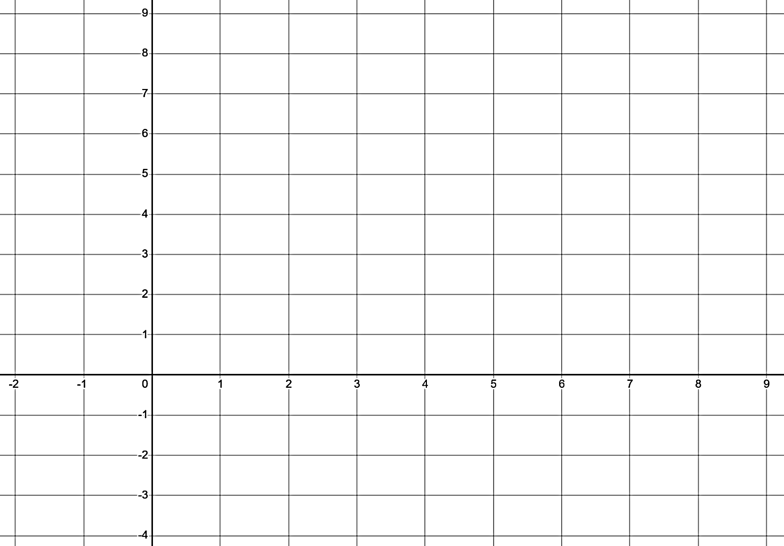 | (1)
- Show that the equation of the line drawn in i) is $y=\frac{-2}{3}x+2\frac{1}{3}$ | (2)

- Find the line that is perpendicular to $y=\frac{-2}{3}x+2\frac{1}{3}$, and passes through point $C\left(5,7\right)$ | (2)
(f) Fully simplify and expand the following expression  $$\frac{x^{2}+4x-21}{7x-7}÷\frac{14+2x}{x^{2}-3x+2}$$ | (2)
(g) Solve the following equation for $x$  $$\frac{4x+4}{3}+\frac{x-3}{2}=9$$ | (2)
(h) The canteen is selling brownies and has 2 deals.  Deal 1 – 3 brownies for $5  Deal 2 – 7 brownies for $11  Regular price – 1 brownie for $2  What is the cheapest price to buy at least 19 brownies? | (2)
(i) Jane and John both have $6 500. Jane invests her money at 6% P.A. for 3 years, compounded quarterly. If John invests his money for 2 years in compounding monthly, what would the monthly interest rate be if he earned the same amount as Jane? Find the rate as a percentage to 2 decimal places | (2)

Question 7 – Measurement and Geometry (5 marks)
(a) Consider the prism below. All lengths are in centimetres
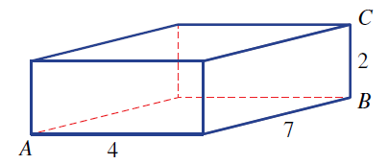
Not to scale
- Find the exact length of diagonal $AB$ | (1)
- Find the exact length of diagonal $AC$ | (1)
- Find the angle $∠BAC$ to the nearest minute | (1)
(c) Consider the cone and sphere below. If the sphere and cone have the same volume and radius, find the height of the cone in terms of the radius.  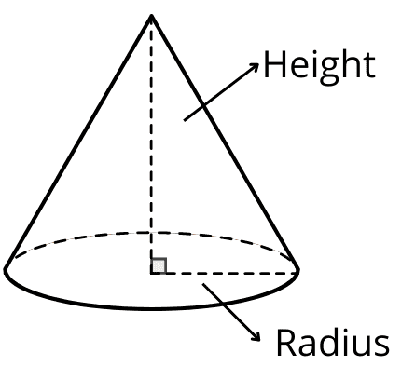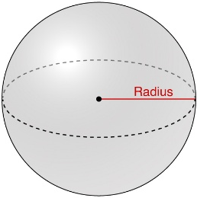 | (2)

Question 8 – Statistics and Probability (6 marks)
(a) One hundred people were surveyed regarding their use of water for their garden. Of that group, 23 said that they used rainwater, 48 said that they used tap water and 41 said that they did not water at all.
- Represent this information in a 2-way table | (1)
- Find $P(Tap∩Rain)$ | (1)
- Find $P(Tap^{'})$ | (1)
(b) Consider the sorted data set below

$$23 33 34 35 43 44 49 53 55 64 74$$

- Draw a box plot | (2)
- Describe the skewness or symmetry of the box plot | (1)

End of Exam

Norwest Christian College
Mathematics Formulas (Advanced)

Indices  $$a^{m}×a^{n}=a^{m+n}$$  $$a^{m}÷a^{n}=a^{m-n}$$  $${\left(a^{m}\right)}^{n}=a^{m×n}$$  $$a^{-m}=\frac{1}{a^{m}}$$  $$a^{0}=1$$  $$a^{\frac{1}{m}}=\sqrt[m]{a}$$  $${\left(\frac{a}{b}\right)}^{m}=\frac{a^{m}}{b^{m}}$$  Surds  $$\sqrt{a}×\sqrt{b}=\sqrt{ab}$$  $$\frac{\sqrt{a}}{\sqrt{b}}=\sqrt{\frac{a}{b}}$$  Gradient-intercept form of straight line  $$y=mx+c$$  Distance and Midpoint  $$d=\sqrt{{\left(x_{2}-x_{1}\right)}^{2}+{\left(y_{2}-y_{1}\right)}^{2}}$$  $$M=\left(\frac{x_{1}+x_{2}}{2} , \frac{y_{1}+y_{2}}{2}\right)$$  $$Gradient$$  $$m=\frac{y_{2}-y_{1}}{x_{2}-x_{1}}$$ | Parallel lines  $$m_{1}=m_{2}$$  Perpendicular lines  $$m_{1}m_{2}=-1$$  Financial Mathematics  Simple Interest: $I=Prn$  Compound Interest: $FV=PV{\left(1+r\right)}^{n}$  Depreciation: $S=V_{0}{\left(1-r\right)}^{n}$  Pythagoras’ Theorem  $$a^{2}+b^{2}=c^{2}$$  Measurement  $${SA}_{Square Pyramid}=2bh+b^{2}$$  $$V_{cone}=\frac{πhr^{2}}{3}$$  $$V_{sphere}=\frac{4πr^{3}}{3}$$  $$V_{pyramid}=\frac{a^{2}h}{3}$$  Trigonometry  $$\sin{θ=\frac{opp}{hyp}, \cos{θ}=\frac{adj}{hyp}, \tan{θ=\frac{opp}{adj}}}$$  Probability  $$P\left(event\right)=\frac{number of favourable outcomes}{total number of outcomes}$$

