

Name ______________

Teacher_____________

Year 9 MATHEMATICS Standard 2025
Yearly Examination
General Instructions  - Reading time – 5 minutes  - Working time – 90 minutes  - Show all necessary working/units  - Board-approved calculators are allowed  - Exam guidelines  - Use black pen for your working  - Use a pencil and ruler for diagrams  - Marks may be lost for poorly organised written work. | Total Marks – 80  Section I Core – 40 marks  Allow 40 minutes  Section II Standard – 40 marks  Allow 50 minutes

Question | Number and Algebra | Measurement and Geometry | Statistics and Probability | Total
Section II  Standard |  |  |  | /40
1,2,6 | /24
4,5,7 |  | /11
3,8 |  |  | /5

Section II – Standard (40 marks)
Allow approximately 50 minutes for this section

Multiple Choice Questions (5 marks) – Circle one correct answer
1 | Select the graph that represents $y=2x-3$
1 | (A)  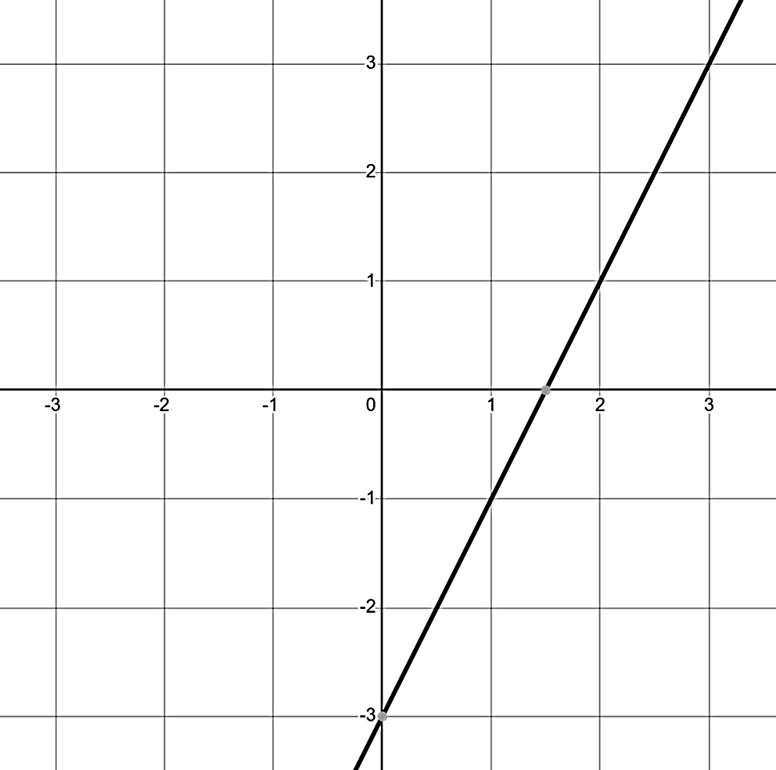 | (B)  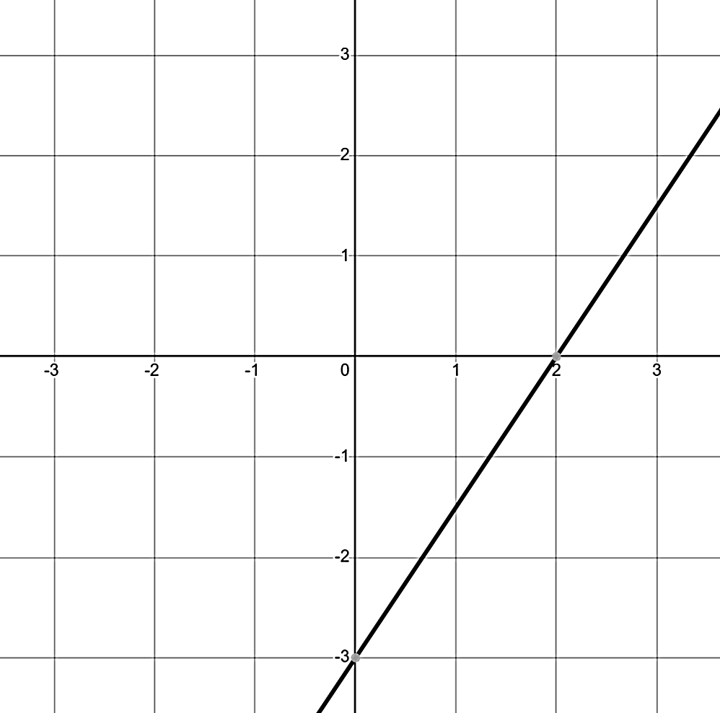
1 | (C)  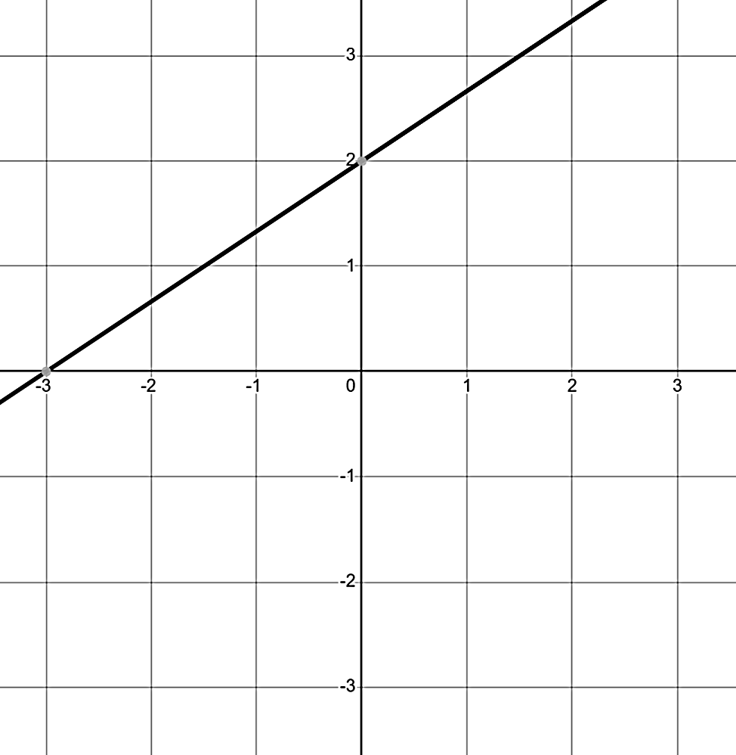 | (D)  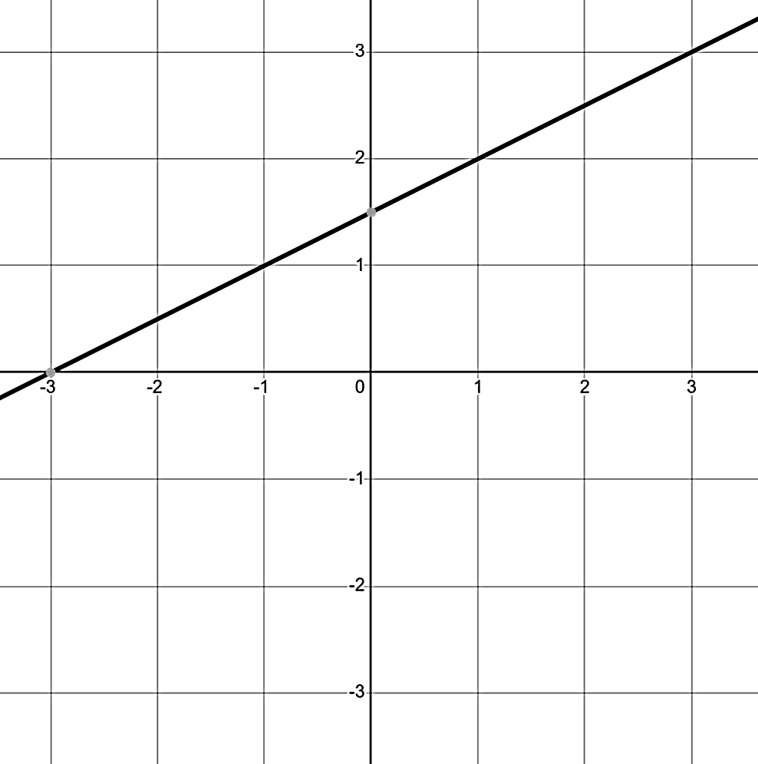
2 | Find Oliver’s hourly wage if he works 13 hours a week and at the end of the fortnight is paid $637.78.  (A) $53.15  (B) $49.06  (C) $318.89  (D) $24.53
3 | Madison snoozed her first alarm for school 3 times in the last fortnight.  What is the observed probability that Madison snoozes her alarm for school?  (A) 0.3  (B) $\frac{3}{14}$  (C) 3  (D) 0.2

4 | Identify the trigonometric ratio used to solve for $x$  $$x$$  $$50°$$  12  (A) $\cos{12}$  (B) $\tan{50°}$  (C) $\sin{50°}$  (D) $\tan{12}$
5 | Identify the working used to find the arc length of the quadrant  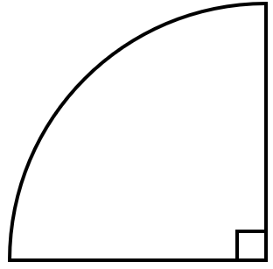  6 cm  (A) $\frac{90}{180}×2×π$  (B) $\frac{90}{360}×2×π×6$  (C) $\frac{90}{180}×2×6$  (D) $\frac{90}{360}×6×π$

Short Answer Questions (35 marks)
Answer the questions in the spaces provided. Your responses should include relevant mathematical reasoning and/or calculations.
Marks CANNOT be awarded for poorly organised written work.

Question 6 - Number and Algebra (22 marks)
(a) Simplify the following expression  $${\left(4x^{4}\right)}^{3}$$ | (2)
(b) Express the following expression with a positive index  $$\frac{3}{y^{-4}}$$ | (1)

(c) Solve the following equations, leaving solutions as simplified fractions where appropriate
- $9x-4=14$ | (1)

- $\frac{x+7}{4}=4$ | (2)
- $3\left(5x-6\right)=21$ | (2)

(d) Izzy has two cousins; one is 5 years older than the other. Their combined age is 23. How old are Izzy’s cousins? | (2)

(e) Consider the following graph
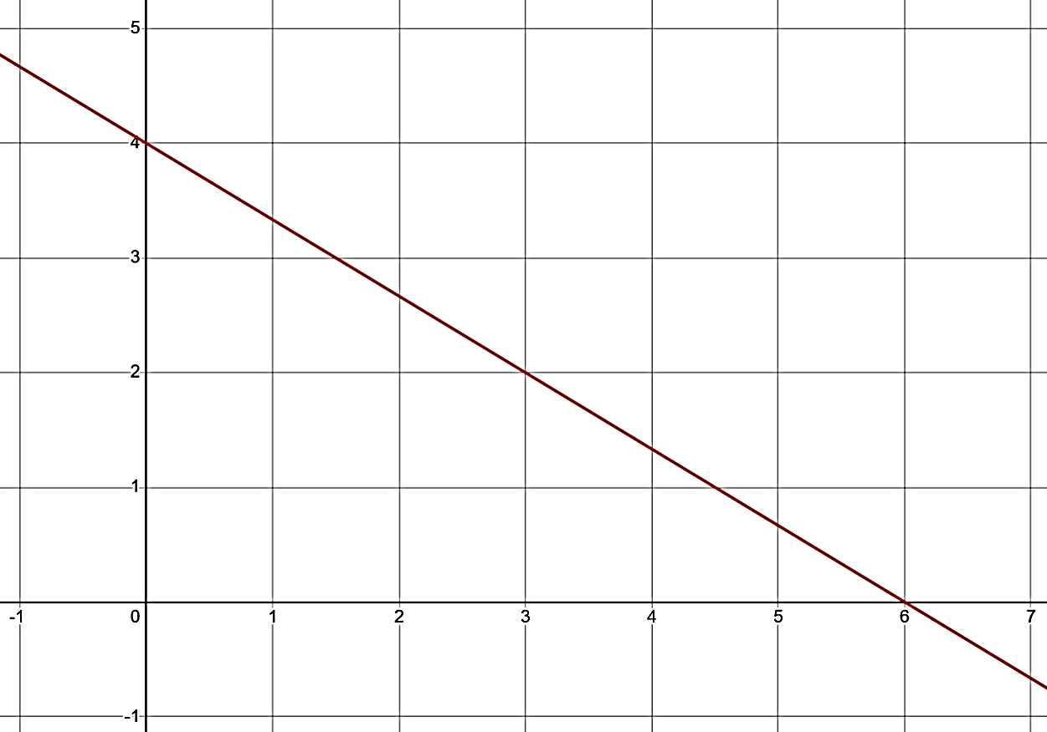
- Find the gradient of the line | (1)
- By first finding the $y$-intercept, find the equation of the line in gradient-intercept form (i.e. $y=mx+c$) | (1)
- Find the length of the segment of the line between the $x$-intercept and $y$-intercept to 2 decimal places | (2)

(f) Cohen is filling in his tax return. He earns a salary of $97 030 and also receives $540 every quarter from shares in Lucas’ company. Cohen makes tax deductable donations of $67 every month to Elijah’s charity.

- Find Cohen’s total yearly income | (1)
- Calculate Cohen’s total tax deductions | (1)
- Hence show that Cohen’s taxable income is $98 386 | (1)

- Use Cohen’s taxable income ($98 386) and the tax table below to show that Cohen’s income tax is $20 303.80  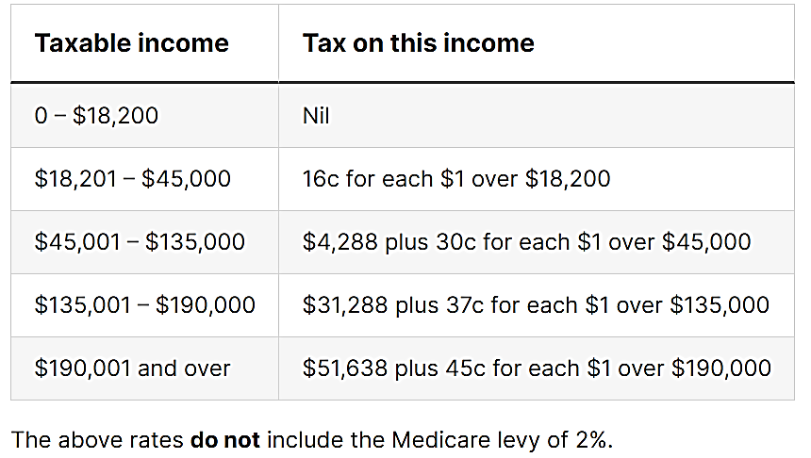 | (2)
- In addition to income tax, he must also pay a Medicare Levy of 2% of his taxable income. Calculate Cohen’s Medicare Levy | (1)
- Determine the total tax Coehn owes | (1)
- The PAYG system means that Cohen has already paid $27 000 as tax. Determine whether he is owed a refund or is required to pay more money to the government | (1)
Question 7 – Measurement and Geometry (9 marks)
(a) Find the length of the unknown side of the right-angled triangle to 2 decimal places  5  12  $$x$$ | (1)
(b) Juliet is on the Sydney ferry looking at the flags on the top of the Sydney Harbour Bridge. She is looking up at $48°$ from the horizontal and judges the direct distance to the flags as 800 metres.
- Label the diagram with the appropriate numbers  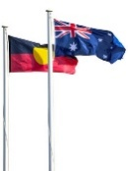 | (1)
- Using the diagram, find the horizontal distance to the point on the water directly below the flags to the nearest metre | (1)
(c) Flynn wants to know how much wrapping paper he needs to wrap his gifts for his parents. Find the surface area of the following prisms to 1 decimal place where necessary
- Cylinder  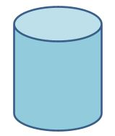  13 cm  24 cm | (2)
- Trapezoidal  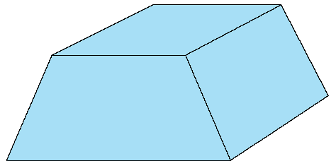  5 mm  12 mm  14 mm  9 mm  9 mm  34 mm² | (2)

(d) Cruze has bought a bush property, shown in the diagram.￼
- Find the perimeter of the property | (1)
- Find the area of the property | (1)

Question 8 – Statistics and Probability (4 marks)
(a) Over the last 12 netball games Ose scored the following number of points
$$7 6 12 13 2 6 12 9 13 11 13 13$$
- Find the mean | (1)
- Find the median score | (1)
- Draw a dot plot of points scored  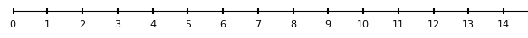 | (1)

(b) Find the error in the tree diagram  $$\frac{15}{24}$$  $$\frac{18}{48}$$  $$\frac{18}{24}$$  $$\frac{9}{27}$$  $$\frac{14}{35}$$  $$\frac{15}{25}$$ | (1)

End of Exam


Norwest Christian College
Mathematics Formulas (Standard)

Indices  $$a^{m}×a^{n}=a^{m+n}$$  $$a^{m}÷a^{n}=a^{m-n}$$  $${\left(a^{m}\right)}^{n}=a^{m×n}$$  $$a^{-m}=\frac{1}{a^{m}}$$  $$a^{0}=1$$  Gradient-intercept form of straight line  $$y=mx+c$$  Distance and Midpoint  $$d=\sqrt{{\left(x_{2}-x_{1}\right)}^{2}+{\left(y_{2}-y_{1}\right)}^{2}}$$  $$M=\left(\frac{x_{1}+x_{2}}{2} , \frac{y_{1}+y_{2}}{2}\right)$$  $$Gradient$$  $$m=\frac{rise}{run}=\frac{y_{2}-y_{1}}{x_{2}-x_{1}}$$ | Financial Mathematics  Simple Interest: $I=Prn$  Pythagoras’ Theorem  $$a^{2}+b^{2}=c^{2}$$  Trigonometry  $$\sin{θ=\frac{opp}{hyp}, \cos{θ}=\frac{adj}{hyp}, \tan{θ=\frac{opp}{adj}}}$$  Geometry  $$A_{triangle}=\frac{bh}{2}$$  $$A_{trapezium}=\frac{h}{2}\left(a+b\right)$$  $$A_{circle}=πr^{2}$$  $${SA}_{cylinder}=2πr^{2}+2πrh$$  Probability  $$P\left(event\right)=\frac{number of favourable outcomes}{total number of outcomes}$$  Data  Mode – highest frequency score  Median – middle score  Mean – average score  Range – the overall spread of the scores

